Revelation 15:1-8 – Judgments from Heaven

Revelation chapter 15: The “of God” Chapter

One could call this 15th chapter of Revelation the “of God” chapter. The chapter is a short one – only 8 verses. There are five times in 8 verses in which something is said to be “of God”:

- Verse 1 “…wrath of God”
- Verse 2 “…harps of God”
- Verse 3 “…servant of God”
- Verse 7 “…wrath of God”
- Verse 8 “…glory of God”

Truthfully, isn’t our position in Christ “of God”, too (1 Corinthians 1:30)?

1 Then I saw another sign in heaven, great and marvelous, seven angels who had seven plagues, which are the last, because in them the wrath of God is finished.

If you read “another” and thought that must be the Greek word allos, meaning “another of the same kind”… you were right – very good!

This is now the third and final “sign in heaven”, the first two being given in chapter 12. John calls this third and last sign “great and marvelous” - massive in significance. It is of a nature that is to stimulate wonder. We might use the word ‘awesome”.

This sign consists of the seven angels. These are the ones who have the seven last plagues. These seven angels are mentioned again in chapters 15, 16, 17 and 21.

These last plagues are going to be detailed for us in chapter 16. But just so we all have a general idea in mind as to what will take place, they are listed in order, with a brief description in the text box to the left. We need to understand ahead of time that they will be devastating beyond imagination.

Coming to the Earth in the Last Half of the Tribulation Period

Bowl Revelation
Judgment Chapter 16:

1 Boils 2

2 Sea of Blood 3

3 Rivers of Blood 4-7
4 Heat 8-9
5 Darkness 10-11
6 Dry Up Euphrates 12
Armageddon 13-16
7 Hail & Earthquake 17-21

Then…The 2nd Coming of Christ

These seven angels are here described as having the seven plagues, which are seen as being the same as the seven bowls of the final judgments. This becomes abundantly clear as one reads through this passage.
There are some who will try to say that the seven seals and the seven trumpets and the seven bowls all happen at the same time or are the same. However:

- Revelation 15:1 says that these seven plagues are “the last”.
- Revelation 21:9 also says that those same seven plagues are “the last”.
- This (“the last”) is never said of the seven seals and seven trumpets.
- Further, the seven trumpets are just begun by the opening of the seventh seal.

Now is a good place to pause to take a look at just a few of the insights from the Greek text that stands behind this passage.

The first is the word translated as finished, “filled up”, or fulfilled, and this shows up in verses 1 and 8 in Revelation chapter 15. The Greek word is teleo, which means ‘brought to completion’. In these seven last plagues, the wrath of God is finished. The wrath of God is completed – made to come to an end – done.

The next word is typically translated “something like” or “as it were”. This word shows up in verse 2, and is the Greek word hos. It is used in describing something unfamiliar with something that is familiar by way of comparison.

Then we have the English word “stand”, which we will see in verse 2. The Greek word behind that (histemi) means ‘to be established’ or ‘to be set in place’. In verse 2 it is in the perfect tense, passive voice, meaning that it is completed with ongoing results and that it is established not of itself, but by God.

With that as a background, let’s look at what John describes next for us…

2 And I saw something like a sea of glass mixed with fire, and those who had been victorious over the beast and his image and the number of his name, standing on the sea of glass, holding harps of God.

Now John has said “I saw” to us before dozens of times, and he will tell us that again over a dozen times more. That is because he has been writing from the start for us as an “eye witness”. John then uses a Greek word that he uses a number of times in Revelation: the word hos, which means “something like”. It is translated “as it were” in the KJV. John is using comparative language. He then tells us that what he sees is like a sea of glass mixed with fire. We’ve talked about this sea of glass and I’m sure you all remember that very clearly, so just humor me a minute while I bring it up again. John has mentioned the “sea of glass” in Revelation 4:6, and there he added to the description “like crystal”.

In New Testament times, clear smooth glass like we use on many windows now was simply not available. The technology for making clear, smooth glass was not to come for many centuries. Glass then was bumpy, bubbly, milky looking at best, and small in size. That is why John uses the additional comparative phrase, “like crystal”. By that he meant rock crystal – like quartz, which could sometimes be found in a form that was clear and smooth on the surface.

Notice very carefully something here: the ones who were martyred out of the Tribulation period are called “victorious”. That should bring a very important point home to our hearts and minds: From the standpoint of the world, it looks like these Tribulation saints just lost their lives and were anything but “victorious”. The world wouldn’t say that these had been victorious unless they had defeated the Beast in some battle or had at the very least survived. But that is not the way God sees it at all. Here is how God sees it: Even if saints here on earth succumb to the worst duress we can imagine, so that some power on earth seems to have clearly gained the upper hand, God sees victory as our depending upon Him and who He is and what He has done. For us as believers, victory consists of beholding Christ, no matter what the external circumstances seem to be like or if world’s forces feel like they have us in a bad headlock. Paul writes in 1 Corinthians 15:57, “but thanks be to God, who gives us the victory through our Lord Jesus Christ.”
The beast, the image, the mark and the number of his name will take these saints out of earth and God calls that victory.

There are some additional insights from the Greek text that will be of value to us:

The English words in verse 2, “victory over” or “victorious over” (Greek: nikao ek) literally mean “victory from”. In verse 2 the preposition ek is repeated with the definite article in front of each noun, so the Greek text would convey literally, “…having the victory from the beast and from the image of him and from the number of the name of him…”. The Tribulation saints have “victory from" the Tribulation by ‘being taken out from it’. This contrasts with church age believers who are kept from the hour of testing which is to come upon the whole world (Revelation 3:10).

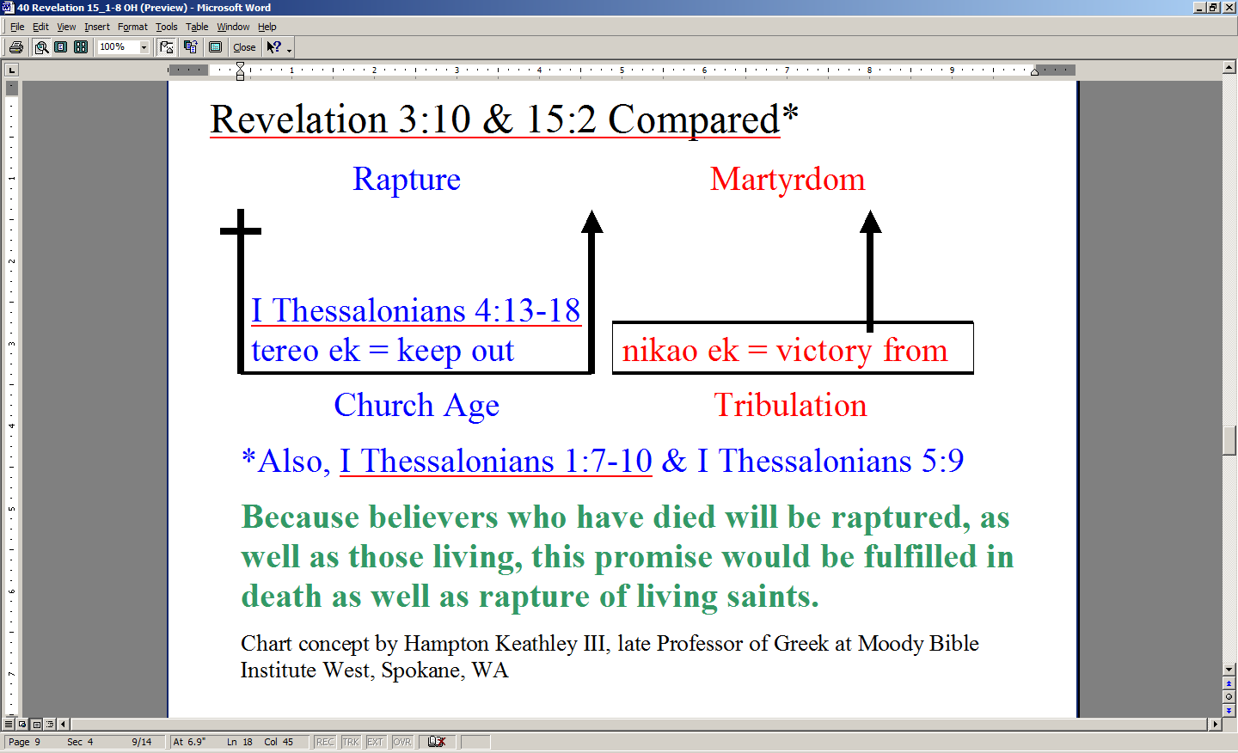
Church age believers are then raptured, that is, kept from the hour of testing that will come upon the whole world. Tribulation age believers, in contrast, are said to have victory from the midst of the hour of testing that has come upon the whole world by being martyred.

3 And they sang the song of Moses, the bond-servant of God, and the song of the Lamb, saying,
"Great and marvelous are Your works, O Lord God, the Almighty; Righteous and true are Your ways, King of the nations! 4 "Who will not fear, O Lord, and glorify Your name? For You alone are holy; For all the nations will come and worship before You, for Your righteous acts have been revealed."

Here John refers to two songs that these Tribulation martyrs sing:

- The song of Moses, and
- The song of the Lamb

Now these are not one song but two distinct songs. Each has the word “song” separately, and each has a definite article in front of it as well. The song of Moses is not repeated here in Revelation 15 because it is given in Deuteronomy 32:1-43. That is a song which glorifies God, and is also a song which speaks of the Lord’s deliverance of the Jews from the hand of Pharaoh - it tells of what God has done.

The song of the Lamb, on the other hand, is given here in Revelation, and that is what we read in the rest of verses 3 and 4. The song of the Lamb is not about our position in Christ as church age believers, because these martyred saints are not church age believers. They are Tribulation saints, coming out of a time which anticipates the earthly reign of the Messiah on earth for 1000 years. That is why it says, “…all nations shall come and worship before Thee”.

Why these two songs? Why one of Moses and another of the Lamb?

- The song of Moses praises God for delivering Israel from Pharoah just before Israel went into the land God promised.
- The song of the Lamb praises the Lamb for His soon to begin reign over the earth from Israel, having delivered Israel again from its enemies during the last half of the Tribulation period.

5 After these things I looked, and the temple of the tabernacle of testimony in heaven was opened,
6 and the seven angels who had the seven plagues came out of the temple, clothed in linen, clean and bright, and girded around their chests with golden sashes.

John is giving us sequence. Following the songs of Moses and of the Lamb, John next is seeing this scene in verses 5 through 8.

We’ve read about the temple in heaven before. Revelation 11:19 also spoke of the temple being opened. We read of angels coming from the temple in heaven in chapter 14. John is using the Greek word for temple here that means the inner part of the temple (naos). Verses 5-8 contain this Greek word naos, translated ‘temple’, four times. That is the Holy Place of the temple area.

But what about this tabernacle of testimony? What’s that?

The entire temple, and earlier the tabernacle, and its ceremonies and sacrifices were a testimony and a witness to the grace plan of the God in Jesus Christ the Savior. But there is something going on here we don’t want to skip over: when Jesus died on the cross, the curtain in the temple on earth was torn in two - opened – so that the Holy of Holies in the earthly temple was opened. Grace was made known and God’s presence made available to mankind. But here in this heavenly scene the heavenly temple was opened in order to pour out God’s judgment for the rejection of God’s graceful provision made evident in Christ’s first coming.

7 Then one of the four living creatures gave to the seven angels seven golden bowls full of the wrath of God, who lives forever and ever.

We’ve seen the four living creatures before, and they are often, but not always, described as being with the 24 elders. These living creatures and the 24 elders are often described as worshipping the Lord together. But here we see evidence of a contrast between what the four living creatures do and the 24 elders do. The 24 elders are never involved in bringing about the judgments upon the earth, but here we see the four living creatures being directly involved. Scripture does not say explicitly why the 24 elders do not get involved in bringing about the judgments, but does it make sense to think that the positive reason is because the 24 elders, being the glorified church, are focused upon Christ the Lord, and so enthralled with Him that if they were to be involved with the judgments that they would be diverted from their focus and purpose? Perhaps on the negative side, our Lord does not ask the 24 elders, who represent the glorified church, to involve themselves with the judgments because there would be those in heaven who would then be involved with pouring wrath on those whom they had known, and perhaps loved personally? We may have to wait until heaven to ask these questions, if it even crosses our mind to ask them.

8 And the temple was filled with smoke from the glory of God and from His power; and no one was able to enter the temple until the seven plagues of the seven angels were finished.

The idea of the temple being filled with smoke is very intriguing. When we think of the glory of the Lord we often are prone to think of overwhelming light and brightness, and that would be correct. But more than one of these Old Testament passages refers to smoke or clouds in relation to the glory of God. This passage from 2 Chronicles 5:13 and 14 is especially fitting to the character of Revelation 15:8.

Smoke or Cloud in the Tabernacle or Temple

Exodus 40:34
1 Kings 8:10,11
2 Chronicles 5:11-14
Isaiah 6:4
Revelation 15:8

2 Chronicles 5:13d-14
…then the house, the house of the LORD, was filled with a cloud, so that the priests could not stand to minister because of the cloud, for the glory of the LORD filled the house of God.

Notice that the smoke keeps anyone from doing anything in the temple. In the Old Testament passage before us, the priests could not even go about their duties because of the smoke from the glory of God that overwhelmed the temple building.

Paul writes twice in 1 Corinthians that we church age believers are God’s temple right now, in 1 Corinthians 3:16, 17 the believers are a temple as a church body and 1 Corinthians 6:19 each believer is a temple individually. Paul exhorts them in each case to recognize that we believers are His temple – His dwelling place. Could it be that His glory in us is such that there is room for no other? Could it be that His glory - which He is so marvelously sharing with those who believe - overwhelms any other presence, duty, activity or apparent priority?

