Revelation 16:10-21 – Three more bowls

The last three plagues and an interlude

This passage presents the last three of the seven plagues, known as the bowl judgments. Between the sixth and the seventh plague is an interlude, which includes the war of Armageddon.
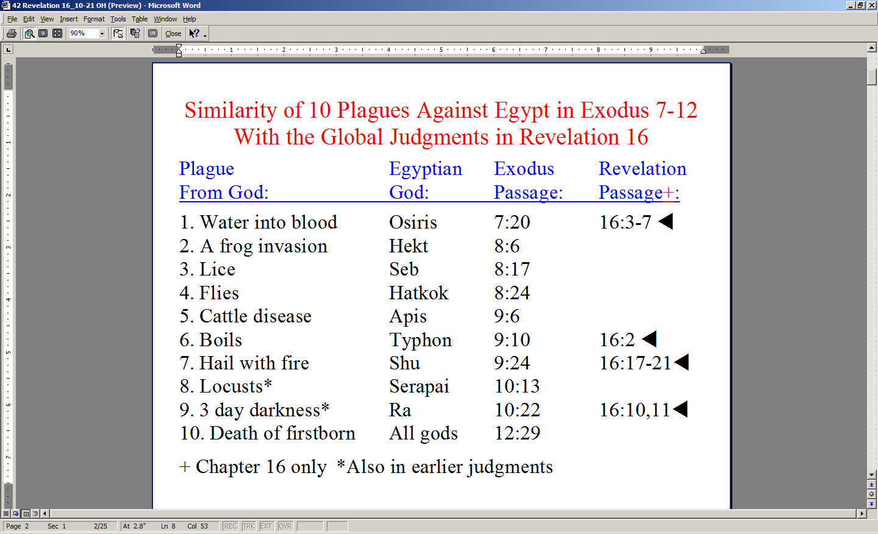

Last Sunday we looked at this chart. There are two plagues from this chart of plagues upon Egypt that will be revisited upon the entire earth in these last three bowl judgments. Verses 13 and 14 have some similarity to the plague of frogs upon Egypt.

You might have already noticed that each of these bowl judgments is not simply poured out upon the earth, but is poured out on some particular part of the earth. These bowl judgments are intentionally directed judgments. As we read the next verses, observe where each one is directed.

10 Then the fifth angel poured out his bowl on the throne of the beast, and his kingdom became darkened; and they gnawed their tongues because of pain, 11 and they blasphemed the God of heaven because of their pains and their sores; and they did not repent of their deeds.
John 3:16-19

For God so loved the world, that He gave His only begotten Son, that whoever believes in Him shall not perish, but have eternal life. For God did not send the Son into the world to judge the world, but that the world might be saved through Him. He who believes in Him is not judged; he who does not believe has been judged already, because he has not believed in the name of the only begotten Son of God. This is the judgment, that the Light has come into the world, and men loved the darkness rather than the Light, for their deeds were evil.

Let’s first observe together where this judgment is directed. The very throne of the beast is the target of this judgment. His very rule is challenged and the character of His rule is revealed. His kingdom is saturated with spiritual darkness, so the physical equivalent of that darkness is brought about worldwide. His kingdom – the entire globe – is saturated with physical darkness.

If we could take the time, we would see that the sharp and eternal contrast between darkness and light is often repeated in Scripture. John, the author of the book of Revelation, is one who frequently addresses spiritual darkness and spiritual light, and most New Testament authors speak in these terms of darkness and light. The plain principles of Scripture light and darkness are these:

- Spiritual beings have an orientation to spiritual light or spiritual darkness
- In I John 1:5 and says “God is Light, and in Him there is no darkness at all.”
- In John 3:19 (see text box on prior page), John puts it this way: “This is the judgment, that the Light has come into the world, and men loved the darkness rather than the Light, for their deeds were evil.”

That is the ultimate truth about this fifth bowl judgment, isn’t it? If people want darkness, then God will give it to them in totality.
Romans 1:18-21

For the wrath of God is revealed from heaven against all ungodliness and unrighteousness of men who suppress the truth in unrighteousness,
because that which is known about God is evident within them; for God made it evident to them. For since the creation of the world His invisible attributes, His eternal power and divine nature, have been clearly seen, being understood through what has been made, so that they are without excuse. For even though they knew God, they did not honor Him as God or give thanks, but they became futile in their speculations, and their foolish heart was darkened.

The oppressive physical darkness of this fifth bowl judgment is a physical representation of the suppressive spiritual darkness already true of those living upon the earth.
Exodus 10:21-23

Then the LORD said to Moses, "Stretch out your hand toward the sky, that there may be darkness over the land of Egypt, even a darkness which may be felt.” So Moses stretched out his hand toward the sky, and there was thick darkness in all the land of Egypt for three days. They did not see one another, nor did anyone rise from his place for three days, but all the sons of Israel had light in their dwellings.

When we look at the responses to the plague of darkness upon the globe, notice how intense a response we read about:

There are three responses given here to the fifth plague:
- they gnawed their tongues because of pain
- they blasphemed the God of heaven
- they did not repent of their deeds

Isn’t it amazing that mankind will not be changed at heart even in light of the incredible evidences they will have that there is a God in heaven? This plague of darkness seems to be an earthly foretaste of the pains and miseries of hell…yet people still do not respond in repentance! These unrepentant people do not seem to be atheists or agnostics at heart. They seem to know full well that there is a God is heaven, but they abjectly refuse God’s offer of grace just the same! They pure, plain and simple prefer the darkness!

12 The sixth angel poured out his bowl on the great river, the Euphrates; and its water was dried up, so that the way would be prepared for the kings from the east.

Though the Euphrates River is mentioned about thirty times in the Bible, Even in the early chapters of Genesis, in the New Testament it is mentioned only twice – both of those in the book of Revelation. This is the very last time we read of it. The reason given for the Euphrates River to be dried up is that the kings from the east are going to be coming through this way shortly. This drying up the river by itself will have a direct impact only on the Euphrates River Basin – which is admittedly pretty large. But the main point is that the way is prepared for troop movements to come through. These troops are those of the kings of the east. The Greek words translated “east” here are actually anatoles heliou – “the rising of the sun”.

Asia has a massive population - more than the populations of all the other continents combined. The ability to cross the Euphrates River in large capacity is not so minor an issue after all. We aren’t told how many kings are represented or which ones, but the nations of Asia have a massive population to contribute to the battle.

13 And I saw coming out of the mouth of the dragon and out of the mouth of the beast and out of the mouth of the false prophet, three unclean spirits like frogs; 14 for they are spirits of demons, performing signs, which go out to the kings of the whole world, to gather them together for the war of the great day of God, the Almighty.

Verse 13 contains in one verse all three of the members of the Satanic Trinity that we spoke of just a few weeks back. What is unusual is that all three of them are said to have frog-like unclean spirits coming out of their mouths. That sounds a bit strange, until we take note of a few things:

The Jews considered frogs to be horrid creatures.
- The Egyptians and Parthians had a hatred for frogs as well, which is likely why the Lord sent a plague of frogs upon Egypt when the Pharaoh would not let Israel go
- The people considered putting a frog in your mouth to be horrible or worse.
The thought of a frog coming out from ones mouth was detestable in the extreme. But we read in verse 14 the explanation of these: they are demons performing enticing miracles to draw these hordes of troops into Israel. In spite of the fact that these are demons doing the drawing and enticing and miracles, it is the Lord Himself – God Almighty – who will display His power and sovereignty.

15 ("Behold, I am coming like a thief. Blessed is the one who stays awake and keeps his clothes, so that he will not walk about naked and men will not see his shame.")

Passages that compare the
Lord’s coming to that of a thief:

- Matthew 24:43
- Luke 12:39
- Thessalonians 5:2, 4
- 2 Peter 3:10
- Revelation 3:3; 16:15

The key idea in these warning passages is that of avoiding surprise & unexpected loss of reward, because it is the Lord’s desire to reward us fully!
Certainly this word picture of coming like a thief is not intended to convey the intent to harm or steal. Instead, the idea that comes across in these passages is that the picture of a thief is intended to convey the element of surprise and of loss if one is not prepared. We are told many times over to be alert, be ready, be on guard, so that surprise and risk of loss should not overtake us. God does not want us to be spiritually surprised and He so greatly desires to reward us!

So what’s this part of the warning about keeping clothes and nakedness and shame? In Revelation 3:3-5 (remember when we studied that passage about the church at Sardis?) the Lord warns that He will come like a thief as well. He also talks about clothes – “wearing white” to be specific. The picture the Lord is conveying is this:

- Our position in Christ is fixed – untouchable in the heavens.
- Our position in Christ, having believed, depends entirely upon God’s accomplishment and person and character.
- We needn’t concern ourselves one bit with what will happen in our position.
- Our condition, however, can be founded either in this world’s moorings or in our position.

He is telling us in this little parenthesis in verse 15 that He greatly desires that we behold Him, and live by depending upon the spiritual facts of our position, so that our condition is consistent with our position as we live out our lives here on planet earth.

16 And they gathered them together to the place which in Hebrew is called Har-Magedon.

We’ve talked a few weeks ago about Armageddon – the Greek form of the Hebrew “Har Megiddo”. This word has taken on a vague but ominous significance in the eyes of the world, generating at least one movie with that title, and making the word ‘Armageddon’ an expression of global gloom and doom.

But the Scriptures are not vague about what this “Armageddon” is all about. Armegeddon in the Bible is specifically about the small part of the globe called ‘Israel’.
As we’ve presented this topic before, the Bible describes a “war” or “campaign” called Armageddon. It refers not to a singular battle, but to a distinct series of battles – an entire military campaign. The focal point of this campaign - so far as the Satanic Trinity is concerned – is the annihilation of the Jews – God’s chosen people. But this series of military events known as Armageddon are events in which our Lord has the ultimate victory, and in which it becomes clear to Israel that only by the hand of God will they survive this attack. Satan is roundly shown to be unsuccessful in his attempts to thwart God’s promises to Abraham made about 4000 yrs ago. These events take place in four major geographical areas:

- Babylon and the Euphrates River
- Megiddo in the northern part of Israel
- Jerusalem in the middle of Israel
- The wilderness of Bozrah and Petra in southern Israel and Jordan

But the word “Armageddon” represents a valley in Israel which opens out to the Mediterranean coast, including what is now known as Haifa. It is a landing place for troops and military equipment anticipated here in the New Testament, with a rich military history as well:

- It is the place where Barak fought and won a battle as recorded for us in Judges 4.
- It is the place where Gideon defeated the Midianites as recorded in Judges 7.
- It is where both Saul and Josiah lost their lives.

Though we could spend weeks and weeks studying the passages that detail the various aspects of the campaign of Armageddon, what is most important for us to come away with is:

- Armageddon is all about satanically motivated forces attacking, on several battle fronts, and Israel, God’s chosen people, are Satan’s specific target.

God will protect Israel, as He promised to do back in the books of Moses, starting with Genesis 12:1-3.
- God’s wrath is shown to be revealed against those opposing Israel and His Messiah’s reign on earth.

At this point we come to the seventh bowl judgment, which lays out the final judgment of the three sets of seven judgments we’ve been looking at from Revelation 6:1 until now.

17 Then the seventh angel poured out his bowl upon the air, and a loud voice came out of the temple from the throne, saying, "It is done."

This final bowl is poured out upon the air (Greek: aer). It is the same Greek word found in Ephesians 2:2, in which we read:

…the course of this world, according to the prince of the power of the air, of the spirit that is now working in the sons of disobedience.

So this judgment is a direct assault on the domain of the evil one. His domain as the prince of the power of the air is being dealt a fatal blow. This voice – a loud one - comes out of the temple – the throne room of God - from the throne from which God reigns. The loud voice of the Lord Himself says, “It is done!” The Greek words here are different from what Christ says when He has finished His work on the cross, and says, “It is finished” but the verb tense is the same. It is a perfect tense verb – action is completed with ongoing results.

18 And there were flashes of lightning and sounds and peals of thunder; and there was a great earthquake, such as there had not been since man came to be upon the earth, so great an earthquake was it, and so mighty.

As we’ve seen in the seal and trumpet judgments, the seventh judgment in each series – and in this one as well – includes flashes of lightning and peals of thunder. This is very similar to the pattern we read about when the Lord is on Mt. Sinai with Moses (Exodus 19:16; 20:18).

Then we are told that there was a great earthquake, as we saw before in the seventh seal judgment and the seventh trumpet judgment. But this is more than just a repeat of these earlier events. John describes this earthquake this way, “there was a great earthquake, such as there had not been since man came to be upon the earth, so great an earthquake was it, and so mighty.”

Let’s look at some of the impacts from that earthquake, in verses 19 and 20.

19 The great city was split into three parts, and the cities of the nations fell. Babylon the great was remembered before God, to give her the cup of the wine of His fierce wrath.
20 And every island fled away, and the mountains were not found.

The phrase “the great city” is used for several different cities in Scripture, but there are a few reasons “the great city” refers to Jerusalem:
- The other great city in Revelation is Babylon, and that is mentioned in the last half of this verse separately.
- The phrase, “the cities of the nations” would be seen as Gentile cities, so Jerusalem would be a city not of the nations.
- Zechariah 14:4 says that when the Messiah comes to the Mt. of Olives, that it will split in two from east to west and this may well be part of the same geological movement.

There is no doubt but what this great massive global earthquake will turn man’s creations into ruins. There is no building code on earth which will protect against this magnitude of earthquake.

Babylon will be remembered before God. It is certainly not that God forgot, but that the Lord included Babylon in this final judgment. We’ll talk more about Babylon when we get to chapters 17 and 18.

Islands were knocked down to nothing. We aren’t told down to what size islands were removed, but certainly smaller ones were taken out. There is no article in the Greek in front of the word mountain. This phrase at the end of verse 20 literally comes across in English as, “and mountains were not found”. A great many mountains were brought down.

21 And huge hailstones, about one hundred pounds each, came down from heaven upon men; and men blasphemed God because of the plague of the hail, because its plague was extremely severe.

These 100 pound hailstones are 17 to 18 inches in diameter. Amazingly, the response of mankind is not to repent or feel remorseful. Instead, the response of mankind is to blaspheme God. They don’t even say, “Thank God”, when its over!

Revelation 16:10-21: Contrasts & Choices

This: Or This:
Darkness Light of the World
Dried Up Euphrates Living Water

Armageddon’s War with God Peace with God
Earthquake and Hail Established upon the Rock

