Matthew 23:37 – 24:44 – Jerusalem, Jerusalem

A few days before Christ was crucified

If one accepts the traditional chronology for the week in which Christ was crucified, then Christ spoke the words in this passage on Tuesday of that week. What we will see shortly is that everything that Jesus says is culturally very Jewish, but when one is in Jerusalem, in the land of Israel, and talking about the people of Israel, that just makes sense.

Matthew 23:37-39
"Jerusalem, Jerusalem, who kills the prophets and stones those who are sent to her! How often I wanted to gather your children together, the way a hen gathers her chicks under her wings, and you were unwilling. 38 Behold, your house is being left to you desolate! 39 For I say to you, from now on you will not see Me until you say, 'Blessed is he who comes in the name of the Lord!'"

While Jesus, who was born king of the Jews (Matthew 2:2; 27:11), had been proclaiming the gospel of the kingdom to the people of Israel in the land of Israel (Matthew 4:17, 23; 10:26; 15:24), they would not receive Christ as their King – in spite of appearances on what is often misnamed “The Triumphal Entry”.

Jesus says several things that are Jewish phrases, language patterns and figures of speech:

- “Jerusalem, Jerusalem…” is as serious and as Jewish as “Simon, Simon…” (Luke 22:31), “Saul, Saul…” (Acts 9:4), and “Truly, truly I say to you…” (John 1:51).
- “…who kills the prophets and stones those who are sent to her…” is a rhyming Jewish poetry pattern - restatement. Killing was often by stoning, and the prophets were the ones who were sent.
- There is a figure of speech in Psalms , Israel’s national hymnbook, in which the author calls upon God to protect under “the shadow of Your wings” (Psalms 17:8; 36:7; 57:1 and 63:7). Psalm 91:4 says, “He will cover you with His pinions, and under His wings you may seek refuge; His faithfulness is a shield and bulwark.” As for their house being desolate, see Jeremiah 22:1-5, especially verse 5. See also Exodus 19:4; Deuteronomy 32:11; Ruth 2:12.
- 'Blessed is he who comes in the name of the Lord!' was from the traditional recitation of Psalms 113-188, known as the Hallel, by pilgrims coming to Jerusalem for the appointed feasts (Psalm 118:26), which was in anticipation of the coming of the Messiah.
Matthew 24:1, 2
1 Jesus came out from the temple and was going away when His disciples came up to point out the temple buildings to Him. 2 And He said to them, "Do you not see all these things? Truly I say to you, not one stone here will be left upon another, which will not be torn down."

The Greek verbs here convey a sense of timing like this: “Jesus, having gone out from the temple, was proceeding on His way…”. From 20 BC until the early 60s AD, the temple reconstruction continued as begun under Herod the (not so) Great. And the temple reconstruction was very, very impressive. Some of the largest stones weighed as much as 50 tons, and the fit between these stones was tight. There were massive foundations, huge retaining walls, multiple and sometimes broad stairways, huge gates, water works, impressive columns and other structures, highlighted with dazzling brass and gold ornamentation, and engraved stones.

How shocking it must have been for Jesus to respond to them by telling them that all these impressive stones, and everything associated with them would be torn down - completely. The Jews would begin a violent rebellion in 66 AD, only to have the Romans return with an intense suppression, with twelve legions of soldiers, that would result in massive death and destruction.

3 As He was sitting on the Mount of Olives, the disciples came to Him privately, saying, "Tell us, when will these things happen, and what will be the sign of Your coming, and of the end of the age?"

Because what Jesus said from here forward in this passage was given on the Mount of Olives, this passage has become known as “the Olivet discourse”. The disciples asked Jesus to answer three questions for them:

- when will these things happen, and
- what will be the sign of Your coming, and
- [what will be the sign of] the end of the age?"

While there are subtle evidences of the Roman destruction of Jerusalem in 70 AD in the Old Testament, the Jews of Jesus’ day only understood the coming of the Messiah at the end of the Tribulation period, ending the present age, and beginning the next one. So they only understood questions 2) and 3) above. The disciples also did not understand that there would be a long period of time inserted between their time and the seven year Tribulation period that was not revealed in the Old Testament: the Church Age (see more evidence of this point in Acts 1:1-8). But in the Greek structure of their question, they viewed the answers to questions 2) and 3) as the same event.

4 And Jesus answered and said to them, "See to it that no one misleads you. 5 For many will come in My name, saying, 'I am the Christ,' and will mislead many. 6 You will be hearing of wars and rumors of wars. See that you are not frightened, for those things must take place, but that is not yet the end. 7 For nation will rise against nation, and kingdom against kingdom, and in various places there will be famines and earthquakes. 8 But all these things are merely the beginning of birth pangs. 9 Then they will deliver you to tribulation, and will kill you, and you will be hated by all nations because of My name. 10 At that time many will fall away and will betray one another and hate one another. 11 Many false prophets will arise and will mislead many. 12 Because lawlessness is increased, most people's love will grow cold. 13 But the one who endures to the end, he will be saved. 14 This gospel of the kingdom shall be preached in the whole world as a testimony to all the nations, and then the end will come."

Conservative commentators have understood Matthew 4:4-14, as given above, as being 1) entirely before the Tribulation period, 2) partly before the Tribulation period and partly during the tribulation period, 3) entirely during the Tribulation period. We will present that Christ intended to communicate the third interpretation, that Matthew 24:4-14 was intended to be understood as being entirely in the Tribulation period, and mostly in the first half of the Tribulation period because:

- The Matthew 24 discourse focuses on the Jews and Israel in its words, audience, and geographical context, and does not refer to the church at all, as the church was not revealed in the Old Testament, but was revealed in the New Testament (Ephesians 3:1-13).
- A parallel can be made between every event in Matthew 24:4-14 (and parallel passages in Mark and Luke) and those of the Revelation 6 seal judgments.

Parallels Between the Olivet Discourse
and the Seal Judgments of Revelation
Events | Revelation 6 | Matthew 24 | Mark 13 | Luke 21
False Messiahs and Prophets | 2 | 5,11 | 6 | 8
Wars | 2-4 | 6-7 | 7 | 9
International Discord | 3-4 | 7 | 8 | 10
Famines | 5-8 | 7 | 8 | 11
Pestilences | 8 | - | - | 11
Persecution and Martyrdom | 9-11 | 9 | 9-13 | 12-17
Earthquakes | 12 | 7 | 8 | 11
Cosmic Phenomenon | 12-14 | - | - | 11

- The term “birth pangs” is used by Christ (in Matthew 24:8), Paul (in 1 Thessalonians 5:3), and in other Jewish literature to describe Tribulation events. In The Messiah Texts, by Raphael Patai, on pages 95-96, he quoted the Jewish Talmud, a collection of Jewish traditional writings, when he wrote, “…the pangs of the Messianic times are imagined as having heavenly as well as earthly sources and expressions. . . Things will come to such a head that people will despair of Redemption. This will last seven years. And then, unexpectedly, the Messiah will come…”
- The word translated “coming” (Greek: paraousia; Matthew 24:3) indicates not just “coming” but “abiding presence”. This corresponds to the time when Christ will come again and remain on earth as the Messiah.
- The word translated “end” (Greek: sunteleias; Matthew 24:3,13,14) means entire completion or consummation. It refers to the time of the very end of this age, with the Messiah’s coming marking the beginning of the next age, so “the end” does not refer to century after century of process along the way, during this, the Church age, nor does it refer to just the Tribulation period. In the Jewish mind there is this present age before the coming of the Messiah, and the next age, when the Messiah would come and reign on the earth over His kingdom (e.g., Ephesians 1:21).

In this passage and all the way to verse 44, Jesus used “you”, in speaking to the disciples, in the sense of the disciples being representative of the people of Israel, not that the disciples would all go through these things personally. They would not personally go through these things, but would instead personally put their lives on the line for the gospel of Jesus Christ in other lands outside of the land of Israel.

Observe that the first thing our Lord tells these men is that they are to see to it that no one misleads them. At the outset of the Tribulation period there will be a great number claiming to be the Messiah – not just false teachers – but saying to the Jews, “I’m your guy!” – “Follow me!” The disciples are warned that there will be many who will be misled. Support for these false Christs will eventually align behind the antichrist – the first horseman of the seal judgments.

In verse 13 Jesus says, “But the one who endures to the end, he will be saved.” The Jewish concept of ‘salvation’ or ‘being saved’ was often thought of in terms of earthly salvation and being rescued from terrible circumstances (Genesis 19:20; 47:25; Exodus 14:30; Numbers 10:9; Deuteronomy 33:29; Judges 3:31, etc.). That is Christ’s meaning for “saved” in this verse.

Then, in verse 14 Jesus said, “This gospel of the kingdom shall be preached in the whole world as a testimony to all the nations, and then the end will come.” Recall that the gospel, with a focus on the kingdom, will be preached by the 144,000, the two witnesses, and by the gospel angel.

15 "Therefore when you see the abomination of desolation which was spoken of through Daniel the prophet, standing in the holy place (let the reader understand), 16 then those who are in Judea must flee to the mountains. 17 Whoever is on the housetop must not go down to get the things out that are in his house. 18 Whoever is in the field must not turn back to get his cloak. 19 But woe to those who are pregnant and to those who are nursing babies in those days! 20 But pray that your flight will not be in the winter, or on a Sabbath. 21 For then there will be a great tribulation, such as has not occurred since the beginning of the world until now, nor ever will. 22 Unless those days had been cut short, no life would have been saved; but for the sake of the elect those days will be cut short. 23 Then if anyone says to you, 'Behold, here is the Christ,' or ' There He is,' do not believe him. 24 For false Christs and false prophets will arise and will show great signs and wonders, so as to mislead, if possible, even the elect. 25 Behold, I have told you in advance. 26 So if they say to you, 'Behold, He is in the wilderness,' do not go out, or, 'Behold, He is in the inner rooms,' do not believe them. 27 For just as the lightning comes from the east and flashes even to the west, so will the coming of the Son of Man be. 28 Wherever the corpse is, there the vultures will gather."

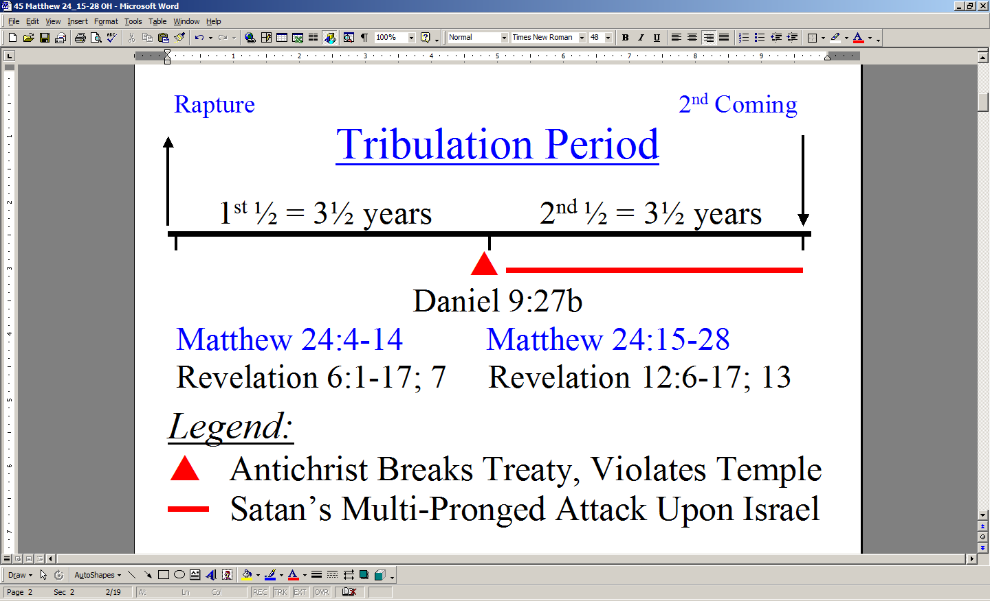
Bringing the book of Daniel, Matthew 24, and the book of Revelation together, the passages weave together a picture like that shown on the left. The rapture, though shown on the chart to the left, was not mentioned in Matthew 24, since that relates only to the church, which Jesus does not address in Matthew 24, since it is entirely from a Jewish perspective.

As in the previous passage (Matthew 24: 4-14), there are clear evidences that this passage draws from the Old Testament, is spoken in Jewish cultural terms, and is focused on the nation of Israel and the land of Israel:

- “the abomination of desolation spoken of through the prophet Daniel, standing in the holy place” (Daniel 9:27; 11:31; 12:11).

“those who are in Judea must flee to the mountains” (Judea being in the southern part of the land of Israel). The fleeing to the mountains that Jesus mentioned means the fleeing to the places of protection (such as Bozrah and Petra) that we have discussed previously. Jesus gives the Jews three warnings in this passage, “16 then those who are in Judea must flee to the mountains. 17 "Whoever is on the housetop must not go down to get the things out that are in his house. 18 "Whoever is in the field must not turn back to get his cloak. This is consistent with what we read in Revelation 12:14a, “…But the two wings of the great eagle were given to the woman [Israel], so that she could fly into the wilderness to her place…”
- “…pray that your flight will not be in the winter, or on a Sabbath.” Only Jews, of course, would be concerned about traveling on the Sabbath, since they have a limitation of distance known as ‘a Sabbath day’s journey’ (Acts 1:12).
- “Behold, here is the Christ”. “The Christ” is the Greek term for “the Messiah”. The definite article (English: ‘the’) denotes the specific one. Both ‘Christ’ from Greek, and ‘Messiah’ from Hebrew mean, “anointed one”.
- “the coming of the Son of Man” (Daniel 7:13,14).

29 "But immediately after the tribulation of those days the sun will be darkened, and the moon will not give its light, and the stars will fall from the sky, and the powers of the heavens will be shaken. 30 And then the sign of the Son of Man will appear in the sky, and then all the tribes of the earth will mourn, and they will see the Son of Man coming on the clouds of the sky with power and great glory. 31 And He will send forth His angels with a great trumpet and they will gather together His elect from the four winds, from one end of the sky to the other."

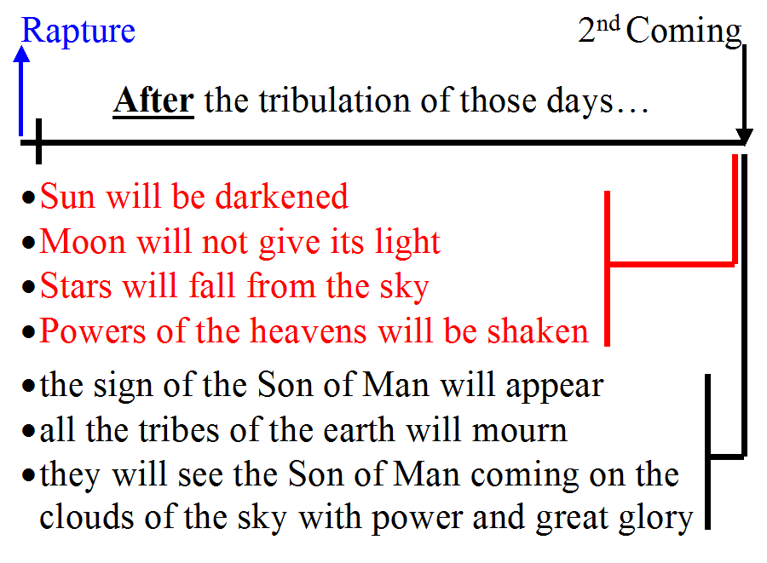
The chart to the left puts these words of Jesus in a time perspective, which fits with the very last of the seven bowl judgments. The sign of the Son of Man appearing, the tribes of the earth mourning, and seeing the Son of Man coming on the clouds of the sky with power and great glory will be seen as we study Revelation chapter 19.

Some have seen in verse 31 a post-Tribulation rapture, but we have seen the reasons that only a pre-Tribulation rapture fits the many biblical passages that apply. In addition, we find that the gathering together of Israel, God’s elect, is drawn from the following Old Testament passages:

“…gather together [Israel]…” “…His elect [Israel]…”

Jeremiah 16:14-15 I Chronicles 16:13
Isaiah 11:11-16; 27:13 Psalm 105:6,43; 106:5
Isaiah 41:8; 43:20; 45:4; 65:9,15,22

Gathering and saving Israel with a trumpet also draws from Numbers 10:1-10:

2 "Make yourself two trumpets of silver, of hammered work you shall make them; and you shall use them for summoning the congregation and for having the camps set out. 3 When both are blown, all the congregation shall gather themselves to you at the doorway of the tent of meeting… 9 "When you go to war in your land against the adversary who attacks you, then you shall sound an alarm with the trumpets, that you may be remembered before the LORD your God, and be saved from your enemies.

32 "Now learn the parable from the fig tree: when its branch has already become tender and puts forth its leaves, you know that summer is near; 33 so, you too, when you see all these things, recognize that He is near, right at the door. 34 Truly I say to you, this generation will not pass away until all these things take place. 35 Heaven and earth will pass away, but My words will not pass away."

Christians, and even some non-Christians, have always tended to look now for signs of the Lord’s coming in their present circumstances, as well as setting dates for the Lord’s coming. But part of what Jesus is saying here is that the signs of the Lord’s coming won’t show up until the Tribulation period has begun – until the Lord’s coming is “right at the door”. The timing signals from the fig tree are intended to communicate that.

The term “this generation” has stirred quite a bit of discussion over time, and has been understood several different ways:

1) Jesus mistakenly thought these things would happen in his generation
- Our Lord was not mistaken about anything, so we won’t waste our time with that notion any further

Jesus meant that His generation would see these things

This refers to the idea that the destruction of Jerusalem in 70 AD was the 2nd coming of the Lord.
- This is known as Preterism, a view we’ve discussed before, and which forces spiritualizing or allegorical interpretation upon a great number of passages – so we won’t go there.

3) Jesus meant that ‘this generation’ referred to the continuity of the Jewish people.
- This view is based on the possibility that the meaning of the word genea is here meaning “race” instead of “generation”.
- While that is theoretically possible, it does not fit the context well, and there seems an insufficient reason in the context for Christ to state that fact – the Jews would have assumed already.

4) Jesus meant that all these things would start in his generation.
- Folks who take this meaning think of the 2nd coming as being a stretched out series of events – outside the timeline of the Tribulation period.

5) Jesus meant that “this generation” referred to the generation of the time of the Tribulation.
- This is the understanding that our Lord meant, that is consistent with biblical context and principles of interpretation. And use of this Greek word for a generation of another time fits the use of the same word in Hebrew 3:10.
- Those who were present at the beginning of these events – all these things – would find that they culminated in His coming within their time – not spread out over several generations of time. Jesus was saying that the seven year period written of by Daniel and John in the book of Revelation is to be taken literally, and not figuratively.

Verse 35 carries a similar meaning to these other Old Testament passages.

Psalm 119:89
Forever, O LORD, Your word is settled in heaven.

Isaiah 40:8
The grass withers, the flower fades, but the word of our God stands forever.

Jesus is claiming at least these four things:

- His words are eternally and objectively true
- These things will most certainly come to pass
- He is claiming deity
- He will preserve His words so that future generations will be able to read them – including ourselves and those in the time of the Tribulation

36 "But of that day and hour no one knows, not even the angels of heaven, nor the Son, but the Father alone. 37 For the coming of the Son of Man will be just like the days of Noah. 38 For as in those days before the flood they were eating and drinking, marrying and giving in marriage, until the day that Noah entered the ark, 39 and they did not understand until the flood came and took them all away; so will the coming of the Son of Man be. 40 Then there will be two men in the field; one will be taken and one will be left. 41 Two women will be grinding at the mill; one will be taken and one will be left."

Jesus, on more than one occasion, made it clear that God the Father ‘calls the timing’ on the rapture of the Church and the beginning of the Tribulation period, which starts the clock for the second coming (Matthew 24:36 Acts 1:7). But that does not seem to keep people from setting dates and times.

Verses 37-41 compare the Tribulation period judgments to the judgment of the flood in the time of Noah. This is a judgment passage applying to those living in the Tribulation period – it is not a rapture passage. The ‘taking away’ is through judgment: “the flood came and took them all away”. Rapture is a different word in both Greek and English.

42 "Therefore be on the alert, for you do not know which day your Lord is coming. 43 But be sure of this, that if the head of the house had known at what time of the night the thief was coming, he would have been on the alert and would not have allowed his house to be broken into. 44 For this reason you also must be ready; for the Son of Man is coming at an hour when you do not think He will."

This is another passage where the thief in the night analogy is used to tell people to be ready always, since the timing of the start of the Tribulation period is unknown. When people are suspecting that everything is just fine, and life will go on, that is the time when the Lord will come. Most people think that just because times seem bad, that this is a sign that the Tribulation will begin and the Lord will come. But Jesus says just the opposite!

Church age believers ought rather to be looking for our Lord’s appearing to take us to be with Him before the Tribulation period begins – that is the “blessed hope” for us church saints:

Titus 2:11-14
For the grace of God has appeared, bringing salvation to all men, 12 instructing us to deny ungodliness and worldly desires and to live sensibly, righteously and godly in the present age, 13 looking for the blessed hope and the appearing of the glory of our great God and Savior, Christ Jesus, 14 who gave Himself for us to redeem us from every lawless deed, and to purify for Himself a people for His own possession, zealous for good deeds.

Passages indicating how Jerusalem and the Jews treated prophets and other messengers: 2 Chronicles 24:21-22; 36:11-16; Nehemiah 9:26; Jeremiah 2:30; 25:3,34; Zechariah 1:4; Matthew 5:12; 21:35-36; 22:6; 23:30; Mark 12:3-6; Luke 20:11-14; Acts 7:51-52; 1 Thessalonians 2:15.

