Revelation 17:1-18 – Religious Babylon

Introduction to Babylon

We completed the examination of the passage in Matthew, so now we again turn our attention to the book of Revelation – at the beginning of chapter 17. As we approach this passage, we would do well to stand back for a moment, because both chapters 17 and 18 of the book of Revelation speak about the end of Babylon. We need to stand back and take a careful look for at least three reasons:

- Even conservative scholars have come to a few different conclusions regarding the identity of Babylon in these chapters.
- John brings up Babylon and its destruction for 2 chapters, as the last topic before the 2nd coming of our Lord Jesus Christ to conquer His enemies and to reign.
- The original culture and/or nation of Babylon is a thread that is woven through the pages of Scripture – from Genesis to Revelation, and mentioned in Scripture some 300 times, its continuity and longevity in Scripture implying importance.

A very brief overview of the history of Babylon

Babylon began as a humanistic culture in the area of what is now the Middle East. Genesis 10 tells us that a man named Nimrod established a kingdom there not long after the flood of Noah’s time. By Genesis 11, we’re hearing about the tower of Babel, where the Lord confused the languages because men were diligently seeking the exaltation of human beings rather than the Lord Himself.

The Babylonian culture developed mathematics and geometry, and we still measure our angles in 360 degrees based on the Babylonian system. The Babylonians developed both astronomy and astrology. The Maji, or ‘wise men’ as they are also called, recorded for us in the gospel of Matthew chapter 2, were likely of Babylonian background. The prophet Daniel was no doubt trained in many of the Babylonian systems of learning. The Babylonians also developed systems of mapping. There is one way in which the Babylonian clay tablet maps were far ahead of our own - you didn’t have to figure out how to fold them again! You just had to be careful about asking somebody to toss you a map! The Babylonians also founded legal systems and established studies in medicine and the arts.

But while there were systems of learning for which we might have high regard - and even have adopted into our own culture – there were also deeply engrained elements of the Babylonian culture which the Lord has found vile and repulsive. The Babylonians founded and propagated a system or pantheon of gods – we call it polytheism. These same gods were carried over into all the other Mediterranean cultures of ancient time, just given different names. Those of Egypt, Greece, Rome, and other ancient Middle Eastern cultures had similar pantheons of gods and goddesses. Even other more remote cultures reflected elements of early Babylonian religion. These gods were, of course, a complete replacement for the God of Scripture – occultic and sexually perverse. They were also morally repulsive and engrained in a system of religion that caused people to be immoral and worship idols. The system of commerce surrounding the Babylonian culture was also found to be an idol in itself.

What is the identity of “the Whore of Babylon”?

Now a fascinating piece of the puzzle here is the history of the identity of the harlot or whore of Babylon as described in these two chapters:

Person/Group Date View

Irenaeus 130-200 The literal City of Babylon
Franciscan Order ~1200 Roman Catholic Church
John Wesley 1703-1791 Roman Catholic Church
John Darby 1800-1882 Roman Catholic Church
William Newell 1868-1956 World System – who also made some connection to the literal city of Babylon

Accordingly, we find that today there are three main views presented by conservative scholars as to who this woman is in Revelation 17 who rides the beast:

Some of the Primary Proponents of the Three Main Views on
the Identity of the Woman on the Beast:

- The Roman Catholic Church:
  - Dave Hunt
  - John Walvoord
  - Hampton Keathley III

- An Empire Centered on a Rebuilt City of Babylon:
  - Charles Dyer
  - Thomas Ice
  - Joseph Chambers

- All False Religion of All Time – A World System:
- Robert L. Thomas
- Grant Richison
- William Newell

Now since conservative, Bible-believing scholars hold to all three of these views, how are we to resolve this? How can we confidently arrive at a conclusion? There is a rather simple answer – and you like simple answers, don’t you? While men have written whole volumes on this one question, one principle we have already come across in our study of the book of Revelation is that the identity of some key players in the cosmic drama have not been revealed at this time:
- We don’t really know who the Two Witnesses will be – but those living during the Tribulation period will know for certain who they are!
- We don’t really know who the Antichrist, this beast, will be – but those living during the Tribulation period will know for certain who he is!
- Since this “woman” rides the beast, and we don’t know who precisely the beast is, doesn’t it make sense to say that we don’t know who this woman is yet, but that those living during the Tribulation period will most certainly know who the beast is and who this woman is?

It seems best, then to say that there will indeed be an idolatrous world religious system, but that the identity of that world system of religion will be identifiable specifically and with certainty only when the time comes. Its formation may well take shape only after the church is taken out at the rapture. Let’s move into our passage.

1 Then one of the seven angels who had the seven bowls came and spoke with me, saying, "Come here, I will show you the judgment of the great harlot who sits on many waters, 2 with whom the kings of the earth committed acts of immorality, and those who dwell on the earth were made drunk with the wine of her immorality."

We’ve looked previously at who these seven angels are who had the seven bowls of judgment. John is now listening to one of these seven angels. The angel invites John, offering to show him the judgment of the great harlot who sits on many waters. The word translated “harlot” is from the Greek word pornas, strongly implying sexual sins. If we have any doubt about what sitting on many waters means, we can glance down to verse 15 which tell us exactly what “many waters” means (remember, that is one of the key principles of interpreting the book of Revelation – John often tells us what things mean right in the book!):

    - And he said to me, "The waters which you saw where the harlot sits, are peoples and multitudes and nations and tongues.

This is global domination John is writing about. He speaks of the kings of the earth committing immorality with her. The English word translated ‘immorality’ is the Greek word pornea – where we get our word pornography. The Old Testament often uses sexual immorality as a vivid picture of religious apostasy. Next, John uses the phrase “those who dwell on the earth”.

We’ve seen before that this phrase “those who dwell on the earth” refers specifically to those unsaved living during the Tribulation period. What’s interesting here is that the Greek word for drunk (methusko) is in the passive voice – they were made drunk forcibly. These Tribulation period earth dwellers were force-fed immorality. They didn’t just fall into it – immorality was shoved down their throats! Our own culture seems to be heading in that direction, doesn’t it?

Let’s look at verses 3-6:

3 And he carried me away in the Spirit into a wilderness; and I saw a woman sitting on a scarlet beast, full of blasphemous names, having seven heads and ten horns. 4 The woman was clothed in purple and scarlet, and adorned with gold and precious stones and pearls, having in her hand a gold cup full of abominations and of the unclean things of her immorality, 5 and on her forehead a name was written, a mystery, "BABYLON THE GREAT, THE MOTHER OF HARLOTS AND OF THE ABOMINATIONS OF THE EARTH." 6 And I saw the woman drunk with the blood of the saints, and with the blood of the witnesses of Jesus. When I saw her, I wondered greatly.

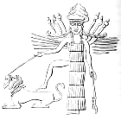
This woman – this false religious system – is described as sitting on top of the beast. Archaeologists have found numerous images, reliefs and clay impressions in and around the region of Babylon that show the goddess Inanna or Ishtar riding upon or at least dominating a beast – typically a lion. The Babylonian cylinder seal drawing to the left is an example. It shows the goddess Inanna dominating a lion.

The color scarlet was worn by royalty, so the reference to the color scarlet conveys wealth and exalted position. John then writes of blasphemous names. The names of false gods and goddesses have blasphemed the true God for centuries. The time of the Tribulation will simply be the apex of blasphemy. John writes “full of blasphemous names”, which is defiance of and confrontation of God’s character. Religion on man’s terms is not going to be any match with or assistance to salvation through Jesus Christ. This gross word picture tells us how God sees man-made religion. Any spirituality that is not biblical is not spiritually neutral.

Every piece of her clothing and adornment communicates her opulence and personal exaltation – dripping with moral and spiritual filth.

Verse 5 tells us what is written across the woman’s forehead. Prostitutes in the Greek and Roman cultures would often have their names written across their foreheads. This woman is a spiritual prostitute – gross in every regard. The spiritual and moral filthiness of this woman – this picture of the world system – is so prominent that you can see it on her face.

Look at what Jeremiah 51:7 says of Babylon in Jeremiah’s own day:

Babylon has been a golden cup in the hand of the LORD,
Intoxicating all the earth.
The nations have drunk of her wine;
Therefore the nations are going mad.

The focus in verse 6 is the martyrdom of the saints of the Lord. They have been killed by the man-made world religious system of all times. Man-made religion isn’t nice – it’s filthy and it slaughters the saints. Man-made religion hates grace and hates absolute and exclusive truth. This martyrdom will come to its peak in the Tribulation period.

John wondered greatly – he marveled to hear that this ancient kingdom also had a part in the character and key events of the end times.

7 And the angel said to me, "Why do you wonder? I will tell you the mystery of the woman and of the beast that carries her, which has the seven heads and the ten horns.

Here the angel recognizes John’s shock at what he has just heard. At this point we should recognize a distinction between man-made religion and God’s revelation in Scripture. Man-made religion tries to keep people under its power by claiming to be the unique source of some ongoing mystery – the only channel. But the mystery remains a mystery. The New Testament, however, uses the word “mystery” as something previously unknown or unclear that is now being revealed (e.g., Colossians 1:26). The angel is about to make things more clear to John.

8 "The beast that you saw was, and is not, and is about to come up out of the abyss and go to destruction. And those who dwell on the earth, whose name has not been written in the book of life from the foundation of the world, will wonder when they see the beast, that he was and is not and will come. 9 Here is the mind which has wisdom. The seven heads are seven mountains on which the woman sits, 10 and they are seven kings; five have fallen, one is, the other has not yet come; and when he comes, he must remain a little while. 11 The beast which was and is not, is himself also an eighth and is one of the seven, and he goes to destruction. 12 The ten horns which you saw are ten kings who have not yet received a kingdom, but they receive authority as kings with the beast for one hour. 13 These have one purpose, and they give their power and authority to the beast."

At first we might think: Wow! What on earth is he talking about? But when we take a closer look, this is what we arrive at these points:

- Verse 8 speaks twice of the beast as being the one who was and is not and is to come.
- It says he will go to destruction.
- Those whose names are not in the book of life and who dwell upon the earth are those not saved – the Tribulation period lost.
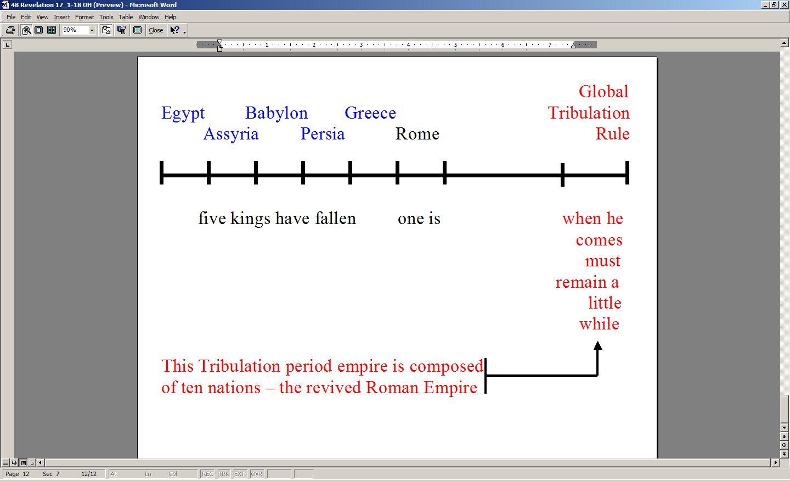
Let’s take a look at the chart to the left to help us make sense of verses 8-12. There have been five major world empires that have come and gone up to the time of John’s writing: Egypt, Assyria, Babylon, Persia and Greece. By the time John is writing, Rome is presently an empire. But for a short period of time, the revived Roman Empire of the antichrist will hold sway. The revived Roman Empire will have ten nations (as told in Daniel chapter 7) and their leaders in its power – the power of the antichrist. Verse 13 makes it clear what is the focus of power in the Tribulation period: All is centered upon giving the antichrist power and increasing it.

14 "These will wage war against the Lamb, and the Lamb will overcome them, because He is Lord of lords and King of kings, and those who are with Him are the called and chosen and faithful."

The rulers of the revived Roman Empire will support the antichrist. They will stand in joint opposition to our Lord the Lamb. It’s not that it will do them any good, but they will try nonetheless. It says the Lamb will overcome them!

- It is not that the Lamb might overcome them
- It is not that the Lamb will probably overcome them
- It is not we surely hope that the Lamb will overcome them
- It is simply the Lamb will overcome them!

Notice, however, the reason given why the Lamb will overcome them: It is because of who He is! He is the Lord of lords and King of kings! We are also told that whose who are with Him are called and chosen and faithful. Who are these that are called and chosen and faithful? Who are they…? That’s us! We will be with Him!

How do we know that we will be with Him the Lord? Here is what Paul writes:

1 Thessalonians 4:17
Then we who are alive and remain will be caught up together with them in the clouds to meet the Lord in the air, and so we shall always be with the Lord.

15 And he said to me, "The waters which you saw where the harlot sits, are peoples and multitudes and nations and tongues. 16 And the ten horns which you saw, and the beast, these will hate the harlot and will make her desolate and naked, and will eat her flesh and will burn her up with fire. 17 For God has put it in their hearts to execute His purpose by having a common purpose, and by giving their kingdom to the beast, until the words of God will be fulfilled. 18 The woman whom you saw is the great city, which reigns over the kings of the earth."

In this passage the angel explains some things to John. It is in some ways like when our Lord explained some parables to the disciples – it makes understanding things much more clear.

The waters are peoples and multitudes and nations and tongues. We’ve seen a similar phrase throughout the book of Revelation – describing the masses of people living during the Tribulation period. This is the last time we will hear of this phrase. The Tribulation period is almost over. But what John is telling us is that the whole world is dominated by this false world religious system.

What verse 16 tells us is that the woman – the false world religious system that has held the world captive for centuries – is not acceptable even to the antichrist – it’s in his way. The leaders of the ten nation confederacy of the revived Roman Empire and the antichrist whom they support will seek to obliterate the woman in order to direct all control to the antichrist and his alliances. These will move to eliminate the competition from the woman, the harlot of Babylon.

Verse 17 is something we have seen the Lord do over time. He is even able to use and influence the hearts of those who oppose Him for His purposes.

- Isn’t that what He did in the case of Pharaoh as told in Exodus?
- Isn’t that what He did in the case of the Hivites as told to us in Joshua?
- That is what he is doing here

We already know that the Lord works all things together for good for those who love Him, right?

In verse 18 we are told - reaffirmed actually – that Babylonianism reigns over the earth. So the Greek of verse 18 carries this significance, “The woman whom you saw is the great city, which is the one right now reigning over the kings of the earth.” Babylon is not just a future issue for a later time. Babylon is a present issue for right here and now - right in the world where you and I live. At this very moment, the world is trying to squeeze you into its mold. The world seeks to impress its values on you. The world seeks to impress its hopes on you.

But the Lord had Paul write this to us:

Romans 12:2
And do not be conformed to this world, but be transformed by the renewing of your mind, so that you may prove what the will of God is, that which is good and acceptable and perfect.

Notice that Paul did not leave us any other options. Either we will be squeezed into this world’s mold – contrary to our position in Christ. Or we will be transformed by the renewing of our minds, which comes as a work of the Holy Spirit as we behold Christ in His written word (2 Corinthians 3:18). Do you want to know what the primary will of God is for your life? This is it! The world’s conforming process is not God’s will. He wants us to be being transformed by beholding the Lord of glory, and walking in fellowship with Him.

