Revelation 20:1-7 – The Millennial Kingdom

1000 years compressed into seven verses

After detailing seven years of Tribulation in chapters 6 through 19 of Revelation, John compresses 1000 years into seven verses (Revelation 20:1-17). But there is a very good reason why John does this: The Old Testament prophets had already provided a great deal of detail about the Millennial Kingdom, when Christ would reign on earth, from Jerusalem, over Israel, as the King of the Jews, and over all of the Gentile nations, as King of kings and Lord of lords. Some of the details that John provides uniquely in those seven verses are:

- How Satan is dealt with during the Millennial Kingdom
- The length of time of the Millennial Kingdom
- Information and clarifications about who is resurrected when

In this way, John fulfills a principle and a pattern that we find common to the pages of Scripture, that one author addresses doctrines and provides information that is harmonious with and complementary to another. And though the Bible is consistent in what it teaches, the various books are not only harmonious and complementary, but also synergistic: the whole is greater than the sum of the parts.

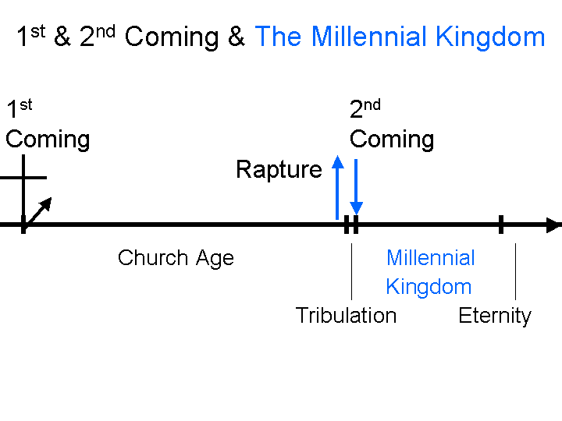
1 Then I saw an angel coming down from heaven, holding the key of the abyss and a great chain in his hand. 2 And he laid hold of the dragon, the serpent of old, who is the devil and Satan, and bound him for a thousand years; 3 and he threw him into the abyss, and shut it and sealed it over him, so that he would not deceive the nations any longer, until the thousand years were completed; after these things he must be released for a short time.

In this passage, the angel who places Satan in chains, and throws him into the abyss, and shuts him in and seals him in, is anonymous. Satan, in sharp contrast, is very clearly identified.

We are not given massive detail in Scripture about Satan’s origins. We do know that he was a created being, having been created with the other angels. All the angels were apparently given a time window within which they could choose their position either with or in opposition to the Lord. Once having made that choice, their wills were fixed. Isaiah chapter 14 and Ezekiel 28 both give us further indications of what took place at Satan’s fall – his decision to stand in opposition to the Lord. Satan appears first in the form of the serpent in Genesis chapter 3, who is instrumental in deceiving Eve. We know that this serpent was Satan because, among other indications, Revelation 12:9, and as we’ll soon see, Revelation 20:2 identifies Satan as “the serpent of old” (Genesis chapter 3). We see that when Satan made his choice, his will and his nature were both fixed – unchangeable through all eternity. It makes it all the more wondrous that the Lord has seen fit to make a way, by His grace, for you and me to have a new nature – that is marvelous.

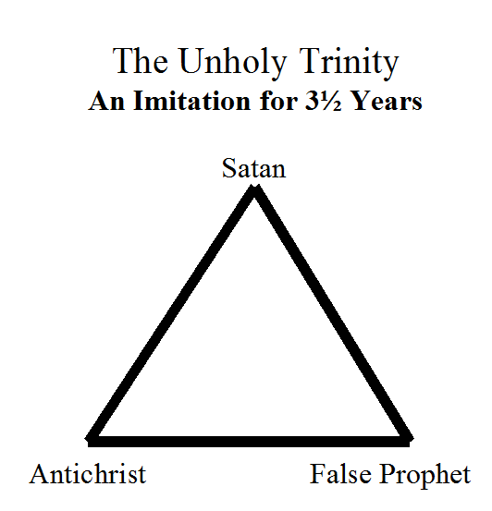
We have seen that Satan is very much involved in the character and events of the Tribulation period. In the Tribulation period, Satan is very close the very end of his time of liberty on planet earth. In the Tribulation period, He is very close to the end of having his way with mankind. So Satan establishes the Antichrist in the revived Roman Empire. Satan establishes the Antichrist and the False Prophet in global government and satanically inspired religion. See “33 Revelation Series - A beast from the sea – Revelation 13:1-10 – August 16, 2009 - Page 1 of 9” in this series for more detail on this Satanic Trinity. At this point Satan also increasingly opposes God’s chosen earthly people – the Jews – to the point of seeking their total annihilation. Satan’s involvements throughout this period also include mass deception, fostering of gross immorality and persecution of those who believe, to the point of martyrdom. In the end the Antichrist and False Prophet are cast directly in the Lake of Fire and Satan is bound, as we will soon examine more closely.
As we’ve seen before, the phrase “down from heaven” or “down out of heaven” is one that is almost unique to John – only Luke uses the phrase once in his gospel. John will use this phrase “down from heaven” a few more times, but this is the last chapter in which John will use this phrase ‘down from heaven” to speak about dealing with evil and rebellion. One of the clear points that is communicated by this phrase is that God is truly involved with His creation. He has not created this world to leave it alone or abandon it (a view known as Deism). He is not apathetic about what goes on here on earth. He is not going to let things here on earth just run their own course. And notice that there is not a corresponding list of things going from the earth to heaven – as if this earth could do such a thing. God is now and will be involved with His creation until He creates a new one. John then tells us that he saw this anonymous angel having two items in his hand:

- A key
- A great chain

Keys have a distinctive and clear history in the book of Revelation. In Revelation 1:17-18, John wrote about seeing the glorified Lord Jesus Christ:

17 When I saw Him, I fell at His feet like a dead man. And He placed His right hand on me, saying, "Do not be afraid; I am the first and the last,
18 and the living One; and I was dead, and behold, I am alive forevermore, and I have the keys of death and of Hades.

Our glorified Lord Jesus Christ had John write down his message to the church at Philadelphia in Revelation 3:7, and He begins by saying:

"And to the angel of the church in Philadelphia write: He who is holy, who is true, who has the key of David, who opens and no one will shut, and who shuts and no one opens, says this:

Then in Revelation 9:1, we read about where Satan himself was given the keys to the bottomless pit – the abyss – in order to release fallen angelic beings to torture those dwelling upon the earth – the fifth trumpet judgment of the Tribulation period:

Then the fifth angel sounded, and I saw a star from heaven which had fallen to the earth; and the key of the bottomless pit was given to him.

Finally, we read of the angel in this passage having hold of the key in order to lock Satan himself into the bottomless pit – chained.

There are two things to remember about these keys that we read about in Revelation:

- The keys are always in the Lord’s possession, or He gives authority to use the keys.
- A key always represents the absolute and unique power to lock or unlock something.

Into the abyss…

Let’s look at this word “abyss”, and see why it is sometimes translated “bottomless pit”. The Greek word is abussos = a + bussos = no + depth. The word is therefore, sometimes translated “bottomless pit”, or simply transliterated as “abyss”. As much as it might surprise some of us, this word was not originally applied to describe a teenagers stomach, but it is at least metaphorically appropriate. This abyss – this bottomless pit – is not the same as Hell, though some have created confusion by applying the word “hell” to that term. The abyss is uniquely a temporary holding place for fallen angels. When our Lord confronted the demons in Luke 8:31, these demons begged not to be sent to the abyss. If sent there, they would be restrained for centuries of earth time, rather than be free to roam the earth. Apparently they knew that, and did not want to be sent there! We read about the abyss in Revelation with regard to these fallen angels who take part in the tortures of human beings in the fifth trumpet judgment. Even the beast – the Antichrist - is said to have come from the abyss. Remember what we said early on in our study of Revelation, and that is that John is an amazingly consistent writer. He consistently calls Hell the “Lake of Fire”. He consistently calls this place where the fallen angels are kept “the abyss”. Fallen angels may be granted to come out of the abyss for a time (Revelation 9:1-11; 20:3, 7), but no being is ever said to come out of the Lake of Fire. The abyss is also called a ‘prison’ (Revelation 20:7), and tartaros (sometimes mistakenly translated “hell”; see 2 Peter 2:4, where chains are also used for the binding of the fallen angelic creatures there).

The angel didn’t just grab Satan gently. Is says he “laid hold” of him. Greek scholar Kenneth Wuest translated this as “he seized him”.

Then John very carefully lists some alternate names for Satan. John does not want us to have any chance of misunderstanding who he means. Including these identities of Satan given in Revelation 20, verse 2, we have a number of identities for Satan given in Scripture (there may be other passages that apply for some of Satan’s many names; the names in Revelation 12:9 and 20:2 are bolded with a vertical bar along side):

- Lucifer (bright star): Isaiah 14:12-14
- Father of lies: John 8:44
- Murderer: John 8:44; 1 John 3:8
- Ruler of this world: John 12:31, 14:30; 16:11
- Prince of the power of the air: Ephesians 2:2
- Dragon: Revelation 20:2
- Serpent of old: Revelation 20:2
- Devil: John 8:44; Revelation 20:2
- Satan: Job: 1:6-2:7; Zechariah 3:1, 2
- Accuser of our brethren: Revelation 12:10
- Greek: Apollyon, Hebrew: Abaddon: Revelation 9:11 = destroyer

Notice that Satan’s binding is not simple - we’re not talking a little bit of duct tape here. After binding Satan with the great chain, we see that the angel threw Satan into the abyss. And the angel shut it – it was closed and locked – access and exit were denied. The angel then sealed it over him – an official seal was placed on things in those days that were not to be opened under penalty of death. He would not deceive the nations any longer until the end of the Millennial Kingdom, and then only for short period of time. See also Revelation 20:7.

4 Then I saw thrones, and they sat on them, and judgment was given to them. And I saw the souls of those who had been beheaded because of their testimony of Jesus and because of the word of God, and those who had not worshiped the beast or his image, and had not received the mark on their forehead and on their hand; and they came to life and reigned with Christ for a thousand years. 5 The rest of the dead did not come to life until the thousand years were completed. This is the first resurrection. 6 Blessed and holy is the one who has a part in the first resurrection; over these the second death has no power, but they will be priests of God and of Christ and will reign with Him for a thousand years.

Though we will postpone fully addressing the judgments and resurrections until next week, we will make note of several important facts that this passage presents to us.

From verse 2 to verse 7, the time period of 1000 years is given six times in this passage. Given the consistent literal nature of the numbers that John wrote in the book of Revelation, it is somewhat surprising that so many have presumed to set aside the literalness of the duration of the seven year Tribulation period as well as the specifically 1000 year Millennial Kingdom. The words Millennium and Millennial come from the Latin word for 1000, because it refers to a time when Christ will reign over the earth, from Jerusalem, from David’s throne for 1000 years.

While this passage does not directly convey these aspects of the Millennial Kingdom reign of Christ, from various Scripture passages we can summarize what will be the principal characteristics of the Millennial Kingdom:

Peace: All wars will cease as the world unifies under the reign of the true King:

• Isaiah 2:4; 9:4-7; 11:6-9
• Zechariah 9:10

Joy: Joy will come to the whole world:

• Isaiah 9:3-4; 12:3-6; 14:7-8; 25:8-9; 30:29
• Jeremiah 30:18-19
• Zephaniah 3:14-17
• Zechariah 8:18-19; 10:6-7

Holiness of God: Christ’s Millennial Kingdom will be a holy kingdom. The holiness of the Lord will be manifest in Him as well as in the citizens of His kingdom. The land, the city, the temple, and the subjects will all be holy unto the Lord:

• Isaiah 4:3-4; 35:8; 52:1
• Ezekiel 43:7-12; 45:1
• Zechariah 8:3; 14:20-21
Glory of God: The glory of God will be fully manifest in Christ’s Millennial Kingdom:

• Isaiah 35:2; 40:5; 60:1-9
• Ezekiel 43:1-5

Knowledge of God: The teaching ministry of the Lord and the indwelling Spirit (at least among Israel) will bring the subjects of the Millennial Kingdom into a full knowledge of the Lord’s ways:

• Isaiah 11:1-2, 9; 41:19-20; 54:13
• Jeremiah 31:33-34
• Habakkuk 2:14

No Sickness or Deformity; Long Life: Christ will heal all diseases and deformities among His people. Also, people will have extended life spans, somewhat like those who lived before the Flood of Noah’s day. A person who dies at the age of 100 will be viewed as having died prematurely.

• Isaiah 29:18; 33:24; 35:5-6; 61:1-2; 65:20

Economic Prosperity: There won’t be any need for rescue missions, welfare programs, food stamps, or relief agencies in Christ’s kingdom:

• Isaiah 35:1-2, 7; 30:23-25; 62:8-9; 65:21-23
• Jeremiah 31:5, 12
• Ezekiel 34:26; 36:29-30
• Joel 2:21-27
• Amos 9:13-14
• Micah 4:4
• Zechariah 8:11-12; 9:16-17

God is Present: Christ Himself will be there. God’s presence will be fully recognized, and the Lord’s people will experience fellowship with Him unlike anything they have ever known:

• Ezekiel 37:27-28; 48:35
• Zechariah 2:10-13

Global Godly Worship: All the inhabitants of the earth will join their hearts and voices in praise and worship to God and His Son, Jesus Christ:

• Isaiah 45:23; 52:7-10; 66:17-23
• Zephaniah 3:9
• Zechariah 13:2; 14:16
• Malachi 1:11

What was not revealed in the Old Testament, however, was the existence of the Church, and the Church’s presence in and involvement in the Millennial Kingdom (see 46 Revelation - Appendix item: Ephesians 1:9-10 and the Millennial Kingdom). We will be the bride of Christ, present with Christ, ruling and reigning with Him, but not one of His subjects, and of a different group than the resurrected saints of other groups and ages.

7 When the thousand years are completed, Satan will be released from his prison

Verse 7 returns to the point made in Revelation 20:3, which introduces the brief period of time in which Satan instigates one last rebellion, which the Lord terminates with fire. After that, Satan is cast into the Lake of Fire to remain there forever.

We’ll next move into a summary of deaths, resurrections, and judgments. Following that, we’ll examine Revelation 20:11-15 – the White Throne Judgment – which will provide one more set of details on the deaths, resurrections and judgments.

Key Old Testament passages regarding the Millennial Kingdom would include: Isaiah 2:1-5; 11:1-16; 32:1-20; 35:1-10; 60:1-22; Jeremiah 31:1-40; 33:1-26; Ezekiel 37:14-38:35; Amos 9:11-15 and Zechariah 14:6-21. This listing is far from exhaustive.

