Revelation 20:4-10 - Deaths, Resurrections & Judgments

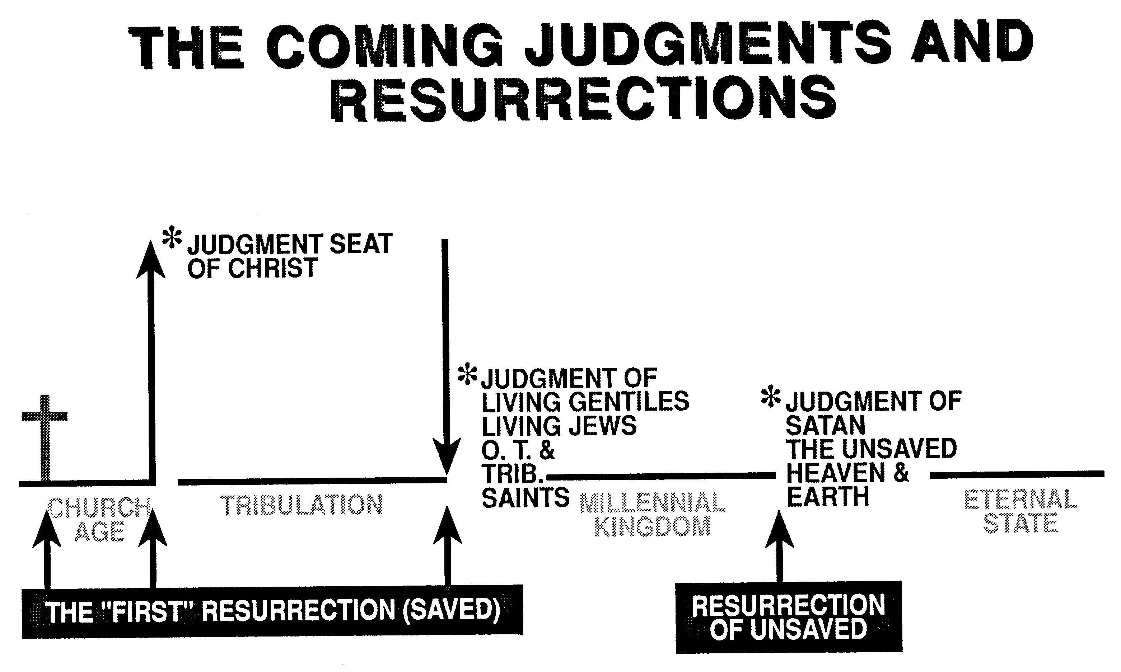
From a chart collection compiled by Thomas Ice, Ph.D.

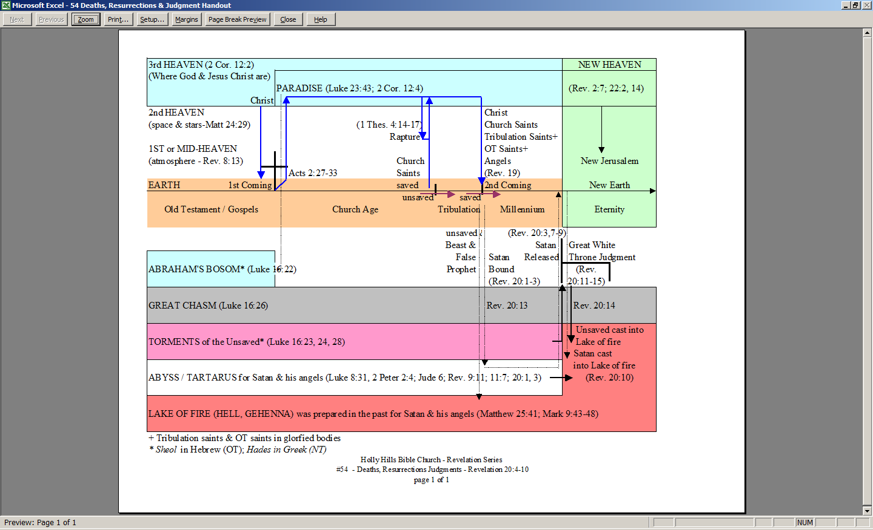
+ Tribulation saints & OT saints in glorfied bodies
* Sheol in Hebrew (OT); Hades in Greek (NT)
