Revelation 21:1-8 - Renewal

We’re turning into a new chapter, not only in the sense that this will move us from chapter 20 to chapter 21, but also in the sense that this will take us into eternity, the new heavens and the new earth, and the new Jerusalem. We’ll find this a very new kind of place than the old heavens and old earth – the one we’re living in physically in now.

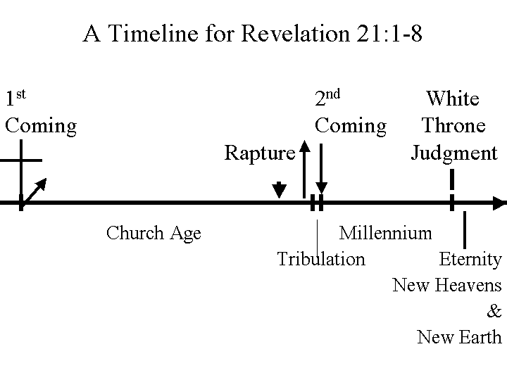
In order for us stay oriented, we should take a look at this timeline. The first coming of Christ, as recorded in the New Testament, is shown first on this chart. The short and downward pointing arrow is where we are now, living in anticipation of the rapture. This is followed by the Tribulation, the second coming, the millennium and the white throne judgment. Today’s passage (Revelation 21:1-8) introduces us to eternity and the new heavens and the new earth.

As we proceed into the last couple of chapters of Revelation, one of the things we’ll notice is that things that started early in the book of Genesis are fulfilled or changed or contrasted in the last few chapters of Revelation – the ones we’re headed into right now. See the chart below for examples of this pattern of starting in Genesis and ending or completing in the last chapters of Revelation:
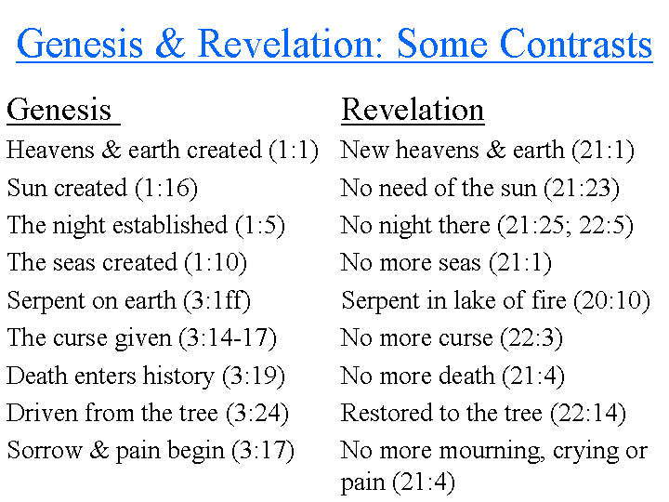
When John begins describing these things, he is telling us the truth as well as current language can begin to describe. After all, how would you go about describing a world that you’ve never seen before that in many ways is unlike the one you’ve lived in?

So get ready to stretch your thinking a bit. Let’s read begin by reading Revelation 21:1.

1 Then I saw a new heaven and a new earth; for the first heaven and the first earth passed away, and there is no longer any sea.

There are several Scripture passages that tell us either about the passing away of this present heavens and earth or the creation of the new heavens and earth – or both:

• Matthew 24:35
• Mark 13:31
• 2 Peter 3:7, 10-12
• Revelation 20:11
• Revelation 21:1

These are some, but not all of those passages. And Scripture gives us at least some of the reasons why God would want to create a new heavens and new earth:

• Earth was a place of rebellion (Genesis 3 - Revelation 20)
• Heaven was a place of rebellion (Isaiah 14:12-14)
• Satan had access to heaven & earth (Job 1,2; Ephesians 2:1, 2)

We’ve talked before about why this present heavens and earth must be replaced with a new one. The bottom line is that both the heavens and the earth – as fascinating and wonderful as they are in many ways – have been contaminated by rebellion and sin. Where we are physically living and breathing right now is inadequate to carry out the rest of the plan that God has in mind for eternity. Even the heaven we will first go to when the Lord takes us to be with Him at the rapture will not be adequate for God’s purposes

When the Lord says “new heaven and new earth” He doesn’t mean just scraping the old paint off and putting on a new coat. This is a totally new world. The Greek word for “new” in Revelation 21:1 (twice), 21:2 and 21:5 is kainos, which means not just “new in time sequence” but “new as to kind and character”.
This new heavens and new earth are new in kind, that is new in character.

John tells us that there was “no longer any sea”. We’re talking about an entirely new kind of earth, aren’t we? It has a different appearance, a different ecology, and a different character. We’ll see shortly why the present earth’s large bodies of water are no longer needed in the new earth.

2 And I saw the holy city, new Jerusalem, coming down out of heaven from God, made ready as a bride adorned for her husband.

The first half of verse 2 comes across like this in the Greek: “and the city, the holy one, new Jerusalem, I saw descending out of heaven from God”.

Though the present place called Jerusalem in Israel has been and is a very special place to God’s program on earth, this new Jerusalem is not like the former one, which in Revelation chapter 11 is compared to Sodom and Egypt. The present Jerusalem was attacked multiple times as a part of God’s judgment in the many centuries before. This New Jerusalem is “the holy one”. It’s new in kind – not in kind like the one before.

What’s fascinating is that John describes the new Jerusalem as coming down out of heaven, but he does not explicitly say that the New Jerusalem will come down to and be on the earth. Yet the present separation between God’s heaven and mankind’s earth that is so prominent now seems to diminish greatly, if not disappear.

Then John makes the comparison here that the New Jerusalem is like a bride adorned for her husband. Now there are three aspects of the bride in preparation for her marriage as a fitting picture here:

- As marriage is designed by God to be permanent (Genesis 2:24), so this will be our eternal home – always – forever – eternal. It will be eternally permanent.

- As a bride is beautifully and gloriously adorned for her wedding (Ephesians 5:27), so this stresses the beauty and glory of this city as it is adorned for the saints.

- As the bride is to be pure (Ephesians 5:27), it pictures the purity of the holy city.

In this specific verse an important point of distinction is that the new Jerusalem is compared to a bride adorned for her husband in order to make the points in the bullets given above. But the new Jerusalem is not explicitly the same as the Church, who is the bride, the wife of the Lamb. That will come in verse 9, which will start our passage next Sunday.

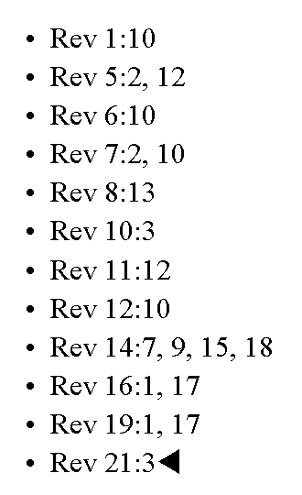
3 And I heard a loud voice from the throne, saying, "Behold, the tabernacle of God is among men, and He will dwell among them, and they shall be His people, and God Himself will be among them, 4 and He will wipe away every tear from their eyes; and there will no longer be any death; there will no longer be any mourning, or crying, or pain; the first things have passed away."

For those with sensitive hearing or weak hearts, you will be delighted to know that this is the last place that the word pair “loud voice” shows up in Revelation (see full listing of verses with a ‘loud voice” to the left). This “loud voice” comes directly from the throne – it comes with authority. But beyond it being loud, this particular voice has a most comforting message to tell us.

Next, let’s take a closer look at some insightful words found in Revelation 21:3:

Revelation 21:3
And I heard a loud voice from the throne, saying, “Behold, the tabernacle of God is among men, and He will dwell among them, and they shall be His people, and God Himself will be among them…”

The word “among” appears three times in this one verse, and it communicates an end to all separation from God. He will be with us, that is, among and in the midst of us. Our already permanent position with Him will also be our eternally permanent condition with Him. Look at the words that are underlined in this verse

- A tabernacle is an abiding place
- To dwell is an abiding action
- To be His people is an abiding personal possession
- To be will mean an abiding presence

The Lord has from before the foundation of the world sought for us to have fellowship with Him. This verse communicates the fulfillment of God’s eternal design so profusely and so profoundly! We who deserve no better than eternal separation from God in the flames of the lake of fire are found to be eternally and permanently and irreversibly with Him as His possession!

John tell us in verse 4 that the Lord will wipe away every tear. The word tear is given in the singular:

- God is not going to wipe away some tears
- God is not going to wipe away most tears
- He is going to wipe away every tear

This is not going to be just some sort of substantial improvement. It will be perfect – without regrets and second thoughts. No lingering doubts…There will be no doubts!
There will be no mourning or crying or pain.

Think of the thing that pains you the most, perhaps in your body, or in your mind, or in your past. Perhaps something that was done to you or even something you did to another. We know that God has a purpose in everything. We know that even those pains He will use. We know that God is able to sooth pains of heart in this life. But this means no more pain – no more, ever.

5 And He who sits on the throne said, "Behold, I am making all things new." And He said, "Write, for these words are faithful and true."

We have it from the Lord Himself that He is making all things new. This is the One who made all things before by the word of His mouth. The world has had trouble believing that God could make everything in the universe in six days, so they came up with a theory that everything we see evolved over about 4½ billion years of time, as if that’s going to solve the question of how things got to be the way they are.

But in this verse the Lord here- just as boldly as in Genesis 1- tells us that He is going to do away with the old universe and this one will be created new in an instant – no problem! Right away!

The Lord tells John to write these things down, telling John that “these words are faithful and true”. Now the Lord is not telling John to write just because these words are nice things to write. “Faithful and true” words in John’s day were words that were verifiably true such that they would hold up in a court of law. These things are real-life fact in space and time based on the words of Him who has a character that is eternally and unchangeably faithful and true. That is why we see this phrase “faithful and true”.

We’ve seen this phrase before more than once and we’ll see it again once more in Revelation chapter 22:

• Revelation 3:14
• Revelation 19:11
• Revelation 21:5 

• Revelation 22:6

In chapter 22 He will say again that these words are faithful and true – just so we get the point. These words are for real, even though they haven’t happened yet.

6 Then He said to me, "It is done. I am the Alpha and the Omega, the beginning and the end. I will give to the one who thirsts from the spring of the water of life without cost.

This is the second time that we have read “It is done!” in Revelation. In Revelation 16:17 we heard the Lord say that same brief sentence when the last of the Tribulation period judgments had been poured out. Now we read that it is done, but there is nothing more to be done at all with this world’s evil affairs and personalities. When He says that He is the Alpha and the Omega, the Beginning and the End, those words bring us back to the study we surfaced in the early chapters of Revelation. There we brought out a chart that is reproduced at the end of this handout (the last page – page 9):

While we don’t have time to go into the details now, you may recall the passages in Revelation that refer to:

- the First and the Last,
- the Beginning and the End
- The Alpha and the Omega

These passages clearly point out the deity of Christ. In these passages from Isaiah chapters 41-48, the Lord God says that He is the First and the Last, the Beginning and the End. We’re also going to see the Lord Jesus Christ refer to these things again in Revelation chapter 22.
Our Lord also tells us that He, “…will give to those who thirst from the spring of the water of life without cost.”

First we see that there are references to when John wrote about our Lord’s meeting with the Samaritan women at Jacob’s well:

John 4:13-14
Jesus answered and said to her, "Everyone who drinks of this water will thirst again; 14 but whoever drinks of the water that I will give him shall never thirst; but the water that I will give him will become in him a well of water springing up to eternal life."

Another detail that jumps out at us from Revelation chapter 21 is that while there is no longer any sea – as we were told in verse 1, there is no shortage of water, and unlike the water of the ocean – which never satisfies thirst – this water will be ultimately satisfying. It will be Christ Himself supplied to us without end and without bound.

Did you notice the very end of verse 6? Did you see that? The life of Christ is supplied to us without cost! Isn’t it amazing that even though our Lord states and restates this truth that there is no price we can pay for it? That there is no way we can gain what He has bought at His own expense. There is no earning this. Not one bit - not even a part. Our Lord tells us straight out – it comes without cost. It is given – did you see that – given - entirely at His expense. We call that grace, and it is eternally amazing. It will require rolling ages after ages to come for Him to show it all to us (Ephesians 2:7).

7 "He who overcomes will inherit these things, and I will be his God and he will be My son.

Here we have a return to the frequent “he who overcomes” theme of Revelation. As a matter of fact, John is almost uniquely the one in his writings who writes about Christ having overcome the world (John 16:33), and about we as believers being the overcomers (1 John 5:4). Back when we started our study of the Revelation earlier this year, we included a chart on overcomers in the handout. That chart is reproduced at the end of this handout (page 8).

The references to the believer in this verse are singular and individual:

- He who overcomes
- His God
- My son

The Lord is telling us in this verse that our relationship with Him - in a way that seems impossible in this world we now live in – will be personal and individual. It is the Lord Himself telling you that He Himself wants to have ongoing, uninterrupted, intimate and personal fellowship with you – explicitly – you. That is true of our position now as believers. That is true in our condition now, as we place our faith in the spiritual facts God has revealed to us. But then it will be true always - all the time – for we will see Him as He is. There will be no variability between our position and our condition – none!
8 "But for the cowardly and unbelieving and abominable and murderers and immoral persons and sorcerers and idolaters and all liars, their part will be in the lake that burns with fire and brimstone, which is the second death."

Our Lord is not mentioning these people in order to ‘hang something over our heads’. The truth is that many of the people in heaven will have had these very backgrounds. Wasn’t Peter a coward as he denied knowing Christ? Wasn’t Thomas unbelieving as he refused unless he personally saw and felt the Lord’s wounds from crucifixion? Wasn’t the thief on the cross abominable? Wasn’t Paul a murderer? Didn’t Paul write of the Corinthians about these kinds of things, saying, “such were some of you”?

1 Corinthians 6:9-11
Or do you not know that the unrighteous will not inherit the kingdom of God? Do not be deceived; neither fornicators, nor idolaters, nor adulterers, nor effeminate, nor homosexuals, 10 nor thieves, nor the covetous, nor drunkards, nor revilers, nor swindlers, will inherit the kingdom of God. 11 Such were some of you; but you were washed, but you were sanctified, but you were justified in the name of the Lord Jesus Christ and in the Spirit of our God.

These people that Paul is describing are those who make up the church at Corinth. It is not so much that he is speaking badly about the people at the church of Corinth – but not that he is complimenting them, either. No, instead Paul is speaking powerfully about the washing and justification and sanctification of every one who believes on Jesus Christ for salvation.

So in this passage in Revelation 21:8, our Lord is not saying that anyone who has done these sorts of things or been this sort of person won’t get into the new Jerusalem. No, He is saying that those who have lived by dependence upon their own righteousness – whatever that looks like – have not been washed and justified by reason of their faith in Jesus Christ. Let’s put it this way to make it clear: Only the righteousness of Jesus Christ that comes by faith in Jesus Christ will give you a character and a relationship and an identity with Christ that will place you into the new Jerusalem. None of us is good enough on our own, so it is only by His righteousness that we will be in the New Jerusalem.

What we’ve begun reading about this morning is how we who have placed our faith in Jesus Christ will spend eternity. We don’t know everything we might think of asking, but the Lord of Glory wants us to know about the things He’s told us, so that we can live by faith in the revealed spiritual facts, right now.

Ephesians 2:4-7
But God, being rich in mercy, because of His great love with which He loved us, 5 even when we were dead in our transgressions, made us alive together with Christ (by grace you have been saved), 6 and raised us up with Him, and seated us with Him in the heavenly places in Christ Jesus, 7 so that in the ages to come He might show the surpassing riches of His grace in kindness toward us in Christ Jesus.
Who are the Overcomers?

Church | Epistles to the Seven  Churches | Fulfillment in Revelation Chapters 19-22 Inclusive
EPHESUS | "To him who overcomes, I will grant to eat of the tree of life which is in the Paradise of God.' (2:7b) | (22:14)
SMYRNA | He who overcomes shall not be hurt by the second death.' (2:11) | (20:14)
PERGAMOS | To him who overcomes, to him I will give some of the hidden manna, and I will give him a white stone, and a new name written on the stone which no one knows but he who receives it.'' (2:17) | (19:12)
THYATIRA | And he who overcomes, and he who keeps My deeds until the end, to him I will give authority over the nations; and he shall rule them with a rod of iron, as the vessels of the potter are broken to pieces, as I also have received authority from My Father; and I will give him the morning star.  (2:26-28) | (19:15)  (22:16)
SARDIS | 'He who overcomes shall thus be clothed in white garments; and I will not erase his name from the book of life, (3:5) | (22:14)  (20:15)
PHILADELPHIA | "He who overcomes, I will make him a pillar in the temple of My God, and he will not go out from it anymore; and I will write upon him the name of My God, and the name of the city of My God, the new Jerusalem, which comes down out of heaven from My God, and My new name.  (3:12) | (21:22b)  (22:4)  (21:10b)  (19:12)
LAODICIA | 'He who overcomes, I will grant to him to sit down with Me on My throne, (3:21) | (20:4) Also see Ephesians 2:6

