Revelation 22:12-21 – Coming quickly!

Rivers in the New Testament
There is an interesting pattern in the mention of rivers in the New Testament books:

- Outside of Matthew 3:6 and Mark 1:5 mentioning the River Jordan, Revelation is the only New Testament book to even mention a river.

- Revelation 9:14; 12:15,16 and 16:12 mention rivers during the Tribulation period, but each is given in a negative context, on an earth that will end.
- Revelation chapter 12 verses 15 and 16 use the word “river” as a figure of speech illustrating the flowing massive nature of Satan’s wrath against the Jews

- In what is clearly a great contrast, Revelation 22:1, 2 speaks of a river of life in the New Jerusalem that flows eternally from the throne of God and the Lamb.

- This picture is there to point our attention to Christ, who is Himself the continuous source of life (John 10:28).

Question: When did the beginning of the New Creation take place?

Answer:

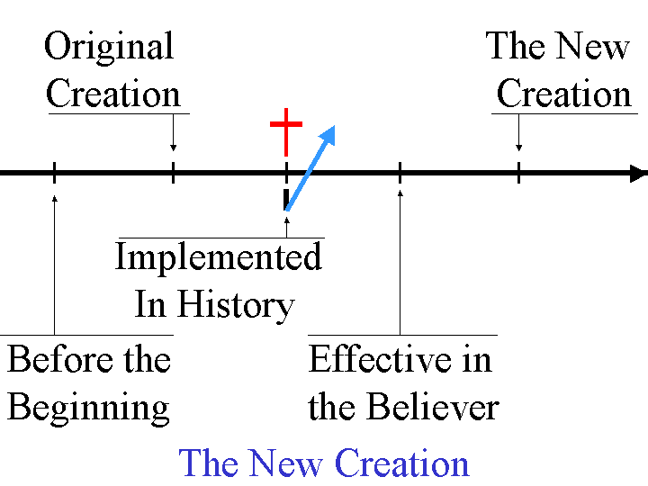

Question: In Revelation 21:3, are these people “the bride of the Lamb”, or someone else? Does Revelation chapter 21 speak of more than one group of saints?

Answer:

The New Heavens and the New Earth will be populated by all the saints of all time, because by this time Old Testament saints, church saints, tribulation saints, and millennial saints will all be gathered. The bride, the wife of the Lamb, is one of those groups, but is included with those in the New Jerusalem. By the way, the word “saints” – which means “set apart ones” – applies to all those who believe of all time, but not exclusively the church age saints. See also the supplement, “49 Revelation Series – December 6, 2009 - Supplement: The 3 groups which make up the peoples of God in eternity”.
As we approach the last half of the last chapter of Revelation, we are approaching the last verses of the very last book of the Bible. John has been telling us the things that have been revealed to Him – recording these things with meticulous care. He recorded for us this prophetic masterpiece, which syncopates between heaven and earth like a musical score written with genius and inspiration. He started it with a promise of blessing for those who read and hear it, and he will finish it – as we will soon see – with a blessing as well. All of it has been written as a Revelation of and by the person of Jesus Christ – so that we might behold Him, with whom we are identified, and to whom we will be the bride, in all His eternal and infinite glory.

12 "Behold, I am coming quickly, and My reward is with Me, to render to every man according to what he has done.

John writes for the last time “Behold”, which in modern vernacular means “take a mental picture”.

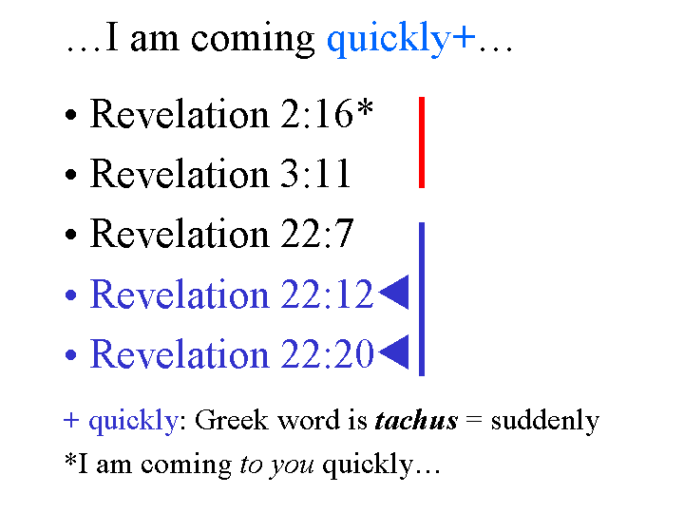
This verse and verse 22 are the last 2 of 5 times that the book of Revelation records Jesus Christ as saying, “I am coming quickly”. The first two instances of this phrase are spoken in the messages to the seven churches. The last three instances of this phrase are spoken in the closing chapters of this book, as we’ve been reading through recently. As we brought up before, this is not saying that Jesus Christ is necessarily returning at a time very soon after John is writing these things. Rather it is saying that the Lord’s coming will be sudden, and that when He returns, things will progress rapidly. Some key observations about Christ’s reward:

- First, our Lord Jesus Christ is looking to reward believers – not looking for an opportunity to clobber us!
- Next, His reward is personal. His reward is in His possession so that He can give that reward to us. He’s not going to have somebody else send it to us via bulk mail. He has it and He is intent upon giving it to us personally.
- Finally, His reward to us will be based on our works – but, the works He will reward us for are the ones He has prepared before hand (Ephesians 2:10), and they are done by His life (Colossians 3:1-4). For anything that the Lord asks for us to do, He provides the motive, means and opportunity!

13 "I am the Alpha and the Omega, the first and the last, the beginning and the end."

We have already made clear identification that this quote and quotes like it say that Christ is claiming deity (see, “49 Revelation Series - Revelation 21:1-8- Renewal - December 6, 2009 - Page 3 of 9”). Here is one of the verses that clearly connects what Christ says here with the claim of God – the God of Israel:

Isaiah 44:6
"Thus says the LORD, the King of Israel, and his Redeemer, the LORD of hosts: 'I am the first and I am the last, and there is no God besides Me."

See also Isaiah 41:4 and 48:12 for the claim of God to be the first and the last.

Rev 1:3 - Blessed is he who reads and those who hear the words of the prophecy…

Rev 14:13 - Blessed are the dead who die in the Lord from now on!…

Rev 16:15 - Blessed is the one who stays awake and keeps his clothes…

Rev 19:9 - Blessed are those who are invited to the marriage supper of the Lamb.

Rev 20:6 - Blessed and holy is the one who has a part in the first resurrection…

Rev 22:7 - Blessed is he who heeds the words of the prophecy of this book…

Rev 22:14 - Blessed are those who wash their robes…

14 Blessed are those who wash their robes, so that they may have the right to the tree of life, and may enter by the gates into the city.

John has written in the book of Revelation now seven times “blessed is” or “blessed are”.
In this verse we find the last of the seven places where John writes that in this book - the last thread in this most impressive tapestry of words.

In this, the seventh verse in Revelation saying “blessed”, John writes what our Lord says “…blessed are those who wash their robes…”.

Wearing White

• Rev 3:4, 5, 18
• Rev 4:4
• Rev 6:11
• Rev 7:9, 13, 14
• Rev 19:14

Washed and/or White Robe(s)

• Rev 1:13
• Rev 6:11
• Rev 7:9, 13, 14
• Rev 19:13, 16
• Rev 22:14

We’ve been told about wearing white and about robes many times in this book, and this is the last time. From the earliest chapters until now, this matter of wearing white robes is used as a word picture to tell us about the righteousness of Jesus Christ in the life of the believer. The believer has a position in Jesus Christ that is untouchable and which irreversibly gives Him the righteousness of Jesus Christ to wear as a robe forever. The believer is called to live righteously in his condition by the righteousness of the Lord Jesus Christ such that his condition is consistent with his position. That is ‘the other half of the picture’ of wearing a white robe.

This righteousness of Jesus Christ is the means to access into the tree of life and the gates of the New Jerusalem. The tree of life has been promised to the church in chapter 2, and referred to three times in Revelation chapter 22.

• Revelation 2:7 Promised to those of us in the Church

• Revelation 22:2 Promise fulfilled in the New Jerusalem
• Revelation 22:14 Promise fulfilled in the New Jerusalem
• Revelation 22:19 Promise fulfilled in the New Jerusalem

The tree of life points to the person of Jesus Christ, who, in John 10:28, has said that He is constantly giving us life.

15 Outside are the dogs and the sorcerers and the immoral persons and the murderers and the idolaters, and everyone who loves and practices lying.

As we’ve seen before, there are three places in chapters 21 and 22 where those who are excluded from the New Jerusalem are spelled out (Revelation 21:8; 22:11; 22:15).

It is not that those who lack the righteousness that comes through faith in Jesus Christ are positioned right outside the city of New Jerusalem, but the point is that these are not in the New Jerusalem. There is no place for them there, because they lack the righteousness of Jesus Christ that can only be had by faith in Jesus Christ. No, those who lack Christ’s righteousness that is gained only by faith are in the Lake of Fire, so most certainly they are not in the New Jerusalem. Here is the detailed listing of the character of those who are not in the New Jerusalem:

• dogs: Greek “kuon” = moral and spiritual “low life”
• sorcerers: from Greek “pharmakia” = drugs/sorcery
• immoral persons: Greek “pornos” = fornicators
• murderers: from Greek “phonos” = homicide
• idolaters: Greek “eidololatres” = image worshipper
• everyone who loves and practices lying:
Greek for “loves” is “phileo” = to have affection for
Greek for “practices” is “poieo’ = does

What their hearts love, their bodies put into action.

16 "I, Jesus, have sent My angel to testify to you these things for the churches. I am the root and the descendant of David, the bright morning star."

What we saw in the very first chapter of Revelation, and now twice in chapter 22, is that the Lord Jesus Christ has specifically sent His angel to convey these truths (Revelation 11:1; 22:6, 16). The word translated “angel” is angelos, which means “messenger”. Jesus Christ is specifically intent upon and interested in you knowing and understanding the truth – that is why He has taken deliberate steps for you to get these facts before you, that is, to ‘testify’. In John’s day, for a person “to testify” meant for them to tell the truth so that is has legal validity as evidence, both in its content and in its completeness.
Testifying in Revelation 22:16 and 18 is given very similarly to a legal certification in John’s day, certifying the truth and trustworthiness of the contents of this book, which matches the certification of truth in the beginning of Revelation (1:1-8).

In this verse we find, after the word churches is issued for the first time since chapter 3. What we are and have been reading is truth for the churches. It is intended for you and for me, who need this truth, and all the rest of the truth that is in Scripture. All of Scripture is written for our benefit, so that we might believe and be fed and grow.

17 The Spirit and the bride say, "Come." And let the one who hears say, "Come." And let* the one who is thirsty come; let the one who wishes take the water of life without cost. * Let does not mean ‘allow’, but rather is an imperative.

This is a verse of open invitation. “Come…”:

- It is part of the ministry of the Holy Spirit
- It is part of the ministry of the church, the bride
- It is the desired response of those who read this book to say, “Come!”

Now the water of life has been offered without cost before, in chapter 21. People on this planet spend their lives looking for what they think is life. John is writing that the Lord is offering life without cost – totally and completely by grace. One cannot earn nor pay for it, nor pay it back.

18 I testify to everyone who hears the words of the prophecy of this book: if anyone adds to them, God will add to him the plagues which are written in this book; 19 and if anyone takes away from the words of the book of this prophecy, God will take away his part from the tree of life and from the holy city, which are written in this book.

Now there are two ways in which a person who through a response of unbelief might add to or take away from this book and would then receive the plagues in the book:

- Anyone who goes into the Tribulation as an unbeliever will receive the plagues of the Tribulation directly.

- Anyone who is an unbeliever will go into the Lake of Fire.

It becomes very clear that John is very concerned about the prophecy in this book:

• Verse 7—The words of the prophecy of this book.
• Verse 9—The words of this book.
• Verse 10—The words of the prophecy of this book.
• Verse 18—The words of the prophecy of this book.
• Verse 19—The words of the book of this prophecy.
• Verse 19—Which are written in this book.

Why is John so very concerned about maintaining the integrity of this book? Why does he warn anyone who might consider adding to or taking away from this book?
John had already come across some who did not accept his apostolic authority, and John records that for us in 2 John 10, 11 and 3 John 9,10. Secondly, the gift of prophecy ended with the completion of this book, the last book of the New Testament (1 Corinthians 13:8-13, Ephesians 2:20, et al). So anyone who claimed the gift of prophecy after the writing of this book (mostly by adding to it) would be a false prophet.

20 He who testifies to these things says, "Yes, I am coming quickly." Amen. Come, Lord Jesus. 21 The grace of the Lord Jesus be with all. Amen.

Jesus is the one who testifies. He finishes off his testimony by saying that He is coming quickly – suddenly and with an element of surprise. “Amen”, he says twice – it is true!
Before we heard the invitation for others to come! Now we read of the invitation for our Lord Jesus to come. The Lord has put in the hearts of believers the desire for His coming. Paul writes about it multiple times, as do the other apostles.

As we’ve gone through this book, we’ve read about a great many things. But the one thing that John wrote this book for was to reveal Jesus Christ. Our hope is that as we’ve worked our way through the pages of this book that you have come across verses through which you behold Jesus Christ, that you might be transformed – growing from glory to glory, as the Lord Jesus Christ shares His glory with us, and we look forward to seeing Him face to face.

