Growing – what is God doing?

To grow and mature spiritually would not even be possible if God had not acted out of His mercy and grace to save us. Everything about each believer’s position in Christ and eternal salvation is accomplished by God Himself – all we did is believe:

1 Corinthians 1:30a
But by His doing you are in Christ Jesus…

Ephesians 2:4-9
But God, being rich in mercy, because of His great love with which He loved us, 5 even when we were dead in our transgressions, made us alive together with Christ (by grace you have been saved), 6 and raised us up with Him, and seated us with Him in the heavenly places in Christ Jesus, 7 so that in the ages to come He might show the surpassing riches of His grace in kindness toward us in Christ Jesus. 8 For by grace you have been saved through faith; and that not of yourselves, it is the gift of God; 9 not as a result of works, so that no one may boast.

Titus 3:5-7
He saved us, not on the basis of deeds which we have done in righteousness, but according to His mercy, by the washing of regeneration and renewing by the Holy Spirit, 6 whom He poured out upon us richly through Jesus Christ our Savior, 7 so that being justified by His grace we would be made heirs according to the hope of eternal life.

So God accomplished everything about our salvation and our position in Christ when we first believed. It is all God’s doing that we are in Christ, and have the New Man, the New Nature, and a new history. These are unchanging. And since the time of our initial salvation, God has had an essential part in our ongoing growth and maturity, which is a change that God accomplishes in the Continuing Person. That growth and maturing process is our Continuing Person catching up with who we are in Christ, the New Man, the New Nature, and the new history that we have because we now share Christ’s history:

death > burial > resurrection > ascension > seating in the heavenlies

Today we will want to examine what God has done and is doing to bring about spiritual growth in us, and to bring us to maturity. The ultimate standard of the characteristics of maturity, and the direction towards which we are to be growing is Jesus Christ the Lord.

God works through circumstances

God works through circumstances - even the really hard ones – to bring about growth and maturity in the believer. God is sovereign, and even when human beings make choices to think and act contrary to God’s moral and spiritual will, God’s purposes will not be thwarted. God does work all things together for good (Romans 8:28, 29), and manages all of history towards a specific future in which all things will be summed up in Christ (Ephesians 1:9, 10), and works all things according to the counsel of His will (Ephesians 1:11). So while people will make their choices, and be free to do so, God will make everything from supposed acts of nature to acts of mankind and failures of mankind to act a planned part of our growth and maturity. God is fully able to bring about a good outcome of all things in our lives, even those that are unpleasant or painful or truly bad:

James 1:2-4 (Expanded & Explained)
You must esteem it ultimate joy, my Israelite brethren in Christ, when you encounter various fiery tests with a view to approval, 3 knowing that the fiery testing with a view to approval of your faith produces endurance – patience through and under the circumstances. 4 And you must choose to have endurance – patience through and under the circumstances - have its maturity-producing result, so that you may be spiritually mature and complete, lacking in nothing that God intends to bring about in your life.

Now while many have thought that James was very Jewish and ‘legal’ in his perspective, we must point out that based on Deuteronomy 28, and related passages, the Jews thought that any earthly trial in a person’s life was the result of God’s curse upon the person for violating the Law of Moses (see Deuteronomy 28:1-68 & John 9:1-34). James, writing from a perspective of grace, turns that perspective upside down, saying:

- The Christian must come to a perspective of seeing the trials as God’s test of the believer with a view to approval by God – not a curse from God. James’ friend in the faith, Paul, said that those who are in Christ are blessed unconditionally (Galatians 2:9; Ephesians 1:3).

- While the Israelites came to view bad circumstances as curses from God for disobedience which is the expression of a character flaw, James is calling for believers to see the trial as God’s intentional test with a view to approval that has a beneficial character outcome, which is spiritual maturity.

1 Peter 1:3-9
Blessed be the God and Father of our Lord Jesus Christ, who according to His great mercy has caused us to be born again to a living hope through the resurrection of Jesus Christ from the dead, 4 to obtain an inheritance which is imperishable and undefiled and will not fade away, reserved in heaven for you, 5 who are protected by the power of God through faith for a salvation ready to be revealed in the last time. 6 In this you greatly rejoice, even though now for a little while, if necessary, you have been distressed by various trials, 7 so that the proof of your faith, being more precious than gold which is perishable, even though tested by fire, may be found to result in praise and glory and honor at the revelation of Jesus Christ; 8 and though you have not seen Him, you love Him, and though you do not see Him now, but believe in Him, you greatly rejoice with joy inexpressible and full of glory, 9 obtaining as the outcome of your faith the salvation of your souls.

Peter does not say that the trails are just bad things that happen that we just have to grit our teeth and just get through them. Rather, Peter places the trails in an eternal context, with words and phrases like ‘living hope’, ‘the revelation of Jesus Christ’, and ‘you love Him’ and ‘believe in Him’. Our trials are about our relationship with Christ and our fellowship with Him. Like James, Peter also sees these trials as a fiery testing with a view to approval. Though James and Peter choose some similar words, Peter particularly makes a comparison of the believer’s trials with a metallurgical refining process intended to prove out the valuable content of the ore or metal nuggets. The trials that Peter ‘speaks’ of are forward looking, and ultimately are spiritually productive (see Peter’s use of the words ‘result’ and ‘outcome’).

The Holy Spirit

The Holy Spirit has had and continues to have several ministries that are an essential part of the believer’s spiritual growth and maturity. These include:

 Bringing the word of God to us: the inspiration and preservation of God’s word as God’s special revelation to us (John 16:13; 2 Timothy 3:16, 17).
 Bringing us to the word of God: bringing the message of the word of God to the heart of the believer (1 Thessalonians 1:5, 6).
 Using the word of God mightily in our hearts and lives (Ephesians 6:17).
 Directing believers to focus upon and behold Christ who is revealed in the written word of God (John 16:14).

It is for this reason that the same Peter who wrote about trials in the passage quoted above writes this about the Holy Spirit inspired word of God and spiritual growth:

1 Peter 2:2
…like newborn babies, long for the pure milk of the word, so that by it you may grow in respect to salvation, 3 if you have tasted the kindness of the Lord.

Now Peter’s comparison of the believer’s to newborn babes brings us to another important point. The content of the word of God as fitting for various ages and stages of spiritual maturity is a word picture that is persistent throughout the New Testament epistles. Here we quote two passages that mention both milk and meat in relation to spiritual food, and express that the readers ought to be ready for spiritual meat, but are not yet ready, so are only able to take in spiritual milk.

1 Corinthians 3:1-3
And I, brethren, could not speak to you as to spiritual men, but as to men of flesh, as to infants in Christ. 2 I gave you milk to drink, not solid food; for you were not yet able to receive it. Indeed, even now you are not yet able, 3 for you are still fleshly. For since there is jealousy and strife among you, are you not fleshly, and are you not walking like mere men?

Hebrews 5:11-14
Concerning him we have much to say, and it is hard to explain, since you have become dull of hearing. 12 For though by this time you ought to be teachers, you have need again for someone to teach you the elementary principles of the oracles of God, and you have come to need milk and not solid food. 13 For everyone who partakes only of milk is not accustomed to the word of righteousness, for he is an infant. 14 But solid food is for the mature, who because of practice have their senses trained to discern good and evil.

If we collect the various passages that speak of spiritual food in terms of milk and meat, appropriate to the various ages and stages of spiritual maturity, we can generate a chart like this.

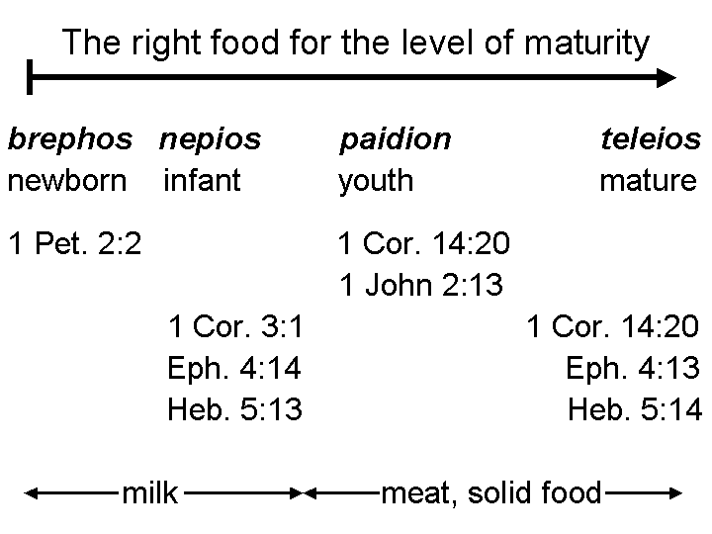

The growing of believers isn’t to be in just a physical way, or in some way that is impersonal, but rather it is focused upon the person of Jesus Christ, by God’s intent.

2 Peter 3:17-18
You therefore, beloved, knowing this beforehand, be on your guard so that you are not carried away by the error of unprincipled men and fall from your own steadfastness, 18 but grow in the grace and knowledge of our Lord and Savior Jesus Christ. To Him be the glory, both now and to the day of eternity. Amen.

God has clearly provided both the milk and the meat. Next Sunday we’ll look at the believer’s part in moving from milk to meat at the right age and stage of spiritual growth.

When we say that people are free to make choices, we do not mean that they have absolute and total freedom. The freedom that a person has to make choices is constrained by: 1) circumstances within which each person chooses, 2) the capabilities and capacities of the individual, 3) that person’s own nature (in the case of an unbeliever) or natures (in the case of a believer). With the believer, the ultimate choice is that of dependence upon the sin nature or dependence upon who we have been made to be in Christ.
This set of words is identical to 2 Corinthians 1:3 and Ephesians 1:3.

