Dead Sea Scrolls and Qumran: Good Biblical Resources
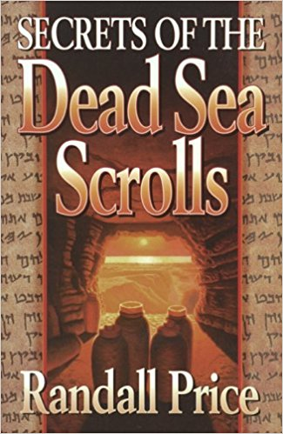
Secrets of the Dead Sea Scrolls, by Randall Price, 1996
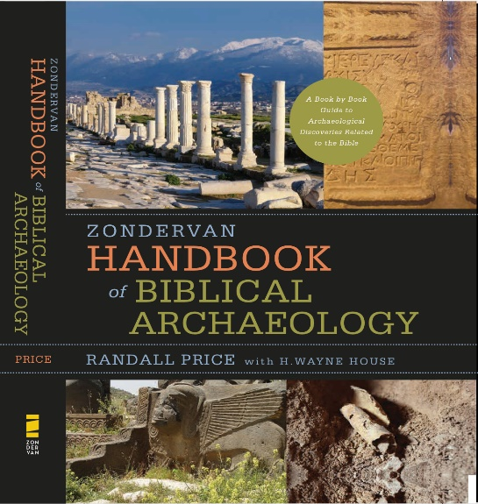
Google Books Link (shows many of the pages online) https://tinyurl.com/ybwqsy3z
The book is full of good insights, but the secrets revealed in the last 22 years are not included. For those secrets see:
Chapter 10 of the Zondervan Handbook of Biblical Archaeology, 2017, is a great summary of the Dead Sea Scrolls and Qumran. It is packed with recent revelations!

Video Resources include:
Secrets of the Dead Sea Scrolls (7:52), by Randall Price, 2012: https://tinyurl.com/yckxcqvz

Archaeological Discoveries in the Israeli Desert (10:01), CBN, with Randall Price, 2017:
https://tinyurl.com/ybjls974
Youtube has many other videos of Randall Price speaking on Qumran and the Dead Sea Scrolls.

For further study and resources:
World of the Bible Ministries, Dr. Randall Price https://www.worldofthebible.com/
Trinity Western University, Dead Sea Scrolls Institute, Dr. Andrew Perrin: https://tinyurl.com/y8lfvvh8

View the Dead Sea Scrolls online:
https://www.deadseascrolls.org.il/featured-scrolls
https://tinyurl.com/yctcqk2u

These resources are available for you to review and check out today: The Secrets of the Dead Sea Scrolls, The Zondervan Handbook of Biblical Archaeology, The Rose Publishing poster and pamphlet on the Dead Sea Scrolls, and the Rose Publishing pamphlet on 50 Proofs of the Old Testament and New Testament, and The Dead Sea Scrolls Booklet (John J. Davis). Also, papyrus samples.

