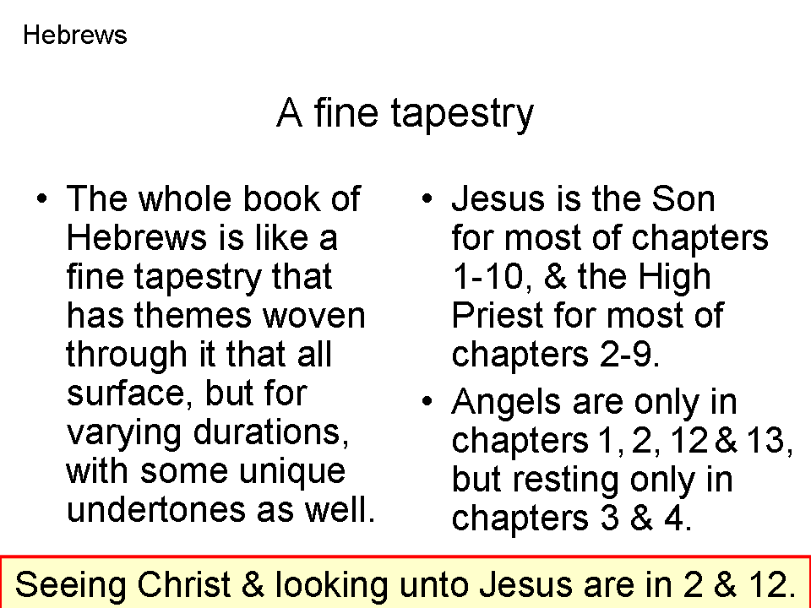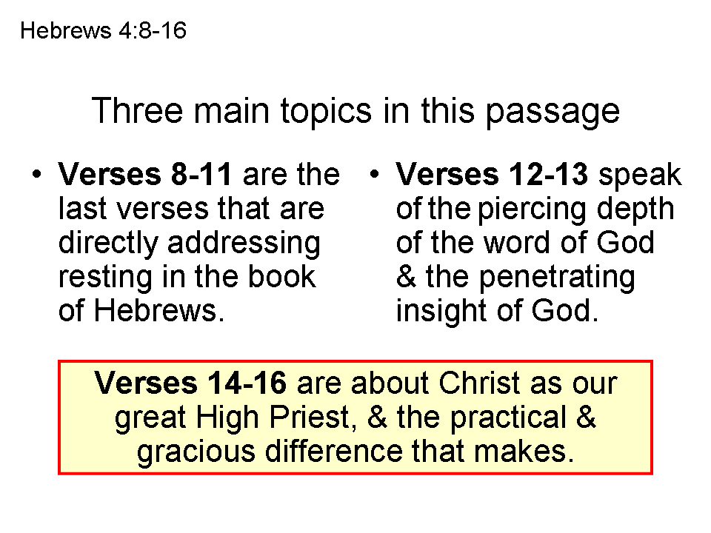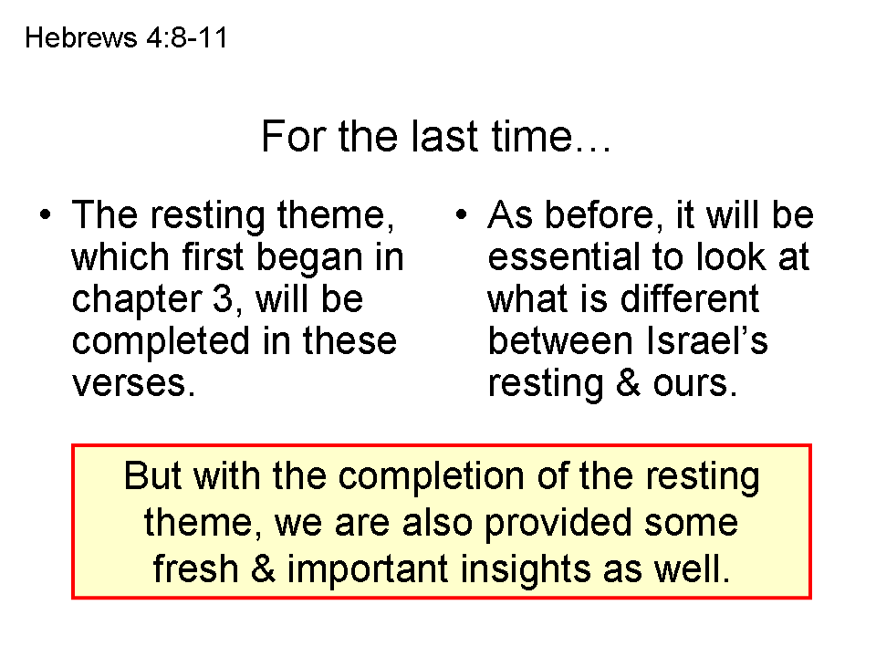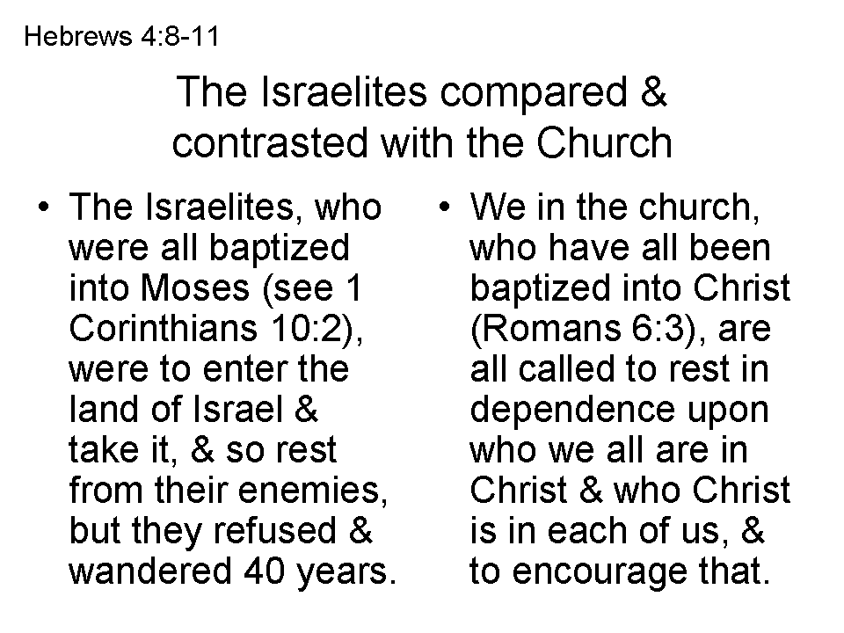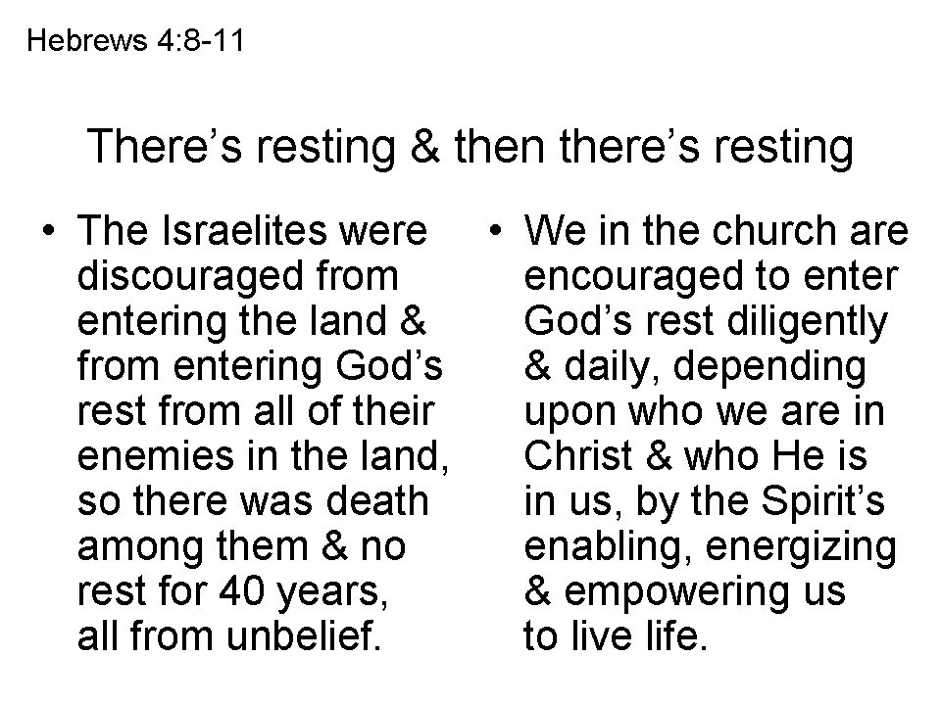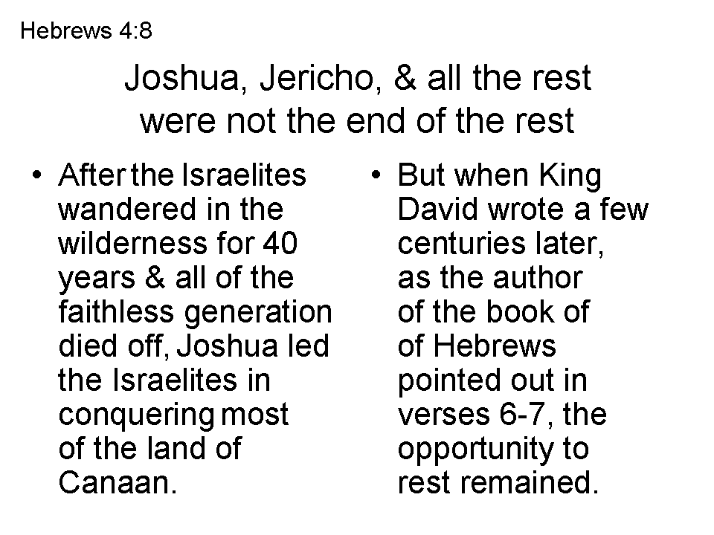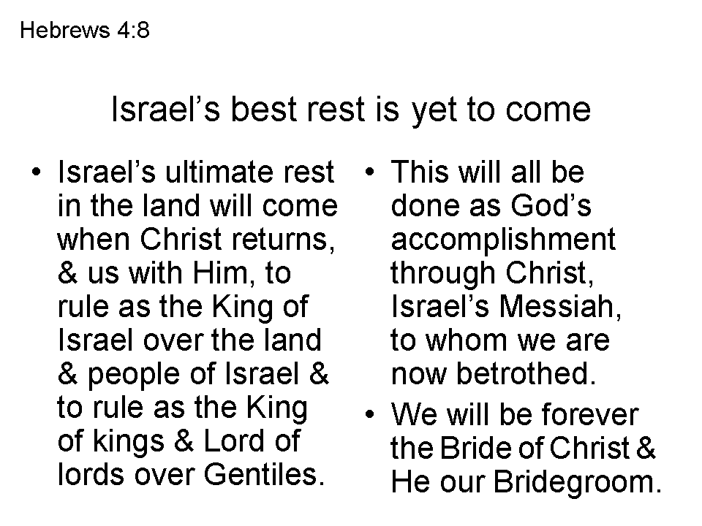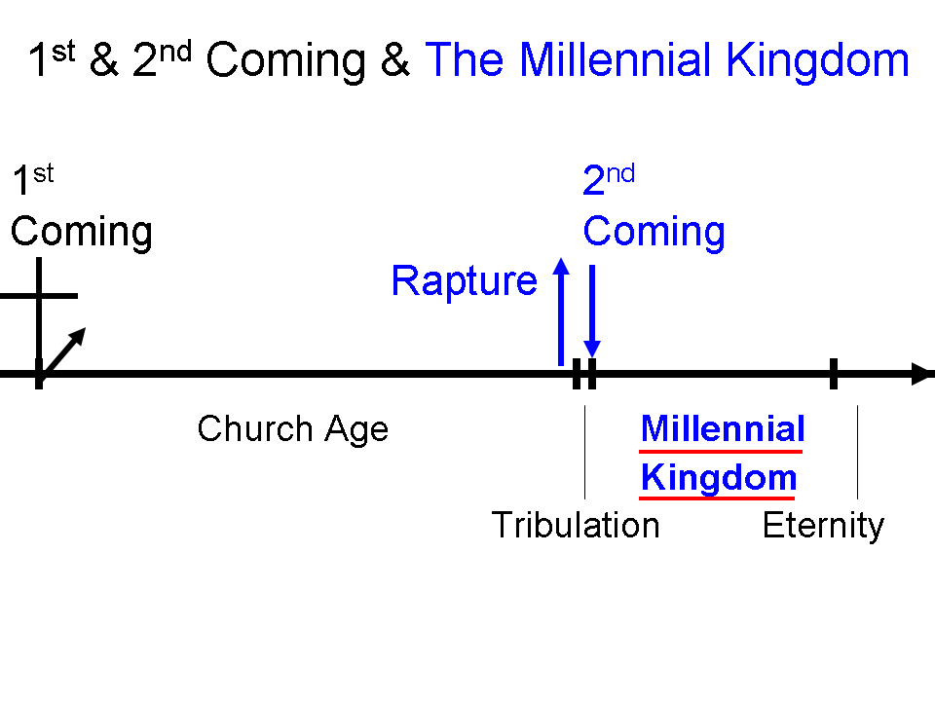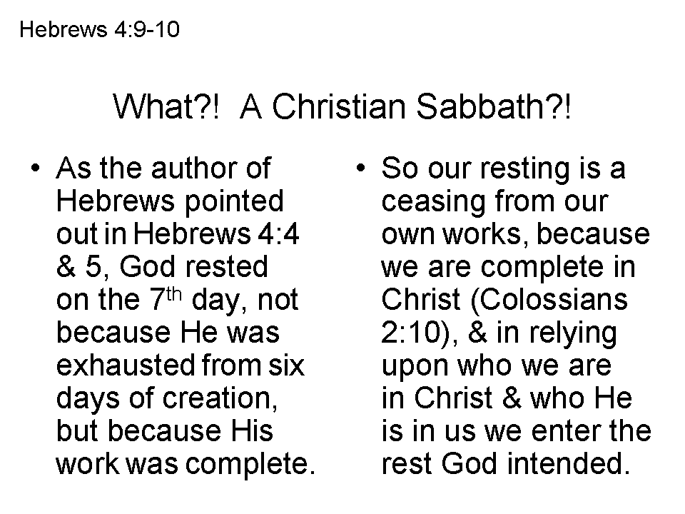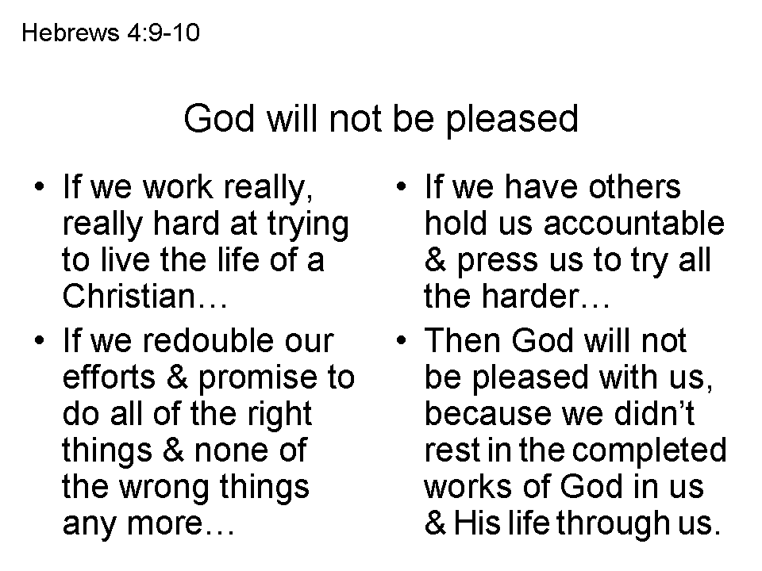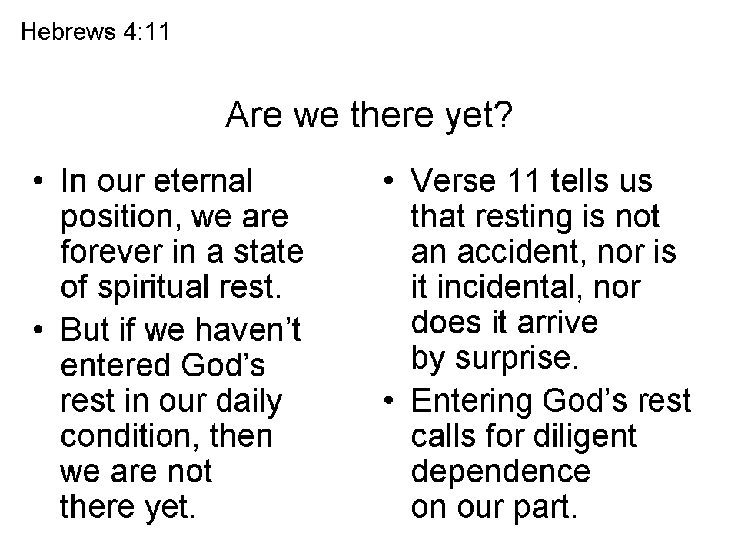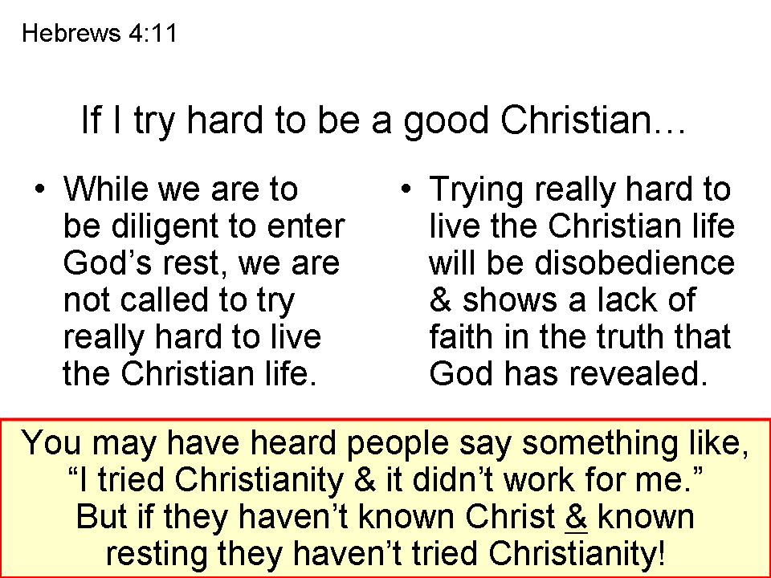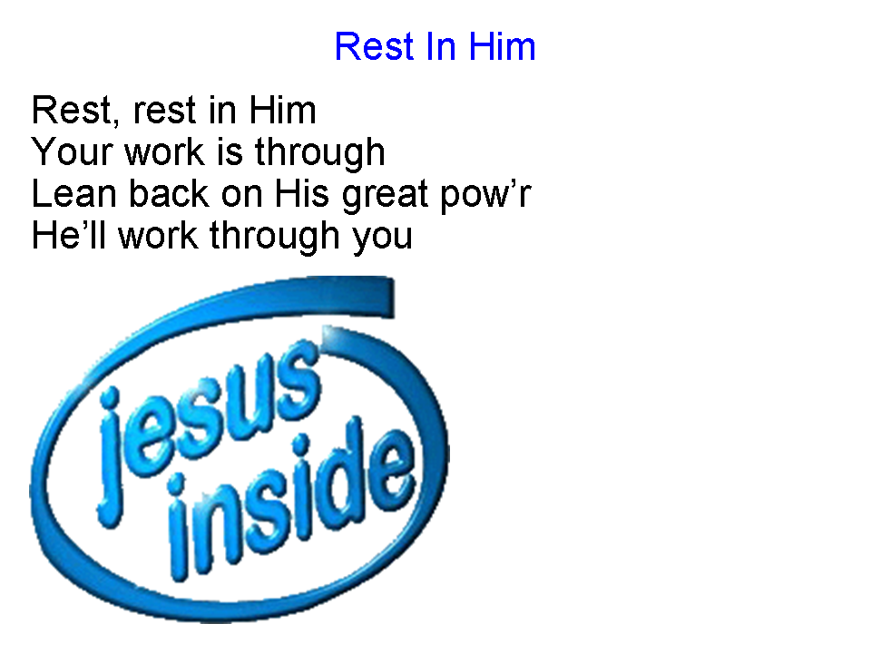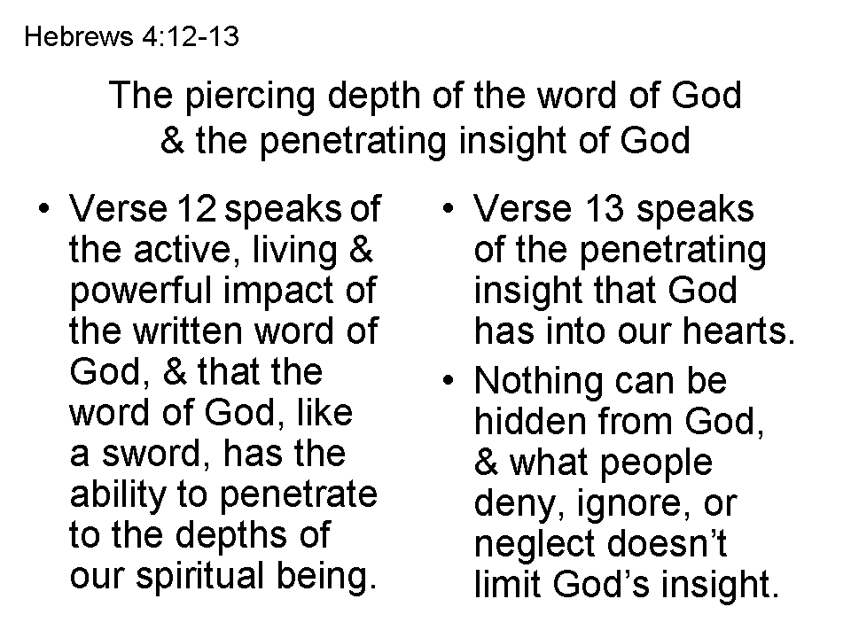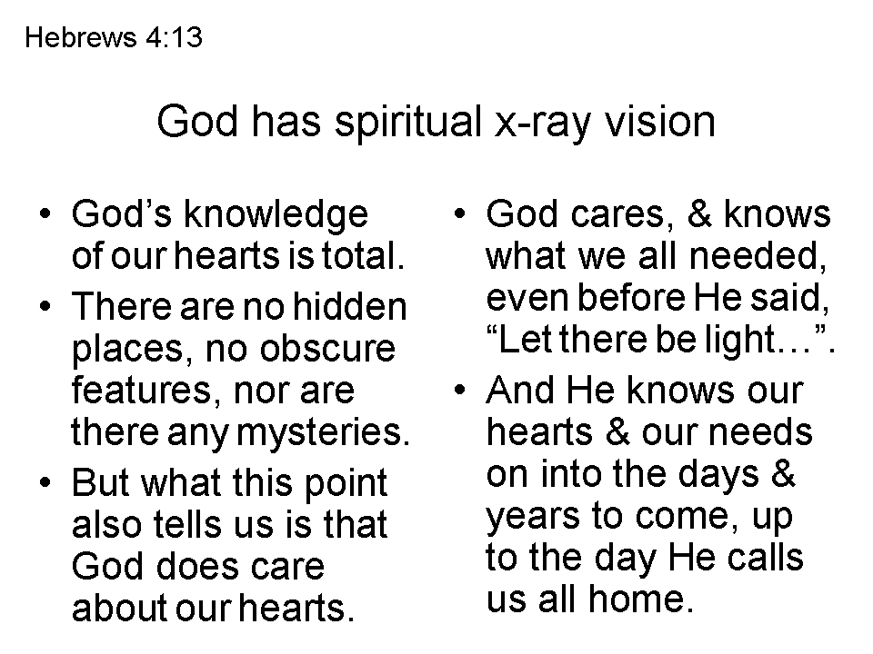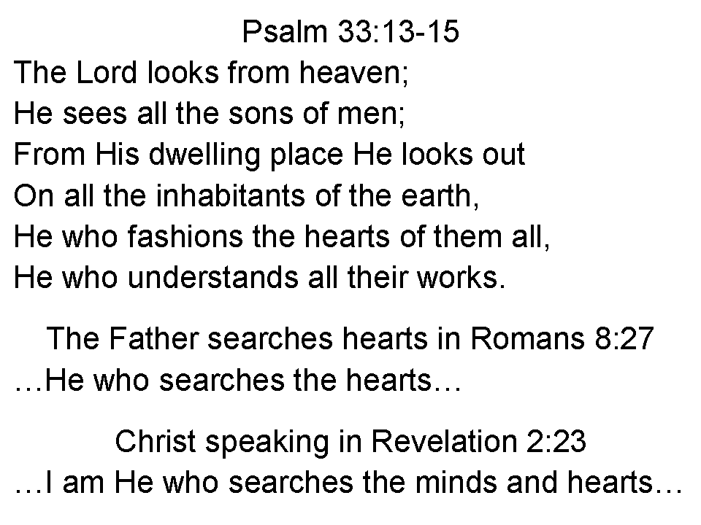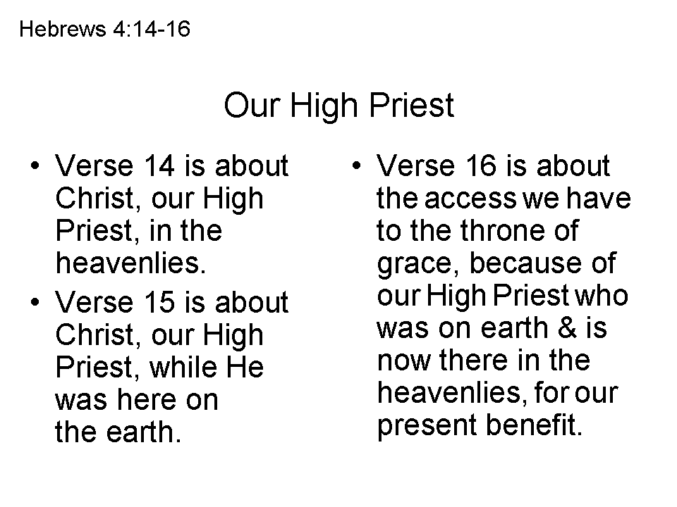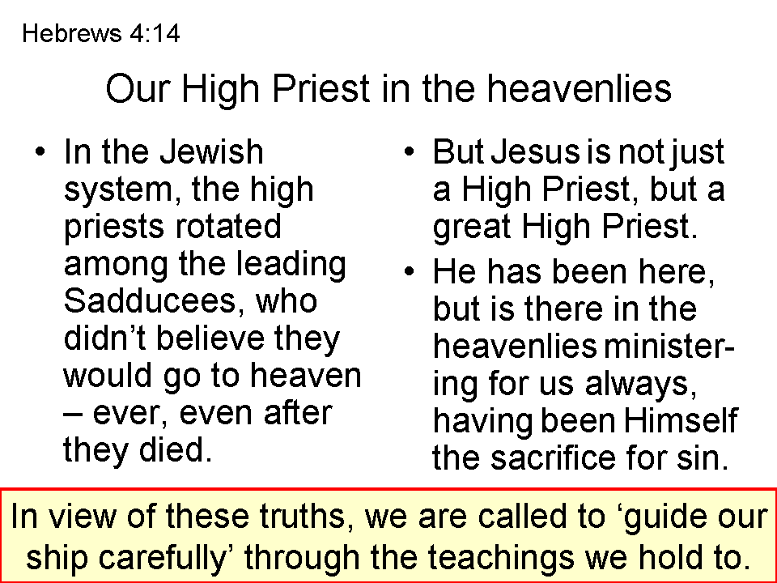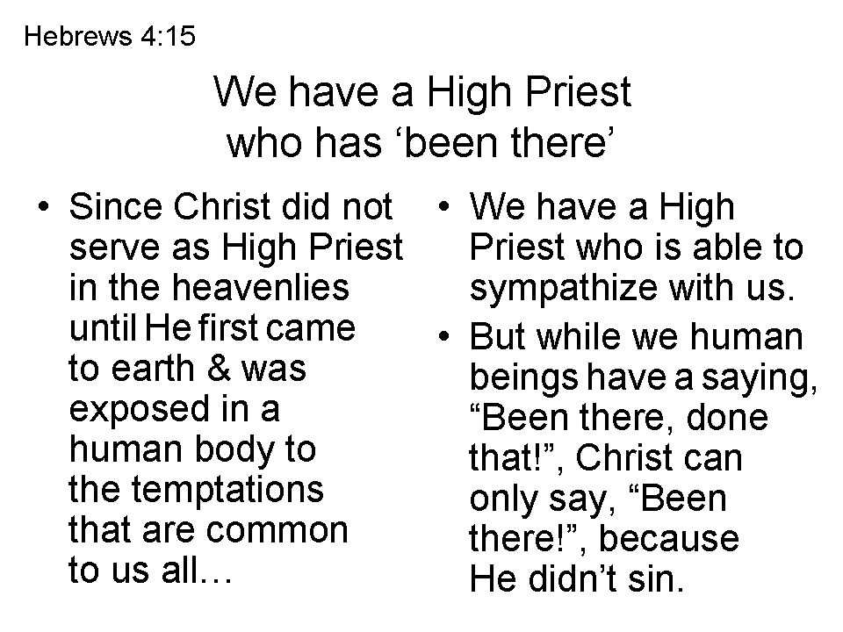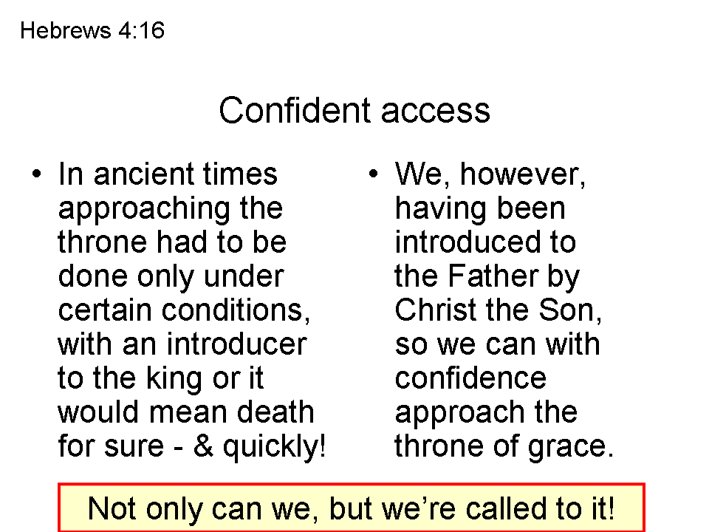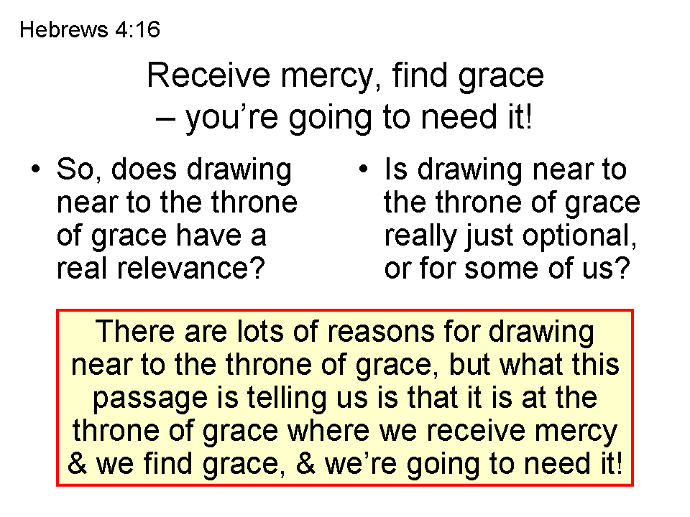
Nautical Terms in the Book of Hebrews (July 12, 2013 update):

Hebrews 2:1
For this reason we must pay much closer attention (prosecho = to fasten an anchor) to what we have heard, so that we do not drift away (pararrhueo = slip past the harbor) from it.

Hebrews 3:6
but Christ was faithful as a Son over His house-- whose house we are, if we hold fast (katecho, as in Acts 27:40) our confidence and the boast of our hope firm until the end.

Hebrews 3:14
For we have become partakers of Christ, if we hold fast (katecho, as in Acts 27:40 and Hebrews 10:23) the beginning of our assurance firm until the end,

Hebrews 4:14
Therefore, since we have a great high priest who has passed through the heavens, Jesus the Son of God, let us hold fast (krateo; the related word perikrateis is used in Acts 27:16 for “running under” as in guiding a ship carefully around) our confession.

Hebrews 6:19-20
This hope we have as an anchor (angkuros, as in Acts 27:29,30 & 40) of the soul, a hope both sure and steadfast (bebaios; see also Hebrews 3:6 & 3:14) and one which enters within the veil, 20 where Jesus has entered as a forerunner for us, having become a high priest forever according to the order of Melchizedek.

Hebrews 10:23
Let us hold fast (katecho, as in Acts 27:40 and Hebrews 3:14) the confession of our hope without wavering, for He who promised is faithful…

Hebrews 10:35
Therefore, do not throw away (apoballo = away + throw = throw something overboard; similar to ekbolen in Acts 27:18) your confidence, which has a great reward.

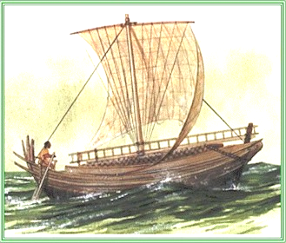
Hebrews 11:7
By faith Noah, being warned by God about things not yet seen, in reverence prepared an ark (kibotos) for the salvation of his household, by which he condemned the world, and became an heir of the righteousness which is according to faith.

Hebrews 13:9
Do not be carried away (paraphero) by varied and strange teachings; for it is good for the heart to be strengthened by grace, not by foods, through which those who were so occupied were not benefited.

Hebrews 13:20
Now the God of peace, who brought up from (anago ek = loosed from the moorings, so as to set sail; anago is used in Acts 27:2, 4, 12 & 21) the dead the great Shepherd of the sheep through the blood of the eternal covenant, even Jesus our Lord…

