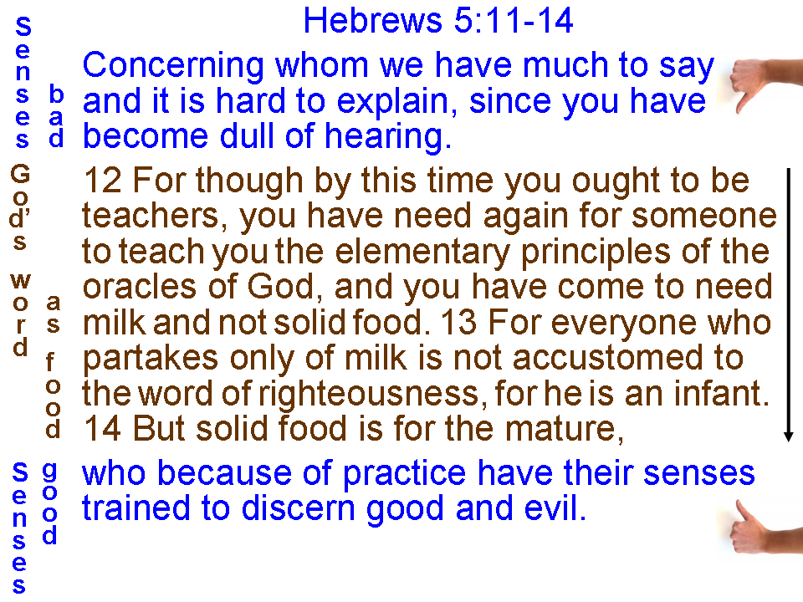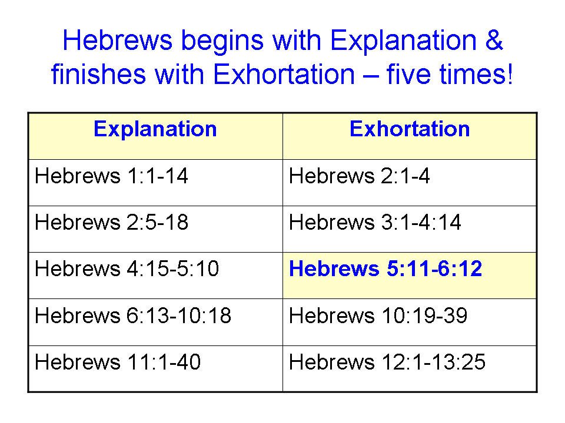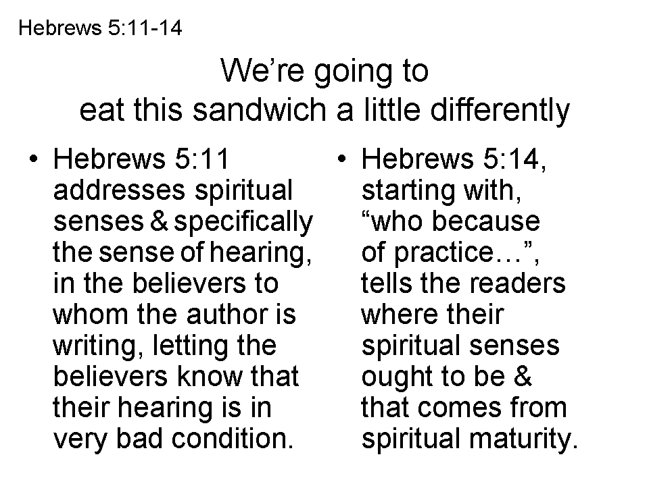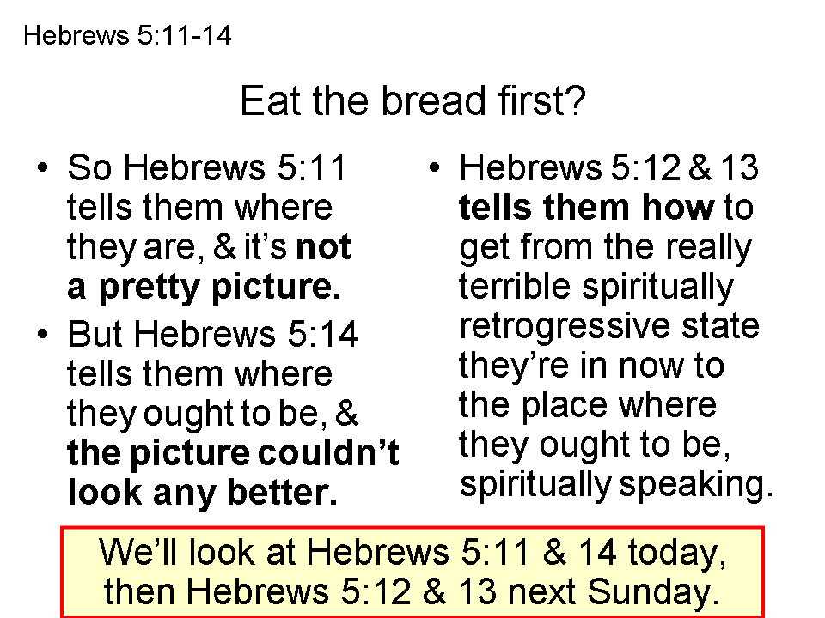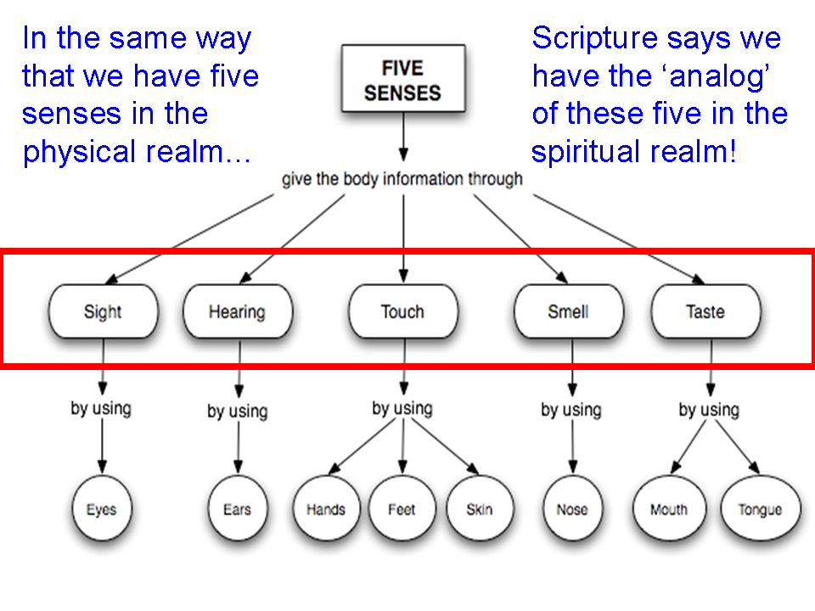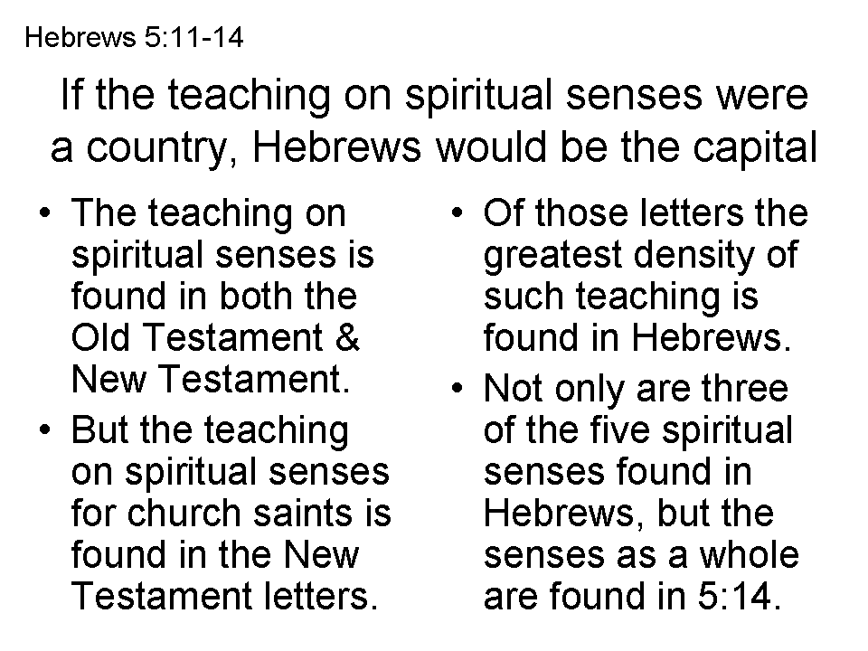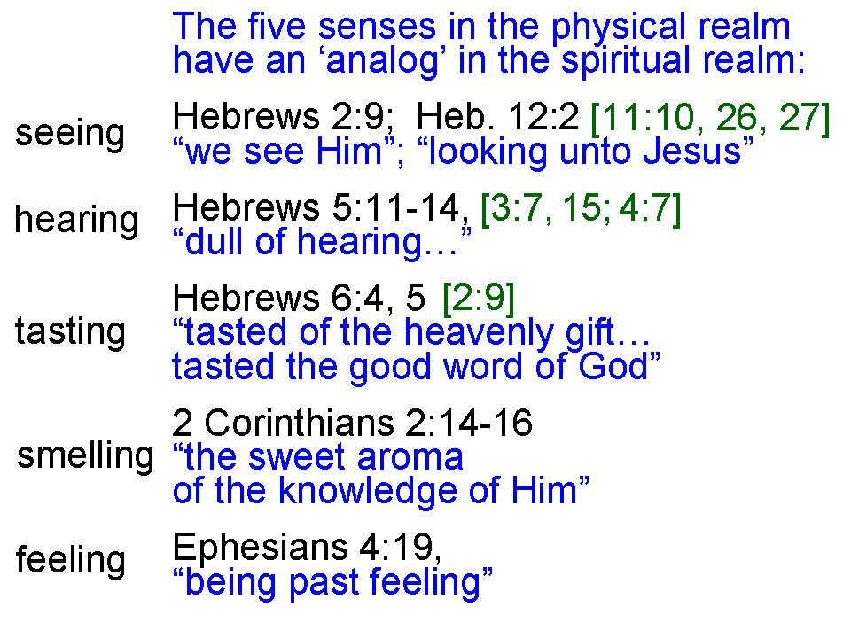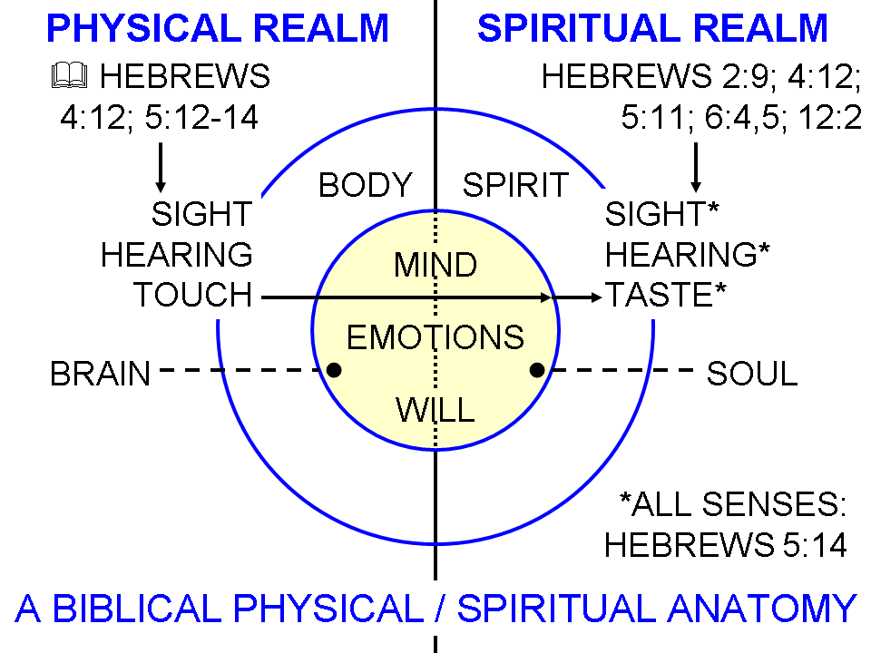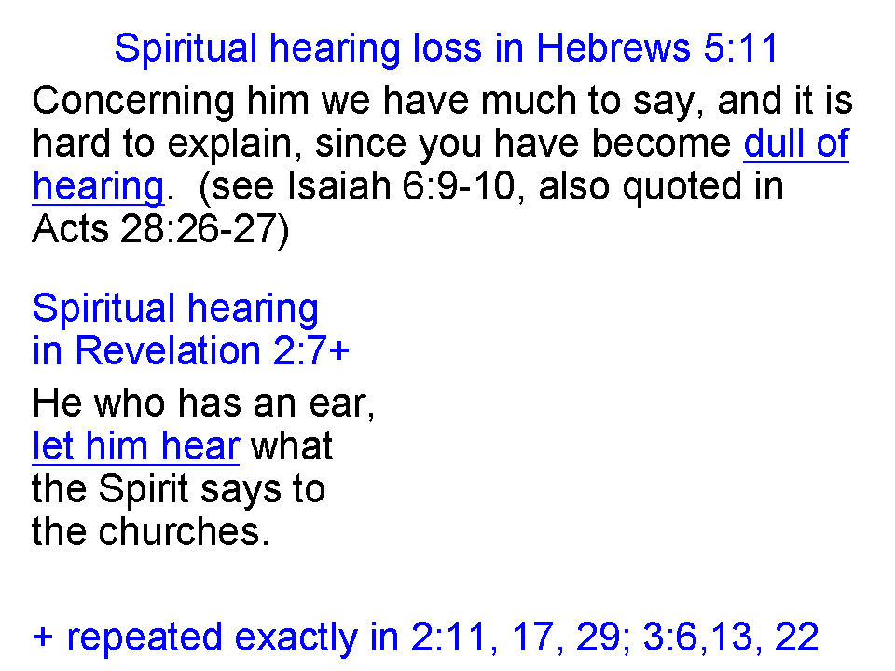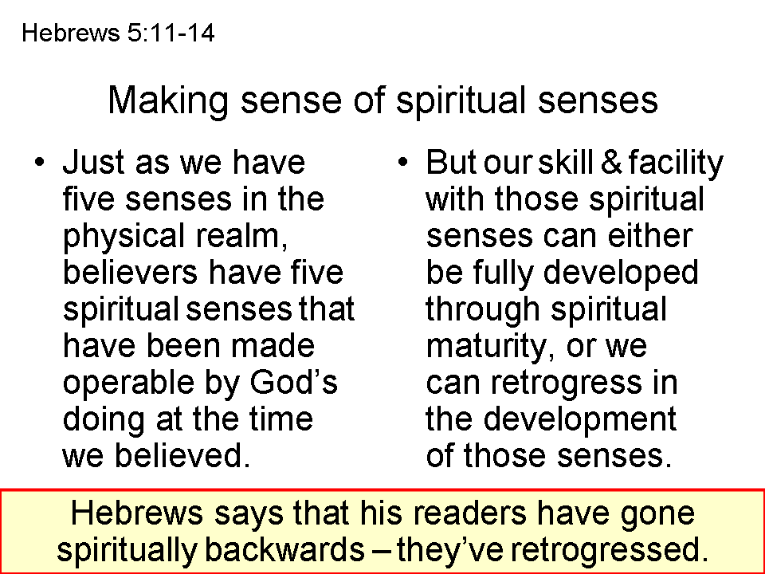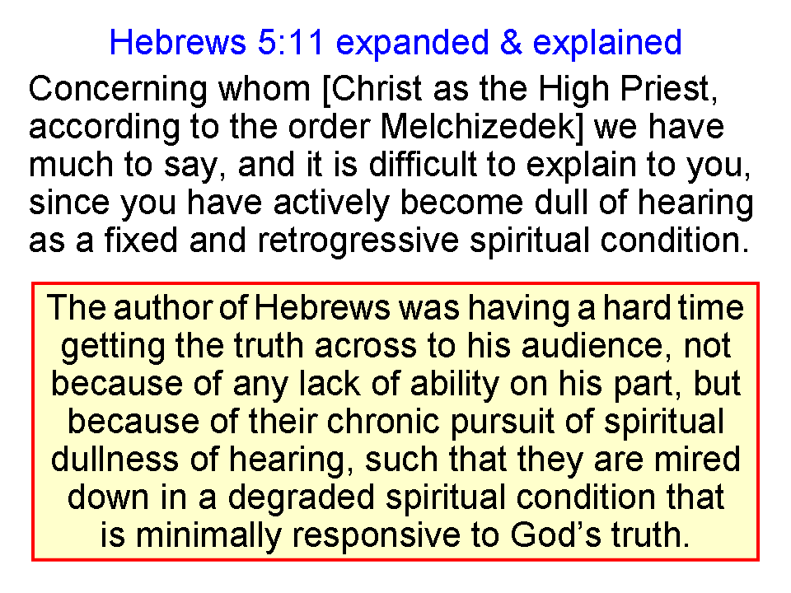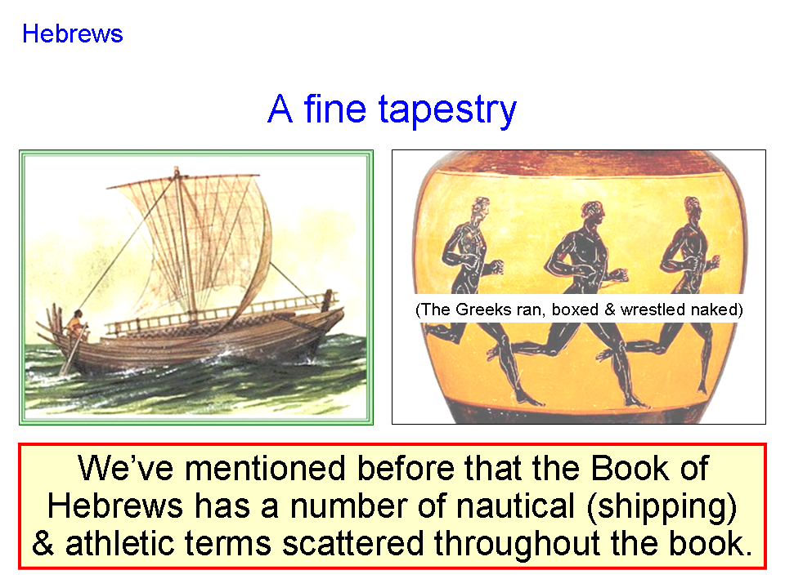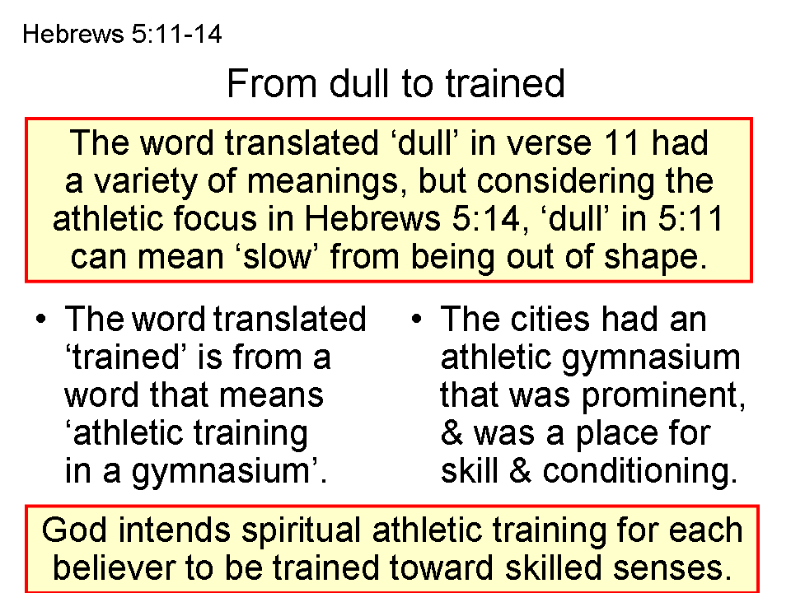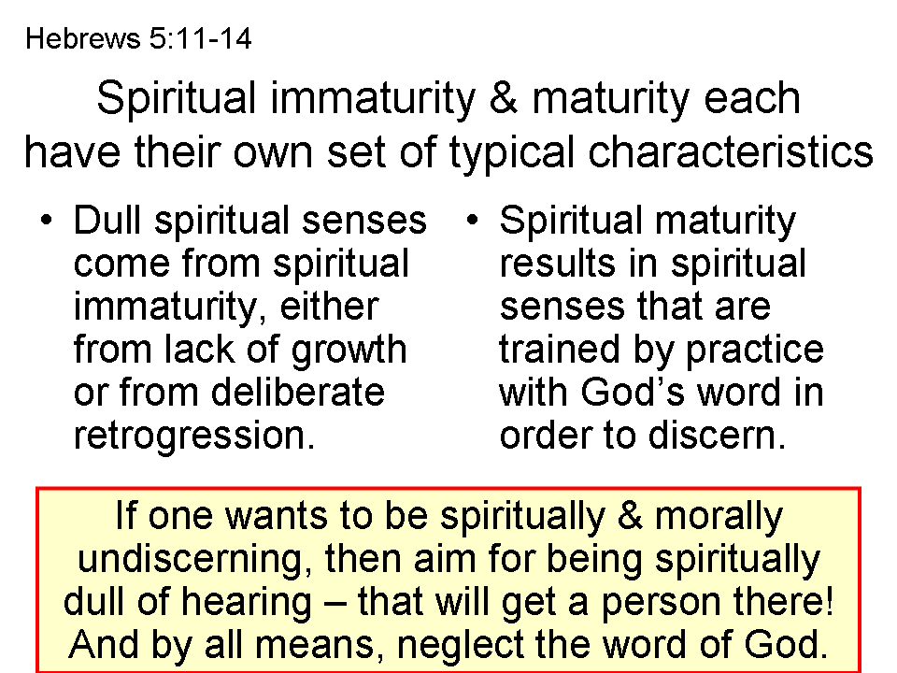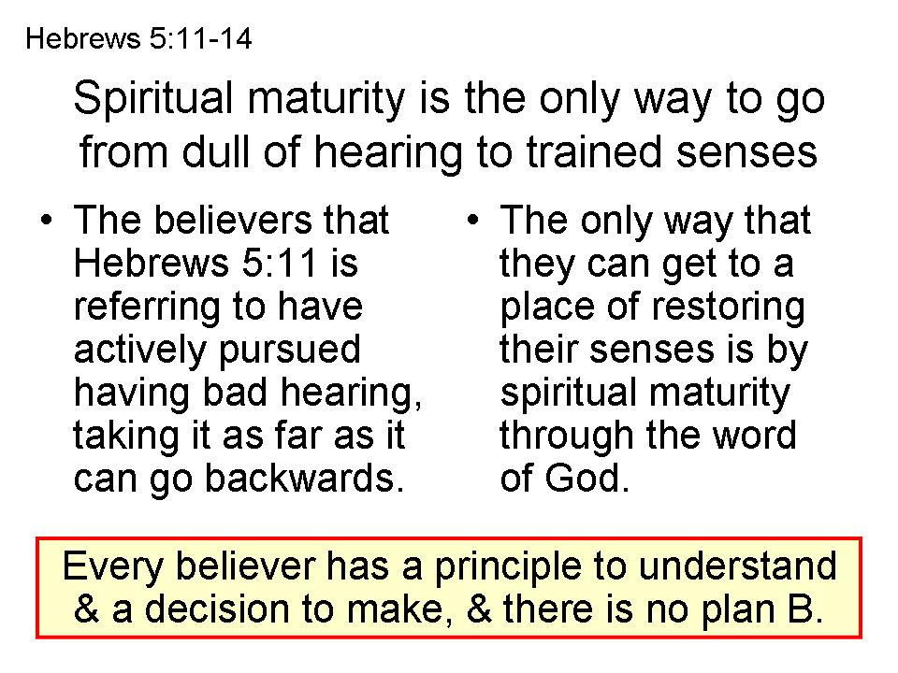
See page 4
Athletic Terms in the Book of Hebrews:

Hebrews 5:14
But solid food is for the mature, who because of practice (hexis = habitual or regular) have their senses trained (gumnazō, from the family of words from which we get the English words gym, gymnasium, and gymnastics; since the Greeks would train for and practice their athletic sports naked, the Greek root of gumnazō, gumnos actually means ‘naked’) to discern good and evil.

Hebrews 12:1-2
Therefore, since we have so great a cloud of witnesses (martus, which typically is used for testimony, but in the athletic context these witnesses also serve as spectators of an athletic event, as in a large amphitheater or stadium; see similar use in 1 Timothy 6:11,12) surrounding us, let us also lay aside every encumbrance (athletic training and competition involved ridding oneself of any excess clothing or body weight, both of which could limit athletic performance; see also Galatians 5:7) and the sin which so easily entangles us, and let us run (trechō; see also 1 Corinthians 9:24,26; Galatians 2:2; 5:7; Philippians 2:16) with endurance (hupomone) the race that is set before (prokeimai) us, 2 fixing our eyes on Jesus (the ‘goal’ in a race was called the skopos, where we get our English word scope; competitors would fix their eyes on that goal, as in Philippians 3:12-14), the author and perfecter of faith, who for the joy set before (also prokeima, as in a race) Him endured (hupomeno, related to hupomone above) the cross, despising the shame, and has sat down at the right hand of the throne of God.

Hebrews 12:11
All discipline for the moment seems not to be joyful, but sorrowful; yet to those who have been trained (gumnazō, as in Hebrews 5:14 above) by it, afterwards it yields the peaceful fruit of righteousness. 12 Therefore, strengthen the hands that are weak and the knees that are feeble, 13 and make straight paths for your feet, so that the limb which is lame may not be put out of joint, but rather be healed.

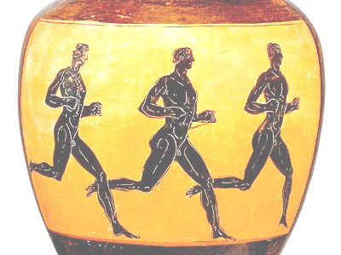
(The Greeks ran, boxed & wrestled naked) ☺

