Nautical Terms in the Book of Hebrews:

Hebrews 2:1
For this reason we must pay much closer attention (prosecho = to fasten an anchor) to what we have heard, so that we do not drift away (pararrhueo = slip past the harbor) from it.

Hebrews 3:6
but Christ was faithful as a Son over His house-- whose house we are, if we hold fast (katecho, as in Acts 27:40) our confidence and the boast of our hope firm until the end.

Hebrews 3:14
For we have become partakers of Christ, if we hold fast (katecho, as in Acts 27:40) the beginning of our assurance firm until the end,

Hebrews 4:14
Therefore, since we have a great high priest who has passed through the heavens, Jesus the Son of God, let us hold fast (krateo; the related word perikrateis is used in Acts 27:16 for “running under” as in guiding a ship carefully around) our confession.

Hebrews 6:19-20
This hope we have as an anchor (angkuros, as in Acts 27:29,30 & 40) of the soul, a hope both sure and steadfast (bebaios; see also Hebrews 3:6 & 3:14) and one which enters within the veil, 20 where Jesus has entered as a forerunner for us, having become a high priest forever according to the order of Melchizedek.

Hebrews 10:35
Therefore, do not throw away (apoballo = away + throw = throw something overboard; similar to ekbolen in Acts 27:18) your confidence, which has a great reward.

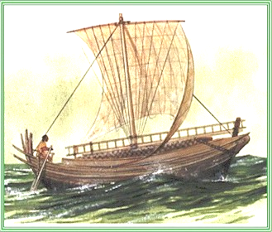
Hebrews 11:7
By faith Noah, being warned by God about things not yet seen, in reverence prepared an ark (kibotos) for the salvation of his household, by which he condemned the world, and became an heir of the righteousness which is according to faith.

Hebrews 13:9
Do not be carried away (paraphero) by varied and strange teachings; for it is good for the heart to be strengthened by grace, not by foods, through which those who were so occupied were not benefited.
Hebrews 13:20
Now the God of peace, who brought up from (anago ek = loosed from the moorings, so as to set sail; anago is used in Acts 27:2, 4, 12 & 21) the dead the great Shepherd of the sheep through the blood of the eternal covenant, even Jesus our Lord,

Athletic Terms in the Book of Hebrews:

Hebrews 5:14
But solid food is for the mature, who because of practice (hexis = habitual or regular exercise) have their senses trained (gumnazō, from the family of words from which we get the English words gym, gymnasium, and gymnastics; since the Greeks would train for and practice their athletic sports naked, the Greek root of gumnazō, gumnos actually means ‘naked’) to discern good and evil.

Hebrews 10:32-33
But remember the former days, when, after being enlightened, you endured a great conflict (athlesis, used of athletic events, especially involving boxing or wrestling) of sufferings, 33 partly by being made a public spectacle through reproaches and tribulations, and partly by becoming sharers with those who were so treated.

Hebrews 12:1-2
Therefore, since we have so great a cloud of witnesses (martus, which typically is used for testimony, but in the athletic context these witnesses also serve as spectators of an athletic event, as in a large amphitheater or stadium; see similar use in 1 Timothy 6:11,12) surrounding us, let us also lay aside every encumbrance (athletic training and competition involved ridding oneself of any excess clothing or body weight, both of which could limit athletic performance; see also Galatians 5:7) and the sin which so easily entangles us, and let us run (trechō; see also 1 Corinthians 9:24,26; Galatians 2:2; 5:7; Philippians 2:16) with endurance (hupomone) the race that is set before (prokeimai) us, 2 fixing our eyes on Jesus (the ‘goal’ in a race was called the skopos, where we get our English word scope; competitors would fix their eyes on that goal, as in Philippians 3:12-14), the author and perfecter of faith, who for the joy set before (also prokeima, as in a race) Him endured (hupomeno, related to hupomone above) the cross, despising the shame, and has sat down at the right hand of the throne of God.

Hebrews 12:11
All discipline for the moment seems not to be joyful, but sorrowful; yet to those who have been trained (gumnazō, as in Hebrews 5:14 above) by it, afterwards it yields the peaceful fruit of righteousness. 12 Therefore, strengthen the hands that are weak and the knees that are feeble, 13 and make straight paths for your feet, so that the limb which is lame may not be put out of joint, but rather be healed.

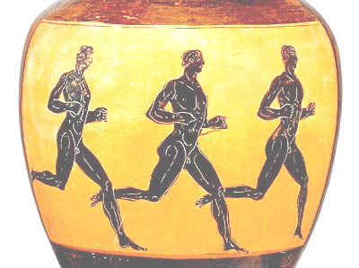
(The Greeks ran, boxed & wrestled naked) ☺

