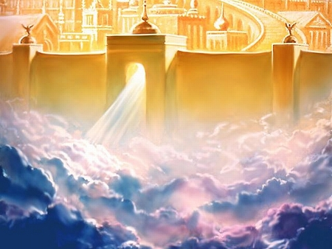
Present Heaven

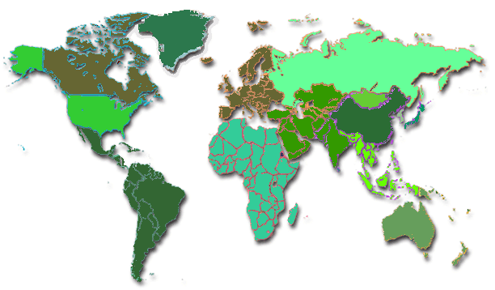
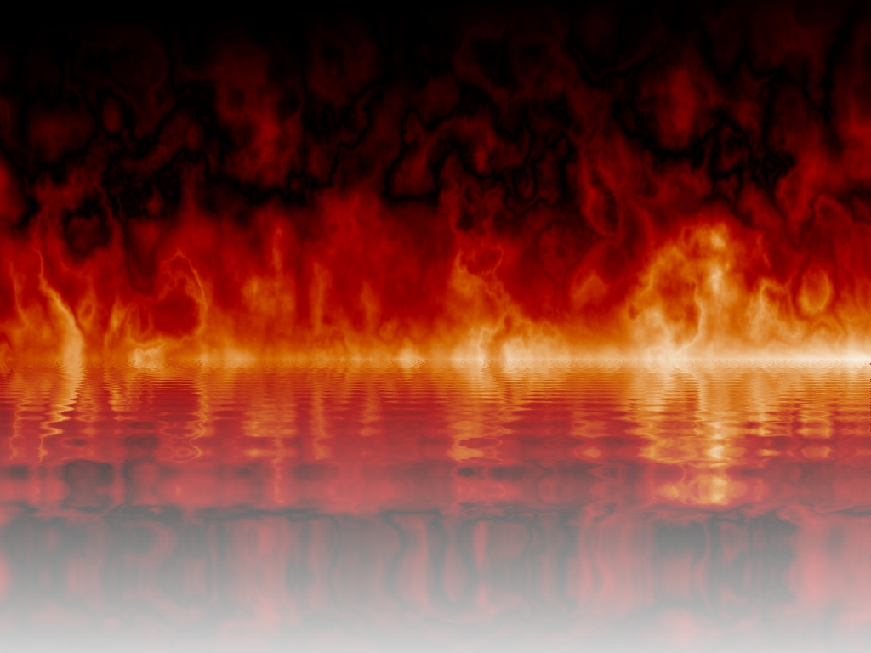
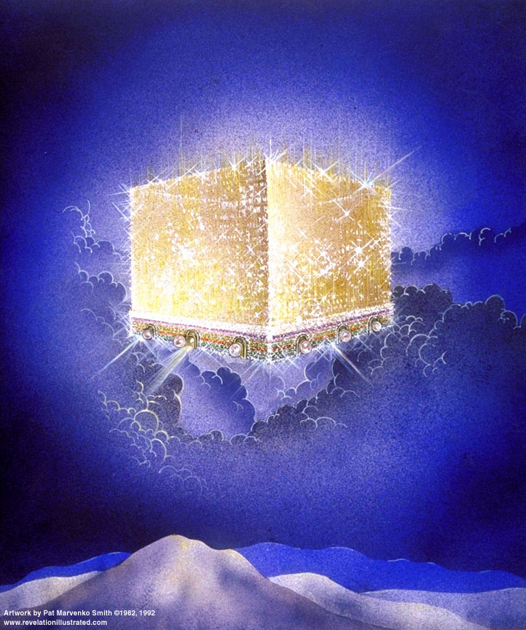
New Heaven & New Earth
Present Earth
Lake of Fire
7 Year Tribulation
1000 Year Kingdom
Present Era = ‘this age’
Rapture of the Church, 1st those asleep in Christ, then those who remain
2nd Coming of Christ with the Church, saints of all prior times, angels
The Beast & The False Prophet, & those who receive the mark of the Beast
Saints who die during the Kingdom
The Great White Throne Judgment: the rest of the unsaved of all time
Satan & all fallen angels (demons)
Saved of all time: Church, Israel, Gentiles
Christ, resurrected saints & earthly saints

