Introduction to the Gospel of John

The gospel of John is the fourth of the four gospels, written by the apostle John, likely about 85-90 AD. While the gospel of John presents some accounts in parallel with the other three gospels, it also has much that is unique. All four gospels describe Christ in His first coming, but John does so in some different ways, as we will see.

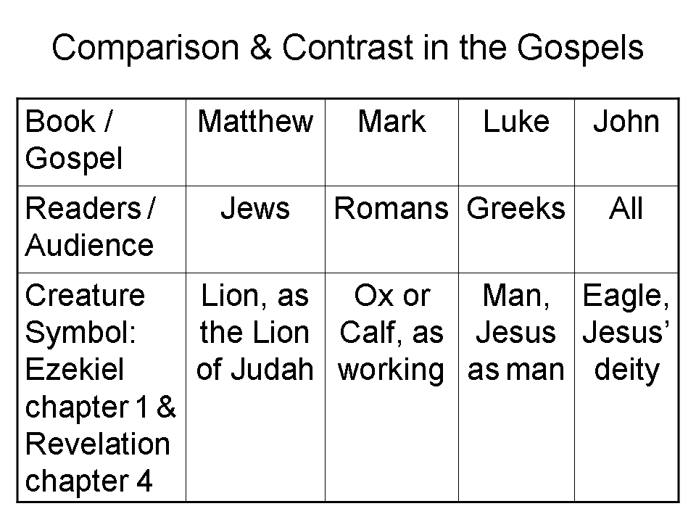
John and his brother James (actually ‘Jacob’) were the sons of Zebedee (Matthew 4:21). At one point their mother asked that they have special honors (Matthew 20:20). As John wrote, he called himself ‘the disciple whom Jesus loved’ (John 13:23; 20:2; 21:7; 21:20).
John’s brother, James, was the first of the apostles to die (Acts 12:1,2), and John was the last to die. So far as we know, John was the only disciple to die a natural death.

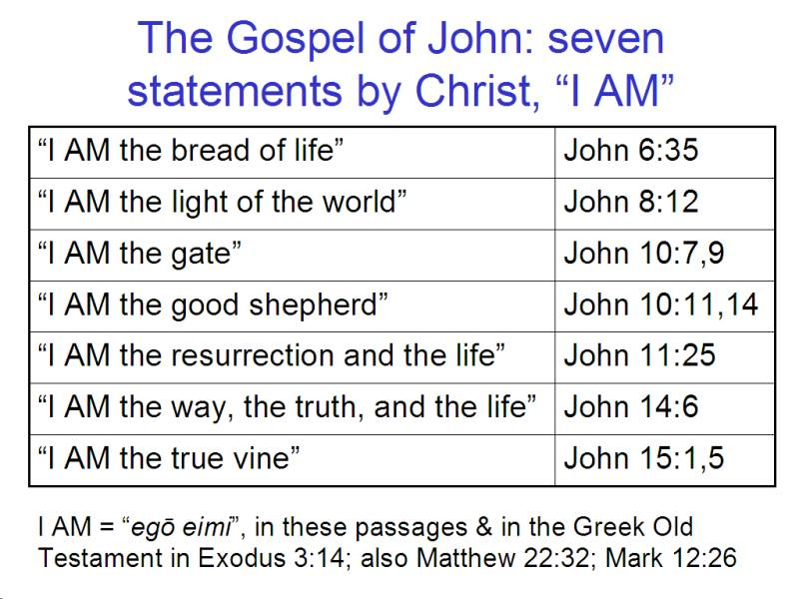
Both in the gospel of John and in the book of Revelation, also written by John, there is a pattern of sevens. For instance, in the gospel of John there are seven metaphorical statements of ‘I AM’ by Christ, and with multiple statements of the same claim, these totaling 23 times. The significance of these statements is that ‘I AM (Greek: egō eimi) is used in the Greek Old Testament by God Himself (Exodus 3:14; Isaiah 43:3,
et al). So Christ makes multiple claims to be God in the gospel of John, in addition to accepting worship, which is not allowed for another person or an angel (John 20:28; Revelation 19:10; 22:8).

In addition to the seven, ‘I AM’ metaphors, Jesus also performs seven miracles or signs in the Gospel of John:

- Turns water into wine at the wedding in Cana (John 2:1-12)
- Heals a nobleman’s son (4:46-54)
- Heals a lame man at the pool of Bethesda (John 5:1-17)
- Feeds 5000 near the sea of Galilee (John 6:1-14)
- Walks on water and stills the storm (John 6:15-21)
- Heals a man blind from birth (John 9:1-41)
- Raises Lazarus from the dead (John 11:17-45)

John also calls Christ ‘the Lamb’, as he does in the book of Revelation numerous times:

John 1:29 (NASU)
The next day he saw Jesus coming to him and said, "Behold, the Lamb of God who takes away the sin of the world!

John 1:35-36 (NASU)
Again the next day John was standing with two of his disciples, 36 and he looked at Jesus as He walked, and said, "Behold, the Lamb of God!"

The apostle John seems to have some unique connections to the Sanhedrin and the priestly class. Only John mentions Nicodemus, one of the Sanhedrin, and also Joseph of Arimathea, also of the Council (John 3:1, 4, 9; 7:50-52; 19:39). Nicodemus is named when he comes to Jesus by night, when he attempts to defend Jesus before the Sanhedrin, and at Jesus’ burial after Christ was crucified. John also, not naming himself, but calling himself ‘another disciple’, ‘that disciple’ or ‘the other disciple’, was able to get Peter into the courtyard of the high priest, and he was known by the high priest:

John 18:15-16 (NASU)
Simon Peter was following Jesus, and so was another disciple. Now that disciple was known to the high priest, and entered with Jesus into the court of the high priest, 16 but Peter was standing at the door outside. So the other disciple, who was known to the high priest, went out and spoke to the doorkeeper, and brought Peter in.

Though it is not known explicitly, some have suggested that John was a priest, and that might explain why John would have such connections among the Sanhedrin. But there may be other reasons why John had such religious/political connections and insights.

In John 14-16 Jesus tells a great deal about the ministry that is to be in the near future, and the Holy Spirit’s involvement in it, but the disciples seem to understand little about it until much later. The apostle John records the longest prayer of Christ by far, in John 17, which is to the Father. He prays to the Father for Himself, for His disciples, and for all who will believe.

As he also does in the book of Revelation, John records the purpose of his writing:

John 20:30-31 (NASU)
Therefore many other signs Jesus also performed in the presence of the disciples, which are not written in this book; 31 but these have been written so that you may believe that Jesus is the Christ [the Messiah], the Son of God; and that believing you may have life in His name.

Indeed, to believe is a key theme of the gospel of John, as is life. Believing is the key to life (John 3:16; 5:24; 11:25; 20:31). Belief comes first, then life.

John is the one of the four gospels that includes identification truths. He does not explain the identifications, but they are included within the gospel of John. These would include:

John 8:21-25 (NASU; See also 1 Corinthians 15:17 and Ephesians 2:1.)
Then He said again to them, "I go away, and you will seek Me, and will die in your sin; where I am going, you cannot come." 22 So the Jews were saying, "Surely He will not kill Himself, will He, since He says, 'Where I am going, you cannot come'?" 23 And He was saying to them, "You are from below, I am from above; you are of this world, I am not of this world. 24 "Therefore I said to you that you will die in your sins; for unless you believe that I am He, you will die in your sins."

John 15:1-11 (NASU, except for ‘lifts up’)
I am the true vine, and My Father is the vinedresser. 2 "Every branch in Me that does not bear fruit, He lifts up; and every branch that bears fruit, He prunes it so that it may bear more fruit. 3 "You are already clean because of the word which I have spoken to you. 4 "Abide in Me, and I in you. As the branch cannot bear fruit of itself unless it abides in the vine, so neither can you unless you abide in Me. 5 "I am the vine, you are the branches; he who abides in Me and I in him, he bears much fruit, for apart from Me you can do nothing. 6 "If anyone does not abide in Me, he is thrown away as a branch and dries up; and they gather them, and cast them into the fire and they are burned. 7 "If you abide in Me, and My words abide in you, ask whatever you wish, and it will be done for you. 8 "My Father is glorified by this, that you bear much fruit, and so prove to be My disciples. 9 "Just as the Father has loved Me, I have also loved you; abide in My love. 10 "If you keep My commandments, you will abide in My love; just as I have kept My Father's commandments and abide in His love. 11 "These things I have spoken to you so that My joy may be in you, and that your joy may be made full.

John 17:20-23
"I do not ask on behalf of these alone, but for those also who believe in Me through their word; 21 that they may all be one; even as You, Father, are in Me and I in You, that they also may be in Us, so that the world may believe that You sent Me.

22 "The glory which You have given Me I have given to them, that they may be one, just as We are one; 23 I in them and You in Me…

As an inspired book, we are about to behold the Lord though His word, and thereby be transformed, and be impacted deeply (John 1:18; 2 Corinthians 3:18; Hebrews 4:12).

