John 1:35-51

The events and conversations that follow began the very next day after the events and words of John 1:19-34, involving John the Baptist.

John 1:35-36
Again the next day John was standing with two of his disciples, 36 and he looked upon Jesus as He walked, and said, "Behold, the Lamb of God!"

John had many disciples, and both John and His disciples continue to show up in the four Gospels and the book of Acts (Acts 10:37; 13:24, 25; 18:25). But these two disciples are not just any disciples of John the Baptist, as we will soon see.

Rabbis and disciples had formed a strong complimentary tradition in Israel in the couple of centuries before the time of the New Testament. John the Baptist, Jesus, and Christian church leaders through the book of Acts had followers who were called ‘disciples’. These all followed some of the traditions of the rabbis and disciples in Judaism, but each of these also did and said some things that were not according to the Jewish traditions, which is one reason why the leaders of the Jews questioned all these and objected to them – sometimes violently.

As John had said the day before, he proclaimed, “Behold the Lamb of God”. We talked about the meaning of this proclamation when John said it in John 1:29. Why would John say this more than once? Is there more than one reason why he would repeat it? Do we behold the Lamb of God in a way that is different from what John intended when he said it to his disciples?

John 1:37-39
And the two disciples heard him speak, and they followed Jesus. 38 And Jesus turned, and beheld them following, and said to them, "What do you seek?" And they said to Him, "Rabbi (which translated means Teacher), where are You staying?" 39 He said to them, "Come, and you will see." They came therefore and saw where He was staying; and they stayed with Him that day, for it was about the tenth hour.

So these two disciples, who had been disciples of John the Baptist, heard John say, “Behold the Lamb of God”, they immediately pursued Jesus, beginning by asking Him where he was staying, addressing him as ‘Rabbi’ (Teacher’). John the Baptist was not considered a rabbi, but Jesus was considered a rabbi. Jesus turns these two disciples’ inquiry into an invitation, “Come and you will see”. So they did stay with him for that day. Next we will find out who these two disciples are and what they believe about Jesus.

John 1:40-42
One of the two who heard John speak, and followed Him, was Andrew, Simon Peter's brother. 41 He found first his own brother Simon, and said to him, "We have found the Messiah" (which translated means Christ). 42 He brought him to Jesus. Jesus looked at him, and said, "You are Simon the son of John; you shall be called Cephas" (which is translated Peter).

We have found that one of the two disciples is Andrew, the brother of Peter. It was Andrew who found Peter and told him, “We have found the Messiah”.

- Hebrew: Ha’Mashiach (meaning, ‘The Anointed One’)
- Greek form of the Hebrew is ‘Messiah’
- Greek word for ‘Anointed One’ is Christos

When Peter was brought to Jesus, Jesus told him that he was Simon the son of John. Peter means ‘stone’, and the Aramaic word for ‘stone’ is Kephas. Most translations carry this over as ‘Cephas’. So Peter has three names, sometimes put together as Simon Peter, and sometimes additionally qualified as the son of John.

John 1:43-44
The next day He purposed to go forth into Galilee, and He found Philip. And Jesus said to him, "Follow Me." 44 Now Philip was from Bethsaida, of the city of Andrew and Peter.

Peter, Andrew and Philip were all from Bethsaida (John 12:21), on the northeast part of the sea of Galilee. Peter pursued Philip, and Jesus invited Philip to be His disciple with, “Follow Me”. That was an invitation for Philip to be Christ’s disciple.

John 1:45-51
Philip found Nathanael and said to him, "We have found Him of whom Moses in the Law and also the Prophets wrote, Jesus of Nazareth, the son of Joseph." 46 And Nathanael said to him, "Can any good thing come out of Nazareth?" Philip said to him, "Come and see." 47 Jesus saw Nathanael coming to Him, and said of him, "Behold, an Israelite indeed, in whom is no guile!" 48 Nathanael said to Him, "How do You know me?" Jesus answered and said to him, "Before Philip called you, when you were under the fig tree, I saw you." 49 Nathanael answered Him, "Rabbi, You are the Son of God; You are the King of Israel." 50 Jesus answered and said to him, "Because I said to you that I saw you under the fig tree, do you believe? You shall see greater things than these." 51 And He said to him, "Truly, truly, I say to you, you shall see the heavens opened, and the angels of God ascending and descending on the Son of Man."

The disciples were involved in passing the message:

Andrew > Peter > Philip > Nathanael

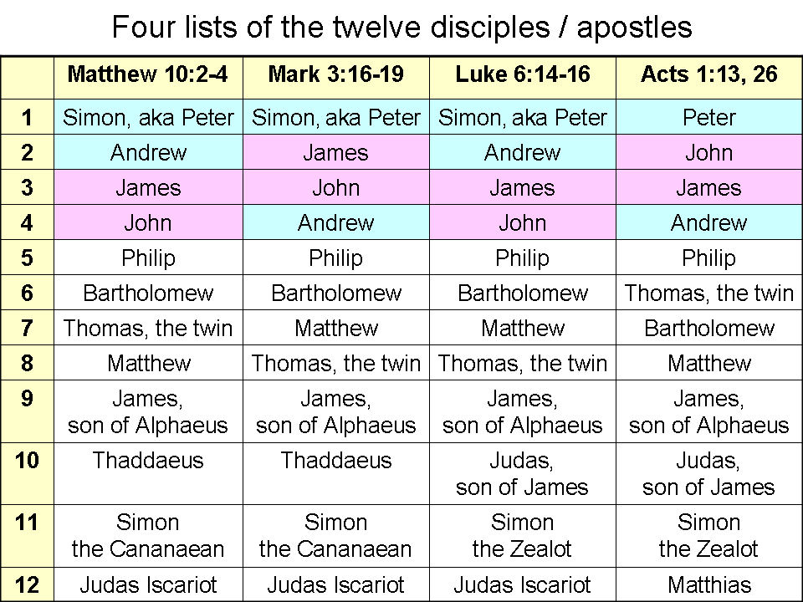
Matthew, Mark, Luke and Acts each have a list of the disciples. John does not have a list of the disciples, but he does provide some unique insights into the disciples. While the other gospels do not list Nathanael, John does, and even provides some unique insights.

Here are some key identifications and clarifications regarding the apostles’ names:

- Peter & Andrew were brothers, as were James & John, the first one listed likely being the older of the two.
- Thaddaeus is another man with two names (Judas, son of Alphaeus), and not the same as Judas the betrayer.
- John calls Bartholomew ‘Nathanael’.
- Simon the Cananaean is the same man as Simon the Zealot, since ‘Cananaean’ is simply the Aramaic word for ‘Zealot’.

Andrew being under a fig tree presents a long-standing Old Testament picture of safety, security, and harmony with fellow Jews (1 Kings 4:25; Micah 4:4; Zechariah 3:10). Angels ascending and descending comes out in one Old Testament passage:

Genesis 28:10-17
Then Jacob departed from Beersheba and went toward Haran. 11 And he came to a certain place and spent the night there, because the sun had set; and he took one of the stones of the place and put it under his head, and lay down in that place. 12 And he had a dream, and behold, a ladder was set on the earth with its top reaching to heaven; and behold, the angels of God were ascending and descending on it. 13 And behold, the Lord stood above it and said, "I am the Lord, the God of your father Abraham and the God of Isaac; the land on which you lie, I will give it to you and to your descendants. 14 Your descendants shall also be like the dust of the earth, and you shall spread out to the west and to the east and to the north and to the south; and in you and in your descendants shall all the families of the earth be blessed. 15 And behold, I am with you, and will keep you wherever you go, and will bring you back to this land; for I will not leave you until I have done what I have promised you." 16 Then Jacob awoke from his sleep and said, "Surely the Lord is in this place, and I did not know it." 17 And he was afraid and said, "How awesome is this place! This is none other than the house of God, and this is the gate of heaven."

So what does this reveal about Jesus as the Son of God?

How many ‘names’ does Jesus have in the first chapter of the gospel of John? What are they – in sequence?

________________ ________________
________________ ________________
________________ ________________
________________ ________________
________________ ________________
________________ ________________
________________ ________________
________________ ________________
________________ ________________
________________ ________________

All Scripture quotations are from the New American Standard Version unless otherwise noted.
The word ‘disciple’, as used in the New Testament, is actually of pagan origin, being used of those who were being trained as pagan priests in the several centuries before New Testament times. Like many Greek words used in the New Testament, ‘disciple’ was a word in common pagan usage that was adapted for Christian use. Grace was another term that was used in the pagan culture but adapted for Christian use, and having a different meaning under Christian use. Christians will sometimes attempt to persuade other Christians to avoid using a word, following a tradition, or observing a holiday by pointing to its pagan roots. While it may be well intended, that is not biblically valid. What matters is the present use and meaning of the word, tradition, holiday, etc. and not the past use and meaning. When we say that we worship the Lord on Sunday, we don’t mean that we worship the Sun god on that day. When we celebrate Christmas, we are not even thinking of celebrating the Roman Saturnalia. A word’s root or historical meaning in prior times should also not be used to derive or gain insight into the present meaning of a word. That is also a fallacy.
‘Rabboni’ in Aramaic (John 20:16).

