John 2:13-25

This passage is about the first Passover in the time of Jesus’ ministry, as well as the first cleansing of the temple in Jesus’ ministry. Jesus had previously gone every year to the Passovers in Jerusalem with His parents, Joseph and Mary, and it was at the Passover that Jesus, at the age of twelve, remained behind at the temple, listening to the teachers and asking questions (Luke 2:41-50). Though this passage tells us about the first Passover and cleansing of the temple in the time of Jesus’ ministry, it was not the last of either one. The last cleansing of the temple would also be at Passover time, and it is recorded, not in the gospel of John, but in the Gospel of Matthew (Matthew 21:12-17).

Below is a graphical representation of the Hebrew calendar. Passover and the Feast of Unleavened Bread were related feasts, both taken from Exodus 12 in the Law of Moses. The day of Passover (from sundown to sundown) began the Feast of Unleavened Bread, these holidays together lasting seven days.
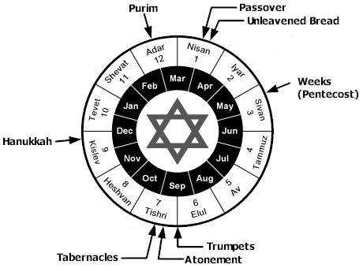

Passover was observed as a combination of those things that were spelled out in Exodus 12 and subsequent Old Testament passages, as well as centuries of accumulated Jewish tradition. Jesus’ final Passover with the disciples is recorded in John chapter 13 and following chapters, which differs in character and content from the other Passovers during Jesus’ ministry. We will examine that last Passover in great detail in the months ahead, starting in about July, since John covers the events and discourse of that evening in substantial detail, and there is much that is unique to the Gospel of John.

This page to be replaced by map of Israel in New Testament times.
John 2:13
The Passover of the Jews was near, and Jesus went up to Jerusalem.

Jewish Feasts in the Gospel of John
Name of Feast | Reference in John | Time Celebrated
Passover | 2:13, 23 | April 7, A.D. 30
“A feast of the Jews” | 5:1 | October 21-28, A.D. 31?
Passover | 6:4 | April 13/14, A.D.32
Tabernacles (Booths) | 7:2 | September 10-17, A.D.32
Dedication (Hanukkah) | 10:22 | December 18-25, A.D. 32
Passover | 11:55, 12:1 | April 3, A.D.33

A great many Jews from Galilee would travel along the Jordan River down to Jericho, then take the steep climb up to Jerusalem, in order to avoid going through Samaria, home of the despised Samaritans. See map of Israel in New Testament times on the previous page. Here are the elevations of each of the key locations:

- Sea of Galilee: about 693 feet below sea level – varies seasonally & from year to year
- Jericho: about 1200 feet below sea level – varies by location in and around Jericho
- Jerusalem: about 2500 feet above sea level – varies by location in Jerusalem
- Mount of Olives: about 2700 feet above sea level at the top

So the climb from Jericho to Jerusalem was more than 3500 feet in elevation, which would explain why it was written that Jesus went up to Jerusalem – it was definitely ‘up’, even from the Sea of Galilee, and especially ‘up’ from Jericho. And the highest point of the climb would be about 2700 feet above sea level, at the top of the Mount of Olives.

John 2:14-16
And He found in the temple those who were selling oxen and sheep and doves, and the money changers seated at their tables. 15 And He made a scourge of cords, and drove them all out of the temple, with the sheep and the oxen; and He poured out the
coins of the money changers and overturned their tables; 16 and to those who were selling the doves He said, "Take these things away; stop making My Father's house a place of business."
The temple mount was built up against the eastern wall of the City of Jerusalem. The ones selling oxen and sheep and doves and changing money operated in what is shown as the Court of the Gentiles (see below).

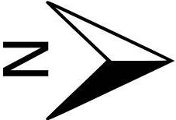
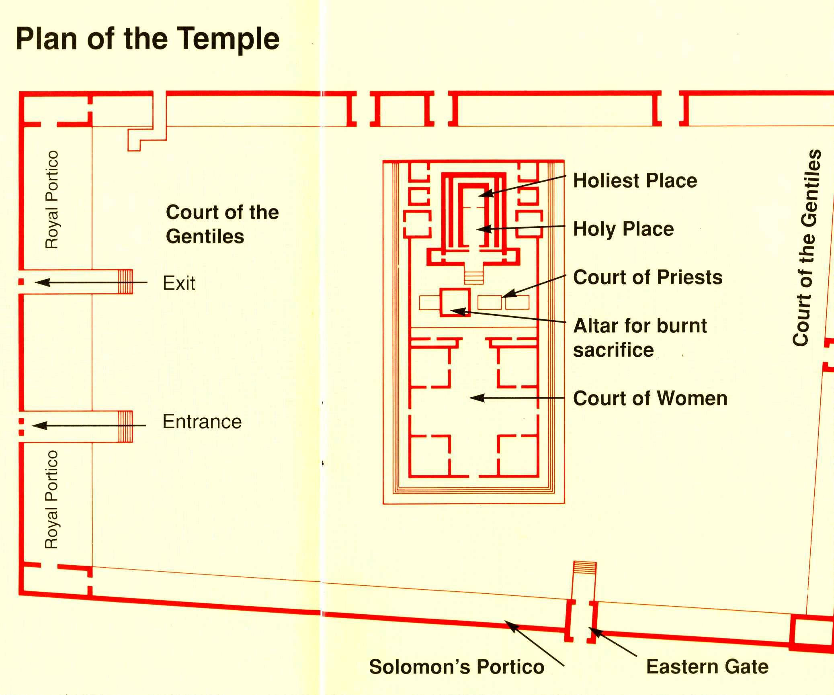
The oxen and sheep were needed for various kinds of sacrificial offerings (Exodus 20:24; 22:30; 24:5; Leviticus 1:3-9; 4:2-21; 8:2; 22:21). Doves were required for the purification of woman, for those who could not afford a larger and more expensive sacrificial animal (Leviticus 12:6, 8; Luke 2:22-24). The doves were also to fulfill the Law of Moses for those to be cleansed of certain kinds of skin diseases (14:22), and other purposes (15:14, 29). So those selling the animals provided a convenience for those traveling a great distance, in that they would not have to bring the animals as they traveled, and for those who lived in or near Jerusalem who did not have a place to raise animals. There the Court of the Gentiles had corrals and cages, and aside from those buying and selling, there was also a constant flow of food in and animal urine and droppings to be taken out.

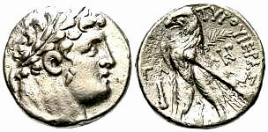
Additionally, the Jews were required to pay a half shekel per person per year as a temple tax (Exodus 30:11-16). The only problem was that there was no half shekel coin issued by New Testament times and no other coin than the shekel was allowed. What had been allowed was the Tyrian shekel, which paid the tax for two people (Matthew 17:24-27). Consequently, no matter what coins anyone had, unless they had a Tyrian shekel (see left), they were going to need to get their money changed in order to pay the temple tax. So that is the reason for the money changers to be in the general vicinity of the temple. By the way, do you see a conflict between what is on the Tyrian shekel and the Law of Moses?

The Law required the products and, it would seem, services that these merchants had to offer. But the Court of the Gentiles was an area that allowed the Gentiles to come and take part in discussions and to worship God from as close as they were allowed. So what the merchants were doing was business in the outer courts of the temple, as well as obstruction and interference with the worship of God by the Gentiles for the sake of business. Wasn’t it possible to conduct this business just outside the temple courtyard and the temple mount?

John 2:17
His disciples remembered that it was written, "Zeal for Your house will consume me."

The verse that the disciples were remembering is Psalm 69:9a. It is a Psalm of David.

John 2:18-19
The Jews then said to Him, "What sign do You show us as your authority for doing these things?" 19 Jesus answered them, "Destroy this temple, and in three days I will raise it up."

The Jewish leaders had allowed this practice of using the temple courtyard as a place of business, and may even have approved it and derived revenue from it (a ‘cut’ as we would say). As usual, the Jews ask for Jesus to give them a sign to indicate that He has authority to drive out these businessmen and their merchandise. This seeking for a sign is such a major theme among the Jews that each of the four gospels records some discourse about signs multiple times. Indeed, in 1 Corinthians 1:22 Paul wrote, “For indeed Jews ask for signs…”

But while Jesus did (John 2:11) and will give signs (John 2:19), He is not inclined to satisfy those who will not believe anyway. So He tells them about the sign He will give them in three years, which they don’t immediately seem to understand, thinking that He is talking about the temple building.

John 2:20
The Jews then said, "It took forty-six years to build this temple, and will You raise it up in three days?"

The Jews, evidently not understanding Jesus’ reference to His own body as ‘this temple’, say that it took 46 years to build this temple. In fact, the temple reconstruction had been started begun years before, had a few brief periods of inactivity, and would not be complete until 63 AD.

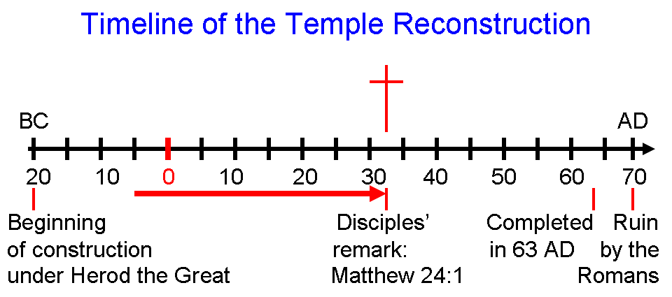

John 2:21-22
But He was speaking of the temple of His body. 22 So when He was raised from the dead, His disciples remembered that He said this; and they believed the Scripture and the word which Jesus had spoken.

Jesus said something here in chapter 2 that the disciples would clearly not understand for more than three more years, in spite of Jesus repeatedly telling them that He would be crucified, die and be resurrected. His disciples remembered because, as is recorded in John 14:26, "But the Helper, the Holy Spirit, whom the Father will send in My name, He will teach you all things, and bring to your remembrance all that I said to you."

John 2:23-25
Now when He was in Jerusalem at the Passover, during the feast, many believed in His name, observing His signs which He was doing. 24 But Jesus, on His part, was not entrusting Himself to them, for He knew all men, 25 and because He did not need anyone to testify concerning man, for He Himself knew what was in man.

Some who initially believed on Him turned against Him later (John 6:15, 60, 66), so their belief was not sincere. About Jesus knowing the hearts of men, we have these insights.

Psalm 44:21
Would not God find this out? For He knows the secrets of the heart.

Luke 16:14-15
Now the Pharisees, who were lovers of money, were listening to all these things and were scoffing at Him. 15 And He said to them, "You are those who justify yourselves in the sight of men, but God knows your hearts…

This, as we have seen in the Gospel of John before, indicates Christ’s deity. Christ knows, as God knows, the hearts of all men.

This and all Scripture quotes are from the New American Standard Updated (NASU), unless stated otherwise.
Adapted from a table in Zondervan Illustrated Bible Backgrounds Commentary, Volume 2, Clinton E. Arnold, General Editor, page 28.

