John 3:22-36

This section shifts from Jesus and Nicodemus to Jesus and John the Baptist. John the Baptist’s disciples are concerned that Jesus is gaining disciples and John the Baptist is not keeping up. So John explains to his disciples why that’s a good thing.

John 3:22-24
After these things Jesus and His disciples came into the land of Judea, and there He was spending time with them and baptizing. 23 John also was baptizing in Aenon near Salim, because there was much water there; and people were coming and were being baptized-- 24 for John had not yet been thrown into prison.

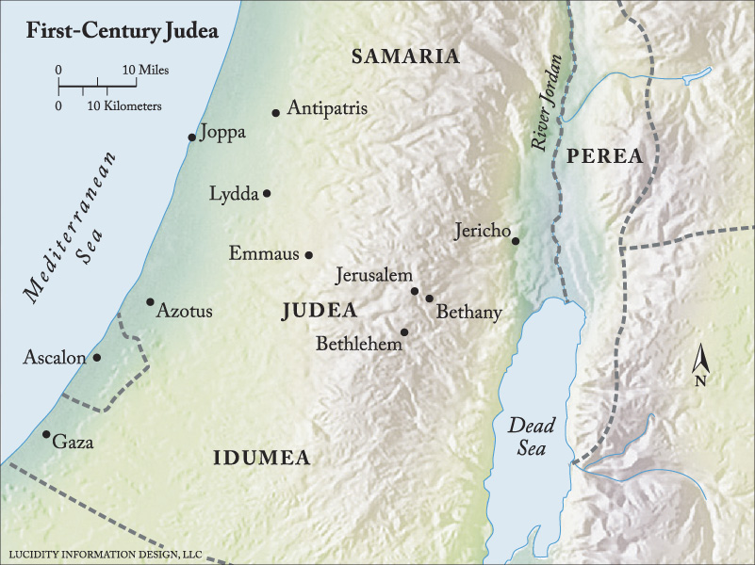
Judea is shown on the map to the left. The exact location of Aenon and Salim are not known for certain, but the ‘much water’ description may place them along or near the Jordan River.

Jesus and John were both baptizing, and you may recall that the Pharisees had questioned John the Baptist about this already (John 1:19-28). The Jewish tradition was that you only baptized Gentiles who were converting to Judaism. So baptizing Jews was, to them, a puzzling if not scandalous practice. After all, Jews were already Jews. But this baptism was an identification with the message of the one baptizing. Some identified with John’s message, and some identified with Jesus’ message. At this time, Jesus’ baptism was not the same as Christian baptism within the church, since the church – the body of Christ - did not yet exist.

John 3:25-26
Therefore there arose a discussion on the part of John's disciples with a Jew about purification. 26 And they came to John and said to him, "Rabbi, He who was with you beyond the Jordan, to whom you have testified, behold, He is baptizing and all are coming to Him."

The discussion about purification very likely meant purification of hands and eating utensils with water before meals, etc, just as it had in John 2:6. These purification rituals were likely good hygiene, but they were not a part of the Law of Moses. They were just human tradition. But when these same disciples came to John the Baptist, they expressed concern that Jesus was drawing more disciples than John, even to the point where the disciples of John say, “…all are coming to Him”. From verse 27 to verse 30, we likely have John the Baptist’s full answer to his disciples.

John 3:27-30
John answered and said, "A man can receive nothing unless it has been given him from heaven. 28 You yourselves are my witnesses that I said, 'I am not the Christ,' but, 'I have been sent ahead of Him.' 29 He who has the bride is the bridegroom; but the friend of the bridegroom, who stands and hears him, rejoices greatly because of the bridegroom's voice. So this joy of mine has been made full. 30 He must increase, but I must decrease."

John’s statement, “A man can receive nothing…” refers to receiving spiritually. Everything that is spiritual originates from God, who created everything in the physical realm, and everything in the spiritual realm except Himself. The word ‘heaven’ is used here as a euphemism, much like ‘the kingdom of God’ is the same as ‘the kingdom of heaven’. According to the rabbinical thinking of the day, since saying ‘God’ directly might allow one to say the name of God in vain at some point, it was common Jewish practice to replace the word ‘God’ with ‘heaven’ as a precaution.

In John 1:20 John the Baptist had indeed said, “I am not the Christ”, that is, the Messiah. Since there is no place where John is recorded to have said, 'I have been sent ahead of Him', either John said exactly those words before, but we have no record of it, or John was summarizing what he had said previously that was recorded in John 1:19-34.

In reference to the bridegroom, the bride, and the friend of the bridegroom in verse 29, there is something we need to sort out. Was John the Baptist referring to:

1) Israel as the bride, or
2) The church as the bride, or
3) The bridegroom, the bride, and the friend of the bridegroom, as an illustration, but with no intent to identify the bride specifically?

Israel is the one identification with the bride that has biblical backing (as in Isaiah 54:5; 62:4-5; Jeremiah 2:2; 3:20; Ezekiel 16:8; Hosea 2:16-20), and John the Baptist would have known of these references, as would his disciples. However, these passages do not specifically identify the Messiah or the Son of God as the husband of Israel, but God – specifically Yahweh, which would be all three persons of the Trinity. For instance:

Isaiah 54:5
"For your husband is your Maker,
Whose name is the LORD of hosts;
And your Redeemer is the Holy One of Israel,
Who is called the God of all the earth."

Also, the last passage, Hosea 2:16-20, looks forward to a yet future betrothal of God to Israel, in the Millennial kingdom.
In some ways, the identification of Christ and the church as bridegroom and bride is a better fit, since specifically Christ, the Messiah, will be the groom and the church the bride, being now betrothed (2 Corinthians 11:2; Ephesians 5:22-33, et al). And Ephesians 1:4 and 5:22-33 picture the bride as “holy and blameless” and without spot or wrinkle, spiritually speaking, as opposed to the unholiness of Israel and Judah in times past wherein God gave Israel a certificate of divorce (Jeremiah 3:8). However, John the Baptist, especially early in the ministry of Christ, would not have had any clue about the future existence of the church, and he would have no earthly ministry with the church. The existence and character of the church was a set of truths yet to be revealed, and that mostly through the apostles and prophets (Ephesians 3:4-7, et al).

We conclude from the above that the best understanding of John’s intent was that John intended to use the bridegroom, bride and friend of the bridegroom as a general illustration, but his purpose was not to identify the bride at this point. At most, Christ is the bridegroom and John the Baptist is the friend of the bridegroom for the sake of John’s illustration, but the identity of the bride was not specifically intended. Indeed, John’s illustration focuses on the bridegroom and the friend of the bridegroom. So how does John the Baptist feel about Jesus gaining more or even all of the disciples in comparison to John? John says that his “…joy has been made full”.

When John said, “He must increase, but I must decrease” he was not simply being humble. John had begun his ministry before Jesus, and was indeed six months older, but because John’s ministry was to prepare the way for Jesus’ ministry, it only made sense that John’s ministry must fade away, while Jesus’ ministry developed even further – much, much further.

It is likely that the words from here forward in this chapter are not that of John the Baptist, but of John the apostle, as he wrote this book. But as we saw earlier in this chapter, either way it is inspired by God for our benefit.

John 3:31-35
"He who comes from above is above all, he who is of the earth is from the earth and speaks of the earth. He who comes from heaven is above all. 32 What He has seen and heard, of that He testifies; and no one receives His testimony. 33 He who has received His testimony has set his seal to this, that God is true. 34 For He whom God has sent speaks the words of God; for He gives the Spirit without measure. 35 "The Father loves the Son and has given all things into His hand."

Verse 31 is a one verse chiasm, with some Hebrew poetry patterns as well:

"He who comes from above is above all,
he who is of the earth is from the earth and
speaks of the earth.
He who comes from heaven is above all."

The words “above all” are used repeatedly in the Old Testament for God, so John’s reference again underscores Christ’s deity (Nehemiah 9:5; Psalm 57:5, 11; 89:7, et al).
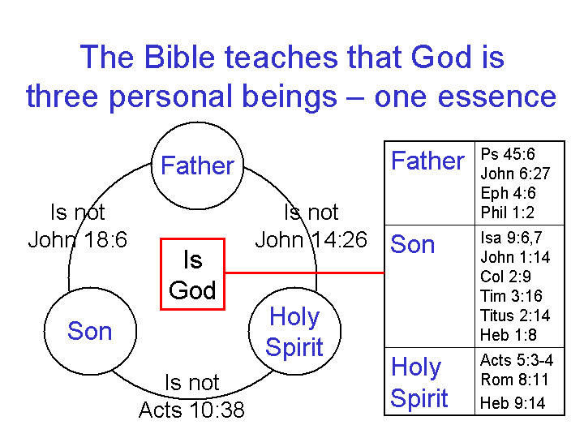
Verses 32 through 34 refer to Christ’s testimony, in which the Father, the Son and the Holy Spirit are all three involved. Christ’s earthly testimony ultimately comes with a message that originates from before the world was created and extends to after this present heavens and earth are ended. Yet with rare exception, Christ’s testimony was rejected. Yet for those few who do receive Christ, there is an awesome treasure of mercy, blessings, and grace from God. John has said similar things just a couple chapters before:

John 1:11-13
"He came to His own, and those who were His own did not receive Him. 12 But as many as received Him, to them He gave the right to become children of God, even to those who believe in His name…"

In John 5:20 we will see the words, “The Father loves the Son” again. The message that the Father has given all things over to the Son (John 3:35) is also given elsewhere:

Matthew 11:27 (see also Luke 10:22)
“All things have been handed over to Me by My Father…”

This truth is actually stated in a positional and promissory way, since the realization of this is yet future (1 Corinthians 15:28).

John 3:36
"He who believes in the Son has eternal life; but he who does not obey the Son will not see life, but the wrath of God abides on him."

John returns to his theme that only in believing does one have eternal life (John 3:16), and that life comes from believing (see also John 5:24; 11:25; 20:31). But we have something to ponder regarding John’s use of the word obey. On the surface, that may sound like obedience in action brings life. But the Greek words translated ‘not obey’ in the New American Standard (KJV: ‘not believeth’) means to willfully disbelieve.
We could expand and explain the last part of John 3:36 as follows:

“…but, in sharp contrast to what was said before, the wrath of the God continually dwells on him who willfully disbelieves.”

The wrath of God remains upon and is destined for those who do not believe, and are therefore still in their trespasses and sins (John 8:24; 1 Corinthians 15:17; Ephesians 2:1; Colossians 2:13):

Romans 1:18
For the wrath of God is revealed from heaven against all ungodliness and unrighteousness of men who suppress the truth in unrighteousness…

Romans 2:5
But because of your stubbornness and unrepentant heart you are storing up wrath for yourself in the day of wrath and revelation of the righteous judgment of God…

Ephesians 5:6
…the wrath of God comes upon the sons of disobedience…

Colossians 3:6
For it is because of these things that the wrath of God will come upon the sons of disobedience…

Believing brings life, and is the only way to avoid the wrath of God. The spiritual issues could not be more clear. Believing or willfully disbelieving is the most important fork in the road for every person. There is an expiration date for that fork in the road for each person. And for the person who believes, life has no expiration date.

