John 4:31-54

In this passage, verses 31-42 continue the account in Sychar of Samaria, first with Jesus’ disciples, then with the Samaritans themselves. Jesus went back to Galilee, then back to Cana in Galilee, where Jesus had turned the water into wine.

John 4:31-33
Meanwhile the disciples were urging Him, saying, "Rabbi, eat." 32 But He said to them, "I have food to eat that you do not know about." 33 So the disciples were saying to one another, "No one brought Him anything to eat, did he?"

After the disciples had gotten over their initial shock to some degree, they presented the food they had bought in Sychar to Jesus, for Him to eat. Having noticed His hesitation in eating, they respectfully urged Jesus to eat. So Jesus tells them about the food He has to eat that they were unaware of, meaning spiritual food, of course. The Old Testament had spoken about this graciously given spiritual food many centuries before.

Isaiah 55:1-2
"Ho! Every one who thirsts, come to the waters;
And you who have no money come, buy and eat.
Come, buy wine and milk
without money and without cost. 2 "Why do you spend money for what is not bread, And your wages for what does not satisfy? Listen carefully to Me, and eat what is good, And delight yourself in abundance."

In the disciples’ response to Jesus’ statement, they are following a pattern that is beginning to get well-established in the Gospel of John: they are taking a spiritual statement by Jesus and interpreting it in physical terms. We saw that already with Nicodemus (‘born again’), and also with the woman at the well (‘living water’).

John 4:34-38
Jesus said to them, "My food is to do the will of Him who sent Me and to accomplish His work. 35 Do you not say, 'There are yet four months, and then comes the harvest'? Behold, I say to you, lift up your eyes and look on the fields, that they are white for harvest. 36 Already he who reaps is receiving wages and is gathering fruit for life eternal; so that he who sows and he who reaps may rejoice together. 37 For in this case the saying is true, 'One sows and another reaps.' 38 I sent you to reap that for which you have not labored; others have labored and you have entered into their labor."

Jesus used His hunger, and even His hesitation to eat to bring a spiritual message. The food Jesus is talking about in this case is from a spiritual harvest that is just about to take place. Some sow and some reap, and they are not always the same ones both sowing and reaping. The work of reaping will produce the spiritual food from the harvest that Jesus is talking about.

John 4:39-42
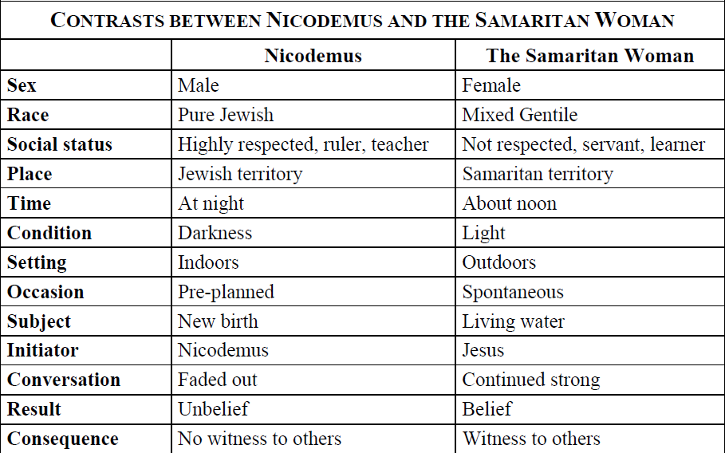
From that city many of the Samaritans believed in Him because of the word of the woman who testified, "He told me all the things that I have done." 40 So when the Samaritans came to Jesus, they were asking Him to stay with them; and He stayed there two days. 41 Many more believed because of His word; 42 and they were saying to the woman, "It is no longer because of what you said that we believe, for we have heard for ourselves and know that this One is indeed the Savior of the world."
Secret belief of a few
Open belief of many
Limited witness to others
Welcomed witness to others tLimited witness to others
Adapted from Notes on John by Thomas Constable & The Bible Knowledge Commentary
The testimony of the woman, though she was questionable on her own merits, had stirred the Samaritans. She wondered whether Jesus was the Christ (essentially asking, “Could it be?”), and she told them that Jesus had told her personal history. The Samaritans responded by believing and asking Jesus to stay longer, so Jesus stayed for two days.

John 4:43-45
After the two days He went forth from there into Galilee. 44 For Jesus Himself testified that a prophet has no honor in his own country. 45 So when He came to Galilee, the Galileans received Him, having seen all the things that He did in Jerusalem at the feast; for they themselves also went to the feast.

So after the two days in Samaria, Jesus returned to Galilee, which was His home territory. Jesus testified that a prophet has no honor in his own country. Now Jesus was more than a prophet, as the Samaritan woman had viewed Him, and more than a teacher, as Nicodemus had viewed Him. But He was a prophet, and the whole line of Old Testament prophets were treated as Jesus had summarized in verse 44. The treatment of prophets is among those whose lives are summarized in Hebrews chapter 11. So why does verse 45 seem to portray a positive reception among the Galileans as Jesus returns there? The Galileans received Jesus on the basis of the things Jesus had done – not the things that Jesus said – the primary role of a prophet, and the focus of the observation and public proclamation of the woman from Samaria. Also, while Jesus had been widely, immediately and openly received and believed upon in Samaria on the basis of His words, in Galilee His reception was on the basis of things done, food provided, signs given, etc. But even that faded after a time. A time came when even with signs there would be those who do not believe (John 12:37).

John 4:46-48
Therefore He came again to Cana of Galilee where He had made the water wine. And there was a royal official whose son was sick at Capernaum. 47 When he heard that Jesus had come out of Judea into Galilee, he went to Him and was imploring Him to come down and heal his son; for he was at the point of death. 48 So Jesus said to him, "Unless you people see signs and wonders, you simply will not believe."

John records this as the second time that Jesus came to Cana in Galilee (see John 2:1-12 as the first). Cana will also be recorded as the home town of Nathanael in John 21:2. Since Cana was a village, it is no surprise that only John mentions the name ‘Cana’ or records any events there.

So a royal official from Capernaum, whose son was gravely ill, came to Jesus in Cana and begged Him to come and heal his son. Jesus responds by stating that the people will not believe unless they see signs and wonders. Indeed, seeking signs and wonders was an overwhelming characteristic of the Jews, in general.

John 4:49-54
The royal official said to Him, "Sir, come down before my child dies." 50 Jesus said to him, "Go; your son lives." The man believed the word that Jesus spoke to him and started off. 51 As he was now going down, his slaves met him, saying that his son was living. 52 So he inquired of them the hour when he began to get better. Then they said to him, "Yesterday at the seventh hour the fever left him." 53 So the father knew that it was at that hour in which Jesus said to him, "Your son lives"; and he himself believed and his whole household. 54 This is again a second sign that Jesus performed when He had come out of Judea into Galilee.

So the royal official asked Jesus again to come down to Capernaum to heal his son before he died. Jesus, rather than going with the royal official back to Capernaum to heal the official’s son, simply told the official (more literally) to, “Be going, the son of yours is living”. Now healing from a distance had happened another time. A centurion asked Jesus to heal his son (or servant), but said that Jesus did not need to come to his house (Matthew 8:5-13). In that case Jesus marveled at the man’s faith, and healed without coming to the house of the centurion.

The servants of the royal official came with the good news that the official’s son was doing better. And by asking questions the official figured that the time of his son’s turn for the better matched the moment that Jesus had told him, “Your son lives”. That time was the seventh hour (1 PM). John marks this as the second sign in Galilee.
_____________________________________________________________

Believing and Receiving in the Gospel of John

John has made it clear that his purpose in writing the gospel of John was for the reader to believe, and the kind of believing John intended resulted in spiritual life.

John 20:30-31 (see also 1 John 5:13)
Therefore many other signs Jesus also performed in the presence of the disciples, which are not written in this book; 31 but these have been written so that you may believe that Jesus is the Christ, the Son of God; and that believing you may have life in His name.

So the believing that John is referring to is the believing that God uses to bring about the initial salvation of a person who believes and is therefore saved eternally. But are there other kinds of believing? In a word, “Yes”.

Examine these verses from the gospel of John, which, taken in sequence convey an apparent superficial and external belief, but not a saving faith:

John 2:23-25
Now when He was in Jerusalem at the Passover, during the feast, many believed in His name, observing His signs which He was doing. 24 But Jesus, on His part, was not entrusting Himself to them, for He knew all men, 25 and because He did not need anyone to testify concerning man, for He Himself knew what was in man.

John 6:64…66
"But there are some of you [plural] who do not believe." For Jesus knew from the beginning who they were [plural] who did not believe, and who it was [singular] that would betray Him."… As a result of this many of His disciples withdrew and were not walking with Him anymore.

In the above quoted verses, believed, entrusted, and believe (twice) are all based in the same word in the Greek. So there were some who appeared to believe, but Jesus did not entrust Himself to them. There were some who appeared to be disciples for a time, but did not in fact believe so as to be saved, and Jesus knew who those were, both as a group, and down to the individual, who was in this case Judas. Jesus knew who these were, but the disciples didn’t seem to always know who these were, especially in the case of Judas. Also, we see that John’s use of the word ‘receive’ can also mean to believe, and that can mean receiving and believing so as to be saved:

John 1:12-13
But as many as received Him, to them He gave the right to become children of God, even to those who believe in His name, 13 who were born, not of blood nor of the will of the flesh nor of the will of man, but of God.

But as we have seen, it is also possible for some to receive Christ on a superficial basis:

John 4:43-45
After the two days He went forth from there into Galilee. 44 For Jesus Himself testified that a prophet has no honor in his own country. 45 So when He came to Galilee, the Galileans received Him, having seen all the things that He did in Jerusalem at the feast; for they themselves also went to the feast.

In this case the receiving appears to be based on seeing things that Christ did, as superficially impressive signs and wonders. But that receiving is not, in this case, the genuine article, as Jesus said in John 4:44 and 6:64, and further revealed by John 6:66. But Scripture - the Gospel of John included - does not support loss of salvation for one who genuinely believes so as to be truly saved so as to have eternal life.

In John 10:28 (expanded and explained), Jesus is therefore saying that eternal life is something He gives constantly to His sheep, and that there is not even the slightest possibility that they can lose that eternal life so as to perish in hell, even of their own doing, and no other outside entity can remove those sheep, those to whom He constantly gives life, from His hand. The saving work of Christ is therefore continually giving us eternal life that cannot be lost of our own doing, nor by that of another. Verse 29 even takes that one step further, with Christ saying that His sheep were given to Him by the Father, and they cannot be taken out of the Father’s hand either.

See also the handout from the Q&A elective: “Holly Hills Bible Church – 17 Q&A series – April 25, May 2 and May 9, 2010 - Q&A 17: Once saved always saved, or can one lose his or her salvation?”, 15 pages.

