John 5:1-24

John 5:1
After these things there was a feast of the Jews, and Jesus went up to Jerusalem.

Unlike other places in the Gospel of John, we aren’t told which feast this is, likely because the specific feast makes no difference to the understanding of the account. What we do know is that Jesus was in Jerusalem for a feast of the Jews. Going up to Jerusalem may refer to His having gone there by means of the Jordan River and Jericho.

John 5:2
Now there is in Jerusalem by the sheep gate a pool, which is called in Hebrew Bethesda, having five porticoes.

The Sheep Gate pool, just north of the temple mount, was also called the Pool of Bethesda (actually ‘Bethzatha’ from a Hebrew form of an Aramaic word meaning possibly, “house of outpouring” or “house of mercy”).

John 5:3-4
In these lay a multitude of those who were sick, blind, lame, and withered, [waiting for the moving of the waters; 4 for an angel of the Lord went down at certain seasons into the pool and stirred up the water; whoever then first, after the stirring up of the water, stepped in was made well from whatever disease with which he was afflicted.]

It is doubtful that the portion of verse 3 and all of verse 4 that are in brackets [] were written by the apostle John. No early Greek manuscript contains there words until about 400 AD. They were probably written by a scribe about 400 AD as an explanatory note that got included in later copies. These words do, however, explain the superstition that caused many to remain by the pool in hopes of healing. The warmth and mineral content of the water may explain some of the stories of healing and hopes of healing.

John 5:5-9a
A man was there who had been ill for thirty-eight years. 6 When Jesus saw him lying there, and knew that he had already been a long time in that condition, He said to him, "Do you wish to get well?" 7 The sick man answered Him, "Sir, I have no man to put me into the pool when the water is stirred up, but while I am coming, another steps down before me." 8 Jesus said to him, "Get up, pick up your pallet and walk." 9 Immediately the man became well, and picked up his pallet and began to walk.

This man had been ill and lame for a long time, as we will later find out. Jesus saw the man, and knowing his condition, asked him, “Do you wish to get well?”

The man’s response did not apparently include an answer that said explicitly, “Yes, I wish to get well”. Rather the man responded essentially implying, “Of course I want to get well, but I have no hope of getting well because I can never get to the water first”. The man told Jesus that he simply didn’t have anyone to help him get to the water in time to be first. But Jesus took that as a ‘Yes”. So Jesus told the man directly, “Get up, pick up your pallet and walk”. And that is exactly what the man did.
It was predicted by the prophets of old that the Messiah would heal the lame (Isaiah 35:6a). But amazingly the Jews were not impressed that a miracle had occurred that day, but rather that that day was Sabbath.

John 5:9b-13
Now it was the Sabbath on that day. 10 So the Jews were saying to the man who was cured, "It is the Sabbath, and it is not permissible for you to carry your pallet." 11 But he answered them, "He who made me well was the one who said to me, 'Pick up your pallet and walk.'" 12 They asked him, "Who is the man who said to you, 'Pick up your pallet and walk'?" 13 But the man who was healed did not know who it was, for Jesus had slipped away while there was a crowd in that place.

The night of the Sabbath had already passed, and this was the next day – what we would call Saturday day. Jesus often healed deliberately on the Sabbath (Matthew 12:10; Mark 3:2; Luke 6:7; 13:14; 14:3), and Jesus knowingly healed this man on the Sabbath and told the man to take up his pallet and walk. See Sabbath Controversies table below.

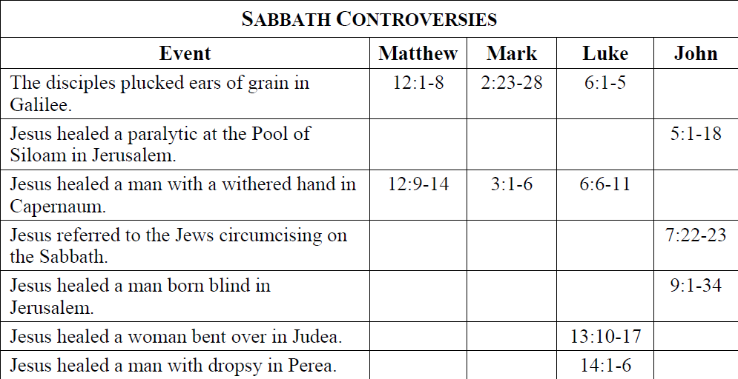

So the Jews were not rejoicing that the man had been healed after all these years. They did not rejoice that this man had been, in a moment, turned from a dependent person to one on whom others could depend. They were rather immediately telling the man who had been cured that he could not break their traditions, which defined picking up one’s pallet as ‘work’, and therefore prohibited on the Sabbath.

Since Jesus had slipped away just as soon as the man was healed, the man could only respond that the One who had healed him told him to pick up the pallet.

John 5:14-17
Afterward Jesus found him in the temple and said to him, "Behold, you have become well; do not sin anymore, so that nothing worse happens to you." 15 The man went away, and told the Jews that it was Jesus who had made him well. 16 For this reason the Jews were persecuting Jesus, because He was doing these things on the Sabbath. 17 But He answered them, "My Father is working until now, and I Myself am working."

When Jesus and the man who had been healed were both in the temple courtyard, Jesus warned the man not to sin, so that nothing bad would happen to him. This is consistent with Jews living under the Law, in which they would be blessed if they obeyed, and cursed if they didn’t obey (Deuteronomy 28), and that curse could include a return to illness – possibly even worse illness.

Once the man went back to answer the Jews that it was Jesus who had healed him, then the Jews came after Jesus both because Jesus had healed on the Sabbath, and because Jesus had told the man to pick up his pallet and walk on the Sabbath. In the view of the Jews, Jesus had caused the Sabbath to be broken twice.

It was permissible, as the Jews saw it, for a Jew to refer to God as ‘Our Father’. But it was not permitted to refer to God as ‘My Father”, as Jesus did, because that implied a special and unique relationship with God that could only come with being on the same level with God – essentially a claim to deity.

John 5:18
For this reason therefore the Jews were seeking all the more to kill Him, because He not only was breaking the Sabbath, but also was calling God His own Father, making Himself equal with God.

The claim to unique relationship with God, and the claim to deity was intensifying the motivation of the Jews to kill Jesus. And Christ knew what they were thinking, which caused Jesus to respond accordingly.

John 5:19-21
Therefore Jesus answered and was saying to them, "Truly, truly, I say to you, the Son can do nothing of Himself, unless it is something He sees the Father doing; for whatever the Father does, these things the Son also does in like manner. 20 For the Father loves the Son, and shows Him all things that He Himself is doing; and the Father will show Him greater works than these, so that you will marvel. 21 For just as the Father raises the dead and gives them life, even so the Son also gives life to whom He wishes.

The Jews figured that God, who is the Father, worked on the Sabbath just sustaining the universe. So if Jesus – Christ the Son – did things like the Father then the Jews should be OK with it. Except that the Jews had no place for Christ as the Son.

In verses 19-21 we see Jesus claiming that the Son does what the Father does. Notice the aspects of the relationship between the Father and the Son:

- The Father initiates for the Son
- The Father loves the Son
- The Father shows the Son greater works
- The Father gives life, so does the Son
John 5:22-24
For not even the Father judges anyone, but He has given all judgment to the Son, 23 so that all will honor the Son even as they honor the Father. He who does not honor the Son does not honor the Father who sent Him. 24 Truly, truly, I say to you, he who hears My word, and believes Him who sent Me, has eternal life, and does not come into judgment, but has passed out of death into life."

So while in verses 19-21 the Father was the one who did things and the Son followed what the Father did, in verse 22 the Father passes on authority and responsibility to the Son for all judgment. In verse 23 the honor shown to the Son is the honor shown to the Father. So these Jews were one day going to be judged by Christ – the one they are now seeking to judge. And their lack of honor shown to the Son will be a dishonor to the Father. They are in deep trouble, and they don’t even recognize it. Next Jesus presents to them the only way out of the deep, deep trouble that they are in. If these Jewish leaders will only believe Christ’s words they won’t come under the catastrophic judgment that will otherwise most certainly come upon them. They will find eternal life instead.
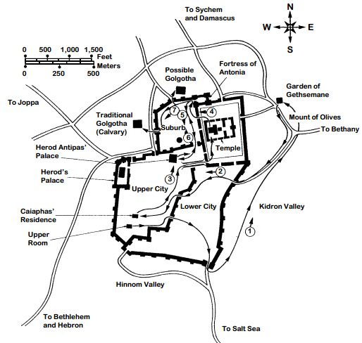
Jerusalem in the Time of Christ
Pools of Bethzatha

