John 5:25-47

John 5:25-47 continues what Jesus has been telling the judgmental Jews who were ready to condemn Jesus both for healing on the Sabbath and telling the man who was healed to pick up his pallet and walk. We could summarize the words of John 5:25-47 with the words, ‘The Father, the Son, life and judgment, two resurrections and four witnesses.’

John 5:25-27
"Truly, truly, I say to you, an hour is coming and now is, when the dead will hear the voice of the Son of God, and those who hear will live. 26 "For just as the Father has life in Himself, even so He gave to the Son also to have life in Himself; 27 and He gave Him authority to execute judgment, because He is the Son of Man.

Jesus continues with these judgmental Jews, beginning with the words that John writes of repeatedly, ‘Truly, truly’. Theses are truths stated double for emphasis, a Hebrew figure of speech. The words, “I say to you” are used repeatedly by Jesus in the four gospels, and by Gamaliel (Acts 5:38). It is likewise a Hebrew figure of speech for emphasizing the importance of the words that follow. The words, “an hour is coming” are a frequent saying of Christ – the One who knows what is coming. The words, “now is” is a way of expressing the certainty of a future event and that the time is approaching relentlessly. Jesus had previously used the words, “an hour is coming and now is” when He spoke to the woman at the well, in John 4:23.

Jesus, in expressing His relationship to the Father, and in carrying out the Father’s will, refers to Himself as:

- the Son of God – refers to His deity, as the third person of the Trinity
- the Son – refers to His relationship with God the Father (Psalm 2:7)
- the Son of Man – refers to His humanity (Ezekiel 2:1, et al) and His role as the Messiah who will judge and carry out judgment (Psalm 2:12; Daniel 7:13)

These words convey that life-giving (as in ‘resurrection’) and judgment are given to the Son. It is not that the Father could not carry out these things - He could – but He has assigned the responsibility and authority to Christ, once and for all. See the last two pages of this handout for a table and a diagram on the biblical end-time judgments and resurrections.
John 5:28-29
"Do not marvel at this; for an hour is coming, in which all who are in the tombs will hear His voice, 29 and will come forth; those who did the good deeds to a resurrection of life, those who committed the evil deeds to a resurrection of judgment.

This is not something that they should marvel at, but rather expect, as revealed in the Old Testament (compare Jesus speaking to Nicodemus, in John 3:7, “Do not be amazed…”). This same set of teachings is in various Old Testament passages which were recognized by the Pharisees, but not the Sadducees. These included:

Job 19:25-27
"As for me, I know that my Redeemer lives, and at the last He will take His stand on the earth. 26 Even after my skin is destroyed, yet from my flesh I shall see God; 27 Whom I myself shall behold, and whom my eyes will see and not another. My heart faints within me!"

Isaiah 26:19
"Your dead will live; their corpses will rise. You who lie in the dust, awake and shout for joy, for your dew is as the dew of the dawn, and the earth will give birth to the departed spirits."

Daniel 12:1-2
"Now at that time Michael, the great prince who stands guard over the sons of your people, will arise. And there will be a time of distress such as never occurred since there was a nation until that time; and at that time your people, everyone who is found written in the book, will be rescued. 2 Many of those who sleep in the dust of the ground will awake, these to everlasting life, but the others to disgrace and everlasting contempt."

And there are other Old Testament passages as well. At first review, it would sound like good deeds sends you to a resurrection of eternal life and bad deeds sends you to a resurrection of judgment. But in the context of all of Scripture it looks like this:

- All have sinned, and have gone astray (Isaiah 53:6; Romans 6:23).
- Salvation is entirely at God’s expense – by grace (John 3:16; Galatians 2:20, et al)
- Salvation is entirely by faith, and not of works (Galatians 2:16; Ephesians 2:4, 8 ,9)
- All are resurrected, but some for eternal life and others to judgment and misery.
- The works of those who are saved by faith are judged for rewards (such as, 1 Corinthians 3:10-15), and the works of those who are not saved by faith are judged for punishment (such Revelation 20:11-15).

See the two supplements on crowns and rewards for church age believers and proportional punishment for unbelievers located at the end of this handout. The judgment of works is for believers and unbelievers, but has a different basis and outcome for believers and unbelievers. All will be resurrected, some to life and some to judgment.

John 5:30
"I can do nothing on My own initiative. As I hear, I judge; and My judgment is just, because I do not seek My own will, but the will of Him who sent Me.
Jesus is saying that He does not decide or act independent from the Father who sent Him. Christ’s judgment will be just, because it will be based on all of the facts, and it will be based on God’s infinite justice. There will be no favoritism, ignorance, unfair advantages, loopholes or miscalculations.

John 5:31
"If I alone testify about Myself, My testimony is not true. 32 "There is another who testifies of Me, and I know that the testimony which He gives about Me is true.”

John is real big on testimony and witness, here in the Gospel of John, in 1 John, and in the book of Revelation. While John writes the purpose of each of those three books in each book, he has an overriding theme in all three major works: testimony (testifying) and witness. He brings forth Jesus testimony about Himself, the Father’s testimony on His behalf (which He’ll expand upon shortly), and four other witnesses:

- John the Baptist (John 5:33-35)
- Works (John 5:36)
- The Father (John 5:37-38)
- Scripture (John 5:39-47)

John 5:33-35
"You have sent [perfect tense] to John, and he has testified [perfect tense] to the truth. 34 But the testimony which I receive is not from man, but I say these things so that you may be saved. 35 He was the lamp that was burning and was shining and you were willing to rejoice for a while in his light.

John shed light for a time, but he was not the Light. Instead He pointed to the Light. John testified to the truth, but he was not the Truth, as Christ was and is the Truth (John 14:6). Jesus is telling these Jewish leaders about the truth so that they might be saved.

John 5:36
"But the testimony which I have is greater than the testimony of John; for the works which the Father has given Me to accomplish--the very works that I do--testify about Me, that the Father has sent Me.

Jesus definitely had works to testify about who He was and is, and Nicodemus had at least seen that, and spoke for others who had seen and recognized His works as valid testimony (John 3:2).

John 5:37-38
"And the Father who sent Me, He has testified of Me. You have neither heard His voice at any time nor seen His form. 38 You do not have His word abiding in you, for you do not believe Him whom He sent."

Both before and after this passage, John has declared similar truths:

John 1:18
No one has seen God at any time; the only begotten God [Jesus] who is in the bosom of the Father, He [Jesus] has explained Him.

1 John 2:14
I have written to you, fathers, because you know Him who has been from the beginning [John 1:1]. I have written to you, young men, because you are strong, and the word of God abides in you, and you have overcome the evil one.

1 John 4:12-14
No one has seen God at any time; if we love one another, God abides in us, and His love is perfected in us. 13 By this we know that we abide in Him and He in us, because He has given us of His Spirit. 14 We have seen and testify that the Father has sent the Son to be the Savior of the world.

The last words of this passage turn to the Scriptures for testimony. The Scriptures, at this point, consist of the books that we call the Old Testament.

John 5:39-47
"You search the Scriptures because you think that in them you have eternal life; it is these that testify about Me; 40 and you are unwilling to come to Me so that you may have life. 41 I do not receive glory from men; 42 but I know you, that you do not have the love of God in yourselves. 43 I have come in My Father's name, and you do not receive Me; if another comes in his own name, you will receive him. 44 How can you believe, when you receive glory from one another and you do not seek the glory that is from the one and only God? 45 Do not think that I will accuse you before the Father; the one who accuses you is Moses, in whom you have set your hope. 46 For if you believed Moses, you would believe Me, for he wrote about Me. 47 But if you do not believe his writings, how will you believe My words?"

These make it clear that it is possible for people to have the truth of God’s inspired word right in front of them, and to even appear to be preoccupied with it and examining it faithfully, but not see in it what really matters – the truth. Of the the Scriptures of the Old Testament – even the five books of Moses – Jesus said that these, “Testify about Me” and that Moses “wrote about Me”. Did they see that in the Old Testament Scriptures? Not at all.

John comes back to his theme again, doesn’t He? Belief. There is no alternate path to spiritual life, though these leaders of the Jews think they are certainly on that path. Belief is central, necessary, and essential. And it is essential that one believe the truth and believe the One who is the truth, and that believing that truth, one has life in His name (John 20:31).

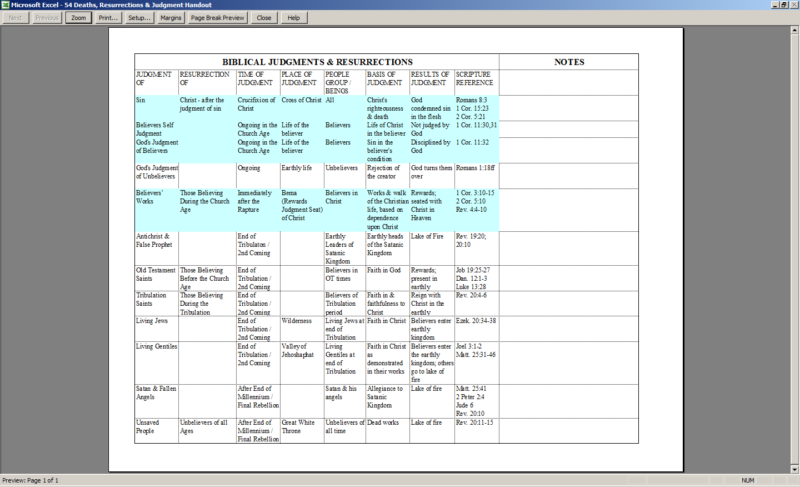
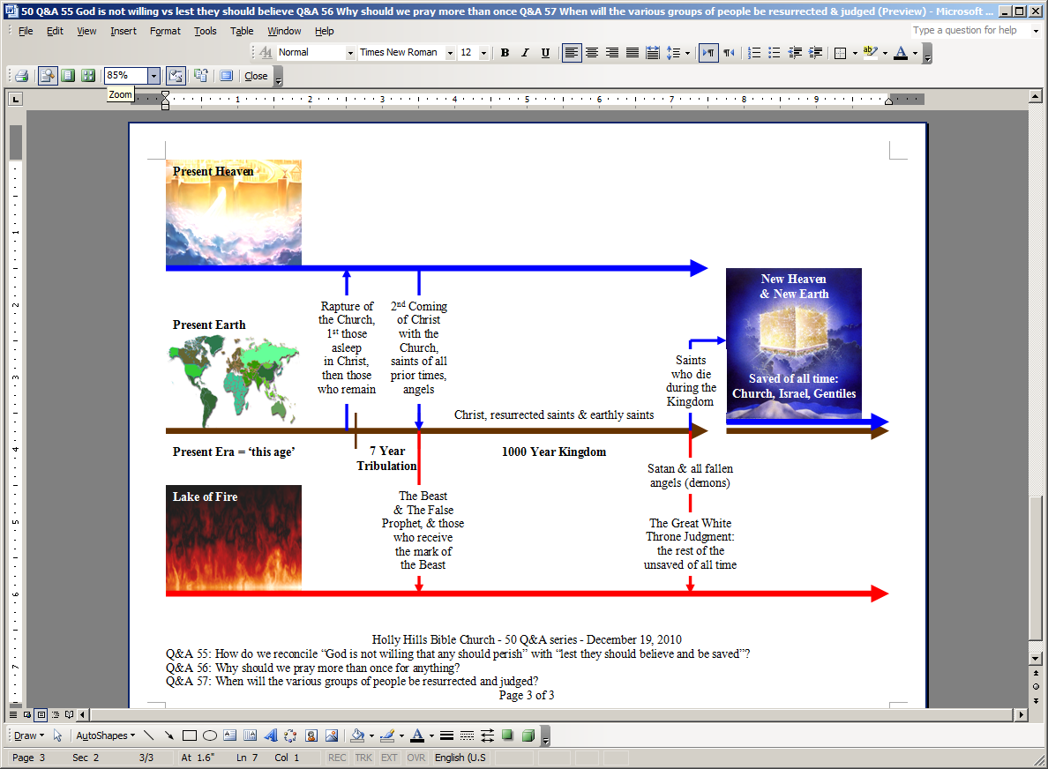
Text of ‘New Heaven & New Earth’ is on top of copyrighted artwork by Pat Marvenko Smith. Right to use has been purchased.
Future Things: Key Places, Events, Resurrections, Judgments & People Groups

This and all Scripture quotes are New American Standard Updated, unless stated otherwise.
In Isaiah 26:3 where Isaiah writes, "The steadfast of mind You will keep in perfect peace, because he trusts in You.” What is translated, “perfect peace” is actually, “peace, peace” – double for emphasis. In Isaiah 40:1, in order to emphasize the message of comfort for Israel, Isaiah expresses it as, “Comfort, comfort…”.
This same emphasis upon certainty is sometimes carried across in the Bible by stating a future event in the present tense, or by using other words to convey the relentless passage of time towards a future event (as in Revelation 3:11; 11:14; 22:7, 12, 20).

