John 6:41-71

In this passage the interaction continues after Jesus had fed the 5000 on the eastern shores of the Sea of Galilee, and had walked on water as the disciples returned to Capernaum by boat.

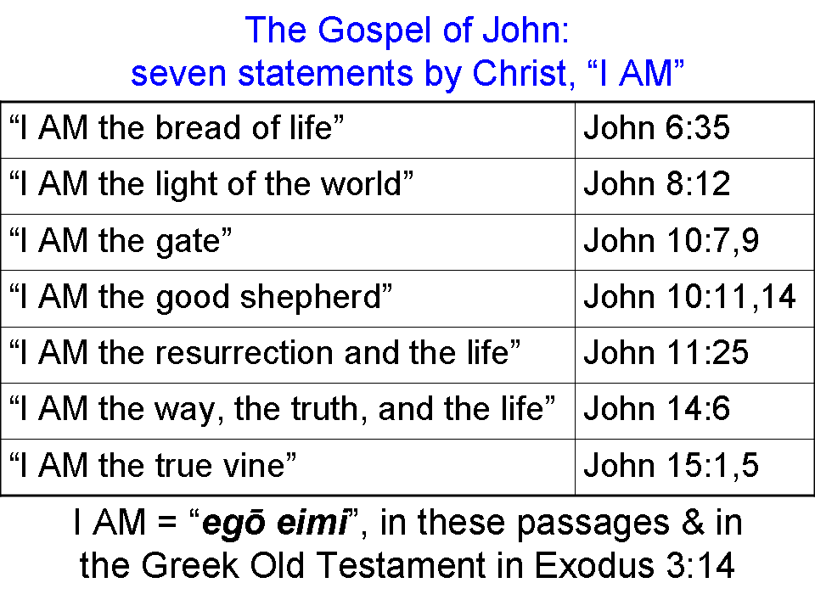
John 6:41-42
Therefore the Jews were grumbling about Him, because He said, "I AM the bread that came down out of heaven." 42 They were saying, "Is not this Jesus, the son of Joseph, whose father and mother we know? How does He now say, 'I have come down out of heaven'?"

The Jews heard that Jesus made the claim, “I AM the bread…”, which would have implied deity. Elsewhere Jesus said “I AM” and the Jews were ready to stone Him (John 8:59). As far as what was recorded, Jesus said that He was the bread and that He came down out of heaven. So either the Jews put this together from what Jesus said or Jesus said those words quoted in verse 41, but it was not recorded earlier in those exact words. In the Bible, “down out of heaven” is exclusively a set of words that John uses. In verse 42 the Jews say that they know who Jesus is in earthly terms, including his lineage through Mary and Joseph. Matthew and Mark each record similar statements by the Jews, but in a different context. The Jews could not reconcile Jesus coming “down out of heaven” with His earthly birth from Mary, and being familiar with His family members. For Jesus to come “down out of heaven”, as they saw it, He had to have come as described in Daniel 7:13, that is, bodily, with the clouds of heaven, as we envision the Second Coming of Christ.
John 6:43-51
Jesus answered and said to them, "Do not grumble among yourselves. 44 "No one can come to Me unless the Father who sent Me draws him; and I will raise him up on the last day. 45 "It is written in the prophets, 'And they shall all be taught of God.' Everyone who has heard and learned from the Father, comes to Me. 46 "Not that anyone has seen the Father, except the One who is from God; He has seen the Father. 47 "Truly, truly, I say to you, he who believes has eternal life. 48 "I AM the bread of life. 49 "Your fathers ate the manna in the wilderness, and they died. 50 "This is the bread which comes down out of heaven, so that one may eat of it and not die. 51 "I AM the living bread that came down out of heaven; if anyone eats of this bread, he will live forever; and the bread also which I will give for the life of the world is My flesh."

Jesus tells these Jews to stop grumbling among themselves. Why? Because their grumbling revealed a bad ‘heart condition’, and because none of them was going to arrive at the truth through that process. They were already failing to observe properly, and misinterpreting and misapplying what they read in Scripture. So grumbling among themselves about who Jesus claimed to be was not going to ‘fix’ anything in their minds and hearts.

Verse 44 is sometimes taken by Calvinists to say that the Father draws some, and does not draw others based upon God’s sovereign election and choosing. But verse 45 explains what is meant by verse 44: The Father draws people to Christ using the Scripture, which at this point is what we call the Old Testament (see also John 17:17).

Verse 46 is conveying what John has stated before, that human beings cannot see the essence of God with their physical eyes.

From verse 47 through 51 Jesus makes clear that the one who believes has eternal life.
The Israelites ate the manna – the physical bread – but they died physically. Jesus, who is the bread of life, or the living bread – spiritual bread – was also given by God, but anyone who eats of that bread will live forever.

John 6:52
Then the Jews began to argue with one another, saying, "How can this man give us His flesh to eat?"

Again, the Jews do not understand things spiritually, but in physical terms. And their grumbling among themselves turned to arguing among themselves, which was as spiritually useless as the grumbling had been.

The next passage will repeat some themes from previous verses, but will also introduce a new theme, and will raise a significant question about how it is to be interpreted. This interpretive issue has been a point of contention in Christendom for centuries.

John 6:53-58
So Jesus said to them, "Truly, truly, I say to you, unless you eat the flesh of the Son of Man and drink His blood, you have no life in yourselves. 54 "He who eats My flesh and drinks My blood has eternal life, and I will raise him up on the last day. 55 "For My flesh is true food, and My blood is true drink. 56 "He who eats My flesh and drinks My blood abides in Me, and I in him. 57 "As the living Father sent Me, and I live because of the Father, so he who eats Me, he also will live because of Me. 58 "This is the bread which came down out of heaven; not as the fathers ate and died; he who eats this bread will live forever."

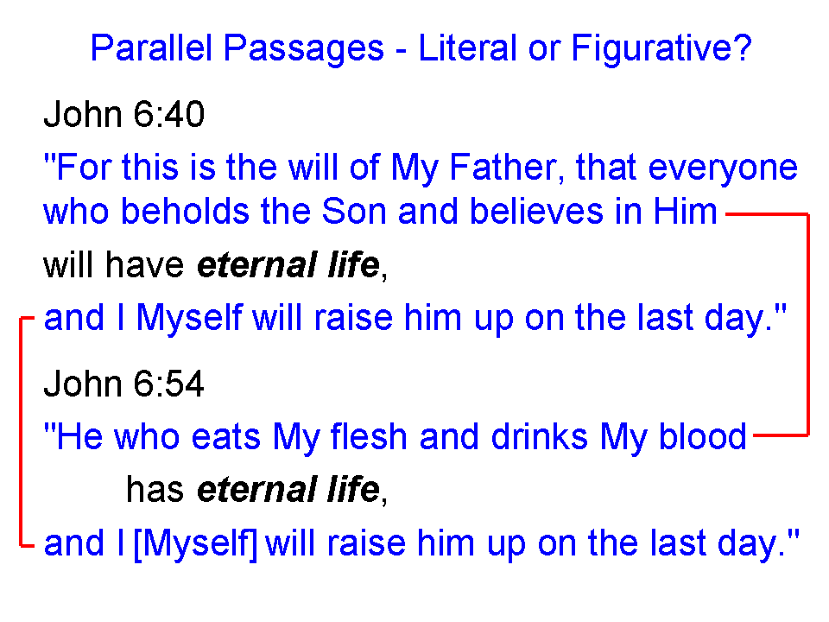
Beyond eating His flesh, which was brought up before, this passage introduces drinking His blood. With these words, some have seen this passage pointing to Jesus’ words in the Last Supper (Luke 22:14-23; 1 Corinthians 11:23-26). Seeing the verses in the inset in parallel, we can see that eating His flesh and drinking His blood is a metaphor for believing.

John 6:59-65
These things He said in the synagogue as He taught in Capernaum. 60 Therefore many of His disciples, when they heard this said, "This is a difficult statement; who can listen to it?" 61 But Jesus, conscious that His disciples grumbled at this, said to them, "Does this cause you to stumble? 62 "What then if you see the Son of Man ascending to where He was before? 63 "It is the Spirit who gives life; the flesh profits nothing; the words that I have spoken to you are spirit and are life. 64 "But there are some of you who do not believe." For Jesus knew from the beginning who they were who did not believe, and who it was that would betray Him. 65 And He was saying, "For this reason I have said to you, that no one can come to Me unless it has been granted him from the Father."

There was a time not too long ago when skeptics would have said that there were no synagogues in Israel at this time, but they have since been proven wrong by multiple lines of evidence, including the discovery of actual synagogues from the time of Christ and before. The disciples that verse 60 is referring to do not include any of the 12 disciples, but to others who do not believe (verse 64) and will soon stop following Christ (see verse 66). It is these who tell Jesus that His words are hard to believe, harsh and offensive. The word stumble is the word for a trigger in a trap – a snare. This is not a stumble that one recovers from – this one snags you for keeps.
John 6:66-71
As a result of this many of His disciples withdrew and were not walking with Him anymore. 67 So Jesus said to the twelve, "You do not want to go away also, do you?" 68 Simon Peter answered Him, "Lord, to whom shall we go? You have words of eternal life. 69 "We have believed and have come to know that You are the Holy One of God." 70 Jesus answered them, "Did I Myself not choose you, the twelve, and yet one of you is a devil?" 71 Now He meant Judas the son of Simon Iscariot, for he, one of the twelve, was going to betray Him.

At one point the disciples of John the Baptist are concerned that Jesus is gaining all of the disciples and John is gaining none. At one point earlier in this same chapter people were following Jesus everywhere they thought He went, and on finding Him asked Him to do a sign (again) so that they might believe. But on Christ’s words above many of them who did not believe anyway withdrew, and no longer supported and followed Jesus.

So Jesus turned to the twelve and asked if they would not also want to go away. Peter said that Christ had the words of eternal life, and that they had believed [perfect tense] and had come to know [perfect tense] Him as the Holy One of God. The name “Holy One” is used 45 times in the Old Testament, and in almost every case is clearly referring to God. In at least one case it is clearly referring to Christ being dead but resurrected:

Psalm 16:10
For You will not abandon my soul to Sheol;
Nor will You allow Your Holy One to undergo decay.

This passage in the Psalm of David was confirmed to be a prophecy about Christ’s resurrection. In Acts 2:24-32, Peter quoted passage regarding the resurrection of Christ, as did the apostle Paul in Acts 13:34-37.

Jesus, having chosen the twelve, and knowing the future of each one, knows that Judas will be His betrayer. The disciples, however, are clueless as to who that betrayer will be until after Judas’ betrayal is complete.

This and all Scripture quotes are NASU unless otherwise stated. ‘AM’ is not per NASU.
The words, “down out of heaven” are found only in John 6:33, 41, 42, 50, 51, 58 and Revelation 3:12; 10:1; 13:13; 21:2; 21:10.
? Matthew 13:55-56 "Is not this the carpenter's son? Is not His mother called Mary, and His brothers, James and Joseph and Simon and Judas? 56 "And His sisters, are they not all with us? Where then did this man get all these things?" Mark 6:3 "Is not this the carpenter, the son of Mary, and brother of James and Joses and Judas and Simon? Are not His sisters here with us?" And they took offense at Him.
See also Acts 3:14, where Peter calls Christ “the Holy and Righteous One”.

