John 7:1-24

John 7:1-5
After these things Jesus was walking in Galilee, for He was unwilling to walk in Judea because the Jews were seeking to kill Him. 2 Now the feast of the Jews, the Feast of Booths, was near. 3 Therefore His brothers said to Him, "Leave here and go into Judea, so that Your disciples also may see Your works which You are doing. 4 For no one does anything in secret when he himself seeks to be known publicly. If You do these things, show Yourself to the world." 5 For not even His brothers were believing in Him.
Jerusalem
Galilee

If we just read the first verse we might get the idea that Jesus just wasn’t going to go to Jerusalem, and would go about in Galilee instead. But we will see as we proceed through this passage, that the situation is quite complicated, and Jesus’ strategy is indirect. See the appendix items about the Feasts of Israel and the four brothers of Jesus. His brothers, knowing, apparently, that the Jews were seeking to kill Jesus, were encouraging Him to go to Jerusalem. As verse 5 discloses, Jesus’ brothers did not believe in Him. It is only after the resurrection that we find that Jesus’ brothers believed in Him – when at least Jesus’ brother James saw Him raised (1 Corinthians 15:7).

John 7:6-9
So Jesus said to them, "My time is not yet here, but your time is always opportune. 7 The world cannot hate you, but it hates Me because I testify of it, that its deeds are evil. 8 Go up to the feast yourselves; I do not go up to this feast because My time has not yet fully come." 9 Having said these things to them, He stayed in Galilee.

The apostle John begins with John 2:4 to state that Jesus’ time or hour had not yet come:

John 2:4
And Jesus said to her, "Woman, what does that have to do with us? My hour has not yet come."

John 7:6
So Jesus said to them, "My time is not yet here, but your time is always opportune.

John 7:8
"Go up to the feast yourselves; I do not go up to this feast because My time has not yet fully come."

John 7:30
So they were seeking to seize Him; and no man laid his hand on Him, because His hour had not yet come.

John 8:20
These words He spoke in the treasury, as He taught in the temple; and no one seized Him, because His hour had not yet come.

Why state that Jesus’ hour or time had not yet come (or similar) – several times? We find our answer in John 12:23, 13:1 and 17:1:

John 12:23 (see also John 12:27-50)
And Jesus answered them, saying, "The hour has come for the Son of Man to be glorified."

John 13:1
Now before the Feast of the Passover, Jesus knowing that His hour had come that He would depart out of this world to the Father, having loved His own who were in the world, He loved them to the end.

John 17:1
Jesus spoke these things; and lifting up His eyes to heaven, He said, "Father, the hour has come; glorify Your Son, that the Son may glorify You…"

So Jesus’ time or hour refers to His death, burial, resurrection, ascension and seating – historical and spiritual events in which we have been identified with Him. John 13:1 and Galatians 2:20 (also John 3:16, and Ephesians 5:2, 25) tell us that Jesus loved and gave Himself up for us, which meant the cross. So from the time that Jesus was preparing to turn the water into wine He was looking towards His ‘time’ and His ‘hour’. And John chapters 7 and 8 are the last of those times of anticipation.

Jesus tells His brothers that the world cannot hate them, as it does Jesus Himself. Later Jesus will tell His disciples something that reveals more about the world and who it hates:

John 15:18-20
"If the world hates you, you know that it has hated Me before it hated you. 19 If you were of the world, the world would love its own; but because you are not of the world, but I chose you out of the world, because of this the world hates you."

In John 7:8 we should observe that in the Greek verb Jesus says, “I am not right now going to the feast” instead of “I will not be going to the feast”. Jesus is telling the truth very carefully. If His brothers know that He will be there they will inform the Jewish authorities that Jesus is present.

John 7:10-13
But when His brothers had gone up to the feast, then He Himself also went up, not publicly, but as if, in secret. 11 So the Jews were seeking Him at the feast and were saying, "Where is He?" 12 There was much grumbling among the crowds concerning Him; some were saying, "He is a good man"; others were saying, "No, on the contrary, He leads the people astray." 13 Yet no one was speaking openly of Him for fear of the Jews.

Once Jesus’ brother had gone, Jesus did in fact go to Jerusalem covertly. The term ‘Jews’ in this context refers to the Jewish leaders. While the Jewish leaders were seeking to kill Jesus, the general public was divided, but expressing themselves privately.
John 7:14-18
But when it was now the midst of the feast Jesus went up into the temple, and began to teach. 15 The Jews then were astonished, saying, "How has this man become learned, having never been educated?" 16 So Jesus answered them and said, "My teaching is not Mine, but His who sent Me. 17 If anyone is willing to do His will, he will know of the teaching, whether it is of God or whether I speak from Myself. 18 He who speaks from himself seeks his own glory; but He who is seeking the glory of the One who sent Him, He is true, and there is no unrighteousness in Him."

Rather than remaining hidden, right in the middle of the feast Jesus goes into the temple area, which was the larger courtyard, rather than the inner temple area reserved for legally qualified Jews. Teaching was typically done by or under the colonnade (aka portico). The Jews – the Jewish leaders – are astonished that a man who had not been trained under another rabbi, according to the rabbinical traditions, speaks as a learned man.

Jesus, either hearing them or knowing what they are thinking responds that the teaching isn’t His own, but the teaching is from the One who sent Him – God the Father. If there is a willingness to do the Father’s will, then the one who is willing has the discernment to tell if what Jesus is teaching is from God. Selfish glory-seekers speak from their own mind, thoughts and resources. But the one who seeks the glory of the Father, as Christ does, is true and righteous.

John 7:19-24
"Did not Moses give you the Law, and yet none of you carries out the Law? Why do you seek to kill Me?" 20 The crowd answered, "You have a demon! Who seeks to kill You?" 21 Jesus answered them, "I did one deed, and you all marvel. 22 For this reason Moses has given you circumcision (not because it is from Moses, but from the fathers), and on the Sabbath you circumcise a man. 23 If a man receives circumcision on the Sabbath so that the Law of Moses will not be broken, are you angry with Me because I made an entire man well on the Sabbath? 24 "Do not judge according to appearance, but judge with righteous judgment."

Jesus’ accusation is bold! “…none of you carries out the Law!” His reasoning is, “If none of you carries out the Law why do you seek to kill Me by claiming falsely that I have broken one Law – the Sabbath?” The crowd – not the Jewish leaders, who are seeking to kill Him – says that Jesus has a demon because they are unaware of anyone trying to kill Jesus.

But Jesus takes it right to the pivotal point at which they determined to kill Him: When Jesus healed the lame man on the Sabbath, and told him to pick up his pallet and walk. The Jews allowed a baby boy to be circumcised on the 8th day, even if it was on the Sabbath, but would not allow Jesus to make a lame man well on the Sabbath. He told them that they must judge with righteous judgment, implying that they had not done so.
Appendix On The Feasts Of Israel

The Feasts of Israel Given in the Law of Moses
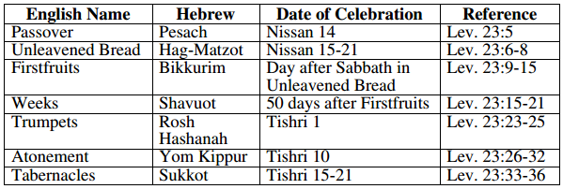

Additional Feasts of Israel, Not Given in the Law of Moses
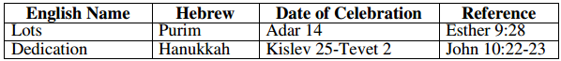

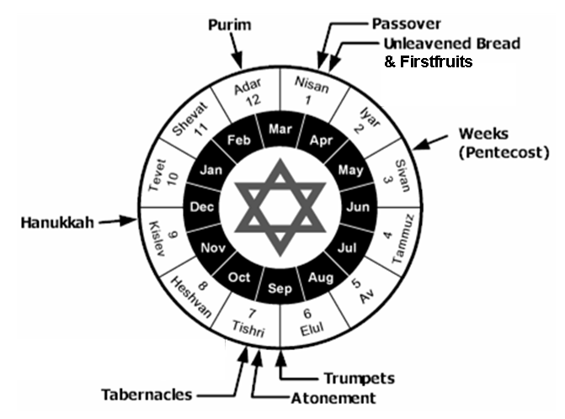
Appendix On The Family Tree of Jesus

Here is a family tree of Jesus’ family, with notes about each:
Joseph Mary

Jesus James Joses Jude Simon Salome Mary

- Since Jesus was born of Mary as a virgin (Matthew 1:23, 25; Luke 1:27, 34), Joseph was not the biological father of Jesus, as he was of Jesus’ other siblings. So Jesus was properly a half-brother to these siblings.
- Jesus’ brothers did not believe in Him until after Christ was resurrected (John 7:5; Acts 1:14).
- James and Jude, actually Jacob and Judas, were the authors of the New Testament books by those names.
- The names James, Joses, Jude & Simon are given in Mark 6:3, as is the fact that Jesus had sisters. The names Salome and Mary are from documents outside of Scripture, so the names and number of Jesus’ sisters has less certainty, though the names and number may be accurate.
- Of Jesus’ brothers, James is the one about whom the most is recorded, including John 12:17; 15:13; 21:18; 1 Corinthians 15:7; Galatians 1:19; 2:9, 12; James 1:1, Jude 1, and in the writings of Josephus. An ossuary box from New Testament times has been found with the inscription, “James (actually ‘Jacob’), son of Joseph, brother of Jesus”. After careful investigation, and even a public trial, it appears to be genuinely that of James, the brother of Jesus.

