John 8:1-30

John 7:53 to 8:11 is noted in many modern translations as not being in the most reliable ancient texts, or language to that effect. While the presentation is brief, the supplement to this handout favors the view that this passage ought to be considered as fully biblical and inspired and located in the place in which it is typically shown. The usual notes about this passage not being original seem to come from a biased assessment of the textual evidence, and from lack of consideration of all of the historical evidence.

The geographical and time context for all of today’s passage (John 8:1-30) continues in Jerusalem at the time of the last Mosaic feast of the year, about six months before Christ was crucified. This passage also fits with the general context of the leaders in Jerusalem challenging Jesus with increasing intensity.

John 8:1-5
But Jesus went to the Mount of Olives. 2 Early in the morning He came again into the temple, and all the people were coming to Him; and He sat down and began to teach them. 3 The scribes and the Pharisees brought a woman caught in adultery, and having set her in the center of the court, 4 they said to Him, "Teacher, this woman has been caught in adultery, in the very act. 5 Now in the Law Moses commanded us to stone such women; what then do You say?"

The scribes and Pharisees, mentioned here together only in John, are not truly interested, of course, in getting an answer from Jesus to solve their dilemma, but rather to place Jesus between the requirements of the Law of Moses and the Romans, who reserved capital punishment for themselves (see John 8:6 for confirmation of this). There were instances in which the Jews carried out stoning anyway, as in the case of Stephen (Acts 7:54-60), but they did so out of view of the Roman officials and officers. Additionally, if Jesus said to execute her, He would contradict His own reputation for being gracious and forgiving (see Luke 5:20; 7:47).

What the Law of Moses actually says about the punishment for adultery differs from how the scribes and the Pharisees were handling this and other cases. This is what the Law of Moses requires (emphasis added):

Leviticus 20:10-12 (see also Deuteronomy 22:22)
If there is a man who commits adultery with another man's wife, one who commits adultery with his friend's wife, the adulterer and the adulteress shall surely be put to death. 11 If there is a man who lies with his father's wife, he has uncovered his father's nakedness; both of them shall surely be put to death, their bloodguiltiness is upon them. 12 If there is a man who lies with his daughter-in-law, both of them shall surely be put to death; they have committed incest, their bloodguiltiness is upon them.

By New Testament times, the Law of Moses had been interpreted in a number of ways that were male biased, but did not reflect the original words or intent of the Law of Moses.
John 8:6-9
They were saying this, testing Him, so that they might have grounds for accusing Him. But Jesus stooped down and with His finger wrote on the ground. 7 But when they persisted in asking Him, He straightened up, and said to them, "He who is without sin among you, let him be the first to throw a stone at her." 8 Again He stooped down and wrote on the ground. 9 When they heard it, they began to go out one by one, beginning with the older ones, and He was left alone, and the woman, where she was, in the center of the court.

The first part of verse 6 reveals the motive for bringing the woman to Jesus for a judgment. And this is not the only instance where the leaders of the Jews try to place Jesus between the Law of Moses and the Roman authorities (see Matthew 22:15-22). The last part of verse 6, where Jesus wrote on the ground, has brought on a great deal of speculation about what Jesus wrote, but we ought to recognize that any proposals about what Jesus wrote on the ground are simply guesses. But whatever Jesus wrote, the scribes and the Pharisees still persisted in their request for a judgment from Jesus, one way or the other. So Jesus stood up, and told them, as quoted from verse 7, "He who is without sin among you, let him be the first to throw a stone at her." At that Jesus resumed writing whatever He wrote on the ground. Incidentally, this is the only instance we have of Jesus writing anything, yet it does not appear to have been permanent, and we don’t know the content of what He wrote.

The leaders, apparently responding to what Jesus said more than what He wrote on the ground, left the woman and Jesus, one at a time, from the oldest to the youngest, such that ultimately Jesus and the woman were left alone. There are several areas where the scribes and the Pharisees could have judged themselves as being guilty:

- These men did not bring both the man and the woman to Jesus for judgment, and in that they had violated the Law of Moses in accusing and bringing only her. Any judgment would be carried out in violation of the explicit terms of the Law of Moses that both the man and the woman were to be punished.

- They may at least have had thoughts of adultery (Matthew 5:27, 28), including:

- They may have arranged for this adultery to take place, in order to catch her in the act at this specific place and at this specific time. This would mean that these men had been involved in pondering, strategizing and arranging for an adultery to take place, and to be present at least in the initial stages of the act. That would contaminate their testimony, leading to:

- They may not have had two or more qualified witnesses who had not been involved in some way (Deuteronomy 17:6; 19:15). In fact, they may not have had two actual qualified witnesses at all – even if the woman was guilty.

- Jesus did not say the word ‘sin’ with a definite article, equivalent to ‘the’, but without the definite article, so being guilty of sin in general was conveyed. These men would be hard-pressed to say that each of them was totally guiltless, and the older the men were the more difficult His words would be.
By stooping to write on the ground again, Jesus did not make this a matter of losing in the confrontation with Him, but of considering the matter in their own hearts, minds, memories, whether recent or longer-term memories. They would be compelled to judge themselves, individually and personally.

John 8:10-11
Straightening up, Jesus said to her, "Woman, where are they? Did no one condemn you?" 11 She said, "No one, Lord." And Jesus said, "I do not condemn you, either. Go. From now on sin no more."

The words in verses 10 and 11 are the words which notably caused some ancient copyists not to include this passage in the text that they copied, or to include it in the lectionaries that were used for public reading in the church services, and that may explain why this passage is not in some ancient copies of the gospel of John.

While Jesus did not condemn the woman, who may have been set up specifically in order to catch Jesus in this concocted dilemma, He also told her to go and sin no more. Even if she had been set up, and not charged according to the Law of Moses, she still cooperated with the adultery to some point, and Christ told her not to continue in that or other sins, but to sin no more from that time forward.

John 8:12-13
Then Jesus again spoke to them, saying, "I AM the Light of the world; he who follows Me will not walk in the darkness, but will have the Light of life." 13 So the Pharisees said to Him, "You are testifying about Yourself; Your testimony is not true."

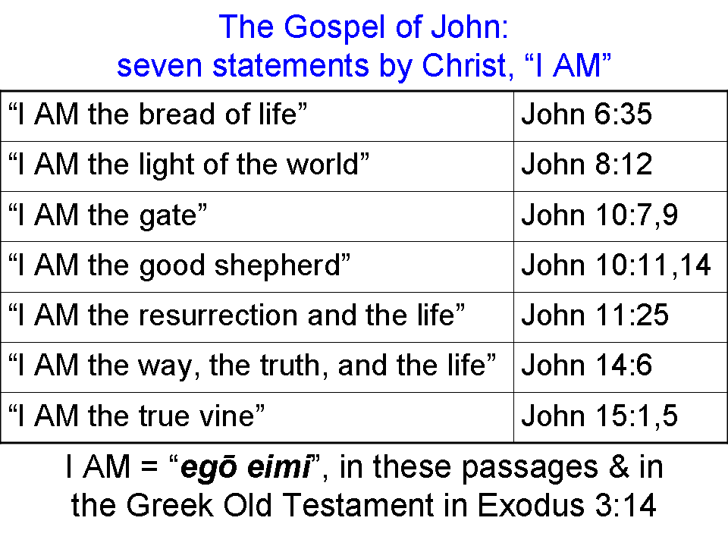
Some Pharisees, being the most numerous and popular of the sects of the Jews, were still nearby to hear Jesus’ words – likely other than the ones who had developed the plot to have Jesus pronounce sentence on the woman caught in adultery. And Jesus did not say these words in secret, but publicly. Jesus made one of His ‘I AM’ statements connected with a metaphor, “I AM the light of the world”.

The Pharisees, eager to discredit Jesus’ statements, discounted His testimony on His own behalf. His testimony about Himself, they said, did not have to be counted as true.
John 8:14-20
Jesus answered and said to them, "Even if I testify about Myself, My testimony is true, for I know where I came from and where I am going; but you do not know where I come from or where I am going. 15 You judge according to the flesh; I am not judging anyone. 16 But even if I do judge, My judgment is true; for I am not alone in it, but I and the Father who sent Me. 17 Even in your law it has been written that the testimony of two men is true. 18 I AM He who testifies about Myself, and the Father who sent Me testifies about Me." 19 So they were saying to Him, "Where is Your Father?" Jesus answered, "You know neither Me nor My Father; if you knew Me, you would know My Father also." 20 These words He spoke in the treasury, as He taught in the temple; and no one seized Him, because His hour had not yet come.

Jesus said that His testimony about Himself is true, knowing as He did, that He came from heaven and would be going to heaven. His testimony did not have the element of unreliability and sin that other testimony might contain, because He came from heaven as the Son of God. But Jesus tells them that they know nothing about heaven, so they judge in physical and materially-oriented ways. Jesus, on the other hand came into the physical realm from the Father, and would return to the Father, who also would testify of Christ.

In verse 18 Jesus again claims ‘I AM’, but without using a metaphor, along with a claim that the Father testifies on His behalf. The Pharisees’ question, of course, is earthly and physical. They apparently expect the name of a human being who is His earthly father. Jesus tells them that they don’t know Him or His (heavenly) Father.

John 8:21-27
Then He said again to them, "I go away, and you will seek Me, and will die in your sin; where I am going, you cannot come." 22 So the Jews were saying, "Surely He will not kill Himself, will He, since He says, 'Where I am going, you cannot come'?" 23 And He was saying to them, "You are from below, I am from above; you are of this world, I am not of this world. 24 "Therefore I said to you that you will die in your sins; for unless you believe that I AM He, you will die in your sins." 25 So they were saying to Him, "Who are You?" Jesus said to them, "What have I been saying to you from the beginning? 26 I have many things to speak and to judge concerning you, but He who sent Me is true; and the things which I heard from Him, these I speak to the world." 27 They did not realize that He had been speaking to them about the Father.

Jesus repeats from before, possibly because it is a different group of people, at least in part, that He will go away, and they will seek Him, and that they cannot come where He is going. A group before had heard similar words, and wondered if Jesus intended to go to the Jews in the diasporia among the Gentiles (John 7:35). Now this group of Jews is wondering if He is going to kill Himself.

Jesus tells these Jews who do not believe that, unless they do believe, they are going to die in their state of sin, and in their sins. This is a positional statement regarding the unbeliever. Only belief takes a person out of the position of sin or being in their sins.
John 8:28-30
So Jesus said, "When you lift up the Son of Man, then you will know that I AM He, and I do nothing on My own initiative, but I speak these things as the Father taught Me. 29 And He who sent Me is with Me; He has not left Me alone, for I always do the things that are pleasing to Him." 30 As He spoke these things, many came to believe in Him.

Jesus tells them that when they lift Him up to be crucified, then His identity will be apparent. Jesus is going to please the Father who is with Him and sent Him, in all that He does – even to the point of death on the cross.

There were various ones about, in addition to the Pharisees that Jesus spoke to. Many of these came to believe. In the verses that follow we will see that the faith of many of these was quite shallow.

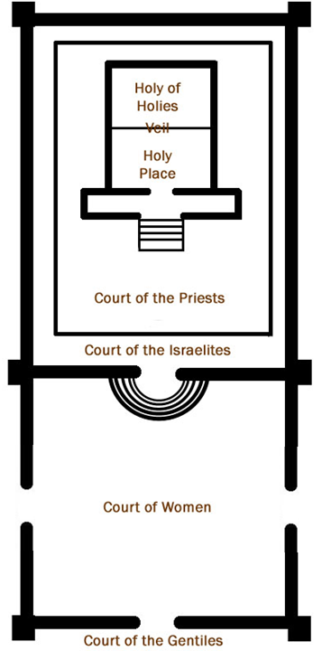

The treasury was in the Court of Women (specifically, qualified Jews and Jewish women were permitted; Mark 13:41-44; Luke 21:1-4).

This and all quotes of Scripture are from the New American Standard Updated (NASU) edition, except in the case where ‘I AM’ reflects the Greek egō eimi, in which case the capitalization of ‘AM’ is not from the NASU, but specific to this handout.
See supplement, “18 4 CLASS CONDITIONS OF ‘IF’…”

