John 9:1-41

Jesus and His disciples were still in Jerusalem for the events and conversations recorded for us in John chapter 9. All of John chapter 9, covered in this one lesson, is centered around the man who was born blind, and was healed by Jesus.

John 9:1-5
As He passed by, He saw a man blind from birth. 2 And His disciples asked Him, "Rabbi, who sinned, this man or his parents, that he would be born blind?" 3 Jesus answered, "It was neither that this man sinned, nor his parents; but it was so that the works of God might be displayed in him. 4 We must work the works of Him who sent Me as long as it is day; night is coming when no one can work. 5 While I am in the world, I am the Light of the world."

It was common among the Jews to see blindness as the result of sin – disobedience to the Law of Moses. There was certainly a place for this belief under the Law of Moses:

Deuteronomy 28:15, 28-29
"But it shall come about, if you do not obey the Lord your God, to observe to do all His commandments and His statutes with which I charge you today, that all these curses will come upon you and overtake you: "… "The Lord will smite you with madness and with blindness and with bewilderment of heart; 29 and you will grope at noon, as the blind man gropes in darkness, and you will not prosper in your ways; but you shall only be oppressed and robbed continually, with none to save you."

And there was even some support in the Law for the idea that the consequences of not obeying the Law might be carried onto the next generations, possibly down to the third or fourth generation after the sin had been committed:

Exodus 20:5
…I, the Lord your God, am a jealous God, visiting the iniquity of the fathers on the children, on the third and the fourth generations of those who hate Me…

So within the Jewish context the only question among them would be as to whether the parents had sinned or the man himself had sinned – though being born blind was admittedly harder to explain as being the result of the man having sinned. As Jesus explains to His disciples, there is another reason for this man to have been born blind than, “Who sinned?” Jesus, as the Messiah would provide evidence of that by healing this man born blind, though the disciples did not know this when they asked their question:

Isaiah 35:5-6 (see also Isaiah 42:6-7)
Then the eyes of the blind will be opened
And the ears of the deaf will be unstopped.
6 Then the lame will leap like a deer,
And the tongue of the mute will shout for joy.
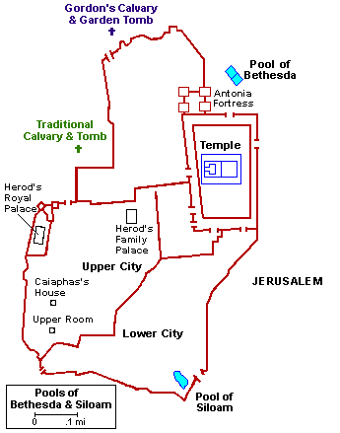
John 9:6-5
When He had said this, He spat on the ground, and made clay of the spittle, and applied the clay to his eyes, 7 and said to him, "Go, wash in the pool of Siloam" (which is translated, Sent). So he went away and washed, and came back seeing.

You will notice that Jesus’ healings were not uniform. In some cases, such as this, action was required (Go, wash) in order for the person to be healed. In one instance Jesus healed two blind men at once, but only touched their eyes. In other cases healings took place at the request of another person than the one to be healed and Jesus even healed from a distance. Then in some others, the element of faith is mentioned, while in still others, it is not. There is even an instance where a healing from blindness involved two stages of healing – partial healing from blindness, then complete healing (Mark 8:22-26).

John 9:7-12
Therefore the neighbors, and those who previously saw him as a beggar, were saying, "Is not this the one who used to sit and beg?" 9 Others were saying, "This is he," still others were saying, "No, but he is like him." He kept saying, "I am the one." 10 So they were saying to him, "How then were your eyes opened?" 11 He answered, "The man who is called Jesus made clay, and anointed my eyes, and said to me, 'Go to Siloam and wash'; so I went away and washed, and I received sight." 12 They said to him, "Where is He?" He said, "I do not know."
We’ve seen this before, when the groups among the Jews had varying opinions. In this case, neighbors of the man, having seen him completely healed, expressed different levels of belief in the healing, and therefore the identification of the man who had been blind. When asked, the man who had been blind gave a brief summary of the account. While he credits his healing to Jesus, he doesn’t know where He is.

John 9:13-17
They brought to the Pharisees the man who was formerly blind. 14 Now it was a Sabbath on the day when Jesus made the clay and opened his eyes. 15 Then the Pharisees also were asking him again how he received his sight. And he said to them, "He applied clay to my eyes, and I washed, and I see." 16 Therefore some of the Pharisees were saying, "This man is not from God, because He does not keep the Sabbath." But others were saying, "How can a man who is a sinner perform such signs?" And there was a division among them. 17 So they said to the blind man again, "What do you say about Him, since He opened your eyes?" And he said, "He is a prophet."

Though Jesus and His disciples had repeatedly done and said things that stirred Sabbath controversies with the Jews, possibly even more than are recorded, this will be the last one we will read about in the gospel of John (see Sabbath Controversies Table below).

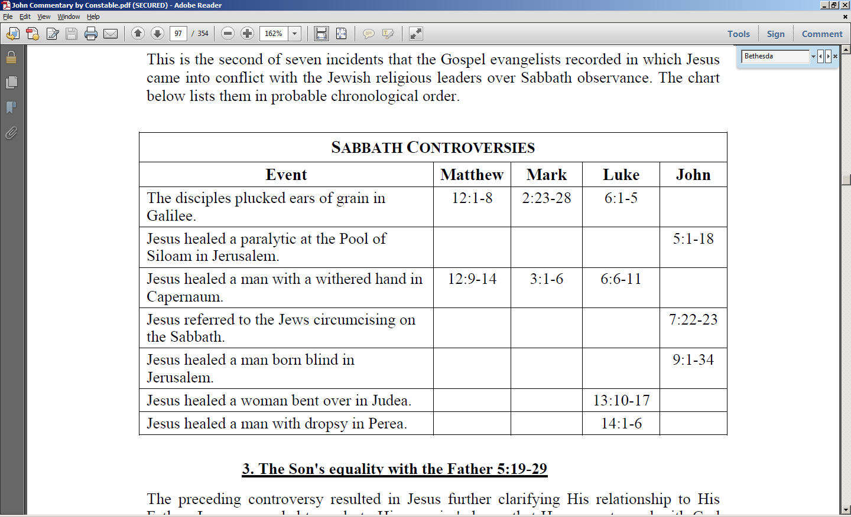

The Pharisees would have considered Jesus to have broken the Sabbath both by healing on the Sabbath, and by mixing and applying the mud to the man’s eyes. So like the healing of the man by the pool of Bethesda, this was a ‘double Sabbath-breaking event’.
But, as usual, the Jews had differing opinions among themselves. When asked, the man who had been blind held to the opinion that Jesus was a prophet. But the Pharisees were still divided among themselves, and still skeptical of what the man who had been born blind had said, so they widened their investigation to include the man’s parents. We also will find out why the man born blind possibly called Jesus a prophet, at first, rather than calling Him ‘the Christ’ (the Messiah).

John 9:18-23
The Jews then did not believe it of him, that he had been blind and had received sight, until they called the parents of the very one who had received his sight, 19 and questioned them, saying, "Is this your son, who you say was born blind? Then how does he now see?" 20 His parents answered them and said, "We know that this is our son, and that he was born blind; 21 but how he now sees, we do not know; or who opened his eyes, we do not know. Ask him; he is of age, he will speak for himself." 22 His parents said this because they were afraid of the Jews; for the Jews had already agreed that if anyone confessed Him to be Christ, he was to be put out of the synagogue. 23 For this reason his parents said, "He is of age; ask him."

The parents of the man who had been born blind were called in to verify that this was, in fact, their son, but they denied knowing anything about Christ, since open confession that Jesus was the Christ (the Messiah) would apparently get them barred from the synagogue. They would essentially be treated as a non-God-fearing Gentile. The parents, apparently in fear of what the Jews might to them, redirected the interrogation back to their son.

John 9:24-34
So a second time they called the man who had been blind, and said to him, "Give glory to God; we know that this man is a sinner." 25 He then answered, "Whether He is a sinner, I do not know; one thing I do know, that though I was blind, now I see." 26 So they said to him, "What did He do to you? How did He open your eyes?" 27 He answered them, "I told you already and you did not listen; why do you want to hear it again? You do not want to become His disciples too, do you?" 28 They reviled him and said, "You are His disciple, but we are disciples of Moses. 29 We know that God has spoken to Moses, but as for this man, we do not know where He is from." 30 The man answered and said to them, "Well, here is an amazing thing, that you do not know where He is from, and yet He opened my eyes. 31 We know that God does not hear sinners; but if anyone is God-fearing and does His will, He hears him. 32 Since the beginning of time it has never been heard that anyone opened the eyes of a person born blind. 33 If this man were not from God, He could do nothing." 34 They answered him, "You were born entirely in sins, and are you teaching us?" So they put him out.

The man who had been born blind was called in for further interrogation. The statement, “Give glory to God” was a way of telling the man to tell the truth, and to give credit where credit is due. We might say in our modern vernacular that they reminded him that he was still under solemn oath. But the Pharisees had already concluded that Jesus was a sinner, so they were also warning the man born blind that his testimony about Christ had better line up with that judgment.
The man born blind testified that he didn’t know if Christ was a sinner or not, but that he once was blind but now he sees. The Pharisees who were doing the interrogation asked the man to tell them what he had already told them before. He came back to the Pharisees by asking if they wished to be Jesus’ disciples, too. The Pharisees came back by flatly stating that this man was Jesus’ disciple, but that they were disciples of Moses, through the books of Moses (Genesis, Exodus, Leviticus, Numbers, Deuteronomy). They stated that they knew that God spoke through Moses, but that they did not know where Jesus is from – that is, that they didn’t see Jesus as speaking from God. The man born blind came back that these Pharisees were amazing! They didn’t know where Jesus’ power came from, but the fact was that Jesus did open this man’s eyes! The man born blind openly stated that God worked through Christ to open his eyes. The Pharisees were greatly offended that this man who was once blind was teaching them truth about Jesus whom they had already judged and condemned, so they barred him from the synagogue, which would have meant the loss of various privileges that were considered essential for a Jew.

John 9:35-41
Jesus heard that they had put him out, and finding him, He said, "Do you believe in the Son of Man?" 36 He answered, "Who is He, Lord, that I may believe in Him?" 37 Jesus said to him, "You have both seen Him, and He is the one who is talking with you." 38 And he said, "Lord, I believe." And he worshiped Him. 39 And Jesus said, "For judgment I came into this world, so that those who do not see may see, and that those who see may become blind." 40 Those of the Pharisees who were with Him heard these things and said to Him, "We are not blind too, are we?" 41 Jesus said to them, "If you were blind, you would have no sin; but since you say, 'We see,' your sin remains.

Jesus brought the issue back to believing, which is the theme of the Gospel of John. He asked the man born blind if he believed in the Son of Man, a term for the Messiah out of Daniel 7:13, 14. The man born blind asked who He is so that he might believe in Him. Jesus told him that He Himself was the Son of Man – the Messiah. The man born blind then declared that he believed, and he worshipped Jesus right then and there.

In verse 39 we have a point of discernment to work out regarding judgment, and a passage just ahead of where we are now will help us gain insight into what Jesus said:

John 12:46-49
"I have come as Light into the world, so that everyone who believes in Me will not remain in darkness. 47 If anyone hears My sayings and does not keep them, I do not judge him; for I did not come to judge the world, but to save the world. 48 He who rejects Me and does not receive My sayings, has one who judges him; the word I spoke is what will judge him at the last day."

Christ came to save in His first coming, but the events from the Tribulation period, His Second coming, the Millennial Kingdom, and the White throne judgment will indeed involve great events and durations of judgment on His part (see pages 6 through 8). The Pharisees claim that they do in fact see will be used as a point of judgment against them on the last day – the White Throne Judgment.

Appendix: The Mostly New Testament Doctrine of ‘Proportional Punishment’

There are a number of Bible-believing Christians who will say that sins will not be the issue for those who spend eternity in the lake of fire – only unbelief. But there a number of biblical passages that indicate that this view sees the biblical teaching ‘upside down’ and therefore not quite correctly. The biblical teaching is rather that a person is now and will be condemned for his or her sins - unless they believe. Believing in Christ for salvation is the only escape from the certain judgment, condemnation and punishment for sins.

The reasons for understanding Scripture in this way can be summarized as follows:

- A tragic identification truth: Unbelievers are now dead in their trespasses and sins and transgressions (Ephesians 2:1-3, 5; Colossians 2:13), which means that they are spiritually separated from God’s life (Ephesians 4:18), because they are positionally in their trespasses and sins and transgressions. Paul wrote in 1 Corinthians 15:17c that without Christ’s actual, historical death and resurrection, “…you are still in your sins”. Jesus told the Pharisees, “… I said to you that you will die in your sins, unless you believe that I am He, you will die in your sins." John 8:24bc.

- If unbelief were the only sin for which a person were condemned, then the condemnation for each unbeliever would be equal. But Christ, the One who will judge unbelievers, repeatedly taught greater judgments and condemnation for greater sins, including unbelief (Matthew 10:15; 11:20-24; 16:27; 18:5-6; 23:14; Mark 9:42-43; 12:38-40; Luke 10:12-15; 20:45-47).

- God’s wrath is now upon and will come upon unbelievers for their sins (Romans 1:18; Ephesians 5:6; Colossians 3:6; 1 Thessalonians 2:16).

- The unbelieving Gentile’s sins will be judged by the law of conscience, and the unbelieving Jew’s sins will be judged by the Law of Moses (Romans 2:1-3:20). In either case it will be their sins, as measured by a Principle of Law, for which they will be condemned, because they don’t believe.

- Both believers and unbelievers are and will be judged on the basis of deeds (KJV: works), the believer for reward, and the unbeliever for degree of condemnation and punishment (Psalm 62:12; Jeremiah 17:10; Matthew 16:27; Romans 2:1-16; 14:10-12; 1 Corinthians 3:10-15; 2 Corinthians 5:10; 11:15; 2 Timothy 4:14; 1 Peter 1:17; Revelation 2:23; 20:12, 13; 22:12). There are about 50 passages of this kind in the Old and New Testaments.

- At the Great White Throne judgment, which will only include unbelievers, Christ will judge on the basis of the absence of the unbelievers’ names from the book of life, which is why they will be there and why they will be headed for the Lake of Fire. He will also judge them on the basis of their works or deeds (Revelation 20:12; Galatians 5:19-21), the criteria for relatively greater or lesser judgments and condemnations in the Lake of Fire (Revelation 20:11-15, also see the references given under the 2nd and 5th bullets above). For the unbeliever who is headed for the Great White Throne Judgment, sins are and will remain the issue because they did not avail themselves of the one means of escape from the wrath of God upon sins, that is, through faith in His costly and gracious provision through Christ.
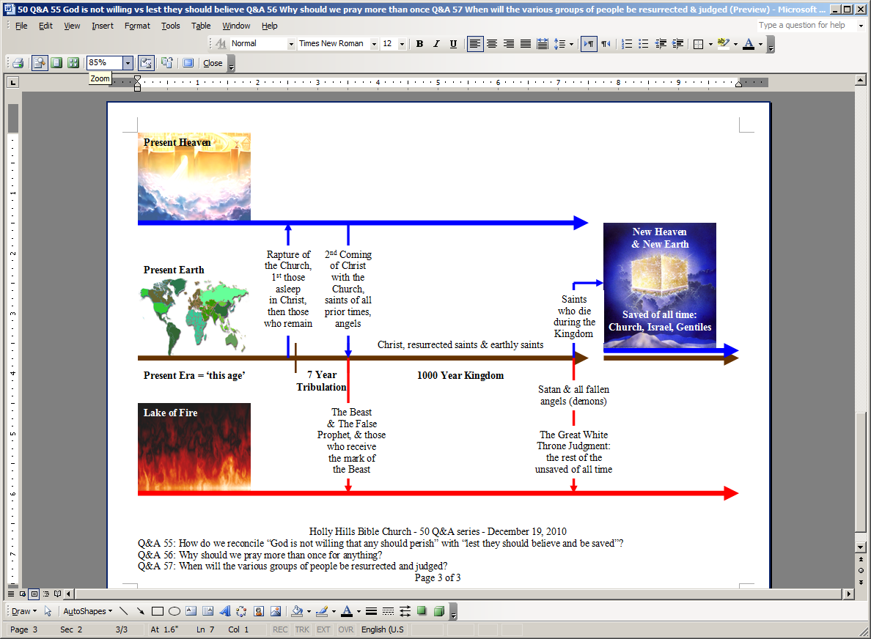
Future Things: Key Places, Events, Resurrections, Judgments & People Groups
Text of ‘New Heaven & New Earth’ is on top of copyrighted artwork by Pat Marvenko Smith. Right to use has been purchased.
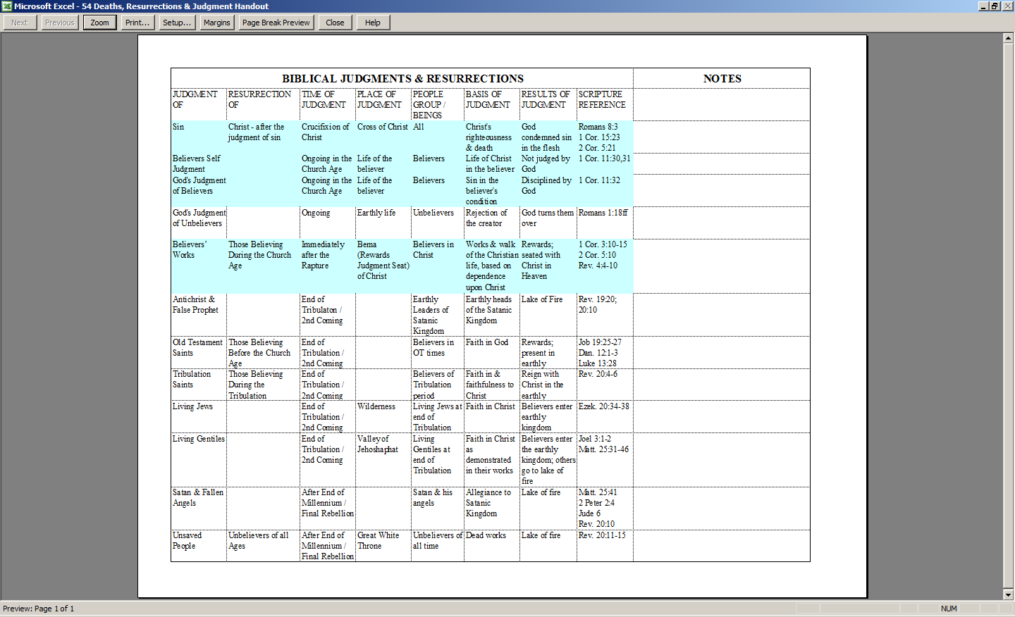
Blue highlight shows judgments for church age believers, those being believers form Acts 2 to the Rapture – the taking home of the church by Christ.

This is an outside storage reservoir called “the waters of Shiloah” (Isaiah 8:6), “the pool of Shelah” (Nehemiah 3:15) & “the pool of Siloam” (in John 9:7 & 11).
Such as Introduction to the Gospel of John, Hall Harris, page 84; Grace in Focus, July / August 2007, Bob Wilkin, page 4, and Grace in Focus, November / December 2007, Zane Hodges, page 4.

