John 10:22-42

John 10:22-23
At that time the Feast of the Dedication took place at Jerusalem; 23 it was winter, and Jesus was walking in the temple in the portico of Solomon.

Jewish Feasts in the Gospel of John
Name of Feast | Reference in John | Time Celebrated
Passover | 2:13, 23 | April 7, A.D. 30
“A feast of the Jews” | 5:1 | October 21-28, A.D. 31?
Passover | 6:4 | April 13/14, A.D.32
Tabernacles (Booths) | 7:2 | September 10-17, A.D.32
Dedication (Hanukkah) | 10:22 | December 18-25, A.D. 32
Passover | 11:55, 12:1 | April 3, A.D.33

This is the only mention of the feast that was added from the time of the Maccabees, known today as Hanukkah. The Portico of Solomon was the portion of the perimeter colonnade that was on either side of the eastern gate to the temple.

John 10:24
The Jews then gathered around Him, and were saying to Him, "How long will You keep us in suspense? If You are the Christ, tell us plainly."

The Jews were wanting to really get a clear and well-witnessed point on which to place a charge against Jesus. If they would be able to get Jesus to just state openly and plainly something like, “I am the Messiah” in front of two or more witnesses, that would fulfill their desire. After all, they supposed, Jesus was from Nazareth, not Bethlehem (Micah 5:2), and Jesus did not come with the clouds (Daniel 7:13), so He could not be the Messiah (Greek: ho Christos; Hebrew: HaMashiach). As we will soon see, Christ does one better than claim to be the Messiah. He claims to be deity in completely unmistakable terms.

John 10:25-30
Jesus answered them, "I told you, and you do not believe; the works that I do in My Father's name, these testify of Me. 26 But you do not believe because you are not of My sheep. 27 My sheep hear My voice, and I know them, and they follow Me; 28 and I give eternal life to them, and they will never perish; and no one will snatch them out of My hand. 29 My Father, who has given them to Me, is greater than all; and no one is able to snatch them out of the Father's hand. 30 I and the Father are one."

There is, in the language of New Testament Greek, a pair of Greek words (ou me, literally, “not not”) that convey the idea of “not the slightest chance” or “not at all” or “by no means”. Though double negatives are not proper in the English language, in New Testament Greek, the double negative serves to emphasize the negation, and is therefore called an emphatic negation – “a double negative strengthening the denial”,,

In part of Jesus’ response to the challenge of some Jews gathered about Him to declare plainly if He was the Christ (Messiah), Jesus told the Jews about His relationship with the sheep. Jesus has already said in John 10:11 and 14, “I AM the Good Shepherd” and that He, as the Shepherd, was also the Door (John 10:2, 7, 9). The words of verses 28 and 29 are of great interest to us regarding the impossibility that one could lose his or her salvation. While this passage was said explicitly to the Jews, in response to their question, it is in the larger context of salvation by faith, the theme of the gospel of John (John 20:31).

The same root word translated “perish” in John 10:28 (Greek: apollumi) is used in Matthew 10:28b. “…but rather fear Him who is able to destroy both soul and body in hell.” It is used similarly in John 3:16 and 17:12. In the John 3:16 context, “perish” (Greek: apollumi) is used in contrast to “eternal life”. So the intent is clear: apollumi means to be in, or reserved for, hell. It is used in the middle voice in John 10:28, meaning that the action of destroying or perishing (apollumi) cannot be accomplished by one’s actions with the result coming back upon oneself. Additionally, the use of ou me regarding the ability of one of the sheep to perish of the sheep’s own doing is emphatically negated: “not the slightest chance”.

The words of Jesus in John 10:28 and 29 also tell us that the life that Jesus graciously and continually gives to His sheep cannot be taken away by any outside hand. Drawing from the Shepherd and the sheep metaphor, neither the thief (John 10:10), nor the robber (John 10:8), nor the wolf (John 10:12) can take anyone out of the hand of the Son or Father. The one who is the Shepherd is also the Door, and will not allow access to any who will take or harm any of the Sheep.
In John 10:28, in expanded and explained form, Jesus is therefore saying that eternal life is something He gives constantly to His sheep, and that there is not even the slightest possibility that they can lose that eternal life so as to perish in hell, even of their own doing, and no other outside entity can remove those sheep from His hand, those to whom He constantly gives life. The saving work of Christ is therefore continually giving us eternal life that cannot be lost of our own doing, nor by that of another. Verse 29 even takes that one step further, with Christ saying that His sheep were given to Him by the Father, and they cannot be taken out of the Father’s hand either.

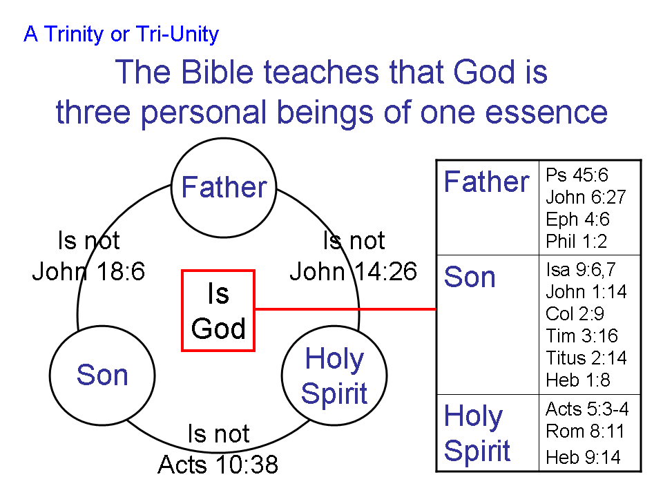
Regarding His words, “I and the Father are one”, Jesus did not mean that He and the Father were the same person of the Godhead. If Jesus had meant that, He would have used the masculine form of the word translated "one". Instead He used the neuter form of the word. So what Jesus says here, down to the smallest detail of Greek grammar, is consistent with the teaching regarding the Trinity that the Godhead consists of three personal beings, one essence.

So did Jesus make a claim to be the Messiah as requested? In truth, He went much farther than that! He made a clear claim in this chapter and in these words to have a unique and intimate connection to and to be God Himself. That is why we read…

John 10:31-33
The Jews picked up stones again to stone Him. 32 Jesus answered them, "I showed you many good works from the Father; for which of them are you stoning Me?" 33 The Jews answered Him, "For a good work we do not stone You, but for blasphemy; and because You, being a man, make Yourself out to be God."

Picking up stones to stone Jesus was a move that challenged the authority of the Romans, who had reserved the right of capital punishment for the Roman government. And the Fortress of Antonia had towers on which were stationed Roman soldiers and a direct stairway access to the temple courtyard (Acts 21:40). The Jews would likely be looking over their shoulders to see if the Romans were watching in their direction and taking notice. Additionally, there were a great many people at the feast, many of whom had positive opinions about Jesus. Anything that looked like a disturbance, including any Jews combating or loudly opposing those who tried to stone Jesus, would draw the attention of the Roman soldiers. Indeed, there were plenty of reasons for the Jews to hesitate to stone Jesus.
Jesus challenged them, asking for which good work they were going to stone Him. They replied that they were going to stone Him for blasphemy, since He made Himself out to be God. In fact He had made Himself out to be God and to have a unique connection with and intimacy with God a number of times. We will see that Jesus will make multiple claims to closeness to and identification with deity in the verses and chapters from this point forward. What the Jews did not at all understand was that God has made Himself to be a man!

John 10:34-39
Jesus answered them, "Has it not been written in your Law, 'I said, you are gods'? 35 "If he called them gods, to whom the word of God came (and the Scripture cannot be broken), 36 do you say of Him, whom the Father sanctified and sent into the world, 'You are blaspheming,' because I said, 'I am the Son of God'? 37 If I do not do the works of My Father, do not believe Me; 38 but if I do them, though you do not believe Me, believe the works, so that you may know and understand that the Father is in Me, and I in the Father." 39 Therefore they were seeking again to seize Him, and He eluded their grasp.

Jesus quoted a portion of Psalm 82:6 to show that the Old Testament used the word "gods" (Hebrew: elohim) to refer to those other than God Himself. If God spoke of people as "gods," why should the Jews object if Jesus implied that He was a god? The identity of the people whom God addressed as "gods" in Psalm 82:6 were Israel's
Judges. They were functioning as God's representatives. In that the context, there is a contrast between God as the true Judge (Ps. 82:1, 8), and the people whom He rebuked for judging falsely (Ps. 82:2-7). So as Jesus brought out this passage He was saying that these Jews, also, were judging falsely (John 7:24).

Jesus brings these unbelieving Jews back to the real issue: If they have to believe on the basis of His works instead of His words, they still need to believe. He then says that He is in the Father and the Father in Him (see John 17: 21-26).

John 10:40-42
And He went away again beyond the Jordan to the place where John was first baptizing, and He was staying there. 41 Many came to Him and were saying, "While John performed no sign, yet everything John said about this man was true." 42 Many believed in Him there.

Jesus left Jerusalem for the Jordan River Valley, where John had been baptizing. Many testified of the truth of the claims that John made about Christ. And many came to believe in Christ there.
Appendix On The Feasts Of Israel

The Feasts of Israel Given in the Law of Moses
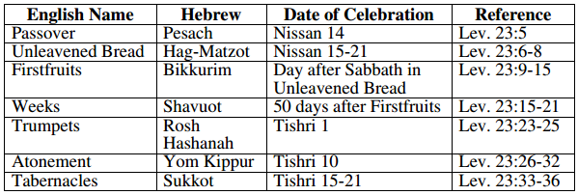

Additional Feasts of Israel, Not Given in the Law of Moses
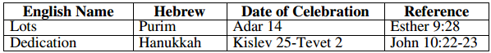

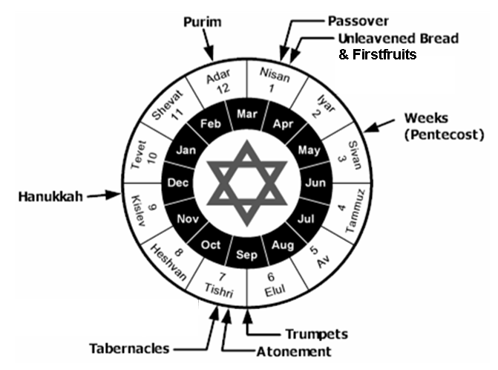

This and all Scripture quotes are from the New American Standard Updated (NASU), unless stated otherwise.
Adapted from a table in Zondervan Illustrated Bible Backgrounds Commentary, Volume 2, Clinton E. Arnold, General Editor, page 28.
The Complete Word Study Dictionary, New Testament, Spiros Zodhiates, 2000. Strong’s number 3364.
? http://www.studylight.org/lex/grk/view.cgi?number=3364
? http://www.duluthbible.org/g_f_j/OU_ME.htm
I AM is from the Greek ego eimi.

