John 11:1-27

John 10:22-23 places that passage at the time of the Festival of Lights, now more commonly known at Hanukkah, which typically falls in the month we call December. But John chapter 11 opens several months later, during the week before the week of the Passover that would be the last Supper. The passage that we will examine today sets up the event that is known as the resurrection of Lazarus, and it offers us major practical insights into how God works in our lives, and why He does things in the way that He does. We will also see that not only will Jesus resurrect Lazarus to this life and Jesus will be resurrected to a new kind of life, but His identity IS the resurrection and the life.

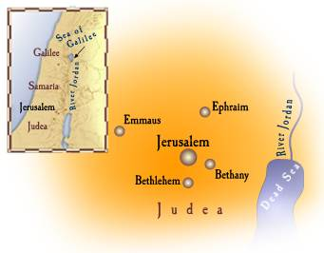
John 11:1-3
Now a certain man was sick, Lazarus of Bethany, the village of Mary and her sister Martha. 2 It was the Mary who anointed the Lord with ointment, and wiped His feet with her hair, whose brother Lazarus was sick. 3 So the sisters sent word to Him, saying, "Lord, behold, he whom You love is sick."

Bethany was a village just to the east of Jerusalem, along the road from Jericho, at the north end of the Dead Sea, to Jerusalem. About one in five women in Israel was named Mary, so the names of her brother Lazarus and sister Martha, as well as the village named Bethany, help to clarify which Mary John wrote about. The account of Mary anointing Jesus’ feet with ointment will be given in the next chapter (chapter 12). As we will soon see, the sisters Mary and Martha sent word to Jesus in the hope that Jesus would arrive in Bethany in time to heal Lazarus and prevent Lazarus’ death.

John 11:4-7
But when Jesus heard this, He said, "This sickness is not to end in death, but for the glory of God, so that the Son of God may be glorified by it." 5 Now Jesus loved Martha and her sister and Lazarus. 6 So when He heard that he was sick, He then stayed two days longer in the place where He was. 7 Then after this He said to the disciples, "Let us go to Judea again."

Jesus’ response is surprising in several respects:

- Knowing that Lazarus would die, Jesus said that this sickness is not to end in death.
- And, knowing that Lazarus would die, Jesus deliberately stayed where He was.
- Verses 3 and 5 both say that Jesus loved Lazarus, Mary and Martha, which does not easily reconcile with the above two points.
Like the man born blind (John 9:3), God had a specific spiritual purpose for the death of Lazarus: God’s glory and the glorification of the Son. In this passage there is a very important application for each of us. If it is God’s job to keep bad things from happening to us, then God is doing a very, very bad job of it. But if the bad things that happen to us are intentional on God’s part, so that God is glorified, and are neither the consequence of specific sins nor of punishment, but meant for good, then that sheds a very different light on the bad things of life. And one more very important point: in the midst of the bad event or experience the purpose in pain that is for the glory of God is not necessarily apparent to us. Also, a part of God’s plan and sovereignty for believers is that every painful experience has multiple spiritual purposes, with eternal outcomes.

John 11:8-16
The disciples said to Him, "Rabbi, the Jews were just now seeking to stone You, and are You going there again?" 9 Jesus answered, "Are there not twelve hours in the day? If anyone walks in the day, he does not stumble, because he sees the light of this world. 10 But if anyone walks in the night, he stumbles, because the light is not in him." 11 This He said, and after that He said to them, "Our friend Lazarus has fallen asleep; but I go, so that I may awaken him out of sleep." 12 The disciples then said to Him, "Lord, if he has fallen asleep, he will recover." 13 Now Jesus had spoken of his death, but they thought that He was speaking of literal sleep. 14 So Jesus then said to them plainly, "Lazarus is dead, 15 and I am glad for your sakes that I was not there, so that you may believe; but let us go to him." 16 Therefore Thomas, who is called Didymus, said to his fellow disciples, "Let us also go, so that we may die with Him."

The disciples had the same problem that the Jews and the Samaritan woman had: they understood things in an earthly sense rather than a spiritual sense. The disciples did not understand that it was Jesus’ purpose, when His time had come, to die, though He had told them about His coming death numerous times. Though Jesus’ purposes in going to Jerusalem included dying for His disciples, now that His time had come, His disciples still think they are going to die physically along with Him and for His cause. Jesus sees a purpose in Lazarus death – that the disciples may believe.

John 11:17-27
So when Jesus came, He found that he had already been in the tomb four days. 18 Now Bethany was near Jerusalem, about two miles off; 19 and many of the Jews had come to Martha and Mary, to console them concerning their brother. 20 Martha therefore, when she heard that Jesus was coming, went to meet Him, but Mary stayed at the house. 21 Martha then said to Jesus, "Lord, if You had been here, my brother would not have died. 22 "Even now I know that whatever You ask of God, God will give You." 23 Jesus said to her, "Your brother will rise again." 24 Martha said to Him, "I know that he will rise again in the resurrection on the last day." 25 Jesus said to her, "I AM the resurrection and the life; he who believes in Me will live even if he dies, 26 and everyone who lives and believes in Me will never die. Do you believe this?" 27 She said to Him, "Yes, Lord; I have believed that You are the Christ, the Son of the God, even He who comes into the world."
In Christ’s perspective, the timing of His arrival was known, intentional, deliberate, and was set for a righteous and godly purpose. But He was the only one that day who had the perspective. Reporting on Jewish tradition, the Talmud says, “Three days for weeping and seven for lamenting and thirty (to refrain) from cutting the hair and (wearing) pressed clothes.”

Though many were coming to see Martha and Mary in Bethany that day, the approaching arrival of Jesus was significant. Martha made that point evident when she said, “Lord, if You had been here, my brother would not have died.” But as Martha said that, she expressed both faith and a limitation to her faith. Martha believed that Lazarus will be resurrected along with the other Old Testament saints on that future day, but she did not apparently believe that Jesus could raise Lazarus back to this life that very day. In John 11:39 she will object to removing the stone over Lazarus’ tomb.

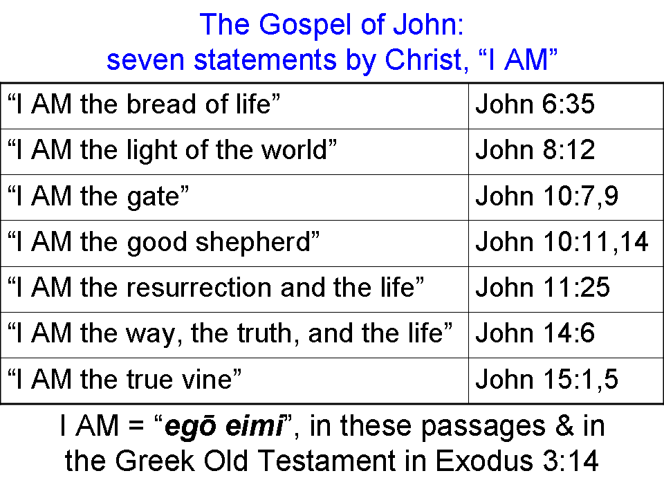
Jesus made the claim that He was (‘I AM’) the resurrection and the life, implying deity, and also saying that anyone who believes in Him will never die. He then asks Martha if she believes this.

Martha’s response, expanded and explained, is:

"Yes, Lord; I specifically have believed as a completed past action with ongoing results on into the future that You are the long-promised Messiah, the Son of the God, even He who is coming into the world, as prophesied on the Old Testament."

This and all Scripture quotes are from the New American Standard Bible, Updated (NASU), unless otherwise stated. Specific changes to the NASU include: ‘I AM’ in verse 25, and ‘the God’ in verse 27.

