John 11:28-57

As we saw in last week’s passage, John 11:1-27, Jesus had been told in advance, by messenger, that Lazarus was sick. At that news, Jesus stayed where He was until Lazarus was dead, then proceeded toward Bethany, where Lazarus was entombed, and his sisters Mary & Martha had been mourning Lazarus’ death. As Jesus approached Bethany, Martha came out to see Him, and near the end of their conversation they had this interaction:

John 11:25-27
Jesus said to her, "I AM the resurrection and the life; he who believes in Me will live even if he dies, 26 and everyone who lives and believes in Me will never die. Do you believe this?" 27 She [Martha] said to Him, "Yes, Lord; I have believed that You are the Christ, the Son of the God, even He who comes into the world."

At this point we start into today’s passage, John 11:28-57.

John 11:28-32
When she had said this, she went away and called Mary her sister, saying secretly, "The Teacher is here and is calling for you." 29 And when she heard it, she got up quickly and was coming to Him. 30 Now Jesus had not yet come into the village, but was still in the place where Martha met Him. 31 Then the Jews who were with her in the house, and consoling her, when they saw that Mary got up quickly and went out, they followed her, supposing that she was going to the tomb to weep there. 32 Therefore, when Mary came where Jesus was, she saw Him, and fell at His feet, saying to Him, "Lord, if You had been here, my brother would not have died."

Martha referred to Jesus as ‘the Teacher’. Though she knew Jesus could perform miracles, He was called ‘the Teacher’. And, in contrast to all of the other rabbis, Jesus would teach women. For some reason Jesus had not moved from the place where Martha had left Him, when Mary came out to see Him. Also with her was a group of mourners, who had thought that she was going to the tomb, so were going to join her. Falling at His feet, she expressed essentially the same viewpoint that Martha had expressed before – ‘if only Jesus had been there…’ In what we read about next, it will require some careful consideration to understand what Jesus did and felt, but we will also see more of the sentiment, ‘if only Jesus had been there…’

John 11:33-37
When Jesus therefore saw her weeping, and the Jews who came with her also weeping, He was deeply moved in spirit and was troubled, 34 and said, "Where have you laid him?" They said to Him, "Lord, come and see." 35 Jesus wept. 36 So the Jews were saying, "See how He loved him!" 37 But some of them said, "Could not this man, who opened the eyes of the blind man, have kept this man also from dying?"
What does it mean for Jesus to be deeply moved and troubled? And how could that be? He knew that Lazarus had died, and He had stayed away from Bethany deliberately until after Lazarus was dead. He even told the disciples that He was glad for their sakes that He was not there.

Christ had proclaimed His deity with I AM (John 1:25), and Martha then acknowledged His deity (John 1:27). But here in these verses we see Jesus expressing His humanity. Furthermore, the death that Adam was warned of (Genesis 2:17, “…you will surely die”), had touched those whom Jesus loved (John 11:3, 5), and within less than a week Jesus would take upon Himself the sins of all those descended from Adam, and suffer a death of separation from the Father.

Many saw that Jesus loved Lazarus, but some only saw the same limitation that Martha and Mary saw: “If only Jesus had been there…”.

John 11:38-44
So Jesus, again being deeply moved within, came to the tomb. Now it was a cave, and a stone was lying against it. 39 Jesus said, "Remove the stone." Martha, the sister of the deceased, said to Him, "Lord, by this time there will be a stench, for he has been dead four days." 40 Jesus said to her, "Did I not say to you that if you believe, you will see the glory of God?" 41 So they removed the stone. Then Jesus raised His eyes, and said, "Father, I thank You that You have heard Me. 42 "I knew that You always hear Me; but because of the people standing around I said it, so that they may believe that You sent Me." 43 When He had said these things, He cried out with a loud voice, "Lazarus, come forth." 44 The man who had died came forth, bound hand and foot with wrappings, and his face was wrapped around with a cloth. Jesus said to them, "Unbind him, and let him go."

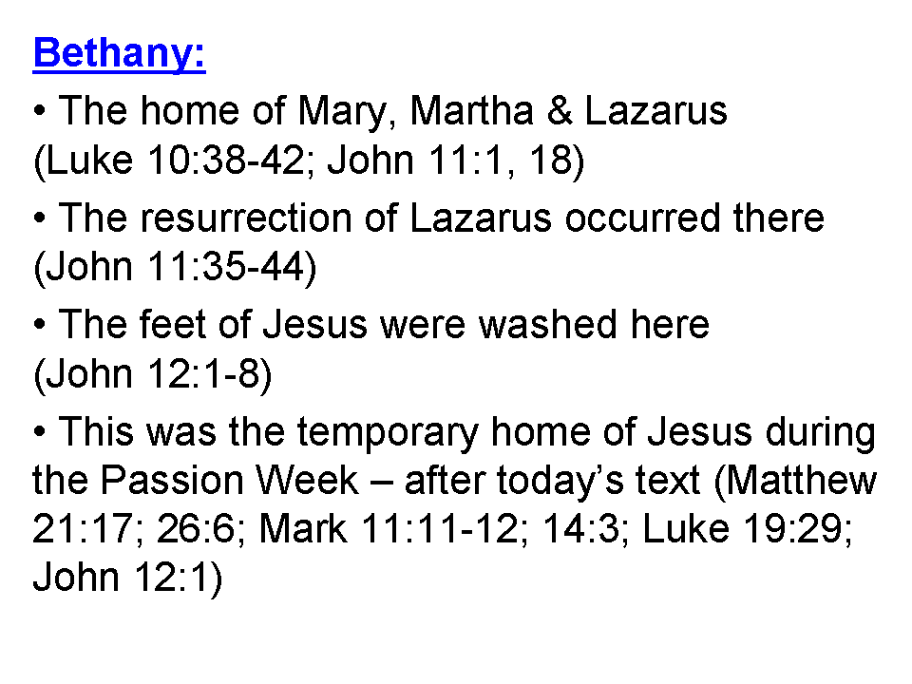
Stones set against the opening of a cave or carved tomb (or some combination) was the typical way of conducting a Jewish burial in those times. The stone, typically, pretty tight-fitting, would prevent odors from escaping too rapidly and prevent animals from damaging the body or its wrappings, and from moving the body, in whole or in part. Martha’s response in verse 39 shows that she is not anticipating that Jesus is going to raise her brother back to life. Martha had believed (John 11:27) in the perfect tense, but this was the opportunity to believe in the present circumstances, in order to see the glory of God in the outcome. They removed the stone, and Jesus prayed. Note that His prayer clarifies that what is about to happen will result in belief that the Father sent the Son. You will recall that what was about to take place was intended to cause the disciples also to believe (John 11:15). On command to come out, Lazarus did come out, though he did need some help getting unbound from his burial cloths.

John 11:45-46
Therefore many of the Jews who came to Mary, and saw what He had done, believed in Him. 46 But some of them went to the Pharisees and told them the things which Jesus had done.

The response was as Jesus had said – many believed. But there were some who reported these events to the Pharisees. That initiated what happened next among the Sanhedrin.

John 11:47-53
Therefore the chief priests and the Pharisees convened a council, and were saying, "What are we doing? For this man is performing many signs. 48 "If we let Him go on like this, all men will believe in Him, and the Romans will come and take away both our place and our nation." 49 But one of them, Caiaphas, who was high priest that year, said to them, "You know nothing at all, 50 nor do you take into account that it is expedient for you that one man die for the people, and that the whole nation not perish." 51 Now he did not say this on his own initiative, but being high priest that year, he prophesied that Jesus was going to die for the nation, 52 and not for the nation only, but in order that He might also gather together into one the children of God who are scattered abroad. 53 So from that day on they planned together to kill Him.

The Jewish leaders walked a tight rope between maintaining control with the political tools available to them and losing control to the Romans. At first they feared the worst, but Caiaphas proposed that Jesus die for the benefit of the nation, which also prophesied that Jesus would indeed die for the benefit of the nation – His substitutionary atonement for the sins of the nation – those within Israel and those elsewhere.

At this the council – the Sanhedrin - took Caiaphas’ guidance and made a plan to kill Jesus.

John 11:54
Therefore Jesus no longer continued to walk publicly among the Jews, but went away from there to the country near the wilderness, into a city called Ephraim; and there He stayed with the disciples.

In the bigger context of the Gospels, we take this to mean that Jesus didn’t walk freely and openly among the Jews, though the record makes clear that He did not simply hide out in Ephraim all that week, either. There are two points of ambiguity as to where Jesus was located at this time. We do not know for certain the location of Ephraim, and besides the Bethany where Lazarus was raised, there was also a Bethany beyond the Jordan (John 1:28).

Jesus’ hour and time was coming quickly, but He would die at the right time (Romans 5:6).
John 11:55-57
Now the Passover of the Jews was near, and many went up to Jerusalem out of the country before the Passover to purify themselves. 56 So they were seeking for Jesus, and were saying to one another as they stood in the temple, "What do you think; that He will not come to the feast at all?" 57 Now the chief priests and the Pharisees had given orders that if anyone knew where He was, he was to report it, so that they might seize Him.

As the Passover was nearing, the Jews were speculating that Jesus might not show up at all. But verse 57 makes clear that there was a warrant out for Jesus’ arrest.

Jewish Feasts in the Gospel of John
Name of Feast | Reference in John | Time Celebrated
Passover | 2:13, 23 | April 7, A.D. 30
“A feast of the Jews” | 5:1 | October 21-28, A.D. 31?
Passover | 6:4 | April 13/14, A.D.32
Tabernacles (Booths) | 7:2 | September 10-17, A.D.32
Dedication (Hanukkah) | 10:22 | December 18-25, A.D. 32
Passover | 11:55, 12:1 | April 3, A.D.33

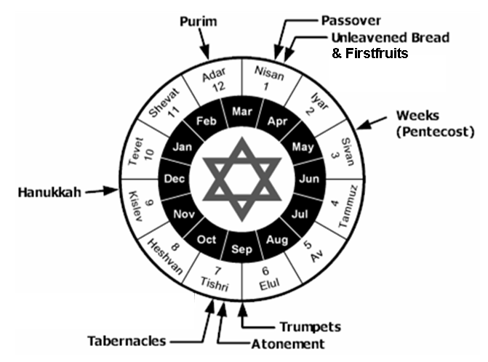
Appendix: John the Apostle’s unique connections to the Sanhedrin

John the apostle wrote uniquely about a number of actions within and communications with the Jewish High Council, also known as the Sanhedrin. Several of these unique passages are quoted below. Initially, though, we see below that John’s mother seems to have been taking the initiative to see that her sons, James and John, were well connected in Israel’s places of power – even to the point of attempting to gain assurances from Christ that her two sons were given the first places in Christ’s coming kingdom on earth.

Matthew 20:20-23 (NASU)
Then the mother of the sons of Zebedee came to Jesus with her sons, bowing down and making a request of Him. 21 And He said to her, "What do you wish?" She said to Him, "Command that in Your kingdom these two sons of mine may sit one on Your right and one on Your left." 22 But Jesus answered, "You do not know what you are asking. Are you able to drink the cup that I am about to drink?" They said to Him, "We are able." 23 He said to them, "My cup you shall drink; but to sit on My right and on My left, this is not Mine to give, but it is for those for whom it has been prepared by My Father."

See also Mark 10:35-40 containing a parallel account to the one quote above in Matthew 20, which presents James and John as making the request. See also Matthew 27:56 regarding the presence of the mother of these two sons of Zebedee at the crucifixion.

John 1:19-28 (NASU)
This is the testimony of John, when the Jews sent to him priests and Levites from Jerusalem to ask him, "Who are you?" 20 And he confessed and did not deny, but confessed, " I am not the Christ." 21 They asked him, "What then? Are you Elijah?" And he said, "I am not." "Are you the Prophet?" And he answered, "No" 22 Then they said to him, "Who are you, so that we may give an answer to those who sent us? What do you say about yourself?" 23 He said, "I am A VOICE OF ONE CRYING IN THE WILDERNESS, 'MAKE STRAIGHT THE WAY OF THE LORD,' as Isaiah the prophet said."

24 Now they had been sent from the Pharisees. 25 They asked him, and said to him, "Why then are you baptizing, if you are not the Christ, nor Elijah, nor the Prophet?" 26 John answered them saying, " I baptize in water, but among you stands One whom you do not know. 27 "It is He who comes after me, the thong of whose sandal I am not worthy to untie." 28 These things took place in Bethany beyond the Jordan, where John was baptizing.

John’s is the only Gospel to include Nicodemus, which it does significantly.

John 3:1-15 (NASU)
Now there was a man of the Pharisees, named Nicodemus, a ruler of the Jews; 2 this man came to Jesus by night and said to Him, "Rabbi, we know that You have come from God as a teacher; for no one can do these signs that You do unless God is with him." 3 Jesus answered and said to him, "Truly, truly, I say to you, unless one is born again he cannot see the kingdom of God."
4 Nicodemus said to Him, "How can a man be born when he is old? He cannot enter a second time into his mother's womb and be born, can he?" 5 Jesus answered, "Truly, truly, I say to you, unless one is born of water and the Spirit he cannot enter into the kingdom of God. 6 "That which is born of the flesh is flesh, and that which is born of the Spirit is spirit. 7 "Do not be amazed that I said to you, 'You must be born again.' 8 "The wind blows where it wishes and you hear the sound of it, but do not know where it comes from and where it is going; so is everyone who is born of the Spirit."

9 Nicodemus said to Him, "How can these things be?" 10 Jesus answered and said to him, "Are you the teacher of Israel and do not understand these things? 11 "Truly, truly, I say to you, we speak of what we know and testify of what we have seen, and you do not accept our testimony. 12 "If I told you earthly things and you do not believe, how will you believe if I tell you heavenly things? 13 "No one has ascended into heaven, but He who descended from heaven: the Son of Man. 14 "As Moses lifted up the serpent in the wilderness, even so must the Son of Man be lifted up; 15 so that whoever believes will in Him have eternal life.

John 7:32-53 (NASU)
The Pharisees heard the crowd muttering these things about Him, and the chief priests and the Pharisees sent officers to seize Him. 33 Therefore Jesus said, "For a little while longer I am with you, then I go to Him who sent Me. 34 "You will seek Me, and will not find Me; and where I am, you cannot come." 35 The Jews then said to one another, "Where does this man intend to go that we will not find Him? He is not intending to go to the Dispersion among the Greeks, and teach the Greeks, is He? 36 "What is this statement that He said, ' You will seek Me, and will not find Me; and where I am, you cannot come'?"

37 Now on the last day, the great day of the feast, Jesus stood and cried out, saying, "If anyone is thirsty, let him come to Me and drink. 38 "He who believes in Me, as the Scripture said, 'From his innermost being will flow rivers of living water.'" 39 But this He spoke of the Spirit, whom those who believed in Him were to receive; for the Spirit was not yet given, because Jesus was not yet glorified.

40 Some of the people therefore, when they heard these words, were saying, "This certainly is the Prophet." 41 Others were saying, "This is the Christ." Still others were saying, " Surely the Christ is not going to come from Galilee, is He? 42 "Has not the Scripture said that the Christ comes from the descendants of David, and from Bethlehem, the village where David was?" 43 So a division occurred in the crowd because of Him. 44 Some of them wanted to seize Him, but no one laid hands on Him.

45 The officers then came to the chief priests and Pharisees, and they said to them, "Why did you not bring Him?" 46 The officers answered, " Never has a man spoken the way this man speaks." 47 The Pharisees then answered them, " You have not also been led astray, have you? 48 "No one of the rulers or Pharisees has believed in Him, has he? 49 "But this crowd which does not know the Law is accursed." 50 Nicodemus (he who came to Him before, being one of them) said to them, 51 "Our Law does not judge a man unless it first hears from him and knows what he is doing, does it?" 52 They answered him, "You are not also from Galilee, are you? Search, and see that no prophet arises out of Galilee." 53 Everyone went to his home.

John 18:15-18 (NASU)
Simon Peter was following Jesus, and so was another disciple. Now that disciple was known to the high priest, and entered with Jesus into the court of the high priest, 16 but Peter was standing at the door outside. So the other disciple, who was known to the high priest, went out and spoke to the doorkeeper, and brought Peter in. 17 Then the slave-girl who kept the door said to Peter, "You are not also one of this man's disciples, are you?" He said, "I am not." 18 Now the slaves and the officers were standing there, having made a charcoal fire, for it was cold and they were warming themselves; and Peter was also with them, standing and warming himself.

John 19:17-22 (NASU)
They took Jesus, therefore, and He went out, bearing His own cross, to the place called the Place of a Skull, which is called in Hebrew, Golgotha. 18 There they crucified Him, and with Him two other men, one on either side, and Jesus in between. 19 Pilate also wrote an inscription and put it on the cross. It was written, " JESUS THE NAZARENE, THE KING OF THE JEWS." 20 Therefore many of the Jews read this inscription, for the place where Jesus was crucified was near the city; and it was written in Hebrew, Latin and in Greek. 21 So the chief priests of the Jews were saying to Pilate, "Do not write, ' The King of the Jews'; but that He said, 'I am King of the Jews.'" 22 Pilate answered, " What I have written I have written."

John 19:38-42 (NASU)
After these things Joseph of Arimathea, being a disciple of Jesus, but a secret one for fear of the Jews, asked Pilate that he might take away the body of Jesus; and Pilate granted permission. So he came and took away His body. 39 Nicodemus, who had first come to Him by night, also came, bringing a mixture of myrrh and aloes, about a hundred pounds weight. 40 So they took the body of Jesus and bound it in linen wrappings with the spices, as is the burial custom of the Jews. 41 Now in the place where He was crucified there was a garden, and in the garden a new tomb in which no one had yet been laid. 42 Therefore because of the Jewish day of preparation, since the tomb was nearby, they laid Jesus there.

This and all Scripture quotes are from the New American Standard Bible, Updated (NASU), unless otherwise stated. Specific changes to the NASU include: ‘I AM’ in verse 25, and ‘the God’ in verse 27.
See the Appendix: John the Apostle’s unique connections to the Sanhedrin
Adapted from a table in Zondervan Illustrated Bible Backgrounds Commentary, Volume 2, Clinton E. Arnold, General Editor, page 28.
Here John calls Himself ‘another disciple’, then here and in John 20:2, 3, 4, & 8 he calls himself ‘the other disciple’. John also referred to himself as the ‘disciple whom Jesus loved’: John 13:23; 21:7, 20. In John 20:2 he referred to himself in a mixture of these expressions, as, “the other disciple, whom Jesus loved’.
Mark 15:43, “Joseph of Arimathea came, a prominent member of the Council, who himself was waiting for the kingdom of God; and he gathered up courage and went in before Pilate, and asked for the body of Jesus.” In Luke 23:50-52, “And a man named Joseph, who was a member of the Council, a good and righteous man 51 (he had not consented to their plan and action), a man from Arimathea, a city of the Jews, who was waiting for the kingdom of God; 52 this man went to Pilate and asked for the body of Jesus.” (NASU)

