John 12:1-26

The events recorded for us in John 11:17-46 took place on the Saturday before Christ was crucified. Jesus raised Lazarus on a Sabbath! But the leaders of the Jews seemed to be beyond challenging Jesus on that point, as they had many times before. The events of John 12:1-11 took place that same evening, when Mary anointed Jesus’ feet. The Jews would have said that the anointing of Jesus’ feet took place on the next day, since they count a day as begun at sundown. The events recorded for us in John 12:12-26, often called the Triumphal Entry, took place on Sunday of the week before Christ was crucified.

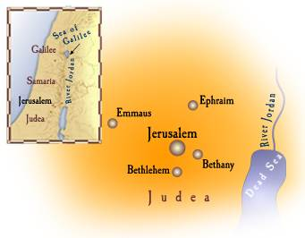
John 12:1-3
Jesus, therefore, six days before the Passover, came to Bethany where Lazarus was, whom Jesus had raised from the dead. 2 So they made Him a supper there, and Martha was serving; but Lazarus was one of those reclining at the table with Him. 3 Mary then took a pound of very costly perfume of pure nard, and anointed the feet of Jesus and wiped His feet with her hair; and the house was filled with the fragrance of the perfume.

Imagine what it would have been like for Mary and Martha to have the Teacher – the One who taught them contrary to Jewish tradition – to be able to anticipate serving supper to Lazarus, their brother, who had been dead for four days! And the One who raised Lazarus, entirely contrary to any expectation that either of them had, was to eat there with them! So Jesus, who had taught these women, contrary to Jewish custom, raised Lazarus on a Sabbath, and now Mary anointed Jesus’ feet with really expensive perfume, then wiped it with her hair, contrary to Jewish custom.

John 12:4-8
But Judas Iscariot, one of His disciples, who was intending to betray Him, said, 5 "Why was this perfume not sold for three hundred denarii and given to poor people?" 6 Now he said this, not because he was concerned about the poor, but because he was a thief, and as he had the money box, he used to pilfer what was put into it. 7 Therefore Jesus said, "Let her alone, so that she may keep it for the day of My burial. 8 For you always have the poor with you, but you do not always have Me."
It is amazing to consider that Jesus knew Judas was to be the one to betray Him when he was selected as one of the twelve disciples, and that Jesus knew his heart, and intent, and that the betrayal would take place in less than a week. A denarius was a day’s wages for a typical laborer and the lowest level Roman soldier. So 300 denarii was a lot of money!
A Denarius coin – front and back
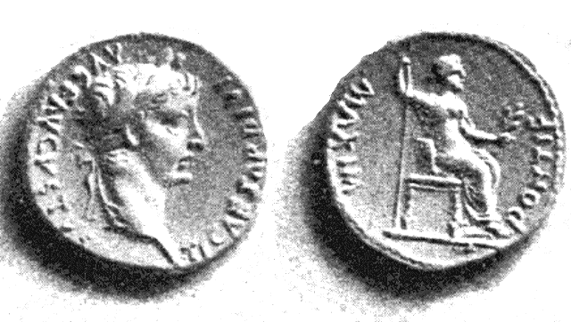
But what may be even more astounding is to ponder that Jesus expressed love and loved Judas so much that none of the other disciples knew that it was Judas who would be the betrayer. Jesus loved Judas so much that He would give His life for him, dying for His sins, in only a matter of days!

Judas always was in this for what was in it for himself – especially financially. And Judas could see that the money flow from being the disciples’ treasurer was close to the end. He had heard enough about the Jewish leaders’ plans to have Jesus arrested and killed to see that he would not be the treasurer, nor be able to pilfer, for very much longer.

Jesus’ statement that, “…you always have the poor with you” was based on Scripture:

Deuteronomy 15:11a, “For the poor will never cease to be in the land…”

John 12:9-11
The large crowd of the Jews then learned that He was there; and they came, not for Jesus' sake only, but that they might also see Lazarus, whom He raised from the dead. 10 But the chief priests planned to put Lazarus to death also; 11 because on account of him many of the Jews were going away and were believing in Jesus.

A resurrection witnessed by so many, at a location close to the city of Jerusalem, at a time close to Passover, when a great many Jews were gathering, would certainly gain a great deal of attention. While it says that the leaders of the Sanhedrin planned to kill Lazarus, too, we have no record that they actually carried that out. It may be that killing Jesus removed the need to carry out the death of Lazarus. The last time Lazarus is mentioned in Scripture is John 12:17, in this next passage:

John 12:12-19
On the next day the large crowd who had come to the feast, when they heard that Jesus was coming to Jerusalem, 13 took the branches of the palm trees and went out to meet Him, and began to shout, "Hosanna! Blessed is He who comes in the name of the Lord, even the King of Israel." 14 Jesus, finding a young donkey, sat on it; as it is written, 15 "Fear not, daughter of Zion; behold, your King is coming, seated on a donkey's colt." 16 These things His disciples did not understand at the first; but when Jesus was glorified, then they remembered that these things were written of Him, and that they had done these things to Him. 17 So the people, who were with Him when He called Lazarus out of the tomb and raised him from the dead, continued to testify about Him. 18 For this reason also the people went and met Him, because they heard that He had performed this sign. 19 So the Pharisees said to one another, "You see that you are not doing any good; look, the world has gone after Him."

This is John’s version of the event commonly known the Palm Sunday / Triumphal Entry, which is recorded in each of the four gospels. The composite of the accounts from each of the four gospels is included in a supplement to this handout. There are several respects in which the traditional Palm Sunday / Triumphal Entry depiction of this event is not really the most accurate portrayal of this event:

1) The things that they were saying of Jesus were part of the traditional Hallel, the songs sung antiphonally by those Jews coming up to Jerusalem, which includes Psalm 113-118.

2) There is much more mention of the donkey and/or colt (almost a dozen times, and in all four gospels) than the palm branch (once in John). The donkey and colt are a matter of fulfillment of Old Testament prophecy (Zechariah 9:9), as well as a fulfillment of Christ’s prophecy about the donkey and colt, their location, and what words the owners would respond to. The palm branches do not have the same prophetic connection.

3) Though Jesus was indeed the King of Israel, the Jewish leaders’ broad and severe rejection of that message meant judgment for the Jewish people.

4) When Jerusalem came into view Jesus’ response was not smiles and joy and cheer, but weeping and lamenting what was going to come upon the city of Jerusalem and its people.

5) All this apparent welcome and cheering would change to near riotous shouts of, “Crucify Him! Crucify Him! We have no king but Caesar!”, and calls to release the robber Barabbas instead of Jesus, by Friday morning of that very same week.

John 12:20-26
Now there were some Greeks among those who were going up to worship at the feast; 21 these then came to Philip, who was from Bethsaida of Galilee, and began to ask him, saying, "Sir, we wish to see Jesus." 22 Philip came and told Andrew; Andrew and Philip came and told Jesus. 23 And Jesus answered them, saying, "The hour has come for the Son of Man to be glorified."

24 "Truly, truly, I say to you, unless a grain of wheat falls into the earth and dies, it remains alone; but if it dies, it bears much fruit. 25 He who loves his life loses it, and he who hates his life in this world will keep it to life eternal. 26 If anyone serves Me, he must follow Me; and where I am, there My servant will be also; if anyone serves Me, the Father will honor him."
This is not the only time that Jesus gave a non-response or even a statement against ministry with the Gentiles:

Matthew 10:5-6
These twelve Jesus sent out after instructing them: "Do not go in the way of the Gentiles, and do not enter any city of the Samaritans; 6 but rather go to the lost sheep of the house of Israel."

Matthew 15:21-28
Jesus went away from there, and withdrew into the district of Tyre and Sidon. 22 And a Canaanite woman from that region came out and began to cry out, saying, "Have mercy on me, Lord, Son of David; my daughter is cruelly demon-possessed." 23 But He did not answer her a word. And His disciples came and implored Him, saying, "Send her away, because she keeps shouting at us." 24 But He answered and said, "I was sent only to the lost sheep of the house of Israel." 25 But she came and began to bow down before Him, saying, "Lord, help me!" 26 And He answered and said, "It is not good to take the children's bread and throw it to the dogs." 27 But she said, "Yes, Lord; but even the dogs feed on the crumbs which fall from their masters' table." 28 Then Jesus said to her, "O woman, your faith is great; it shall be done for you as you wish." And her daughter was healed at once.

‘Dogs’ was a euphemism for ‘Gentiles’.

We can clarify verse 24 by pointing out that the Greek has it as ‘the grain of wheat’. Not a grain. Jesus, though born King of the Jews, must die first. He cannot be made King on the day of he so-called ‘Triumphal Entry’ – that would be the wrong sequence. In order to be fruitful, Christ must die first.

Verses 25-26 was a call to discipleship, but the principle of the grain dying is applied to the disciples themselves. And Judas, who was hearing these words, is the one who loves this life, though that would not be apparent immediately.

This and all Scripture quotes are from the New American Standard Bible, Updated (NASU), unless otherwise stated.

