John 14:1-31

In John 14, 15, 16, and 17 we will find some material that is not recorded in the other three gospels. It is unique to John. In chapters 14, 15 and 16 we will read about Jesus preparing the disciples for the time when they would be apostles, and the Lord would not be present with them, but the Holy Spirit would be present with them. One of the characteristics of this passage is that it is somewhat cyclical. Jesus returns to a theme repeatedly to underscore that theme and to expand on it the next time around.

John 14:1-4
"Do not let your heart be troubled; believe in God, believe also in Me. 2 In My Father's house are many dwelling places; if it were not so, I would have told you; for I go to prepare a place for you. 3 If I go and prepare a place for you, I will come again and receive you to Myself, that where I am, there you may be also. 4 And you know the way where I am going."

In John 14:27 we are going to see the words, “Do not let your heart be troubled…” again. Though Jesus addressed all of them, He referred to their ‘heart’ as singular. The word translated ‘believe’ is in such a form that Jesus could have been making a statement that they believe in God and in Him or that He was telling them to believe in God and in Him. But the content and context may point us toward this understanding of verse 1:

"Do not let the heart of you be troubled; you believe in God, you must believe also in Me."

What is quite clear is that believing in God and specifically in Christ is the remedy for, and godly prevention for, a troubled heart. Also, while we have the words, trust, believe and faith all having separate nuances in English, the Greek had just one word for all three nuances.

Verses 2 and 3 include a message that the disciples likely found both familiar and puzzling at the same time. These were the kinds of words that a groom-to-be would say to his bride-to-be on the day that they were betrothed. Once the couple was betrothed, the groom-to-be would begin preparing a home for the couple to live in once they were married. See also the supplement to this handout (Supplement: Holy & Blameless). The reference to multiple rooms is to accommodate that the church, the bride of Christ, is made up of multiple individuals.

The way that Jesus was referring to was His Father’s house – the place where He was soon to be going, and where He would come from to receive them to Himself. That leads Thomas – yes, the doubting one – to ask a question, because he doesn’t understand what Jesus is saying:

John 14:5-6
Thomas said to Him, "Lord, we do not know where You are going, how do we know the way?" 6 Jesus said to him, "I am the way, and the truth, and the life; no one comes to the Father but through Me."
One can imagine Thomas thinking real hard about Jesus telling the disciples that they could not go where He was going, but that they would come later. Jesus had told them all about where He was going – to the Father, but they didn’t ‘get it’. And they were still trying to figure out how all of this fit in with Jesus restoring the kingdom to Israel (Acts 1: 6). That question would stay on their minds for weeks to come.

Jesus’ response to Thomas’ question is best put into ‘expanded and explained’ form:

John 14:6 expanded and explained
Jesus said to him, "I AM, being in fact deity, and in contradistinction to all others, I am the singular way, and the singular truth, and the singular life; no one comes to the Father but exclusively through Me."

Jesus gave Thomas more of an answer than He was asking for, but it’s still not clear that Thomas understood what Jesus said, nor did the other disciples at that time.

John 14:7
"If you had known Me, you would have known My Father also; from now on you know Him, and have seen Him."

All along Jesus had been telling them that the Father had sent Him, that He and the Father were one, that He does what the Father tells Him, etc. But from here into each of the next three chapters (15, 16, 17), knowing Christ and knowing the Father will be repeated themes. Jesus could only make claims like this if He was in fact deity, like the Father, and a perfect representation of the Father in character, and did just as the Father said to do.

After Peter was told that he would deny Christ at the end of chapter 13, we saw that Thomas had just ‘struck out’ earlier in chapter 14. In the next verses we’ll see that Philip was going to do the same.

John 14:8-11
Philip said to Him, "Lord, show us the Father, and it is enough for us." 9 Jesus said to him, "Have I been so long with you, and yet you have not come to know Me, Philip? He who has seen Me has seen the Father; how can you say, 'Show us the Father'? 10 "Do you not believe that I am in the Father, and the Father is in Me? The words that I say to you I do not speak on My own initiative, but the Father abiding in Me does His works. 11 Believe Me that I am in the Father and the Father is in Me; otherwise believe because of the works themselves."

You may recall that John had written earlier:

John 1:18
No one has seen God at any time; the only begotten God who is in the bosom of the Father, He [Christ] has explained Him.

Jesus’ task since the beginning of His ministry with the disciples had been to explain, show, represent, and speak for the Father, whom no man could see. This is why Jesus asks, “How can you say, ‘Show us the Father’”?

Verses 10 and 11 have some respects in which it appears like Jesus is asking a question about identification between Himself and the Father, and then stating the fact. He is, but it is not exactly the same as our having been identified with Christ. Because the Father and the Son are two different persons of deity, but of one essence, the essence of the Father is in the Son and the essence of the Son is in the Father. Also, the Father and the Son have one essence from eternity past to eternity future.

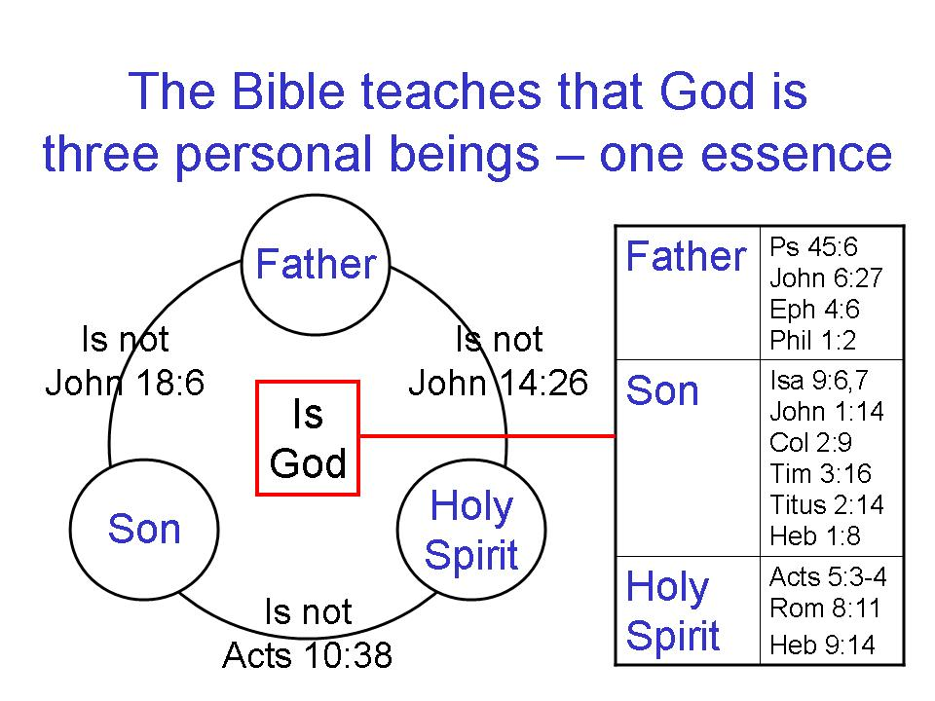

Jesus then said that the works that He had done were ample evidence that the Father abides in Him.

John 14:12-14
"Truly, truly, I say to you, he who believes in Me, the works that I do, he will do also; and greater works than these he will do; because I go to the Father. 13 Whatever you ask in My name, that will I do, so that the Father may be glorified in the Son. 14 If you ask Me anything in My name, I will do it."

Jesus, with all of the puzzlement and discouragement the disciples had gone through, and would yet go through, is seeking to encourage the disciples. His departure to the Father would end up with good results in the disciples who would become apostles. The works that these apostles would do would be greater for a few reasons:
- They would be many voices accompanied by miracles
- They would ultimately extend their ministry beyond the land of Israel and beyond the people of Israel
3) They would be apostles of the gospel of grace
4) They would be the founders among a brand new spiritual body called ‘the church’

God the Father may be approached by the name - standing for the whole person – of Jesus. He is their access to the Father.

John 14:15
"If you love Me, you will keep My commandments."

So is Jesus wanting us to keep the ten commandments? The 613 commandments, or something else? And will those commandments be enforced under principle of law?

The Greek text conveys, “"If you love Me, you will in the future keep the commandments the ones of mine."

Carrying out the directions from Christ about the things that are ahead – those are the commandments - will be motivated by their love for Christ.

John 14:16, 17
"I will ask the Father, and He will give you another Helper, that He may be with you forever; 17 that is the Spirit of truth, whom the world cannot receive, because it does not see Him or know Him, but you know Him because He abides with you and will be in you."

Jesus wanted to make clear that His departure was not a desertion. In fact, the disciples would be better off when Jesus departed. They would get another Helper, the Holy Spirit, the Spirit of truth. The Spirit of truth will abide both with them and in them.

John 14:18-21
"I will not leave you as orphans; I will come to you. 19 After a little while the world will no longer see Me, but you will see Me; because I live, you will live also. 20 In that day you will know that I am in My Father, and you in Me, and I in you. 21 He who has My commandments and keeps them is the one who loves Me; and he who loves Me will be loved by My Father, and I will love him and will disclose Myself
to him."

Jesus will depart, but He will send the Helper, the Spirit of truth to them. And Christ will carry on ministry in the heavenlies and He will also, being omnipresent, be both in the apostles and the apostles in Him. As we know from the New Testament Scriptures, that is true of all believers. We are in Christ for one set of purposes, and Christ is in us for another set of purposes. And rather than Jesus going away and never hearing from Him again, Jesus will disclose Himself to the apostles. There will be love between the Father, the Son and the apostles, and as we see from the New Testament epistles, there is love between us and the Father and the Son.

John 14:22-24
Judas (not Iscariot) said to Him, "Lord, what then has happened that You are going to disclose Yourself to us and not to the world?" 23 Jesus answered and said to him, "If anyone loves Me, he will keep My word; and My Father will love him, and We will come to him and make Our abode with him. 24 He who does not love Me does not keep My words; and the word which you hear is not Mine, but the Father's who sent Me."

Jesus’ words, His directions to them, are from the Father who loves them. Both the Father and the Son will make their abode with these disciples, soon to be apostles. The Father, the Son and the Holy Spirit will, all three, be involved intimately in the lives of these apostles.

John 14:25-31
"These things I have spoken to you while abiding with you. 26 "But the Helper, the Holy Spirit, whom the Father will send in My name, He will teach you all things, and bring to your remembrance all that I said to you. 27 Peace I leave with you; My peace I give to you; not as the world gives do I give to you. Do not let your heart be troubled, nor let it be fearful. 28 You heard that I said to you, 'I go away, and I will come to you.' If you loved Me, you would have rejoiced because I go to the Father, for the Father is greater than I. 29 Now I have told you before it happens, so that when it happens, you may believe. 30 I will not speak much more with you, for the ruler of the world is coming, and he has nothing in Me; 31 but so that the world may know that I love the Father, I do exactly as the Father commanded Me. Get up, let us go from here."

The Helper, the Holy Spirit, will come to abide with and in these disciples turned apostles. The Holy Spirit will have a number of roles in the apostles and in the church, but one of those roles, particularly important for the apostles, will be to call these things to their remembrance, and to teach them. Jesus has been teaching them, but they still have a great deal more to learn.

Jesus returns to the disciples’ need for peace, telling them again not to let their hearts be troubled. Jesus had told them at first not to let their hearts be troubled, and to believe. In this passage He tells them that He will tell them things in advance so that they will believe, which is exactly what is needed to calm a troubled heart.

Some Of The Various Aspects Of The Ministry Of The Holy Spirit In The Believers Life

1. The Spirit dwells in believers. Jn. 14:6; Rom. 5:5; 8:9: 1 Cor. 3:16

2. The Spirit gives believers access to the Father. Ephesians 2:18

3. The Spirit has fellowship with believers. 2 Cor. 13:14; Phil. 2:1; 1 John 4:13

4. The Spirit teaches believers. 1 John 2:20, 27; 1 Cor. 2:13

- The Spirit reveals the glory of Christ to believers. 1 Cor. 2:9-13; John 16:13-15
6. The Spirit transforms believers. 2 Cor 3:18; John 17:24; Eph. 2:6, 7
7. The Spirit manifests his fruit through believers. Galatians 5:22, 23; John 15:5

8. The Spirit gifts every believer for ministry. 1 Cor. 12:7,11,27; Eph. 4:7,8,11,12

9. The Spirit empowers believers. Acts 1:8; Ephesians 3:18

10. The Spirit fills believers. Acts 2:4; Ephesians 5:18

11. The Spirit desires against believers' sin nature. Galatians 5:17; Romans 8:13

12. The Spirit controls the mind of the new man. Romans 8:5, 6; Phil. 2:5

13. The Spirit frees believers. Romans 8:2; 2 Cor. 3:17

14. The Spirit guides believers. Rom. 8:14; Galatians 5:18, 25

15. The Spirit intercedes in prayer for the believer. Rom. 8:26, 27; Eph. 6:18; Phil 3:3

16. The Spirit is God's guarantee of his promises to the believer. 2 Cor. 5:5; Eph. 1:13,14

17. The Spirit is the agent in the believer's sanctification. 2 Thess. 2:13,14; Rom. 15:16

18. The Spirit assures believers. Romans 8:16; 1 John 4:13

19. The Spirit glorifies Christ through believers. John 16:13,14; 1 Cor. 12:3

20. The Spirit can be grieved & quenched by the believer. Eph. 4:30; 1 Thess. 5:19

21. The Spirit is the means by which a believer walks. Galatians 3:2,3; 5:16

- The Spirit perfects the believer. Galatians 3:3

