John 15:1-27

At the end of chapter 14 Jesus had said to the disciples, “Get up, let us go from here.” Since Jesus goes from the Upper Room to the Garden of Gethsemane, what is recorded for us in chapters 15 and 16 were likely said along the way to the Garden of Gethsemane.

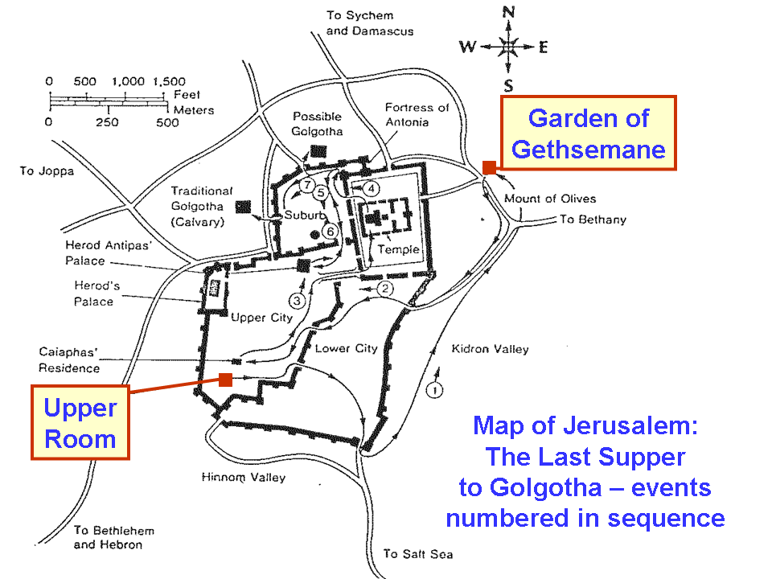

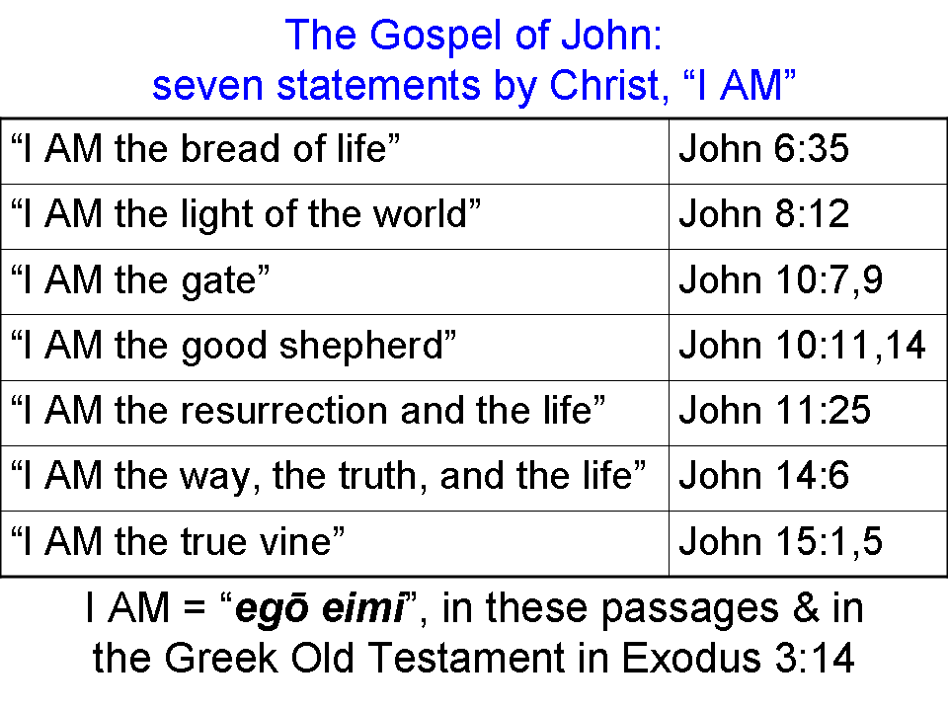
John 15:1-7
"I AM the true vine, and My Father is the vinedresser. 2 "Every branch in Me that does not bear fruit, He takes away; and every branch that bears fruit, He prunes it so that it may bear more fruit. 3 "You are already clean because of the word which I have spoken to you. 4 "Abide in Me, and I in you. As the branch cannot bear fruit of itself unless it abides in the vine, so neither can you unless you abide in Me.

"I AM the vine, you are the branches; he who abides in Me and I in him, he bears much fruit, for apart from Me you can do nothing. 6 "If anyone does not abide in Me, he is thrown away as a branch and dries up; and they gather them, and cast them into the fire and they are burned. 7 "If you abide in Me, and My words abide in you, ask whatever you wish, and it will be done for you.

In John 15:1, 5 Jesus said ‘I AM’, as a claim to deity. This was the last time that He made the claim ‘I AM’ followed by a metaphor in the gospel of John. In this illustration Jesus laid out these roles:

- Jesus is the vine
- The Father is the vinedresser
- The disciples are the productive branches

There are two main areas where John 15:1-7 is controversial:

1) In John 15:2, “He takes away” is thought by many to be better translated, “He lifts up”. Many of the Greek scholars will counter that “He lifts up” is not in the semantic domain for the Greek word (airō), because if it means to lift up, it means to lift up to take away. The debate has gone on for decades, if not longer.

2) The parts about cutting branches off entirely, and even burning them, seems to imply loss of salvation. That would be contrary to John 10:28, 29, among many other passages, if that were true.

The answer to these two areas of debate and concern is threefold:

1) It is important with any illustration such as this to see the point of illustration, which is to tell the disciples to abide in Christ, since apart from Him they can do nothing. Everything the Father does is aimed toward more fruit bearing from the branches, even if that means pruning the branches.

2) From a practical standpoint vines are often pruned back pretty severely after the growing season, and new branches will often grow out to replace them. Suckers that grow from the base of the vine are always cut off, since those almost never turn into healthy, productive branches, and they start too low. In verse 6 who is ‘they’? ‘They’ is not ‘the Father’, but normal vineyard management practices by multiple people.

3) It is best, in addition to seeing the main points of the illustration (see 1) above), to avoid over-extending the illustration beyond the point that was intended. In a real vineyard, the branches are not deciding whether to abide or not, and they are not influenced by the verbal exhortation of the vine to abide.

Real fruitful branches in this illustration are going to be pruned by the Father, but the intent is to produce more fruit. But the branches are not in control of the pruning by the Father nor do they control the vine in any way. The only choice the branches have is to abide in the vine. That’s the only fruitful choice, since not abiding is entirely unproductive.

You will recall that in John 14:13-14 Jesus had said, "Whatever you ask in My name, that will I do, so that the Father may be glorified in the Son. 14 If you ask Me anything in My name, I will do it."

Jesus said something similar in John 15:7, except that He connected it to abiding in Him, and His words abiding in them. Similar statements about ‘asking’ are still ahead in the rest of John 15 and in John 16.

John 15:8-11
"My Father is glorified by this, that you bear much fruit, and so prove to be My disciples. 9 Just as the Father has loved Me, I have also loved you; abide in My love. 10 If you keep My commandments, you will abide in My love; just as I have kept My Father's commandments and abide in His love. 11 These things I have spoken to you so that My joy may be in you, and that your joy may be made full."

Drawing further upon the vine, vinedresser and branches illustration, Jesus said that bearing much fruit glorified the Father, and bore out that they were Christ’s disciples. The disciples were to abide in Christ’s love, as Christ abided in His Father’s love. All these things were to make both Christ’s joy and the disciples’ joy full.

John 15:12 -17
"This is My commandment, that you love one another, just as I have loved you. 13 "Greater love has no one than this, that one lay down his life for his friends. 14 "You are My friends if you do what I command you. 15 "No longer do I call you slaves, for the slave does not know what his master is doing; but I have called you friends, for all things that I have heard from My Father I have made known to you. 16 "You did not choose Me but I chose you, and appointed you that you would go and bear fruit, and that your fruit would remain, so that whatever you ask of the Father in My name He may give to you. 17 This I command you, that you love one another."

Jesus started and ended these verses nearly identically, giving them a commandment that they love one another. Maximum love is expressed by laying down one’s life for his friends – this Jesus would be doing within hours!

These disciples were called friends, rather than slaves, because He would express maximum love by laying down His life, and He would disclose things from His Father to them. Jesus is the one who chose and appointed these men for the task ahead. In verse 16 Jesus told them again that whatever they ask in His name the Father will give them.

John 15:18-27
"If the world hates you, you know that it has hated Me before it hated you. 19 "If you were of the world, the world would love its own; but because you are not of the world, but I chose you out of the world, because of this the world hates you. 20 "Remember the word that I said to you, 'A slave is not greater than his master.' If they persecuted Me, they will also persecute you; if they kept My word, they will keep yours also. 21 "But all these things they will do to you for My name's sake, because they do not know the One who sent Me. 22 "If I had not come and spoken to them, they would not have sin, but now they have no excuse for their sin. 23 "He who hates Me hates My Father also. 24 "If I had not done among them the works which no one else did, they would not have sin; but now they have both seen and hated Me and My Father as well. 25 But they have done this to fulfill the word that is written in their Law, 'They hated Me without a cause.'"

26 "When the Helper comes, whom I will send to you from the Father, that is the Spirit of truth who proceeds from the Father, He will testify about Me, 27 and you will testify also, because you have been with Me from the beginning."

The world, which included the Jewish leaders, would hate the disciples turned apostles, just as they had hated Jesus. But because of the fact that these Jewish leaders had heard the truth and seen the works, they had incurred a responsibility for the truth and the works, and the refusal to listen and see and respond favorably Jesus just called ‘sin’. Their rejection of the truth was rejection of the Father. They have hated Christ without a cause (Psalm 35:19; 69:4).

The Helper, who is the Holy Spirit sent from both the Father and the Son, will testify about Christ, as will the disciples. Note that the Help – the Holy Spirit – is not sent to draw attention to Himself, but will focus the attention of the believer and others upon Christ.

Appendix: 4 CLASS CONDITIONS OF IF

1. 1st class…“If and it’s assumed to be true” …assumed reality.
(ei with indicative in protasis; any mood or tense in the apodosis).

Colossians 3:1 If ye then be risen with Christ, seek those things which are above, where Christ sitteth on the right hand of God.

Mark 4:23 If any man have ears to hear, let him hear.

2. 2nd class…“If and it’s assumed not to be true” …assumed unreality.
(ei with indicative in protasis; an with indicative in apodosis).

John 4:10 Jesus answered and said unto her, If thou knewest the gift of God, and who it is that saith to thee, Give me to drink; thou wouldest have asked of him, and he would have given thee living water.

Galatians 1:10 For do I now persuade men, or God? or do I seek to please men? for if I yet pleased men, I should not be the servant of Christ.

3. 3rd Class…“If and it might or might not be true” …condition of uncertainty and possibility.
(ean with subjunctive in the protasis; any mood or tense in the apodosis).

1 John 1:9 If we confess our sins, he is faithful and just to forgive us our sins, and to cleanse us from all unrighteousness.

Hebrews 10:38 Now the just shall live by faith: but if any man draw back, my soul shall have no pleasure in him.

4. 4th Class…“If and I wish it were true” …condition of wishful desirability.
(ei with optative).

Acts 17:27 That they should seek the Lord, if haply they might feel after him, and find him, though he be not far from every one of us.

1 Peter 3:14 But and if ye suffer for righteousness' sake, happy are ye: and be not afraid of their terror, neither be troubled.

Examples of each in John 15:

John 15:14
"You are My friends if [3rd class] you do what I command you."

John 15:18, 19, 20
"If [1st class] the world hates you, you know that it has hated Me before it hated you. 19 If [2nd class] you were of the world, the world would love its own; but because you are not of the world, but I chose you out of the world, because of this the world hates you. 20 Remember the word that I said to you, ' A slave is not greater than his master.' If [1st class] they persecuted Me, they will also persecute you; if [1st class] they kept My word, they will keep yours also."

John 15:22
"If [1st class negated] I had not come and spoken to them, they would not have sin, but now they have no excuse for their sin."

John 15:24
"If [1st class negated] I had not done among them the works which no one else did, they would not have sin; but now they have both seen and hated Me and My Father as well."

This and all Scripture quotes are from the New American Standard Bible, Updated (NASU), unless otherwise stated. The ‘I AM’ in verse 1 reflects the Greek egō eimi.
See Appendix.
See appendix
See appendix
See Appendix.
See Appendix.
See Appendix.

