John 16:1-33

At the end of chapter 14 Jesus had said to the disciples, “Get up, let us go from here.” Since Jesus goes from the Upper Room to the Garden of Gethsemane, what is recorded for us in chapters 15 and 16 were likely said along the way to the Garden of Gethsemane.

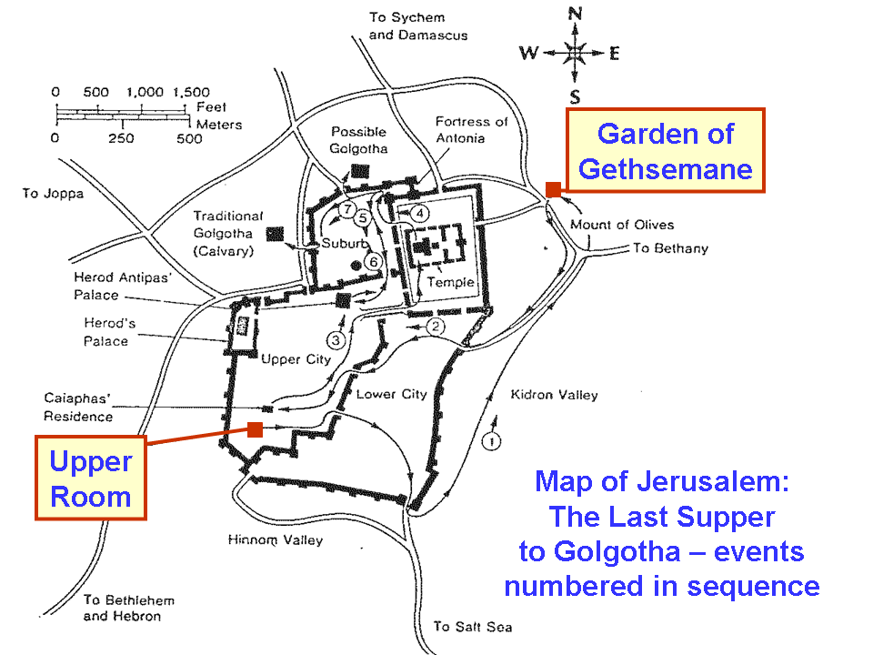

This is the third of three chapters (14, 15 and 16) that build on one another, returning to the same theme at times, only to reinforce and expand upon the teaching with each return. The Holy Spirit, for example, is brought up in all three chapters, but more revelation is given each time Jesus returns to talk about the Holy Spirit or the Helper.

John 16:1-4
"These things I have spoken to you so that you may be kept from stumbling. 2 They will make you outcasts from the synagogue, but an hour is coming for everyone who kills you to think that he is offering service to God. 3 These things they will do because they have not known the Father or Me. 4 But these things I have spoken to you, so that when their hour comes, you may remember that I told you of them. These things I did not say to you at the beginning, because I was with you."

Jesus had been and is even now preparing His disciples for the assignment that He is going to give them. A key point of preparation is to have them be of the right mindset regarding persecution. He had told them before:
John 15:20
If they persecuted Me, they will also persecute you; if they kept My word, they will keep yours also.

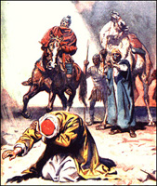
Being an outcast from the synagogue in Israel (as was the man born blind: John 9:22, 34) was not simply like being discharged from church fellowship in our day, but it also made one not a part of the privileges of citizenship in Israel. The last part of verse 2 describes the mindset that the apostle Paul had prior to his conversion on the Damascus Road. Those who persecute them will imagine that they are serving God, as Paul did, but Jesus says that they do not know Him. John 14:26 and 15:20 both had brought up the importance of remembering, and now 16:4 returns to that theme. What Jesus said at this time, and the ministry of the Holy Spirit to follow after, would be directed towards remembering what Jesus said.

Jesus was with them at the beginning of His earthly ministry, but that presence is about to end. The ministry of the Holy Spirit would begin soon after Christ’s ascension.

John 16: 5-11
"But now I am going to Him who sent Me; and none of you asks Me, 'Where are You going?' 6 "But because I have said these things to you, sorrow has filled your heart. 7 "But I tell you the truth, it is to your advantage that I go away; for if I do not go away, the Helper will not come to you; but if I go, I will send Him to you. 8 And He, when He comes, will convict the world concerning sin and righteousness and judgment; 9 concerning sin, because they do not believe in Me; 10 and concerning righteousness, because I go to the Father and you no longer see Me; 11 and concerning judgment, because the ruler of this world has been judged."

Thomas, in John 14:5, came the closest to asking, “Where are You going?”, when he said, “Lord, we do not know where You are going…”. The disciples are noticeably sorrowful, and that would not even begin to change for a few days, and it would not fully change until the day of Pentecost, when the Holy Spirit had been given. As far as the disciples knew, the circumstances were going from bad to really, really bad – and were more than a little baffling, too!

Jesus then tells them all again that the Holy Spirit will be sent by Christ after He leaves, and come to conduct a ministry with the world, convicting (convincing) the world of sin and righteousness and judgment. The world needs to be convinced about sin, because the world, the flesh and the devil are not going to do it – and sin is a serious problem, and its source is terminal. The Holy Spirit will have to convince the world about what right-eousness is, because Jesus, the universal standard of righteousness, will no longer be present on the earth. The world will have to be convinced about judgment because the god of this world (2 Corinthians 4:4) has been judged, and there is a long line of judgments that go along with that (see supplement that goes with this handout: deaths, resurrections and judgments). Every single one of them is certain, and coming quickly.

These are ministries of the Holy Spirit to the world, which will assist the disciples in their assigned task as apostles, as they evangelize. The ministries of the Holy Spirit directly to the believers during the church age are different and they are numerous (about two dozen of them!).

John 16:12-15
"I have many more things to say to you, but you cannot bear them now. 13 But when He, the Spirit of truth, comes, He will guide you into all the truth; for He will not speak on His own initiative, but whatever He hears, He will speak; and He will disclose to you what is to come. 14 He will glorify Me, for He will take of Mine and will disclose it to you. 15 All things that the Father has are Mine; therefore I said that He takes of Mine and will disclose it to you."

The disciples have a ‘truth intake capacity limitation”, and Jesus knows what that is. Even with what He has already told them, it will take time for them to catch up to it. The Father, the Son, and the Holy Spirit together have a part in revealing truth, and the Holy Spirit additionally takes on the role of guiding the apostles “into all the truth” that is to be revealed.

John 16: 16-18
"A little while, and you will no longer see Me; and again a little while, and you will see Me." 17 Some of His disciples then said to one another, "What is this thing He is telling us, A little while, and you will not see Me; and again a little while, and you will see Me'; and, 'because I go to the Father'?" 18 So they were saying, "What is this that He says, 'A little while'? We do not know what He is talking about."

Jesus is telling them that from the time He is crucified and buried, they will not see Him, but when He is resurrected they will see Him again. But they are puzzled by this disclosure – they don’t ‘get it’. Even Jesus going to the Father was not understood.

John 16: 19-22
Jesus knew that they wished to question Him, and He said to them, "Are you deliberating together about this, that I said, 'A little while, and you will not see Me, and again a little while, and you will see Me'? 20 "Truly, truly, I say to you, that you will weep and lament, but the world will rejoice; you will grieve, but your grief will be turned into joy. 21 "Whenever a woman is in labor she has pain, because her hour has come; but when she gives birth to the child, she no longer remembers the anguish because of the joy that a child has been born into the world. 22 "Therefore you too have grief now; but I will see you again, and your heart will rejoice, and no one will take your joy away from you.

So Jesus, knowing that they are discussing His baffling statement, tells them that they would indeed weep and lament, but that in due time this would turn to joy, and the grief would be set aside, as a woman in childbirth sets side the anguish for the sake of the joy.

John 16:23-24
"In that day you will not question Me about anything. Truly, truly, I say to you, if you ask the Father for anything in My name, He will give it to you. 24 Until now you have asked for nothing in My name; ask and you will receive, so that your joy may be made full."

In John 14:13,14 and 15:7, 16 Jesus has already told the disciples that if they ask for anything in His name, it will be given them. Jesus restates that here. In John 15:11 Jesus had already told them that in abiding their joy would be made full. Now He tells them to ask in His name that their joy may be made full.

John 16:25-28
"These things I have spoken to you in figurative language; an hour is coming when I will no longer speak to you in figurative language, but will tell you plainly of the Father. 26 In that day you will ask in My name, and I do not say to you that I will request of the Father on your behalf; 27 for the Father Himself loves you, because you have loved Me and have believed that I came forth from the Father. 28 I came forth from the Father and have come into the world; I am leaving the world again and going to the Father."

Jesus says that His ‘figurative language’ will end, such that He will tell them plainly of the Father. The Father loves these disciples, and these disciples will share an intimate relationship with the Father and the Son. Jesus tells them that He came forth from the Father and that He will return to the Father.

John 16:29-33
His disciples said, "Lo, now You are speaking plainly and are not using a figure of speech. 30 Now we know that You know all things, and have no need for anyone to question You; by this we believe that You came from God." 31 Jesus answered them, "Do you now believe? 32 Behold, an hour is coming, and has already come, for you to be scattered, each to his own home, and to leave Me alone; and yet I am not alone, because the Father is with Me. 33 These things I have spoken to you, so that in Me you may have peace. In the world you have tribulation, but take courage; I have overcome the world."

Jesus’ disciples claim to believe and to understand, but Jesus tells them that they are soon to be scattered, but Jesus tells them these things so that that will ultimately have peace – when all is fulfilled and understood. In the world the disciples are promised tribulation (being raptured before THE Tribulation does not exempt a person from experiencing tribulation). Jesus has overcome the world (John 16:33), so John writes that He who believes has also overcome the world (1 John 5:4, 5), and is therefore among those who overcome, in their eternal position (Revelation 2:7, 11, 17, 26; 3:5, 12, 21; 21:7).

