John 18:1-24

John 18:1-3
When Jesus had spoken these words, He went forth with His disciples over the ravine of the Kidron, where there was a garden, in which He entered with His disciples. 2 Now Judas also, who was betraying Him, knew the place, for Jesus had often met there with His disciples. 3 Judas then, having received the Roman cohort and officers from the chief priests and the Pharisees, came there with lanterns and torches and weapons.

It is of some value to talk about degrees of certainty about the things plotted on this map or any similar map. What is shown as the location of the Upper Room where the Last Supper was held is likely correct. In that location the floor is original, but the column and roof structure were built centuries later. The Garden of Gethsemane is very likely shown in the correct location. The location of the Kidron Valley is undisputed. The identification and location of Caiaphas’ residence is debated, as is the identification and location of the house of Annas. We will identify the certainty of location of other areas shown on the map as we continue our study.

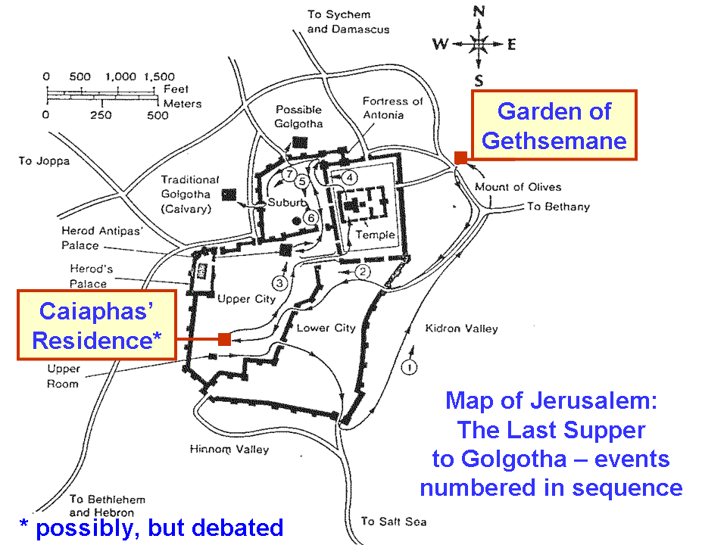

Matthew 26:36 and Mark 14:32 provide us with the name of the Garden where Jesus led His eleven disciples: Gethsemane (meaning ‘olive press’). While John offers a great deal of unique material in John 13, 14, 15, 16 and 17, John does not report the prayers of Jesus in the Garden nor His interactions with the disciples, as do the other three gospels. John does tell us, however, that Jesus had met with His disciples in the Garden of Gethsemane often, which is why Judas could lead the soldiers to where Jesus was. That Jesus went to that place so as to be deliberately found and arrested reveals Jesus’ intent to be crucified now that His time and His hour had come. Both Roman soldiers and members of the Jewish temple guard came to arrest Jesus. While a cohort is often taken as 600, the word that is used here (Greek: speira) could have been a large group but less than 600. Nonetheless, the soldiers brought torches lamps and weapons, anticipating that Jesus might hide and that there might be resistance. Passover was held at the time of the full moon, so the torches and lamps would only be needed if Jesus hid himself, which He did not. In fact, He did the opposite.

The chief priests were Sadducees, actually only serving one at a time, but the series of them serving one at a time were often referred to as chief priests in all four gospels and in Acts. The Pharisees were larger in number in the Sanhedrin than the Sadducees, but for the sake of ‘balance of power’ did not take on the chief priest position.

John 18:4-9
So Jesus, knowing all the things that were coming upon Him, went forth and said to them, "Whom do you seek?" 5 They answered Him, "Jesus the Nazarene." He said to them, "I am He." And Judas also, who was betraying Him, was standing with them. 6 So when He said to them, "I am He," they drew back and fell to the ground. 7 Therefore He again asked them, "Whom do you seek?" And they said, "Jesus the Nazarene." 8 Jesus answered, "I told you that I am He; so if you seek Me, let these go their way," 9 to fulfill the word which He spoke, "Of those whom You have given Me I lost not one."
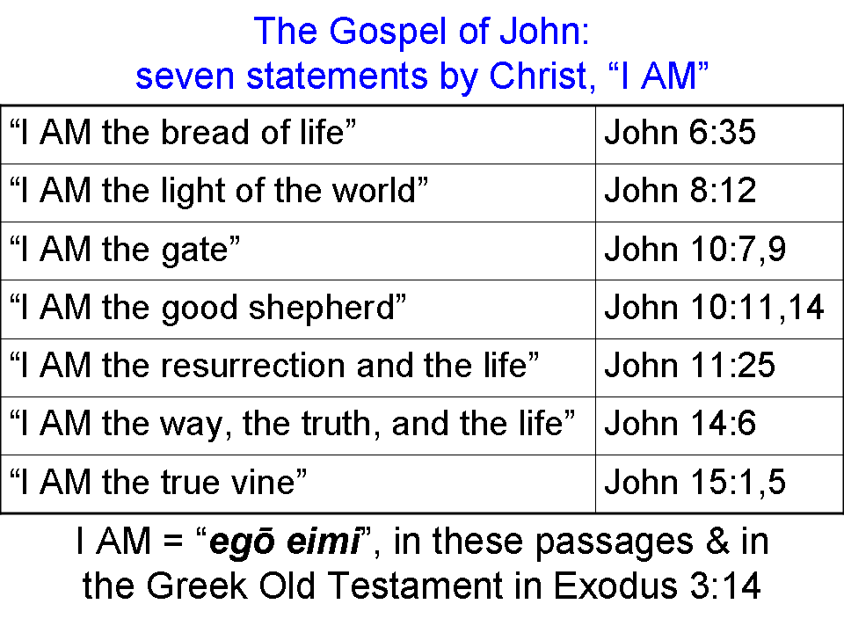
It is exceedingly important to observe that Jesus knew what was “coming upon Him”. He was not just an observant man who had an intuitive sense of what was about to take place from reading the signals. He knew what was about to take place because these were the things that had been agreed upon from eternity past. His hour and His time had come. What was about to take place was central to what the Father had sent Him to accomplish.

The words “I am He” in the Greek text is egō eimi, which we have presented in the past as ‘I AM’ (see insert above). It literally means, “I, I am”. What Jesus was saying, in expanded and explained format, was, “I, being in fact God, am Jesus of Nazareth”. John does not detail Judas’ betrayal, but indicates that he was the betrayer, and that he was standing among the soldiers who had come to arrest Jesus – not among the disciples.

On Jesus’ statement ‘I AM’, the ones who came to arrest Jesus fell back. Now certainly Jesus had the power to turn every arresting soldier into dust. But Jesus’ open identification of Himself as ‘I AM’, was not at all what the soldiers were expecting. They were expecting someone to be hiding out, and possibly putting up a resistance. Instead Jesus came to them, identified Himself as deity and the one they were seeking, with eleven men about Him, who did not appear to be prepared for battle on that moonlit night.

Jesus then claimed again to be Jesus of Nazareth, repeating His identification as deity. But also pleading to have the eleven disciples let go. Jesus was to die, but these disciples were to live to continue on as His apostles. But Peter, being a man of impulsive words action, pulls out his sword…

John 18:10-11
Simon Peter then, having a sword, drew it and struck the high priest's slave, and cut off his right ear; and the slave's name was Malchus. 11 So Jesus said to Peter, "Put the sword into the sheath; the cup which the Father has given Me, shall I not drink it?"

We have this insight from the gospel of Luke that tells us that the disciples had two swords just before they entered the garden of Gethsemane. Jesus told the disciples to arm themselves in their future ministry as apostles as a general defensive weapon against thieves and thugs along the way, but not in order to fight off the crowd of arresting soldiers on that night in the garden.

Luke 22:35-38
And He said to them, "When I sent you out without money belt and bag and sandals, you did not lack anything, did you?" They said, "No, nothing." 36 And He said to them, "But now, whoever has a money belt is to take it along, likewise also a bag, and whoever has no sword is to sell his coat and buy one. 37 "For I tell you that this which is written must be fulfilled in Me, 'And He was numbered with transgressors'; for that which refers to Me has its fulfillment." 38 They said, "Lord, look, here are two swords." And He said to them, "It is enough."

The apostle John seems to have some unique connections to the Sanhedrin and the priestly class. Only John mentions Nicodemus, one of the Sanhedrin, and also Joseph of Arimathea, also of the Council (John 3:1, 4, 9; 7:50-52; 19:39). Nicodemus is named when he comes to Jesus by night, when he attempts to defend Jesus before the Sanhedrin, and at Jesus’ burial after Christ was crucified. John also, not naming himself, but calling himself ‘another disciple’, ‘that disciple’ or ‘the other disciple’, was able to get Peter into the courtyard of the high priest, and he was known by the high priest (John 18:15, 16). We also have John uniquely giving the name of the high priest’s slave: Malchus. And John, being known to the high priest, would be very likely to know the name of the high priest’s slave whose ear was cut off.

But Jesus tells Peter to put his sword away, because Jesus was intending to go to the cross. He had an appointment to keep, agreed upon with the Father who had sent Him. On healing Malchus’ ear (Luke 22:51), one might think that the arresting soldiers should have begun to question what they were doing, but they did not.

John 18:12-14
So the Roman cohort and the commander and the officers of the Jews, arrested Jesus and bound Him, 13 and led Him to Annas first; for he was father-in-law of Caiaphas, who was high priest that year. 14 Now Caiaphas was the one who had advised the Jews that it was expedient for one man to die on behalf of the people.

So in spite of Jesus having approached the arresting soldiers, and in spite of Jesus telling Peter to put his sword away and healing Malchus’ ear, and in spite of Jesus cooperation, they bound Him. At first they took Jesus to the house of Annas, the father-in-law of Caiaphas, the actual high priest for that Jewish year. What Caiaphas had said about Jesus dying for the people is uniquely recorded in John 11:47-53.

John 18:15-18
Simon Peter was following Jesus, and so was another disciple. Now that disciple was known to the high priest, and entered with Jesus into the court of the high priest, 16 but Peter was standing at the door outside. So the other disciple, who was known to the high priest, went out and spoke to the doorkeeper, and brought Peter in. 17 Then the slave-girl who kept the door said to Peter, "You are not also one of this man's disciples, are you?" He said, "I am not." 18 Now the slaves and the officers were standing there, having made a charcoal fire, for it was cold and they were warming themselves; and Peter was also with them, standing and warming himself.

John has a special connection with the high priest, so that John, identifying himself as “another disciple”, is able to get into the high priest’s courtyard and allow Peter to gain access as well. As Peter warmed himself by the fire he denied the slave-girls’ question about him being one of Jesus’ disciples.

John 18:19-24
The high priest then questioned Jesus about His disciples, and about His teaching. 20 Jesus answered him, "I have spoken openly to the world; I always taught in synagogues and in the temple, where all the Jews come together; and I spoke nothing in secret. 21 "Why do you question Me? Question those who have heard what I spoke to them; they know what I said." 22 When He had said this, one of the officers standing nearby struck Jesus, saying, "Is that the way You answer the high priest?" 23 Jesus answered him, "If I have spoken wrongly, testify of the wrong; but if rightly, why do you strike Me?" 24 So Annas sent Him bound to Caiaphas the high priest.

In these things Jesus did not defend Himself, but rather questioned why He must even be asked anything. He had spoken again and again, in plain view, in front of everyone, all along. The proceeding was a sham, since they had already concluded what the outcome would be (John 11:49-50). But Jesus questioning of Annas, even though fitting, resulted in Him being struck. Jesus challenged His being struck, asking for testimony about His supposed wrongdoing. But Annas sent Jesus to Caiaphas, who had developed the plan to have Jesus killed in the first place.

