John 19:1-15

As pointed out last Sunday, when we take all of the Gospels together, we find that Jesus actually had seven trials that night from the time of His arrest to His sentence of crucifixion:

- Annas: John 18:12-14, 19-23
- Caiaphas: Matthew 27:57, 58-68; Mark 14:53, 55-65; Luke 22: 54, 63-65; John 18:24
- Sanhedrin: Matthew 27:1; Mark 15:1; Luke 22:66-71
- Pilate: Matthew 27:2, 11-14; Mark 15:1b-5; Luke 23:1-5; John:18:28-38
- Herod: Luke 23:6-12
- Pilate: Matthew 27:15-23; Mark 15:6-14; Luke 23:13-22; John 18:39-19:6
- Pilate & the Crowd: Matthew 27:24-31; Mark 15:15-20; Luke 23:23-25; John 19:7-16

The end of trial 6) and almost all of trial 7) are included in John 19:1-15.

Pontius Pilate (Latin: Pontivs Pilatvs) ruled as governor (Latin: Praetor) from 26 AD to 36 AD, when both he and Caiaphas were removed from office. Pilate ordinarily lived in and ruled from Caesarea on the coast, but travelled to & stayed in Jerusalem for special seasons & events, such as the Passover & the Feast of Unleavened Bread, since Jewish fervor ran high during those times. At those times he would take more soldiers with him.

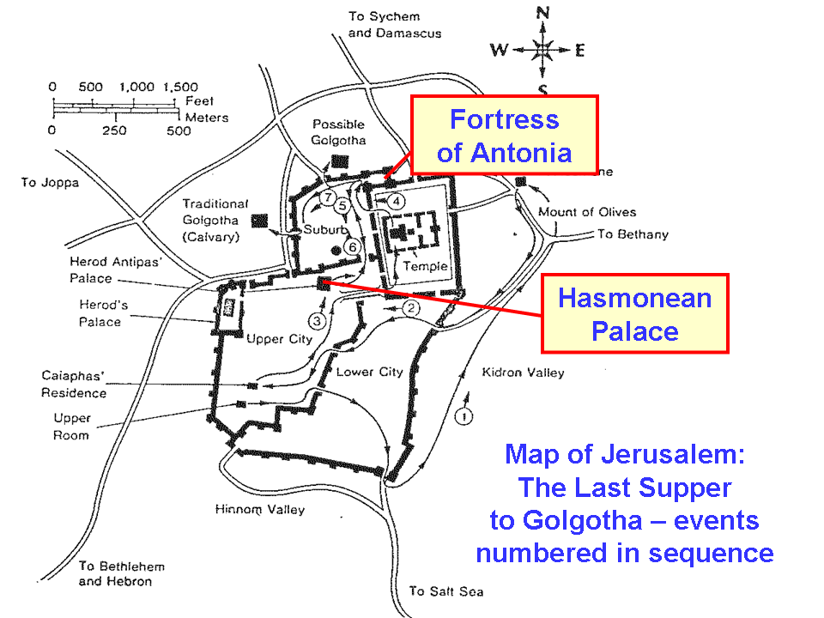
It used to be thought that Pilate interrogated and sentenced Jesus in the Fortress of Antonia, but more recently archaeological excavations have placed the interrogation at the Hasmonean Palace or Herod’s Palace. Dr. Leen Ritmeyer, one of the foremost archaeologists regarding the temple mount and vicinity, believes that the Hasmonean Palace is the right location for Pilate’s interrogation of Jesus.

The Jews wanted Jesus crucified, because in John 11:50 Caiaphas said, “…it is expedient for you that one man die for the people…”. That was the plan. But Pilate had not found any guilt in Jesus, and he said so to the Jews who brought Him to the Praetorium. Pilate repeatedly called Jesus the ‘King of the Jews’ or ‘Your King”. He tried to find several ways to get Jesus off, including offering to set Him free by the Passover tradition – but the crowd called for the release of Barabbas instead.

At about that same point Matthew 27:19 records, “While he [Pilate] was sitting on the judgment seat, his wife sent him a message, saying, "Have nothing to do with that righteous Man; for last night I suffered greatly in a dream because of Him." While various speculative accounts of Pilate’s wife have been generated in later years, likely his wife’s message added to Pilate’s motivation to dismiss Jesus without sentencing Him to crucifixion.

John 19:1-3
Pilate then took Jesus and scourged Him. 2 And the soldiers twisted together a crown of thorns and put it on His head, and put a purple robe on Him; 3 and they began to come up to Him and say, "Hail, King of the Jews!" and to give Him slaps in the face.

Pilate did not personally scourge Jesus, of course, but rather turned Him over to the soldiers for scourging. Because Jesus was not a Roman citizen, as was the case with the vast majority of Jews, the Roman officials and officers had the liberty to scourge Him for any reason (Acts 22:22-29), simply as an interrogation tool. There was also no legal constraint on how much shame, mocking and abuse the soldiers could pour out upon anyone who was to be scourged. What our constitution calls ‘cruel and unusual punishment’ was the norm for the Roman soldiers, and one did not have to be found guilty in order to receive the abuse.

The crown of thorns, the purple robe, and “Hail, King of the Jews” were all cruel mocking of Jesus. Yet Jesus did not defend Himself in the least, though He certainly had the power to do so. Jesus would soon die voluntarily for the sins of Pilate, these soldiers who abused Him, the Jewish leaders who turned Him over to be crucified, Judas who betrayed him, Peter who denied knowing Him, and everyone on the planet from Adam to the last one born in the coming Millennial Kingdom.

John 19:4-7
Pilate came out again and said to them, "Behold, I am bringing Him out to you so that you may know that I find no guilt in Him." 5 Jesus then came out, wearing the crown of thorns and the purple robe. Pilate said to them, "Behold, the Man!" 6 So when the chief priests and the officers saw Him, they cried out saying, "Crucify, crucify!" Pilate said to them, "Take Him yourselves and crucify Him, for I find no guilt in Him." 7 The Jews answered him, "We have a law, and by that law He ought to die because He made Himself out to be the Son of God."

Pilate, having carried out the scourging and mocking, may have thought that scourging and mocking Jesus and presenting Him before the crowds would satisfy the Jews, and Jesus could then be set free. But that would not fulfill the plan that the leaders of the Jews had made. Pilate did not want to have Jesus’ death on his hands. And he said more than once that Jesus had no guilt. He could not pass Jesus’ death off to the Jews – they would not receive it. Instead they called out repeatedly that Jesus be crucified. The Jews deliver an ultimatum to Pilate: He must sentence Jesus to death.

John 19:8-11
Therefore when Pilate heard this statement, he was even more afraid; 9 and he entered into the Praetorium again and said to Jesus, "Where are You from?" But Jesus gave him no answer. 10 So Pilate said to Him, "You do not speak to me? Do You not know that I have authority to release You, and I have authority to crucify You?" 11 Jesus answered, "You would have no authority over Me, unless it had been given you from above; for this reason he who delivered Me to you has the greater sin."

Pilate was likely irritated that Jesus did not answer, but still he was concerned for what he might be getting himself into. Jesus did not defend Himself in such a away that Pilate could set Him free, and the Jewish leaders had stirred up the crowds to demand Jesus’ crucifixion with persistence and volume. Yet this trial, having shifted now to the will of the crowds would soon bring about Jesus’ death. Jesus stated that Pilate’s authority to carry out the sentence of crucifixion came from God Himself.

“He was oppressed and He was afflicted, yet He did not open His mouth; like a lamb that is led to slaughter, and like a sheep that is silent before its shearers, so He did not open His mouth.” Isaiah 53:7

But this trial had to proceed to Christ’s death, though that is not what Pilate wanted, because God so loved the world that He gave His only Son, and Christ loved us and gave Himself for us.
John 3:16
"For God so loved the world, that He gave His …Son…
Galatians 2:20
…the Son of God, who loved me and gave Himself up for me.
Ephesians 5:2
…Christ also loved you and gave Himself up for us…
Ephesians 5:25
…Christ also loved the church and gave Himself up for her…

John 19:12
As a result of this Pilate made efforts to release Him, but the Jews cried out saying, "If you release this Man, you are no friend of Caesar; everyone who makes himself out to be a king opposes Caesar."

Notice the change of strategy of the Jewish leaders. They switched from Jewish law condemning Christ to Roman law condemning Pilate if he did not sentence Christ, the King of the Jews, to death. The Jews despised the rule of Caesar and all of his governors, officers and soldiers. They had even that week presented Jesus with a question about paying taxes to Caesar. But the Jewish leaders knew they could press Pilate on that point, even though Jesus made no claim to be at odds with Caesar, and did not have His small band of disciples fighting against the Jews or the Romans. Yet the Jews pressed that Pilate would not be loyal to Caesar if he let Jesus free, since He had claimed to have been born the King of the Jews. If it were to get back to Caesar that Pilate had let someone go who had claimed to be a rival king to Caesar, Pilate would lose his office and likely his life. Now they had a point that would turn Pilate – fear of losing his office and likely his life.

John 19:13-15
Therefore when Pilate heard these words, he brought Jesus out, and sat down on the judgment seat at a place called The Pavement, but in Hebrew, Gabbatha. 14 Now it was the day of preparation for the Passover; it was about the sixth hour. And he said to the Jews, "Behold, your King!" 15 So they cried out, "Away with Him, away with Him, crucify Him!" Pilate said to them, "Shall I crucify your King?" The chief priests answered, "We have no king but Caesar."

According to Roman law, Pilate was permitted to ‘take the temperature’ of the crowd in pronouncing sentence. Essentially, it became the crowd who pronounced sentence. Before, it was, “Behold, the Man!” But now it was, “Behold, your King”.

The reference to the sixth hour has brought about quite a bit of discussion, because the time was ordinarily marked as 6 AM being the start of the marking of time. But a less commonly used Roman method of marking time started the day at midnight, and that is apparently what John was referring to by saying it was the ‘sixth hour’.

Upon the question, “Shall I crucify your King?”, the Jewish leaders are shameful. They claim loyalty to the despised pagan Caesar, who claims to be deity, rather than the true deity who is their real Messiah, and the Son of God.

There is some difference of opinion as to where some of these divide out certain sections of the appearances before Pilate.

