John 19:16-30

In last week’s study we saw that Pilate, after many attempts to set Jesus free, finally responded to crowd pressure and sentenced Jesus to crucifixion. We will address what John’s gospel records, with some reference to the other three gospels today, and next Sunday. We are at the end of the seven trials, as outlined the previous two weeks:

John 19:16
So he then handed Him over to them to be crucified.

To clarify the pronouns and figure of speech, Pilate pronounced sentence of crucifixion, which the soldiers would carry out. The Jewish leaders got their wish – the plan initiated by Caiaphas had ‘succeeded’. Jesus was going to be crucified, just as He had told the twelve disciples would happen:

Matthew 20:17-19
As Jesus was about to go up to Jerusalem, He took the twelve disciples aside by themselves, and on the way He said to them, 18 "Behold, we are going up to Jerusalem; and the Son of Man will be delivered to the chief priests and scribes, and they will condemn Him to death, 19 and will hand Him over to the Gentiles to mock and scourge and crucify Him, and on the third day He will be raised up."

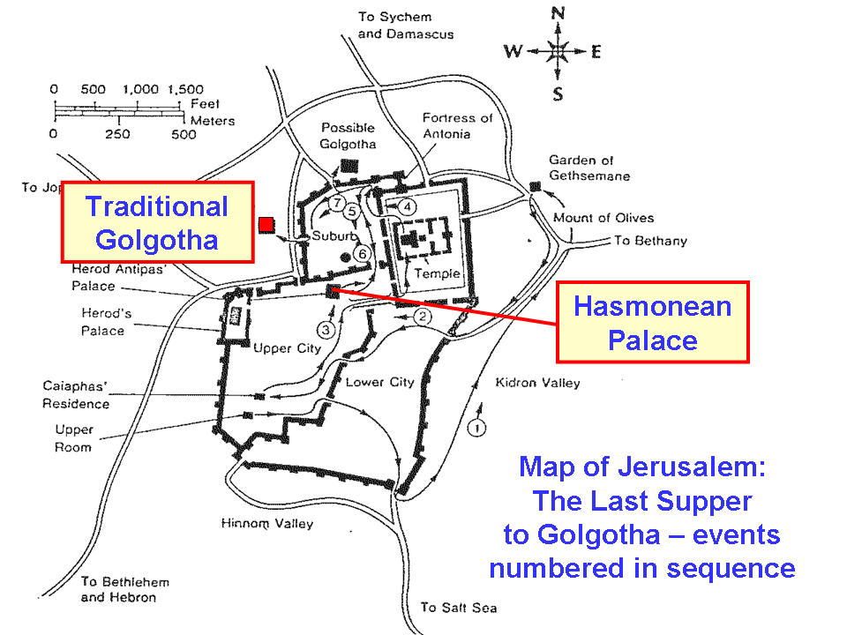
Crucifixion was an exceedingly painful, horrific, and shameful way to die. It was reserved for the worst of criminals, slaves, prisoners of war, and revolutionaries. It was like a billboard that everyone could see that said, “Don’t mess with Rome”. But Jesus was not headed to crucifixion just so that He could feel the pain and the shame. Jesus had multiple spiritual purposes for going to the cross, motivated from the past by love (Galatians 2:20; Ephesians 5:2, 25), and motivated from the future by anticipating the joy (Hebrews 12:2).

John 19:17-18
They took Jesus, therefore, and He went out, bearing His own cross, to the place called the Place of a Skull, which is called in Hebrew, Golgotha. 18 There they crucified Him, and with Him two other men, one on either side, and Jesus in between.

John’s account minimizes the details about the time just before Jesus’ crucifixion which are conveyed in the other gospels (a second, more severe flogging; Jesus collapsing, so the cross is carried by Simon of Cyrene, etc.). The typical portion of the cross that the criminal would carry was just the cross-bar (Latin: patibulum) rather than the entire cross, as is often shown in artistic or dramatic presentations.

The most likely location for Jesus crucifixion (Golgotha) is the traditional location, shown on the map on the previous page. That would be the location of a mound of lower quality rock in an ancient quarry. John’s gospel states that there were two other men who were crucified on either side of Jesus, but how they behaved and what they said to Jesus, and what He said to them is recorded in the other gospels.

John 19:19-22
Pilate also wrote an inscription and put it on the cross. It was written, "Jesus the Nazarene, the King of the Jews." 20 Therefore many of the Jews read this inscription, for the place where Jesus was crucified was near the city; and it was written in Hebrew, Latin and in Greek. 21 So the chief priests of the Jews were saying to Pilate, "Do not write, 'The King of the Jews'; but that He said, 'I am King of the Jews.'" 22 Pilate answered, "What I have written I have written."

It is most likely that Pilate did not personally write the inscription and place it on the cross. But what he ordered was apparently carried out with sufficient size and clarity that it got the attention of the chief priests. In spite of the chief priests’ objections, Pilate insisted that the inscription remain as written. Since Jesus was crucified, the Jewish leaders got what they wanted, but they weren’t expecting Pilate to get in his insult to the Jews.

John 19:23-25
Then the soldiers, when they had crucified Jesus, took His outer garments and made four parts, a part to every soldier and also the tunic; now the tunic was seamless, woven in one piece. 24 So they said to one another, "Let us not tear it, but cast lots for it, to decide whose it shall be"; this was to fulfill the Scripture: "They divided My outer garments among them, and for My clothing they cast lots." 25 Therefore the soldiers did these things.

For the soldiers on execution duty, gambling for clothes and miscellaneous articles was common. The lowest ranking soldiers were pressed to take any economic advantage they could, since their wages were about the same as a day laborer. But their doing so fulfilled Old Testament prophecy (Psalm 22:18).

John 19:26-27
But standing by the cross of Jesus were His mother, and His mother's sister, Mary the wife of Clopas, and Mary Magdalene. 26 When Jesus then saw His mother, and the disciple whom He loved standing nearby, He said to His mother, "Woman, behold, your son!" 27 Then He said to the disciple, "Behold, your mother!" From that hour the disciple took her into his own household.

From statistical studies of ossuary boxes, it appears that about 20% of the woman in Israel were named Mary.

John records only this interaction with His mother and with John, “the disciple whom He loved”. Jesus was assigning responsibility for His mother, Mary, to John. One might ask why Jesus did not assign responsibility for His mother to Jesus’ brothers. A fair question. John 7:1-5 says that Jesus’ brothers didn’t believe, and were extremely antagonistic to Jesus – even wanting Jesus to get killed. So Jesus had to make an assignment of responsibility to John, who was present, cooperative, and willing to receive the assignment. Later, Jesus’ brothers would believe (Acts 1:14), but the assignment had to be made before Christ’s death, if an unbroken line of responsibility for Mary was to be maintained.

As we will examine next Sunday, there were other things said from the third hour (9 AM), when Jesus was crucified until the sixth hour (12 noon), when conversations with others ended. From the sixth hour (12 noon) until just before the 9th hour (3 PM) Jesus was silent.

John 19:28-30
After this, Jesus, knowing that all things had already been accomplished, to fulfill the Scripture, said, "I am thirsty." 29 A jar full of sour wine was standing there; so they put a sponge full of the sour wine upon a branch of hyssop and brought it up to His mouth. 30 Therefore when Jesus had received the sour wine, He said, "It is finished!" And He bowed His head and gave up His spirit.

We will take a brief look at what Jesus accomplished on the cross shortly. “I am thirsty” is from Psalm 69:21, as is the sour wine (vinegar). The word translated “It is finished” is tetelestai, which is an accounting term which means “Paid”. It is in the perfect tense, which means that it is a completed past action with ongoing results on into the future, implying permanence. Jesus paid it all – permanently!
“…all things had already been accomplished…” John 19:28

