John 19:31-42

Jesus, having been crucified, accomplished all the things that He and the Father intended, one of those being that Christ paid for the sins of the whole world by His death on the cross.

John 19:31
Then the Jews, because it was the day of preparation, so that the bodies would not remain on the cross on the Sabbath (for that Sabbath was a high day), asked Pilate that their legs might be broken, and that they might be taken away.

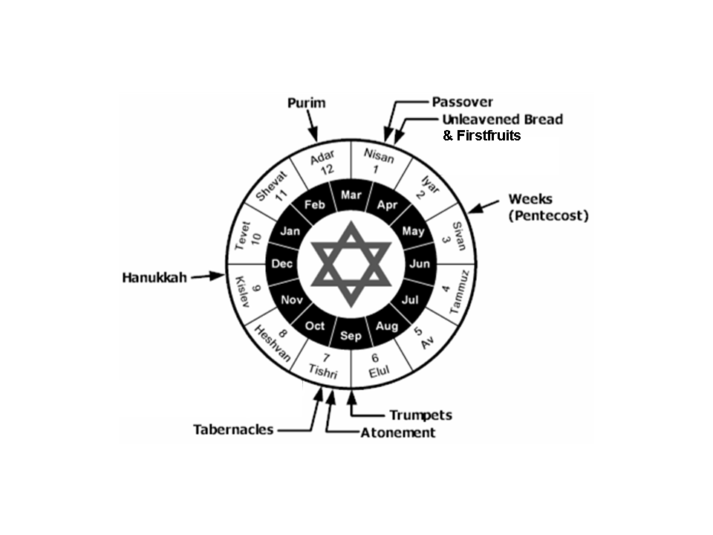

The Law of Moses actually required that bodies be taken down and buried before sundown every day (see Deuteronomy 21:22-23, below), though the Romans typically did not do that. But for the bodies to be left to hang on a Sabbath during the Passover/Feast of Unleavened Bread was more than the Jews would bear, so the Romans complied with the requirements of the Law of Moses just before the Sabbath in the Feast of Unleavened Bread in order to keep peace with the Jews.

Deuteronomy 21:22-23
"If a man has committed a sin worthy of death and he is put to death, and you hang him on a tree, 23 his corpse shall not hang all night on the tree, but you shall surely bury him on the same day (for he who is hanged is accursed of God), so that you do not defile your land which the LORD your God gives you as an inheritance.
This verse has the last use (of about 60) of the words “the Jews” in the gospel of John.

The legs of the ones being crucified were broken to hasten death, as an accommodation to the Jews. This was called crurifragium. Once the legs were broken the person on the cross could not push up on the nail through the feet, so they suffocated shortly thereafter.

John 19:32-34
So the soldiers came, and broke the legs of the first man and of the other who was crucified with Him; 33 but coming to Jesus, when they saw that He was already dead, they did not break His legs. 34 But one of the soldiers pierced His side with a spear, and immediately blood and water came out.

The legs of the two thieves on either side of Jesus were broken, so that they would die quickly. But Jesus had already given up His own spirit voluntarily, so was already physically dead (Luke 23:46).

John 19:35-37
And he who has seen has testified, and his testimony is true; and he knows that he is telling the truth, so that you also may believe. 36 For these things came to pass to fulfill the Scripture, "Not a bone of him shall be broken." 37 And again another Scripture says, "They shall look on him whom they pierced."

Verse 35 is John’s personal testimony that what he wrote about Jesus was true, similar to what he wrote in John 21:24, 1 John 1:1-4 and Revelation 1:1-8.

The unbroken legs draw from both Old Testament prophecy and practice. Psalm 34:19-20 ("Not a bone of him shall be broken.") speaks of the Lord’s care of the righteous, but John makes a specific application to Jesus, in that His bones were not broken, as were those either side of Him. The bones of the Passover lamb were not to be broken (Exodus 12:43-46; Numbers 9:9-12); and since Jesus was the Lamb of God (John 1:29, 36) and the Passover Lamb (1 Corinthians 5:7), His legs were not broken.

"They shall look on him whom they pierced." is from Zechariah 12:10. This has fulfillment in John 19:37 as to the piercing and in Revelation 1:7 at Christ’s second coming (“They shall look on him…”). The spear would have been the Roman pilum. The separation of blood and water confirmed that Jesus was dead.

John 19:38-42
After these things Joseph of Arimathea, being a disciple of Jesus, but a secret one for fear of the Jews, asked Pilate that he might take away the body of Jesus; and Pilate granted permission. So he came and took away His body. 39 Nicodemus, who had first come to Him by night, also came, bringing a mixture of myrrh and aloes, about a hundred pounds weight. So they took the body of Jesus and bound it in linen wrappings with the spices, as is the burial custom of the Jews. 41 Now in the place where He was crucified there was a garden, and in the garden a new tomb in which no one had yet been laid. 42 Therefore because of the Jewish day of preparation, since the tomb was nearby, they laid Jesus there.
The gospel of Mark adds these details to the account of Joseph of Arimathea.

Mark 15:42-47
When evening had already come, because it was the preparation day, that is, the day before the Sabbath, 43 Joseph of Arimathea came, a prominent member of the Council, who himself was waiting for the kingdom of God; and he gathered up courage and went in before Pilate, and asked for the body of Jesus. 44 Pilate wondered if He was dead by this time, and summoning the centurion, he questioned him as to whether He was already dead. 45 And ascertaining this from the centurion, he granted the body to Joseph. 46 Joseph bought a linen cloth, took Him down, wrapped Him in the linen cloth and laid Him in a tomb which had been hewn out in the rock; and he rolled a stone against the entrance of the tomb. 47 Mary Magdalene and Mary the mother of Joses were looking on to see where He was laid.

Joseph of Arimathea, after gathering up his courage, pursued permission from Pontius Pilate to take the body of Jesus. After calling for the centurion in charge of the crucifixion to confirm Jesus’ death, Pilate granted Joseph of Arimathea permission to take Jesus’ body.

Matthew 27:57 adds that Joseph of Arimathea was wealthy and that he was a disciple of Jesus, and was waiting for the kingdom of God. The Council was the Sanhedrin, and Joseph of Arimathea was prominent among them. While Joseph of Arimathea is mentioned in all four gospels, only John also mentions Nicodemus’ involvement in Jesus’ burial.

Jesus’ body was prepared and buried in traditional Jewish fashion, with one exception, adding to the indication that Joseph of Arimathea and Nicodemus were well-off financially. The hundred pounds weight of myrrh and aloes would have been more myrrh than most Jewish people could afford – an amount and expense for a king! Between the body of Jesus, the cloth, and the weight of myrrh and aloes, likely several household servants assisted in transporting and preparing Jesus’ body and the burial preparation materials.

Mary Magdalene (from Magdala) and Mary the mother of James the Less and Joses, and Salome watched where Jesus’ body had been laid (Mark 15:40).

One key passage which gives the meaning of these events is:

Colossians 2:8-14
For in Him [Christ] all the fullness of Deity dwells in bodily form, 10 and in Him you have been made complete, and He is the head over all rule and authority; 11 and in Him you were also circumcised with a circumcision made without hands, in the removal of the body of the flesh by the circumcision of Christ; 12 having been buried with Him in baptism, in which you were also raised up with Him through faith in the working of God, who raised Him from the dead. 13 When you were dead in your transgressions and the uncircumcision of your flesh, He made you alive together with Him, having forgiven us all our transgressions, 14 having canceled out the certificate of debt consisting of decrees against us, which was hostile to us; and He has taken it out of the way, having nailed it to the cross.

