John 20:19-31

John chapter 20 begins John’s resurrection account. We began last Sunday with John 20:1-18, which ended with Mary Magdalene going to tell the disciples that she had seen and spoken with Christ, who had been resurrected. Today’s passage brings us to the evening of that same day.

John 20:19-20
So when it was evening on that day, the first day of the week, and when the doors were shut where the disciples were, for fear of the Jews, Jesus came and stood in their midst and said to them, "Peace be with you." 20 And when He had said this, He showed them both His hands and His side. The disciples then rejoiced when they saw the Lord.

It was evening of the same day in which Jesus had been resurrected. Technically, that would be the second day of the week by Jewish reckoning, since it was past sundown. But John’s point is to say that not even twenty four hours had passed since Jesus had been resurrected. The eleven disciples less Thomas were all present in a room with the doors shut, since they feared the Jews. That tells us something else about the disciples’ state of mind at this point. Even Peter and John were fearfully present here, and they had seen the empty tomb earlier that day! And Mary Magdalene had told them that she had seen the risen Lord. But they didn’t get it! And there is no evidence that the Jews were looking for the disciples, either. See page 4 for the list of the disciples in the gospels and in Acts.

Jesus didn’t knock on the door, tell them He’s coming in, or break it to them slowly. He just entered the room, apparently through a wall or closed doors, and stood in the midst of them. Jesus said, “Peace be with you” in verse 19 and again in verses 21 and 26. He greeted them consistent with the common Jewish greeting (Hebrew shalom 'alekem), and how He had prepared them just a few days before. Earlier, Jesus had said, in John 14:27, "Peace I leave with you; My peace I give to you; not as the world gives do I give to you. Do not let your heart be troubled, nor let it be fearful." And in John 16:33 Jesus had said to them, "These things I have spoken to you, so that in Me you may have peace. In the world you have tribulation, but take courage; I have overcome the world."

Jesus showed the ten disciples, less Thomas, His hands and His side, which bore the marks of the nails and the spear (Latin: “pilum”). At this point the disciples turn from fear to rejoicing. They are beginning to understand and they are convinced that it is indeed the Lord – resurrected from the dead.

John 20:21-23
So Jesus said to them again, "Peace be with you; as the Father has sent Me, I also send you." 22 And when He had said this, He breathed on them and said to them, "Receive the Holy Spirit. 23 If you forgive the sins of any, their sins have been forgiven them [perfect passive]; if you retain the sins of any, they have been retained [perfect passive]."

These verses were preparing the disciples for the ministry that they would have as apostles:

1) In the world, the disciples turned apostles would have tribulation (John 16:33). But there would be a basis for them to have peace and courage as they carry out their apostolic ministry. Jesus had overcome the world, and those who would come to believe would be overcomers (1 John 4:4, 5). Also, the Holy Spirit would be given, and part of the fruit of the Spirit was peace.

2) Verse 22 was not the point of receiving the Holy Spirit, but anticipated the receiving of the Holy Spirit in Acts chapter 2 (Acts 1:8; 2:4). Both Thomas and Mathias would be present in Acts 2, but neither of them were present at this point.

3) If any believed the gospel, the apostles could tell these new believers that God had forgiven their sins. If they disbelieved, they could tell them that God had not forgiven but retained their sins. Compare this verse to Matthew 16:19 and 18:18, which are stated similarly in a church discipline context.

John 20:24-25
But Thomas, one of the twelve, called Didymus, was not with them when Jesus came. 25 So the other disciples were saying to him, "We have seen the Lord!" But he said to them, "Unless I see in His hands the imprint of the nails, and put my finger into the place of the nails, and put my hand into His side, I will not believe."

Thomas, called Dydimus (‘the Twin’) was very skeptical. Not even the unanimous testimony of all ten of His fellow disciples would convince him that Christ had risen. He was not going to be ‘taken in’. Jesus had shown Thomas’ fellow disciples the marks of the nails and the spear in His side, but Thomas would have to see and touch for himself if he were to believe.

John 20:26-28
After eight days His disciples were again inside, and Thomas with them. Jesus came, the doors having been shut, and stood in their midst and said, "Peace be with you." 27 Then He said to Thomas, "Reach here with your finger, and see My hands; and reach here your hand and put it into My side; and do not be unbelieving, but believing." 28 Thomas answered and said to Him, "My Lord and my God!" 29 Jesus said to him, "Because you have seen Me, have you believed? Blessed are they who did not see, and yet believed."

Given that this event took place eight days later (per Jewish custom, inclusive of the day in which Christ resurrected), it is the first day of the next week – what we would call Sunday. Jesus came into the room with shut doors, just as He had done a week before. He began with the same greeting, “Peace be with you”, but He invited Thomas to see His hands and touch His side with his finger. Thomas seemed to immediately recognize Christ as having risen, saying, “My Lord and My God!” In those words, Thomas acknowledged Jesus’ authority, deity, identity and resurrection. Jesus acknowledged Thomas’ belief, having seen Jesus with his own eyes. But Jesus turns from there to those who would believe the message of the apostles based on their testimony alone, not having seen Christ personally. That would soon be Thomas’ ministry – calling those who have not seen to believe.

John 20:30-31
Therefore many other signs Jesus also performed in the presence of the disciples, which are not written in this book; 31 but these have been written so that you may believe that Jesus is the Christ, the Son of God; and that believing you may have life in His name.

In these verses John gave his purpose statement for this book, which he also did for 1 John (1:1-4) and Revelation (1:19).

Jesus performed other signs, a few of which are recorded in the other three gospels. We have these early and late records in John of the things that Jesus did:

John 2:11
This beginning of His signs Jesus did in Cana of Galilee, and manifested His glory, and His disciples believed in Him.

John 21:25
And there are also many other things which Jesus did, which if they were written in detail, I suppose that even the world itself would not contain the books that would be written.

So we can conclude that Jesus did many things during His ministry which are not recorded at all in the four gospels. What is revealed to us in the four gospels is true, but just a divinely inspired sampling of all of what Jesus said and did.

But it is quite clear that John’s purpose was that the reader or hearer of this book believe that Jesus (Hebrew: Yeshua, Savior) is the Christ (Greek: Christos; the Messiah – the Anointed One), the Son of God (the second person of the Trinity), and that anyone who believes may have life in His name (who He is). The clear sequence in the Gospel of John is ‘believe, then be given life’: John 3:16, 36; 5:24; 11:25; 20:31.
Appendix I: A Brief Harmony of the Resurrection Accounts

Here is a possible harmony of the narratives of the resurrection of Christ and His post-resurrection appearances, in chronological order:
Jesus is buried, as several women watch (Matthew 27:57-61; Mark 15:42-47; Luke 23:50-56; John 19:38-42).
The tomb is sealed and a guard is set (Matthew 27:62-66).
At least 3 women, including Mary Magdalene, Mary the mother of James, and Salome, prepare spices to go to the tomb (Matthew 28:1; Mark 16:1).
An angel descends from heaven, rolls the stone away, and sits on it. There is an earthquake, and the guards are initially in shock (Matthew 28:2-4).
The women arrive at the tomb and find it empty. Mary Magdalene leaves the other women there and runs to tell the disciples (John 20:1-2).
The women still at the tomb see two angels who tell them that Jesus is risen and who instruct them to tell the disciples to go to Galilee (Matthew 28:5-7; Mark 16:2-8; Luke 24:1-8).
The women leave to bring the news to the disciples (Matthew 28:8).
The guards report the empty tomb to the chief priests, who bribe the guards to say the body was stolen (Matthew 28:11-15).
Mary the mother of James and the other women, on their way to find the disciples, see Jesus (Matthew 28:9-10).
The women relate what they have seen and heard to the disciples (Luke 24:9-11).
Peter and John run to the tomb, see that it is empty, and find the grave clothes (Luke 24:12; John 20:2-10).
Mary Magdalene returns to the tomb. She sees the angels, and then she sees Jesus (John 20:11-18).

Later the same day, Jesus appears to Peter (Luke 24:34; 1 Corinthians 15:5).
Still on the same day, Jesus appears to Cleopas and another disciple on their way to Emmaus (Luke 24:13-32).
That evening, the two disciples report the event to the eleven in Jerusalem (Luke 24:32-35).
Jesus appears to ten disciples—Thomas is missing (Luke 24:36-43; John 20:19-25).
Jesus appears to all eleven disciples—Thomas included (John 20:26-31).
Jesus appears to seven disciples by the Sea of Galilee (John 21:1-25).
Jesus appears to about 500 disciples in Galilee (1 Corinthians 15:6).
Jesus appears to His half-brother James (1 Corinthians 15:7).
Jesus commissions His disciples (Matthew 28:16-20).
Jesus teaches His disciples the Scriptures and promises to send the Holy Spirit (Luke 24:44-49; Acts 1:4-5).
Jesus ascends into heaven (Luke 24:50-53; Acts 1:6-12).
Recommended Resource: The Case for the Resurrection of Jesus by Gary Habermas.
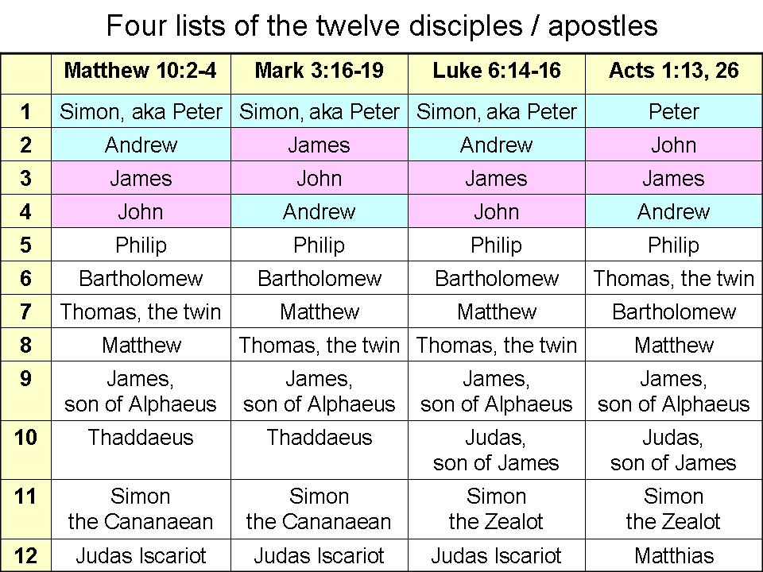

Excerpted and adapted from GotQuestions.org, CEO, S. Michael Houdmann. Complete article at: http://www.gotquestions.org/resurrection-accounts.html#ixzz2gURObuNf

