John 21:1-14

The gospel is given in 1 Corinthians 15:3-4, and a summary of Christ’s resurrection appearances, some uniquely in this passage, in 1 Corinthians 15:5-8:

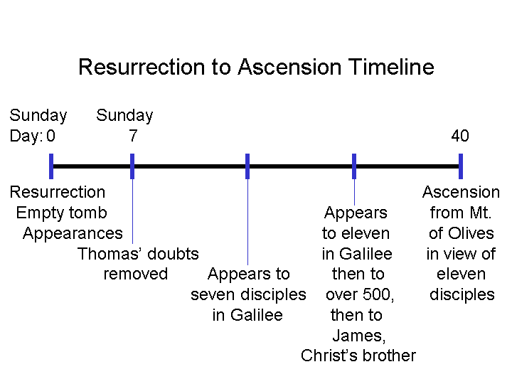
“For I delivered to you as of first importance what I also received, that Christ died for our sins according to the Scriptures, 4 and that He was buried, and that He was raised on the third day according to the Scriptures, 5 and that He appeared to Cephas, then to the twelve. 6 After that He appeared to more than five hundred brethren at one time, most of whom remain until now, but some have fallen asleep; 7 then He appeared to James, then to all the apostles; 8 and last of all, as to one untimely born, He appeared to me also.”

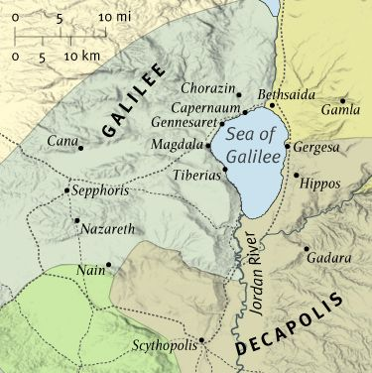
The term “the twelve” came to be a designation for the disciples, even if there were not exactly twelve of them present (e.g., John 20:24).

Though the disciples were told to go to Galilee and that the Lord would meet them there (Matthew 28:7, 10, 16), the account in John 21:1-14 is unique. The exact event is not recorded in any of the other gospels. Likely, this is because neither Matthew, Mark nor Luke were personally present, but John was present. John begins his eyewitness account in this way:
John 21:1-3
After these things Jesus manifested Himself again to the disciples at the Sea of Tiberias, and He manifested Himself in this way. 2 Simon Peter, and Thomas called Didymus, and Nathanael of Cana in Galilee, and the sons of Zebedee, and two others of His disciples were together. 3 Simon Peter said to them, "I am going fishing." They said to him, "We will also come with you." They went out and got into the boat; and that night they caught nothing.

The disciples were already in Galilee (the Roman name being the Sea of Tiberias), since they had been told to go there, but only these seven were present for this particular manifestation of Christ. Verses 1 and 14 both have Jesus being ‘manifested’ to His disciples (see also 1 John 1:2). ‘Manifested’ means that He appeared because He made Himself visible (active voice).

The disciples present, for a total of seven, were:

- Simon Peter
- Thomas called Didymus (Twin)
- Nathanael
- James & John, the sons of Zebedee
- Two other disciples, unnamed (possibly Philip and Andrew: John 1:40, 44)

When one looks at the 40 day period from Christ’s resurrection to His ascension (see slide on prior page), there was a fair amount of waiting time between some of Christ’s appearances, and Peter appears to want to do something useful. They fished at night because the rope nets were visible to the fish during the day. Even though these fishermen were experienced and well-equipped, they caught nothing. But as we will see, there was a very good reason that they caught nothing ☺. It was actually a good thing.

John 21:4-8
But when the day was now breaking, Jesus stood on the beach; yet the disciples did not know that it was Jesus. 5 So Jesus said to them, "Children, you do not have any fish, do you?" They answered Him, "No." 6 And He said to them, "Cast the net on the right-hand side of the boat and you will find a catch." So they cast, and then they were not able to haul it in because of the great number of fish. 7 Therefore that disciple whom Jesus loved said to Peter, "It is the Lord." So when Simon Peter heard that it was the Lord, he put his outer garment on (for he was stripped for work), and threw himself into the sea. 8 But the other disciples came in the little boat, for they were not far from the land, but about one hundred yards away, dragging the net full of fish.

The disciples did not know that it was Jesus on the shore, but, of course, Jesus knew it was the disciples. Jesus’ question was worded to say, “Children, you don’t have any fish (to be put on bread), do you?” to which the disciples responded, “No”. The word for ‘fish to be put on bread’ is only found here in the New Testament, and includes the popular fermented fish paste.
It was extraordinary enough to have caught no fish at all. But to simply cast the net on the right-hand side of the boat, after the sun was starting to come up, when the fish could see the net and to catch so many fish then was indeed miraculous. John, the disciple whom Jesus loved, recognized the miracle first, and told Peter, “It is the Lord”. It was typical for fishermen to take off the outer garment when fishing (see inset below), which Peter had done. Peter then put on his outer garment and dove in, swimming to shore where the Lord was.

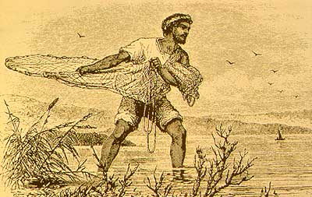
John 21:9-11
So when they got out on the land, they saw a charcoal fire already laid and fish placed on it, and bread. 10 Jesus said to them, "Bring some of the fish which you have now caught." 11 Simon Peter went up and drew the net to land, full of large fish, a hundred and fifty-three; and although there were so many, the net was not torn.

We don’t know how Jesus came up with the fire, fish and bread, whether by miraculous or more normal means, but Jesus invited the disciples to bring some of the many fish that they had just caught – 153 of them – and add them to the meal being prepared. Though the net was very full, and they had to drag it, the net was not torn. Along the northern portion of the Sea of Galilee (Tiberias) there are blocks of sharp basalt rocks which can easily tear up the nets.

John 21:12-14
Jesus said to them, "Come and have breakfast." None of the disciples ventured to question Him, "Who are You?" knowing that it was the Lord. 13 Jesus came and took the bread and gave it to them, and the fish likewise. 14 This is now the third time that Jesus was manifested to the disciples, after He was raised from the dead.

Jesus invited them to come and eat the fish and the bread. The events of the last few minutes had made clear that this was in fact Jesus, so nobody asked Jesus if it was really Him. Jesus served the seven disciples the bread and the fish. Jesus manifested Himself to the seven disciples early in His appearances in Galilee. He would show Himself to the eleven in Galilee after this event (see slide insert on page 1).

Jesus will, in the next passage, which is our final passage in the Gospel of John, restore Peter. Peter had denied Christ on the night of Jesus’ trial, and the Lord restores Peter to service in a gracious and most amazing way.

The Resurrection of Christ – A Summary of the Passages

The Empty Tomb
Day | Subject/Other Features | Scriptures
Sunday | The Tomb visited by the women: Mary  Magdalene, Mary the mother of James, Salome | Matthew 28:1; Mark 16:1
Sunday | The stone rolled away, allowing witnesses to  See the empty tomb | Matthew 28:2-4
Sunday | The tomb found empty by the women, at about  The time of sunrise | Matthew 28:5-8; Mark 16:2-8;  Luke 24:1-8; John 20:1
Sunday | The tomb found empty by Peter & John’ grave  Clothes arranged consistent with resurrection | Luke 24:9-11, 12; John 20:2-10
Post-Resurrection Appearances
Day | Appearance To Whom & Summary Info | Scriptures
Sunday | Mary Magdalene; Jesus predicts His ascension | Mark 16:9-11; John 20:11-18
Sunday | The other women; instruction to meet in Galilee | Matthew 28:9-10
Sunday | Report of the soldiers to the Jewish authorities;  Sanhedrin’s absurd explanation | Matthew 28:11-15
Sunday | The two disciples traveling to Emmaus who  didn’t believe the report about the empty tomb | Mark 16:12-13; Luke 24:13-32
Sunday | Report of the two disciples to the rest, including  an appearance to Peter; Paul also reported  another appearance to Peter | Luke 24:33-35; 1 Corinthians 15:5a
Sunday | Ten disciples, revealing characteristics of Jesus’ resurrected body | Mark 16:14; Luke 24:36-43;  John 20:19-25
Sunday, a  week later | The eleven disciples, in which Thomas’ doubt  is removed | John 20:26-31  1 Corinthians 15:5b
Some time later | Seven disciples fishing in Galilee; Peter told to  feed & care for His sheep | John 21:1-25
Still later | The eleven in Galilee, then to the 500+; Great  Commission to large number of followers | Matthew 28:16-20; Mark  16:15-18; 1 Corinthians 15:6
Still later | James, Jesus’ brother, who becomes a believer | 1 Corinthians 15:7; John 7:1-5
40 Days after resurrection | The disciples in Jerusalem who are told to wait  for the coming of the Spirit | Luke 24:44-59; Acts 1:3-8
After His ascension | To Stephen, Saul, later called Paul, & to John | Acts 7:55-56; 9:3-6; 20:24;  22:17-21; 23:11; 26:17; Gal.  1:12, 17; Rev. 1:12-20

To summarize: there were several recorded testimonies to the empty tomb, including multiple instances of simultaneous witnesses, and at least eleven recorded instances of witnessing Christ’s resurrected body in the 40 days after the resurrection, with witnesses numbering from one to over five hundred, and three witnesses to Christ’s resurrection after His ascension. To these we can add the persistent public testimonies to the resurrection, often spoken among other witnesses in the very same locality (Acts 2:24, 32; 3:26; 4:10; 5:30-32; 10:39-42, et al), and the personal testimony of Peter in writing (1 Peter 1:21), who saw the empty tomb right after Christ was resurrected, and saw and spoke to Him in His resurrected body multiple times, up to the day of Christ’s ascension.

