The Gospel of John: Believing & Beholding

The Gospel of John: Believing

The apostle John was very clear that his aim was that his readers believe. John wrote a purpose statement in each of his major writings, and the statement in the Gospel of John is:

John 20:30-31
Many other signs therefore Jesus also performed in the presence of the disciples, which are not written in this book; 31 but these have been written that you may believe that Jesus is the Christ, the Son of God; and that believing you may have life in His name.

The seven signs written of in the gospel of John are:

- Changing the water into wine (John 2:1-11)
- Healing the royal official's son in Capernaum (John 4:46-54)
- Healing the paralytic by the pool of Bethesda (John 5:1-18)
- Feeding the 5000 (John 6:5-14)
- Jesus' walking on water (John 6:16-24)
- Healing the man born blind (John 9:1-7)
- Raising of Lazarus (John 11:1-45)

Jesus performed many other signs while His disciples were present, and some of those were recorded in the other three gospels, but these were the seven signs that John selected to write about in his gospel. We see in verse 31 that the signs that John selected to write about were aimed toward the reader believing that:

- Jesus (Hebrew: Yeshua = Savior) is
- the Christ (Hebrew: Hamashiach, Anglicized, the Messiah = The Anointed One) and is
- the Son of God (the Second Person of the Trinity).

In believing these things, the believer is granted spiritual life in His name (who He is).

The gospel of John has a distinct pattern among the four gospels: John only uses the verb form of believing, and he uses it 98 times (nearly three times as many as the other three gospels combined). Here is a count on the uses of the verb to believe and the noun faith in the four gospels:

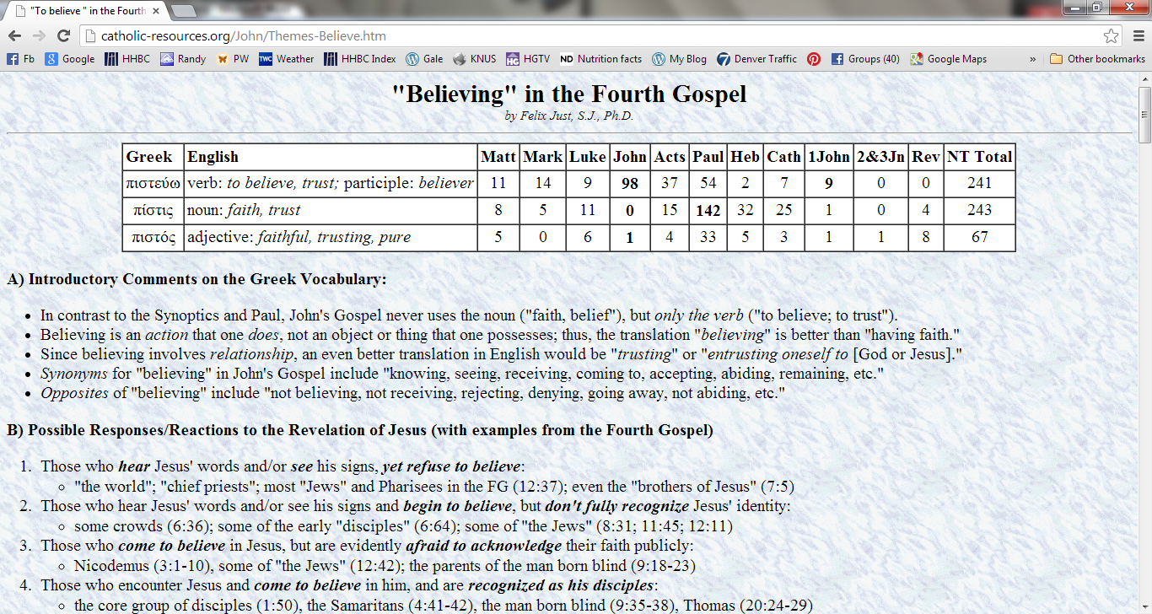
pisteuō
pistis
- Synonyms for "believing" in John's gospel include knowing, seeing, receiving, coming to, accepting, abiding, remaining, etc.
- Opposites of "believing" include not believing, not receiving, rejecting, denying, going away, not abiding, etc.
- Possessing faith (i.e., ‘having faith’) is found in Matthew, Mark and Luke, but not in John. Instead, the gospel of John says that believing (as an action) is necessary in order to have life (John 3:15, 16, 36; 5:24; 6:40, 45; 11:25; 20:31).

In the gospel of John, believing is necessary in order to be saved. And once having believed, continued believing is essential in order to abide, know, see and remain.

There is also a spectrum of not believing to believing in the gospel of John:

- Those who hear Jesus' words and/or see his signs, yet refuse to believe:
"the world"; "chief priests"; most "Jews" and Pharisees (12:37); even the "brothers of Jesus" (7:5)

- Those who hear Jesus' words and/or see his signs and begin to believe, but don't fully recognize Jesus' identity:
some crowds (6:36); some of the early "disciples" (6:64); some of "the Jews" (8:31; 11:45; 12:11)

- Those who come to believe in Jesus, but seem afraid to acknowledge their faith publicly:
Nicodemus (3:1-10), some of "the Jews" (12:42); the parents of the man born blind (9:18-23)

- Those who encounter Jesus and come to believe in him, and are recognized as his disciples:
the core group of disciples (1:50), the Samaritans (4:41-42), the man born blind (9:35-38), Thomas (20:24-29)

- Those who believe even without seeing signs, on the basis of hearing the words of Jesus and/or other witnesses:
the royal official from Capernaum (4:53); Martha (believes before Lazarus is raised, 11:27); later believers, down to today (see the account of Thomas, 20:19-29; and the purpose statement in the gospel of John (20:30-31)

The Gospel of John: Beholding

John 1:14
And the Word became flesh, and dwelt among us, and we saw His glory, glory as of the only begotten from the Father, full of grace and truth.

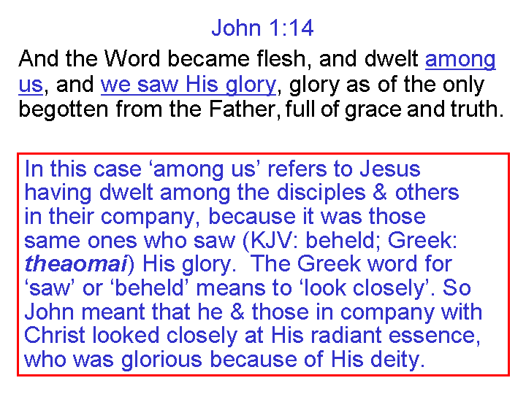
The Word, the Son of God, who was in fact deity, became a human being, and John the apostle saw His glory - the radiant essence of Who He is – having full divine qualities of grace and truth. The particular word John chose for ‘dwelt’ in verse 14 meant ‘to live in a tent’. In the books of the New Testament, only John used the word, four other times, and in each case it is used for God dwelling with men.

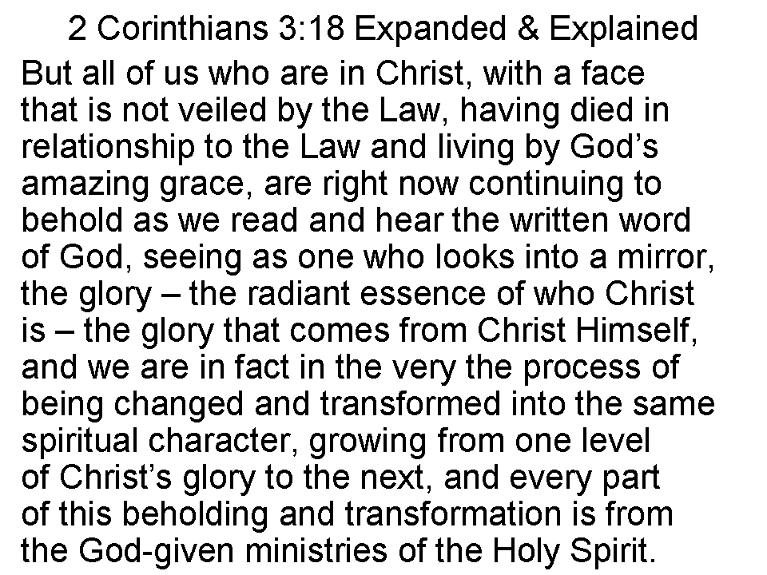
Using 2 Corinthians 3:18 as a lens for viewing John 1:14, the expanded and explained form of 2 Corinthians 3:18 looks like the slide to the left.

John 1:14 expanded and explained, in light of 2 Corinthians 3:18, “And Jesus Christ, the Son of God, and God’s communication of His essential being, came so as to be born in human form, and though total deity, He was dwelling in that human form even while among us, and we beheld – Oh, this is awesome! – we beheld His glory, that radiant essence of God Himself, since Christ is the unique Son of and expression from the Father, full of the grace and the truth which are God’s eternal and infinite character. As we behold John’s description of how he and the disciples beheld Christ, we are beholding Him as well, and as a work of the Holy Spirit, are being made to grow in and into the glorious character of Jesus Christ.”

