Christ, born of a virgin

The accounts regarding Christ’s birth, and that He was born of a virgin are not given in the gospel of John, but rather in Matthew chapters 1 and 2 and Luke chapters 1 and 2. Matthew details the revelation to Joseph about Christ being born of a virgin, and Luke details the revelation to Mary, who was a virgin.

Matthew 1:18-23
Now the birth of Jesus Christ was as follows: when His mother Mary had been betrothed to Joseph, before they came together she was found to be with child by the Holy Spirit. 19 And Joseph her husband, being a righteous man and not wanting to disgrace her, planned to send her away secretly. 20 But when he had considered this, behold, an angel of the Lord appeared to him in a dream, saying, "Joseph, son of David, do not be afraid to take Mary as your wife; for the Child who has been conceived in her is of the Holy Spirit. 21 "She will bear a Son; and you shall call His name Jesus, for He will save His people from their sins." 22 Now all this took place to fulfill what was spoken by the Lord through the prophet: 23 "Behold, the virgin shall be with child and shall bear a son, and they shall call his name Immanuel," which translated means, "God with us."

The gospel of Matthew continues with the account of the magi, Herod the Great, the escape of Joseph, Mary and Jesus, the killing of babies in Bethlehem, and the return to Nazareth after Herod’s death. Verse 23 is a quote of Isaiah 7:14, which prophesied Christ’s virgin birth. The angel spoke to Joseph of Jesus’ part in the gospel of substitution (Jesus as the Savior). In contrast, the angel Gabriel tells Mary about Jesus’ part in the gospel of the kingdom.

Luke 1:26-38
Now in the sixth month the angel Gabriel was sent from God to a city in Galilee called Nazareth, 27 to a virgin engaged to a man whose name was Joseph, of the descendants of David; and the virgin's name was Mary. 28 And coming in, he said to her, "Greetings, favored one! The Lord is with you." 29 But she was very perplexed at this statement, and kept pondering what kind of salutation this was. 30 The angel said to her, "Do not be afraid, Mary; for you have found favor with God. 31 "And behold, you will conceive in your womb and bear a son, and you shall name Him Jesus. 32 "He will be great and will be called the Son of the Most High; and the Lord God will give Him the throne of His father David; 33 and He will reign over the house of Jacob forever, and His kingdom will have no end." 34 Mary said to the angel, "How can this be, since I am a virgin?" 35 The angel answered and said to her, "The Holy Spirit will come upon you, and the power of the Most High will overshadow you; and for that reason the holy Child shall be called the Son of God. 36 "And behold, even your relative Elizabeth has also conceived a son in her old age; and she who was called barren is now in her sixth month. 37 "For nothing will be impossible with God." 38 And Mary said, "Behold, the bondslave of the Lord; may it be done to me according to your word." And the angel departed from her.
Dr. Luke records for us the sole incident and summary of Christ’s upbringing:

Luke 2:41-52
Now His parents went to Jerusalem every year at the Feast of the Passover. 42 And when He became twelve, they went up there according to the custom of the Feast; 43 and as they were returning, after spending the full number of days, the boy Jesus stayed behind in Jerusalem. But His parents were unaware of it, 44 but supposed Him to be in the caravan, and went a day's journey; and they began looking for Him among their relatives and acquaintances. 45 When they did not find Him, they returned to Jerusalem looking for Him. 46 Then, after three days they found Him in the temple, sitting in the midst of the teachers, both listening to them and asking them questions. 47 And all who heard Him were amazed at His understanding and His answers. 48 When they saw Him, they were astonished; and His mother said to Him, " Son, why have You treated us this way? Behold, Your father and I have been anxiously looking for You." 49 And He said to them, "Why is it that you were looking for Me? Did you not know that I had to be in My Father's house?" 50 But they did not understand the statement which He had made to them. 51 And He went down with them and came to Nazareth, and He continued in subjection to them; and His mother treasured all these things in her heart. 52 And Jesus kept increasing in wisdom and stature, and in favor with God and men.

Jesus mother, Mary, was central to the account of Jesus turning the water into wine at the wedding of Cana in Galilee (John 2:1-11). Jesus’ mother and brothers, but not Joseph, are recorded together in the gospel of John as they travelled from the wedding in Cana:

John 2:12
After this He went down to Capernaum, He and His mother and His brothers and His disciples; and they stayed there a few days.

Here is a family tree of Jesus’ family, with notes about each:
Joseph Mary

Jesus James Joses Jude Simon Salome Mary

- Since Jesus was born of Mary as a virgin (Matthew 1:23, 25; Luke 1:27, 34), Joseph was not the biological father of Jesus, as he was of Jesus’ other siblings. So Jesus was properly a half-brother to these siblings.
- Jesus’ brothers did not believe in Him until after Christ was resurrected (John 7:5; Acts 1:14).
- James and Jude, actually Jacob and Judas, were the authors of the New Testament books by those names.
- The names James, Joses, Jude & Simon are given in Mark 6:3, as is the fact that Jesus had sisters. The names Salome and Mary are from records outside of Scripture, so the names and number of Jesus’ sisters has less certainty, though the names and number may be accurate.
- Of Jesus’ brothers, James is the one about which the most is recorded, including John 12:17; 15:13; 21:18; 1 Corinthians 15:7; Galatians 1:19; 2:9, 12; James 1:1, Jude 1, and in the writings of Josephus. An ossuary box from New Testament times has been found with the inscription, “James (actually ‘Jacob’), son of Joseph, brother of Jesus”. After careful investigation, and even a public trial, it appears to be genuinely that of James, the brother of Jesus.

John reports on the mother of Jesus in the interactions with the people of Capernaum, who say, in John 6:42, “They were saying, "Is not this Jesus, the son of Joseph, whose father and mother we know?”

In the gospel of John, the last mention of Mary, the mother of Jesus, is when Jesus speaks to Mary, His mother, and John, the disciple, from the cross.

John 19:25-27
But standing by the cross of Jesus were His mother, and His mother's sister, Mary the wife of Clopas, and Mary Magdalene. 26 When Jesus then saw His mother, and the disciple whom He loved standing nearby, He said to His mother, "Woman, behold, your son!" 27 Then He said to the disciple, "Behold, your mother!" From that hour the disciple took her into his own household.

Jesus assigned John to be responsible to care for Mary in her later years. She was at this time in her mid-40s, and John was likely about 20 years of age. Jesus, being the oldest of her sons and daughters, would have had that place until that time, and Jesus’ brothers did not believe (John 7:5), and were perhaps still antagonistic, even towards Mary, who did believe.

The last mention of Mary by name is alongside Jesus’ brothers, after Christ had appeared to James, Jesus’ brother, and after Christ was ascended, but before the day of Pentecost.

Acts 1:12-14
Then they returned to Jerusalem from the mount called Olivet, which is near Jerusalem, a Sabbath day's journey away. 13 When they had entered the city, they went up to the upper room where they were staying; that is, Peter and John and James and Andrew, Philip and Thomas, Bartholomew and Matthew, James the son of Alphaeus, and Simon the Zealot, and Judas the son of James. 14 These all with one mind were continually devoting themselves to prayer, along with the women, and Mary the mother of Jesus, and with His brothers.

After this point in the New Testament, Mary is never mentioned again by name, though we have this reference to Mary as ‘a woman’:

Galatians 4:4-5
But when the fullness of the time came, God sent forth His Son, born of a woman, born under the Law, 5 so that He might redeem those who were under the Law, that we might receive the adoption as sons.
Scripture makes no record of the rest of Mary’s life, or of her death. James is mentioned by name (Acts 12:17; 15:13; 21:18; 1 Corinthians 15:7; Galatians 1:19; 2:9; 2:12), and Jesus’ brothers are mentioned, in summary, at one point by the apostle Paul, with the implication that he had some contact with them at certain points (1 Corinthians 9:5). James and Jude each wrote one New Testament book in which they only claim to be a bond-servant of Jesus Christ – not His brother.

Does Mary have any special spiritual standing?

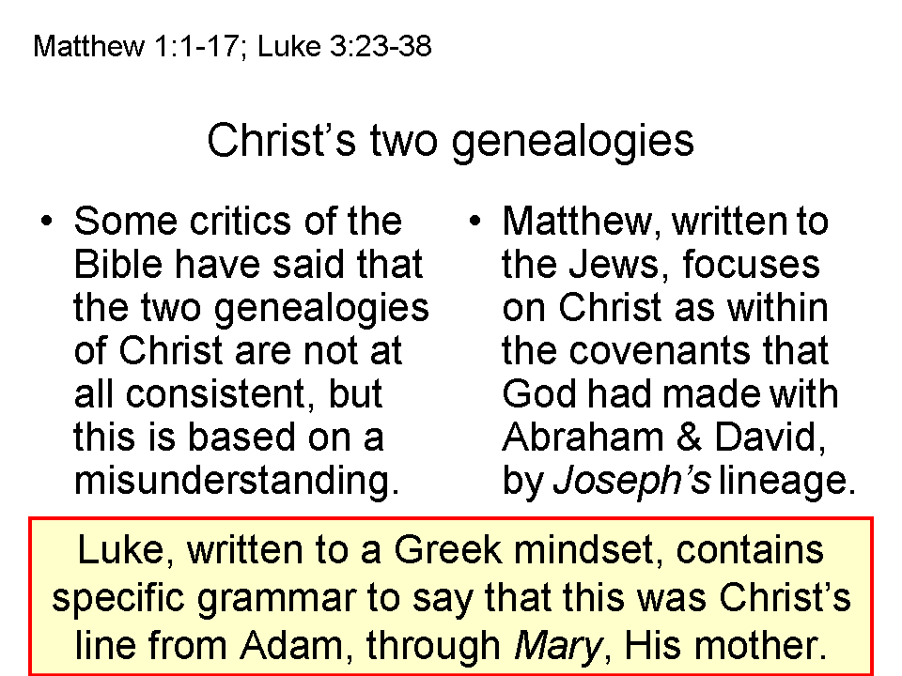
As the physical mother of Jesus, does Mary have any special standing, proximity to God or to Christ, or is she spiritually unique in any way? Scripture would say that she was chosen because of her genealogical connection to David, to Judah, all the way back to Adam. (Luke 3:23-38). She was also chosen because of her willingness and character (Luke 1:28, 38). We will take particular note of the angel Gabriel’s greeting to Mary:

Luke 1:28
And coming in, he said to her, "Greetings, favored one! The Lord is with you."

‘Greetings” is the usual Greek salutation based on the Greek word for ‘grace’. The words ‘favored one’ comes from one Greek word which is also used of the believers in Ephesus:

Ephesians 1:1-6
Paul, an apostle of Christ Jesus by the will of God, to the saints who are at Ephesus and who are faithful in Christ Jesus: 2 Grace to you and peace from God our Father and the Lord Jesus Christ. 3 Blessed be the God and Father of our Lord Jesus Christ, who has blessed us with every spiritual blessing in the heavenly places in Christ, 4 just as He chose us in Him before the foundation of the world, that we would be holy and blameless before Him. In love 5 He predestined us to adoption as sons through Jesus Christ to Himself, according to the kind intention of His will, 6 to the praise of the glory of His grace, which He freely bestowed on us [KJV: He hath made us accepted] in the Beloved.

So we see that all of the church age believers are called saints, and that the word for favor spoken to Mary is the same word used for all of the saints in the church. The words, “Blessed art thou among women”, found in the KJV, do not appear to have been written by Dr. Luke, but to have been added to some hand-copied texts many centuries later.

The idea that Mary was ever-virgin, contrary to Matthew 1:25 and a few lines of Jewish tradition, was begun after the New Testament era. There is no biblical or historical reason to believe that Jesus’ brothers and sisters were from Joseph’s previous marriage or another wife (polygyny). The evidence is that Christ died for Mary’s sins, as well as everyone else’s sins, and that as a believer Mary became a part of the church on the day of Pentecost, and was identified with Christ in His death, burial, resurrection, ascension and seating, just as all church saints were and are. As such, Mary was blessed with every spiritual blessing in the heavenly places, along with all other church saints from Acts 2 to the rapture (Ephesians 1:3). Scripture provides every indication that we have direct access to the Father, through Christ, by means of the Holy Spirit (Romans 8:26, 27; Galatians 4:6; Ephesians 2:18; 3:14-19; Colossians 1:12, et al).

Is Mary ‘the Mother of God’?

If God is defined as the three persons of the Trinity (Father, Son, and Holy Spirit) who are three personal beings and one essence, then Mary cannot be called the mother of God, nor ‘the God bearer’ (theotokos) . We would more precisely and correctly state the truth as follows:

Christ the eternal Son of God existed from eternity past. He was of the same essence with the Father and the Holy Spirit, the Father, the Son and the Holy Spirit each being separate personal beings. By agreement among the Father, the Son and the Holy Spirit, God the Son added humanity to His eternal deity by being born of Mary, Jesus’ conception having been a work of the Holy Spirit.

So God the Son, as deity, also became fully man, as Jesus Christ (Savior, Messiah). We can now refer to Him as Jesus Christ, the Son of God, being fully God and fully man. Jesus, as the Savior, died physically for our sins, was buried, and rose again. As the Messiah, rejected by Israel at His first coming, He will come again (His second coming) to reign as the King of Israel and King of Kings and Lord of Lords over the Gentile nations.

For details on this prophecy, see Lesson, 10, Isaiah chapter 7, 02/12/2006, available on the Holly Hills Bible Church website under ‘messages and audio’ or from the office.
Mary was declared to be theotokos, that is, ‘the God bearer’ at the Council of Ephesus in 431 AD. At that council Nestorius held out for Christotokos, that is, ‘the Christ bearer’, which was ultimately rejected. The problem is that Nestorius held that the Logos indwelt the person of Jesus, rather than Jesus being fully God and fully man as a union. The council of Ephesus was based upon post-New Testament traditions about the veneration of Mary. So, both Nestorius and the Council of Ephesus came to unbiblical conclusions.

