Christ, the Lamb of God

Animal sacrifices offered to God came early in human history:

- Abel (Genesis 4:1-5)
- Noah (Genesis 8:20)
- Abraham (Genesis 12:7,8)
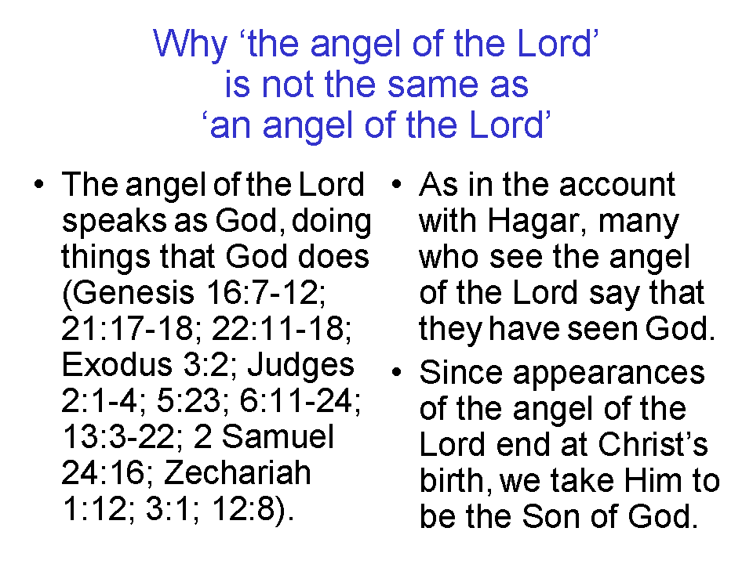
There is the account of Abraham being told to offer up his son, Isaac, as a sacrifice. In that account the angel of the Lord stopped Abraham from sacrificing Isaac, and Abraham instead sacrificed a ram caught in a nearby thicket (Genesis 22). Abraham had told Isaac, "God will provide for Himself the lamb for the burnt offering, my son." (Genesis 22:8). This serves as a picture of God the Father offering up His Son as a sacrifice for sins.

The patriarchs, Abraham, Isaac and Jacob all offered sacrifices to God and built altars for sacrifice a number of times. Sometimes the sacrifice was part of making a covenant, in which the sacrifice was the gesture confirming the covenant (Genesis 15:1-21).

Passover has a number of requirements that point to Christ as the Lamb:

Exodus 12:1-7, 43-47
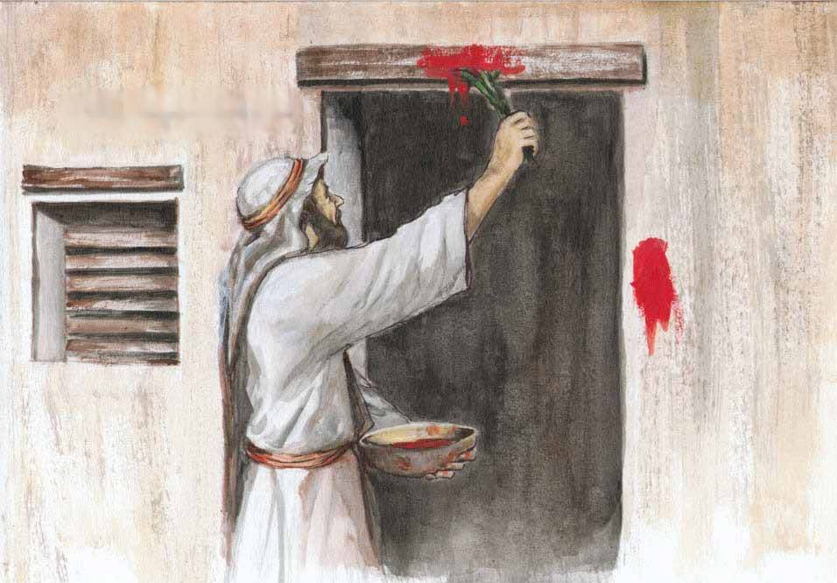
Now the LORD said to Moses and Aaron in the land of Egypt, 2 " This month shall be the beginning of months for you; it is to be the first month of the year to you. 3 "Speak to all the congregation of Israel, saying, 'On the tenth of this month they are each one to take a lamb for themselves, according to their fathers' households, a lamb for each household. 4 'Now if the household is too small for a lamb, then he and his neighbor nearest to his house are to take one according to the number of persons in them; according to what each man should eat, you are to divide the lamb. 5 'Your lamb shall be an unblemished male a year old; you may take it from the sheep or from the goats. 6' You shall keep it until the fourteenth day of the same month, then the whole assembly of the congregation of Israel is to kill it at twilight. 7 'Moreover, they shall take some of the blood and put it on the two doorposts and on the lintel of the houses in which they eat it.

43 The Lord said to Moses and Aaron, "This is the ordinance of the Passover: no foreigner is to eat of it; 44 but every man's slave purchased with money, after you have circumcised him, then he may eat of it. 45 A sojourner or a hired servant shall not eat of it. 46 It is to be eaten in a single house; you are not to bring forth any of the flesh outside of the house, nor are you to break any bone of it. 47 All the congregation of Israel are to celebrate this."

With the giving of the Law of Moses, we find that there are a number of changes in the way that sacrifices are done:

- Sacrifices may only be offered by those who are descended from Levi through Aaron (Leviticus 1:8).
- Sacrifices must be offered in front of the tabernacle or the temple (Deuteronomy 12:13; Joshua 22:29).
- An annual pattern of sacrifices was established (to which Hanukkah – see John 10:22, 23 and Purim – based on the book of Esther - have been added later).

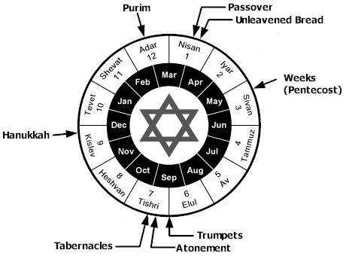

- Additional sacrifices were required based on various life events, such as when a baby was born, which called for a lamb to be sacrificed. A dove was allowed, however, if the couple could not afford a lamb (Leviticus 12:1-8).

The sacrifices required by the Law of Moses never really dealt with sin, which was why they had to be repeated again and again and again. The sacrifices pointed to the ultimate sacrifice offered by God Himself: God’s Lamb.

Isaiah 52:13 to 53:12 prophesies about Christ being crucified for our sins, buried and raised. Verse 7 makes reference to the lamb led to slaughter and a sheep before its shearers being silent.

Isaiah 53
Who has believed our message? And to whom has the arm of the Lord been revealed? 2 For He grew up before Him like a tender shoot, and like a root out of parched ground; He has no stately form or majesty that we should look upon Him, nor appearance that we should be attracted to Him. 3 He was despised and forsaken of men, a man of sorrows and acquainted with grief; and like one from whom men hide their face He was despised, and we did not esteem Him.

4 Surely our griefs He Himself bore, And our sorrows He carried; Yet we ourselves esteemed Him stricken, smitten of God, and afflicted. 5 But He was pierced through for our transgressions, He was crushed for our iniquities; the chastening for our well-being fell upon Him, and by His scourging we are healed. 6 All of us like sheep have gone astray, each of us has turned to his own way; but the Lord has caused the iniquity of us all to fall on Him.

7 He was oppressed and He was afflicted, yet He did not open His mouth; like a lamb that is led to slaughter, and like a sheep that is silent before its shearers, so He did not open His mouth. 8 By oppression and judgment He was taken away; and as for His generation, who considered that He was cut off out of the land of the living for the transgression of my people, to whom the stroke was due? 9 His grave was assigned with wicked men, yet He was with a rich man in His death, because He had done no violence, nor was there any deceit in His mouth.

10 But the Lord was pleased to crush Him, putting Him to grief; if He would render Himself as a guilt offering, He will see His offspring, He will prolong His days, and the good pleasure of the Lord will prosper in His hand. 11 As a result of the anguish of His soul, He will see it and be satisfied; by His knowledge the Righteous One, My Servant, will justify the many, as He will bear their iniquities. 12 Therefore, I will allot Him a portion with the great, and He will divide the booty with the strong; because He poured out Himself to death, and was numbered with the transgressors; yet He Himself bore the sin of many, and interceded for the transgressors.

Isaiah 53:7 is quoted in Acts 8:32 as Philip got into the chariot with the Ethiopian eunuch, who was holding a scroll of Isaiah.

Paul wrote to the believers in Corinth that Christ was our Passover lamb:

1 Corinthians 5:7
For Christ our Passover also has been sacrificed.
1 Peter 1:17-19
If you address as Father the One who impartially judges according to each one's work, conduct yourselves in fear during the time of your stay on earth; 18 knowing that you were not redeemed with perishable things like silver or gold from your futile way of life inherited from your forefathers, 19 but with precious blood, as of a lamb unblemished and spotless, the blood of Christ.

But only in John’s writings is Christ called “the Lamb”:

John 1:29
The next day he saw Jesus coming to him and said, "Behold, the Lamb [up to a year old] of God who takes away the sin of the world!

John 1:35-36
Again the next day John was standing with two of his disciples, 36 and he looked at Jesus as He walked, and said, "Behold, the Lamb [up to a year old] of God!"

Revelation 5:6
And I saw between the throne (with the four living creatures) and the elders a Lamb [a little lamb, up to a few weeks old] standing, as if slain, having seven horns and seven eyes, which are the seven Spirits of God, sent out into all the earth.

See also Revelation 5:8, 12, 13; 6:1, 7, 9, 16; 7:9, 10, 14, 17; 8:1; 12:11; 13:8; 14:1, 4, 10; 15:3; 17:14; 19:7, 9, 14, 22, 23; 22:1, 22:3. Christ is the (little) Lamb 30 times in the book of Revelation, sometimes more than once in each verse. In Revelation chapters 21 and 22, Christ is the (little) Lamb, even on into the New Jerusalem and the New Earth.

Unlike the sacrifices of Abel, Noah, Abraham, Isaac, Jacob, and the Law of Moses, the sacrifice of God’s Lamb, is fully effective, final, and once for all:

John 19:30
Therefore when Jesus had received the sour wine, He said, "It is finished!" (Greek: tetélestai = “Paid, with permanent effectiveness”] And He bowed His head and gave up His spirit.

Romans 6:10
For the death that He died, He died [in relationship] to sin once for all; but the life that He lives, He lives to God.

Hebrews 7:27
[Jesus] …who does not need daily, like those high priests, to offer up sacrifices, first for His own sins and then for the sins of the people, because this He did once for all when He offered up Himself.

Hebrews 9:12
…and not through the blood of goats and calves, but through His own blood, He entered the holy place once for all, having obtained eternal redemption.

Hebrews 10:10
By this will we have been sanctified through the offering of the body of Jesus Christ once for all.

1 Peter 3:18
For Christ also died for sins once for all, the just for the unjust, so that He might bring us to God, having been put to death in the flesh, but made alive in the spirit;

So Christ, the long-promised, greatly anticipated by word and symbol, Lamb of God was given because while we were yet sinners, God loved us and gave Him, and He loved us and gave Himself, with the joy set before Him, that we might have relationship and fellowship with Him for eternity.

“Once for all” in this verse, and those that follow, is based on the Greek word hapax, which in this context means: once done, perpetually effective. It is a one-word equivalent to the perfect tense Greek verb.

