Christ, His burial & resurrection

These words of Paul contain the content of the gospel to be believed in order to be saved, and are direct testimony regarding Paul, and are secondary testimony regarding the other witnesses, numbering more than 500.

1 Corinthians 15:1-8
Now I make known to you, brethren, the gospel which I preached to you, which also you received, in which also you stand [perfect tense: see also Romans 5:2], 2 by which also you are saved, if you hold fast the word which I preached to you, unless you believed in vain.

3 For I delivered to you as of first importance what I also received, that Christ died for our sins according to the Scriptures, 4 and that He was buried, and that He was raised on the third day according to the Scriptures, 5 and that He appeared to Cephas, then to the twelve. 6 After that He appeared to more than five hundred brethren at one time, most of whom remain until now, but some have fallen asleep; 7 then He appeared to James, then to all the apostles; 8 and last of all, as to one untimely born, He appeared to me also.

Last Sunday we examined Christ’s death for us as the Lamb of God. In the lesson, “35 Gospel of John – September 15, 2013, John 19:16-30” we examined Christ’s death for us as it is presented in the Gospel of John. And in the lesson, “36 Gospel of John – September 22, 2013 - Supplement: A ‘Good Friday Clock’” we looked at a composite of the four gospels in the form of a clock of the day of Christ’s crucifixion. We looked at Christ’s burial and resurrection in:

- 37 Gospel of John – September 29, 2013 - John 19:31-42
- 38 Gospel of John – October 6, 2013 - John 20:1-18
- 39 Gospel of John – October 13, 2013 - John 20:19-31
- 40 Gospel of John – October 20, 2013 - John 21:1-14
- 41 Gospel of John – October 27, 2013 - John 21:15-25

We will be examining what the four gospels have to say about Christ’s burial and resurrection, with this schedule in mind:

Nov No. Passage / Topic

24 45 Christ, the Lamb of God

Dec No. Passage / Topic

1 46 Christ, His Burial & Resurrection
8 47 Christ, His Ascension & Seating
15 48 Christ, with Whom we share a history
22 49 Christ, the Messiah
29 50 Christ, our Bridegroom
The Law of Moses gave specific directions for the Jews regarding how soon a dead body had to be removed when hung: it must be taken down and buried the same day, or the land would be defiled:

Deuteronomy 21:22-23
"If a man has committed a sin worthy of death and he is put to death, and you hang him on a tree, 23 his corpse shall not hang all night on the tree, but you shall surely bury him on the same day (for he who is hanged is accursed of God), so that you do not defile your land which the LORD your God gives you as an inheritance."

Now the Romans did not care about the Law of Moses, and their typical practice was to leave the body on a cross for days, and in some cases it might take a person a few days to die by crucifixion. But the Romans made an accommodation to the Jews in this instance, breaking the legs of the criminal a few hours before sundown, because:

- The next day was a Sabbath within the days of Passover / Feast of Unleavened Bread. That day was a high (holy) day (John 19:31).
- There was a great swelling of the number of Jews present in the days of Passover, and the Romans did not want the crowd to get out of hand (Matthew 27:24).

Joseph of Arimathea, a dissenting member of the Sanhedrin (aka ‘the Council’), asked Pilate (Pontius Pilatus) for the body of Jesus (Matthew 27:57; Mark 15:43; Luke 23:51; John 19:38). Pilate confirmed with the centurion that Jesus had died, and then granted permission. Then Joseph of Arimathea and Nicodemus (only reported in John: 3:1, 4, 9; 7:50; 19:39), took the body of Jesus to a newly hewn tomb (Matthew 27:60; John 19:41) owned by Joseph of Arimathea. Nicodemus brought a hundred pounds of wrappings, aloes, and myrrh. This was a huge amount of wrappings, aloes and myrrh – a burial that would be fitting for royalty. The common people in Israel could likely not afford such a costly burial.

Jesus was placed in the tomb by Joseph of Arimathea, Nicodemus, and very likely their servants, with Mary Magdalene (from Magdala) and Mary the mother of Joses as additional witnesses to the identification and preparation of Jesus’ body and the location of the tomb (Matthew 27:61; Mark 15:47; Luke 23:55). The tomb was sealed with a large stone (Matthew 27:60).

Matthew uniquely reports that on the Sabbath of the week of Passover:

Matthew 27:62-66
Now on the next day, the day after the preparation, the chief priests and the Pharisees [the Sanhedrin] gathered together with Pilate, 63 and said, "Sir, we remember that when He was still alive that deceiver said, ' After three days I am to rise again.' 64 "Therefore, give orders for the grave to be made secure until the third day, otherwise His disciples may come and steal Him away and say to the people, 'He has risen from the dead,' and the last deception will be worse than the first." 65 Pilate said to them, "You have a guard; go, make it as secure as you know how." 66 And they went and made the grave secure, and along with the guard they set a seal on the stone.
Jesus had told both His disciples and the Jews about His resurrection in three days, as reported in all four gospels (Matthew 12:40; 15:32; 26:61; 27:40; 27:63; Mark 8:31; 9:31; 10:34; 14:58; 15:29; Luke 2:46; John 2:19, 20). The Jewish leaders referred to ‘deceiver’ and ‘deception’ regarding Jesus and His disciples.

The word for ‘guard’ is a word borrowed from Latin: koustodia. It referred to a Roman sentry of 12 to 16 soldiers who would stand guard. While some believe that these soldiers were simply Jewish temple guards, the use of the Latin term and the seal on the stone would tend to say otherwise. Also, the Jewish temple guards could have guarded the tomb under direct orders from the Sanhedrin without Pilate’s knowledge or permission. The Jewish leaders wanted the tomb guarded well, with death as the consequence for violating the seal.
________________________________________________________________________

Post-resurrection events Matthew Mark Luke John
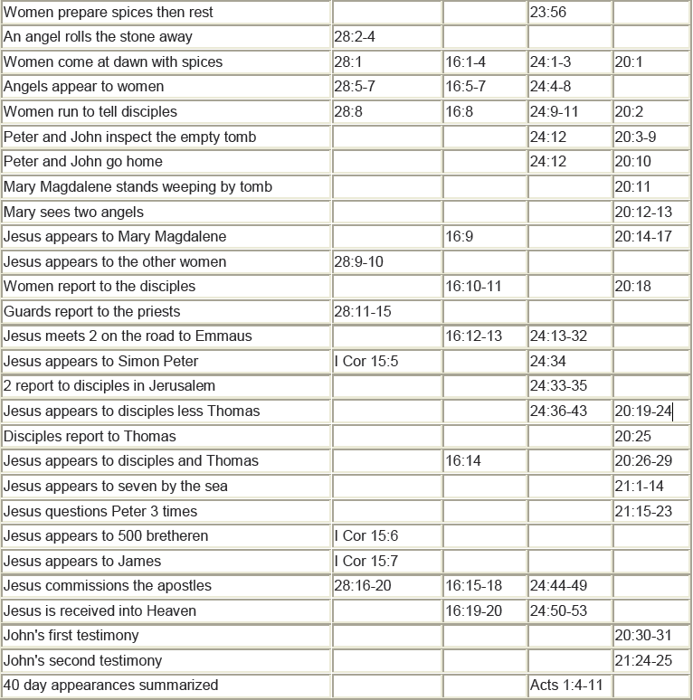
The Resurrection of Christ – A Summary of the Passages

The Empty Tomb
Day | Subject/Other Features | Scriptures
Sunday | The Tomb visited by the women: Mary  Magdalene, Mary the mother of James, Salome | Matthew 28:1; Mark 16:1
Sunday | The stone rolled away, allowing witnesses to  See the empty tomb | Matthew 28:2-4
Sunday | The tomb found empty by the women, at about  The time of sunrise | Matthew 28:5-8; Mark 16:2-8;  Luke 24:1-8; John 20:1
Sunday | The tomb found empty by Peter & John; grave  clothes arranged consistent with resurrection | Luke 24:9-11, 12; John 20:2-10
Post-Resurrection Appearances
Day | Appearance To Whom & Summary Info | Scriptures
Sunday | Mary Magdalene; Jesus predicts His ascension | Mark 16:9-11; John 20:11-18
Sunday | The other women; instruction to meet in Galilee | Matthew 28:9-10
Sunday | Report of the soldiers to the Jewish authorities;  Sanhedrin’s absurd explanation | Matthew 28:11-15
Sunday | The two disciples traveling to Emmaus who  didn’t believe the report about the empty tomb | Mark 16:12-13; Luke 24:13-32
Sunday | Report of the two disciples to the rest, including  an appearance to Peter; Paul also reported  another appearance to Peter | Luke 24:33-35; 1 Corinthians 15:5a
Sunday | Ten disciples, revealing characteristics of Jesus’ resurrected body | Mark 16:14; Luke 24:36-43;  John 20:19-25
Sunday, a  week later | The eleven disciples, in which Thomas’ doubt  is removed | John 20:26-31  1 Corinthians 15:5b
Some time later | Seven disciples fishing in Galilee; Peter told to  feed & care for His sheep | John 21:1-25
Still later | The eleven in Galilee, then to the 500+; Great  Commission to large number of followers | Matthew 28:16-20; Mark  16:15-18; 1 Corinthians 15:6
Still later | James, Jesus’ brother, who becomes a believer | 1 Corinthians 15:7; John 7:1-5
40 Days after resurrection | The disciples in Jerusalem who are told to wait  for the coming of the Spirit | Luke 24:44-59; Acts 1:3-8
After His ascension | To Stephen, Saul, later called Paul, & to John | Acts 7:55-56; 9:3-6; 20:24;  22:17-21; 23:11; 26:17; Galatians  1:12, 17; Revelation 1:12-20

To summarize: there were several recorded testimonies to the empty tomb, including multiple instances of simultaneous witnesses, and at least eleven recorded instances of witnessing Christ’s resurrected body in the 40 days after the resurrection, with witnesses numbering from one to over five hundred, and three witnesses to Christ’s resurrection after His ascension. To these we can add the persistent public testimonies to the resurrection, often spoken among other witnesses in the very same locality (Acts 2:24, 32; 3:26; 4:10; 5:30-32; 10:39-42, et al), and the personal testimony of Peter in writing (1 Peter 1:21), who saw the empty tomb right after Christ was resurrected, and saw and spoke to Him in His resurrected body multiple times, up to the day of Christ’s ascension.

