Christ, the Messiah

The titles ‘The Christ’ [in Greek: tou Christos], and ‘the Messiah’ [in Hebrew: HaMashiach, anglicized as “The Messiah”], both mean ‘the anointed one’. The long-standing Jewish custom was to anoint prophets, priests and kings. The Messiah would be all three of these: prophet, priest and king, so there would be a triple basis for anointing the Messiah. So Jesus Christ is not our Lord’s first and last name ☺, but Jesus (Hebrew: Yeshua, meaning ‘Savior’), and Messiah (the Anointed One).

The message about the coming Messiah came across in multiple places throughout the Old Testament, a few of which are:

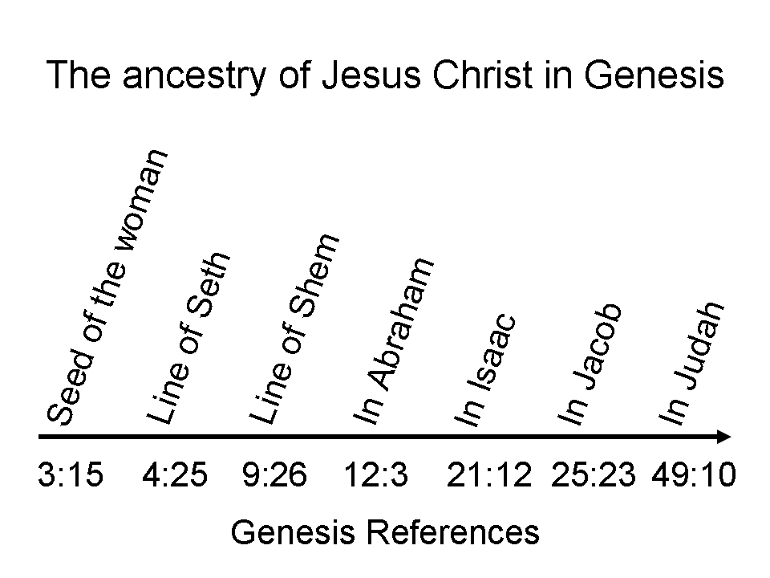
Genesis 49:8-10
"Judah, your brothers shall praise you; your hand shall be on the neck of your enemies; your father's sons shall bow down to you. 9 Judah is a lion's whelp; from the prey, my son, you have gone up. He couches, he lies down as a lion, and as a lion, who dares rouse him up?" The scepter shall not depart from Judah, nor the ruler's staff from between his feet, until Shiloh comes, and to him shall be the obedience of the peoples."

A ‘scepter’ was a common symbol for the rule of a king in both the Bible (Genesis 49:10; Amos 1:5, 8; Psalm 45:6-7) and in other literature of the day. Here are some key points about this scepter:

- Judah’s brothers and their descendants will bow down to Judah and to Judah’s descendants, since Judah’s tribe will be the one in authority over them (verse 8).
- Judah is like a lion: powerful (verse 9).
- ‘Shiloh’ (verse 10) is the English spelling of the sound of the Hebrew word, but, “until Shiloh comes” means that the kingly line of Judah will not end “until He comes to Whom it (the scepter) belongs” (per the NIV).

So this Genesis 49:8-10 prophecy says that Christ will be the Messiah as a king of the line of Judah. Moses speaks to the Israelites, telling them of a prophet to come, to whom they should listen:

Deuteronomy 18:15
"The LORD your God will raise up for you a prophet like me from among you, from your countrymen, you shall listen to him."

Moses is telling of the Messiah as a prophet. Then a covenant is made with King David:

1 Chronicles 17:3-15 (see also 2 Samuel 7:8-17)
It came about the same night that the word of God came to Nathan, saying, 4 "Go and tell David My servant, 'Thus says the LORD, " You shall not build a house for Me to dwell in; 5 for I have not dwelt in a house since the day that I brought up Israel to this day, but I have gone from tent to tent and from one dwelling place to another. 6 "In all places where I have walked with all Israel, have I spoken a word with any of the judges of Israel, whom I commanded to shepherd My people, saying, 'Why have you not built for Me a house of cedar?'"' 7 "Now, therefore, thus shall you say to My servant David, 'Thus says the LORD of hosts, "I took you from the pasture, from following the sheep, to be leader over My people Israel. 8 "I have been with you wherever you have gone, and have cut off all your enemies from before you; and I will make you a name like the name of the great ones who are in the earth. 9 "I will appoint a place for My people Israel, and will plant them, so that they may dwell in their own place and not be moved again; and the wicked will not waste them anymore as formerly, 10 even from the day that I commanded judges to be over My people Israel. And I will subdue all your enemies.

Moreover, I tell you that the LORD will build a house for you. 11 "When your days are fulfilled that you must go to be with your fathers, that I will set up one of your descendants after you, who will be of your sons; and I will establish his kingdom. 12 "He shall build for Me a house, and I will establish his throne forever. 13 " I will be his father and he shall be My son; and I will not take My lovingkindness away from him, as I took it from him who was before you. 14 "But I will settle him in My house and in My kingdom forever, and his throne shall be established forever."'" 15 According to all these words and according to all this vision, so Nathan spoke to David.

Compare this prophecy to what the angel Gabriel told Mary:

Luke 1:26-33
Now in the sixth month the angel Gabriel was sent from God to a city in Galilee called Nazareth, 27 to a virgin engaged to a man whose name was Joseph, of the descendants of David; and the virgin's name was Mary. 28 And coming in, he said to her, "Greetings, favored one! The Lord is with you." 29 But she was very perplexed at this statement, and kept pondering what kind of salutation this was. 30 The angel said to her, "Do not be afraid, Mary; for you have found favor with God. 31 And behold, you will conceive in your womb and bear a son, and you shall name Him Jesus. 32 He will be great and will be called the Son of the Most High; and the Lord God will give Him the throne of His father David; 33 and He will reign over the house of Jacob forever, and His kingdom will have no end."

Take note as well where the Messiah, the King of Israel, was to be born:

Matthew 2:1-6
Now after Jesus was born in Bethlehem of Judea in the days of Herod the king, magi from the east arrived in Jerusalem, saying, 2 "Where is He who has been born King of the Jews? For we saw His star in the east and have come to worship Him." 3 When Herod the king heard this, he was troubled, and all Jerusalem with him. 4 Gathering together all the chief priests and scribes of the people, he inquired of them where the Messiah was to be born. 5 They said to him, "In Bethlehem of Judea; for this is what has been written by the prophet [Micah 5:2]:

6 'And you, Bethlehem, land of Judah,
Are by no means least among the leaders of Judah;
For out of you shall come forth a Ruler
Who will shepherd my people Israel.'"

Many centuries ago the rabbis viewed the Old Testament as teaching that there would be two Messiahs:

- Messiah ben Joseph, who would suffer and die, and
- Messiah ben David who would reign.

Messiah ben David was by far the more publicly taught & anticipated among most of the Jewish population in earlier centuries, but Messiah ben Joseph was seen as being in Isaiah 52:13 - 53:12. So why didn’t the Jews all see that Jesus was Messiah ben Joseph and Messiah ben David? It was the Pharisees who saw in the Old Testament the ‘two Messiahs’, with Messiah ben David raising Messiah ben Joseph from the dead, as two in sequence and not one single person. Since the Pharisees were the champions of the two Messiahs teaching, they were expecting Messiahs who would be very supportive of them. Since Jesus was not supportive, they didn’t see a good ‘fit’.

About 1100 AD the rabbi Rashi was the first to propose that Isaiah 52:13 - 53:12 was really about the hardships of the people of Israel, though that was not well received among other rabbis. Only by about the mid-1800s did most Jewish commentators shift to teaching that this passage was about the people of Israel & not the suffering Messiah: Messiah ben Joseph.

But the Jews of Jesus’ time tended to separate out the prophecies of the Messiah into different roles and people, as was evidenced by the questions asked of John the Baptist:

John 1:19-28
This is the testimony of John, when the Jews sent to him priests and Levites from Jerusalem to ask him, "Who are you?" 20 And he confessed and did not deny, but confessed, "I am not the Christ." 21 They asked him, "What then? Are you Elijah?" And he said, "I am not." "Are you the Prophet?" And he answered, "No." 22 Then they said to him, "Who are you, so that we may give an answer to those who sent us? What do you say about yourself?" 23 He said, "I am a voice of one crying in the wilderness, 'make straight the way of the Lord,' as Isaiah the prophet said."

24 Now they had been sent from the Pharisees. 25 They asked him, and said to him, "Why then are you baptizing, if you are not the Christ, nor Elijah, nor the Prophet?" 26 John answered them saying, " I baptize in water, but among you stands One whom you do not know. 27 "It is He who comes after me, the thong of whose sandal I am not worthy to untie." 28 These things took place in Bethany beyond the Jordan, where John was baptizing.

Christ was recognized by His disciples and some others as the Messiah:

Matthew 1:1, 16 (by the disciple turned apostle, Matthew)
The record of the genealogy of Jesus the Messiah, the son of David, the son of Abraham: … Jacob was the father of Joseph the husband of Mary, by whom Jesus was born, who is called the Messiah.

Matthew 16:13-16 (by the disciple later turned apostle, Peter)
Now when Jesus came into the district of Caesarea Philippi, He was asking His disciples, "Who do people say that the Son of Man is?" 14 And they said, "Some say John the Baptist; and others, Elijah; but still others, Jeremiah, or one of the prophets." 15 He said to them, "But who do you say that I am?" 16 Simon Peter answered, "You are the Christ, the Son of the living God."

John 1:40-41 (by the disciple, later turned apostle, Andrew, Peter’s brother)
One of the two who heard John speak and followed Him, was Andrew, Simon Peter's brother. 41 He found first his own brother Simon and said to him, "We have found the Messiah" (which translated means Christ).

John 4:25-26 (the Samaritan woman would hear it)
The woman said to Him, "I know that Messiah is coming (He who is called Christ); when that One comes, He will declare all things to us." 26 Jesus said to her, "I who speak to you am He [egō eimi: I AM]."

John 11:27 (by Martha, sister of Lazarus)
She said to Him, "Yes, Lord; I have believed that You are the Christ, the Son of God, even He who comes into the world."

But here are two other Old Testament passages that are primary in the prophecies of Christ as the Messiah. Look especially at verses 1 and 4:

Psalms 110:1-6, A Psalm of David. [compare with Psalm 2]
The LORD says to my Lord: "Sit at My right hand Until I make Your enemies a footstool for Your feet." 2 The LORD will stretch forth Your strong scepter from Zion, saying, " Rule in the midst of Your enemies." 3 Your people will volunteer freely in the day of Your power; In holy array, from the womb of the dawn, Your youth are to You as the dew. 4 The LORD has sworn and will not change His mind, "You are a priest forever According to the order of Melchizedek." 5 The Lord is at Your right hand; He will shatter kings in the day of His wrath. 6 He will judge among the nations, He will fill them with corpses, He will shatter the chief men over a broad country.
Daniel 7:13-14
"I kept looking in the night visions,
And behold, with the clouds of heaven
One like a Son of Man was coming,
And He came up to the Ancient of Days
And was presented before Him.
14 And to Him was given dominion,
Glory and a kingdom,
That all the peoples, nations and men of every language
Might serve Him.
His dominion is an everlasting dominion
Which will not pass away;
And His kingdom is one
Which will not be destroyed."

These two passages – and they are not the only ones – look ahead to Christ’s second coming. This is when Christ will come again with us and His angels to judge and to reign as King of Israel (aka King of the Jews) over the land and people of Israel, and as King of kings and Lord of lords over the Gentile nations for 1000 years (Revelation 19 chapters and 20).

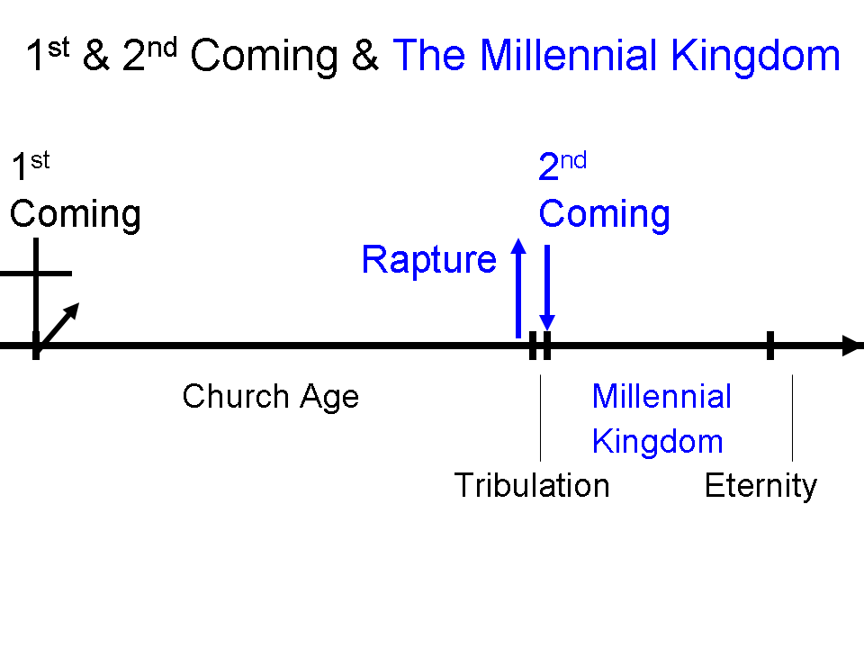
Ephesians has the Christ = the Messiah 26 times, starting with Ephesians 1:10.

Ephesians 1:9-10 (NASU)
He made known to us¹ the mystery of His will, according to His kind intention which He purposed in Him 10 with a view to an administration suitable to the fullness of the times, that is, the summing up of all things in Christ, things in the heavens and things on the earth.

Ephesians 1:9-10 expanded & explained
God the Father made known, by deliberate revelation to us in the Church, the mystery, a truth previously unrevealed but now revealed by the Father’s will, consistent with the Father’s kind intention which He planned for those who are ‘in Christ’, namely the Church. 10 That planning for the Church has this direction: the Father’s management of everything in the created universe, to include those in the Church (the mystery now revealed!), for the final one of all the accumulated times of the present heavens and the present earth, that is, the heading up of all things in the Christ [the Messiah!] during the Millennium, with the ‘all things’ being all those created things in the heavens and those things on the earth, both visible and invisible. The Millennial reign of Christ is the time on the present heavens and earth when all things will be summed up in Him, and it is the beginning of the complete restoration of all things (Acts 3:21; Revelation 20-22).

The Father: Ephesians 1:3, “Blessed be the God and Father of our Lord Jesus Christ, who has blessed us with every spiritual blessing in the heavenly places in Christ”. In verses 3,4,5,6, 8 and 9 ‘us’ means those in the Church, who are ‘in Christ’.
‘in Him’ = in Christ, which is the Church being in Christ. Verse 10 then conveys that the Church, a heavenly people, will be included in the ‘all things’ being headed up in Christ, at ‘the fullness of the times’ for the present heavens and earth. For the meaning of “all things” see footnote 7 below.
This is a forward-looking use of ‘eis’, similar to what we see in Philippians 1:9,10, “And this I pray, that your love may abound still more and more in real knowledge and all discernment, 10 so that you may approve the things that are excellent, in order to be sincere and blameless until (eis) the day of Christ…”
This is the word oikonomia, but without a definite article (so the KJV is possibly misleading here), which refers to a management by the Father, of all things in heaven and on earth toward that fullness [completion] of times. In this context, and lacking the definite article, this word does not refer to a specific earthly dispensation at all, but to the Father’s management of all things - things in the heavens and things on the earth. Some dispensationalists have mistakenly taken oikonomia here to mean the Millennial Kingdom.
The ‘fullness of the times’ is the totality or completeness of the times. The ‘fullness of the times’ (toú pleeroómatos toón kairoón) has only one other similar use in the New Testament: Luke 21:23-24, “Woe to those who are pregnant and to those who are nursing babies in those days; for there will be great distress upon the land and wrath to this people; 24 and they will fall by the edge of the sword, and will be led captive into all the nations; and Jerusalem will be trampled under foot by the Gentiles until the times of the Gentiles are fulfilled (hoú pleeroothoósin kairoí).” The times of the Gentiles will be fulfilled (come to the totality or completeness of times) at the end of the Tribulation - the beginning of the Millennial Kingdom.
The word anakefalaioósasthai conveys the heading up of all things in the Christ (not the same meaning as ‘in Christ’ as before, because of the definite article here). All things being in the Christ has a different message than the prior uses of ‘in Christ”, ‘in Him, etc. in previous verses, since this is in reference to Christ as the Messiah: ‘And Jesus began to say, as He taught in the temple, "How is it that the scribes say that the Christ is the son of David?’" Mark 12:35. The Greek of Mark 12:35 has the definite article.
So what does ‘all things… in the heavens and things on the earth’ convey? Colossians 1:16, “For by Him all things were created, both in the heavens and on earth, visible and invisible, whether thrones or dominions or rulers or authorities-- all things have been created through Him and for Him.” Ephesians 1:9,10 helps explain the ‘for Him”. See also Acts 3:21 for a Millennial Kingdom use of ‘all things’. “In Him” is not included in the above quote at the end of verse 10, since it belongs to the next verse (verse 11).

