Biblical Crowns & Rewards

For Church age believers, the New Testament epistles tell us that there will be a judgement before Christ that is not to determine whether or not we we will be condemned (we will not: Romans 8:1), but rather for evaluation for the extent of eternal reward (Romans 14:10; 1 Corinthians 3:10-15; 2 John 8; Revelation 3:11). These crowns are specified in the New Testament epistles, as listed on the acompanying chart. The crowns in this context do not appear to be crowns of royalty (diadem crowns), but rather of victory, since the word used consistently in the New Testament for these rewards is a stephanos crown – a victor’s crown in an athletic competition (see photograph below).

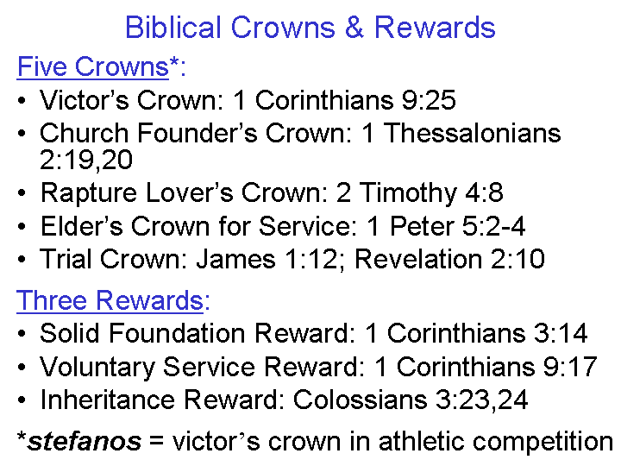
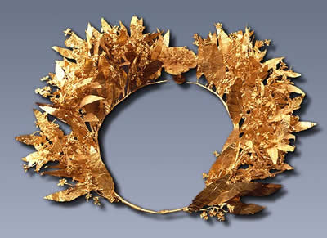

It is possible that the listing above is representative rather than exhaustive, since we are told about these crowns and rewards, but are not told that these are all of them. Also, there are godly virtues, acts, and characteristics that are not listed as associated with crowns or rewards, but which we might discover to be so in eternity.

What are the crowns and rewards? The Bible does not describe in detail what the crowns and rewards are, but the one heavenly scene that provides for us a glimpse of the value and purpose of these crowns and rewards is found in Revelation 4:10, 11 (NASU):

“…the twenty-four elders will fall down before Him who sits on the throne, and will worship Him who lives forever and ever, and will cast their crowns before the throne, saying, 11 "Worthy are You, our Lord and our God, to receive glory and honor and power; for You created all things, and because of Your will they existed, and were created."

So the crowns, rather than being a selfish possession, are instead a capacity to worship and glorify the Lord. That capacity is not simply a one-time capacity to worship and glorify the Lord, but rather a repeated and ongoing capacity, since the word translated “cast” in verse 10 is not explicitly a one time or once and for all casting, but are taken, in context, as rather a continuing casting – again and again. This sense also fits with the ancient custom of repeatedly casting one’s crown before superior royalty.

The identity of the twenty-four elders is taken to be representative of the raptured church, as will be explained and supported by multiple observations later in our study of Revelation (see study of Revelation 4:1-4 – ‘Step on up’).

