Revelation 20:4-10 - Deaths, Resurrections & Judgments

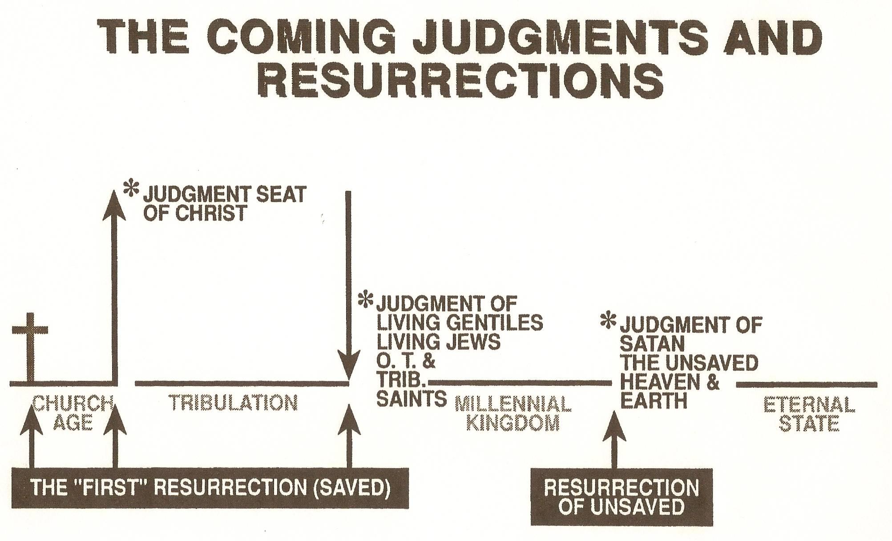
From a chart collection compiled by Thomas Ice, Ph.D.
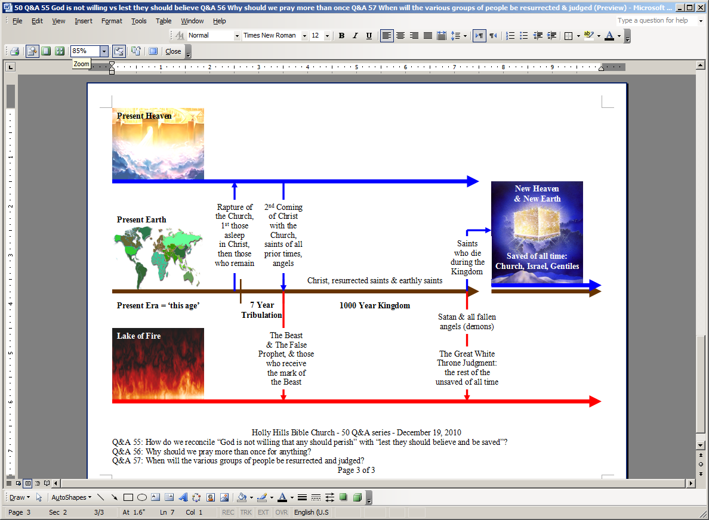
Text of ‘New Heaven & New Earth’ is on top of copyrighted artwork by Pat Marvenko Smith. Right to use has been purchased.
Future Things: Key Places, Events, Resurrections, Judgments & People Groups
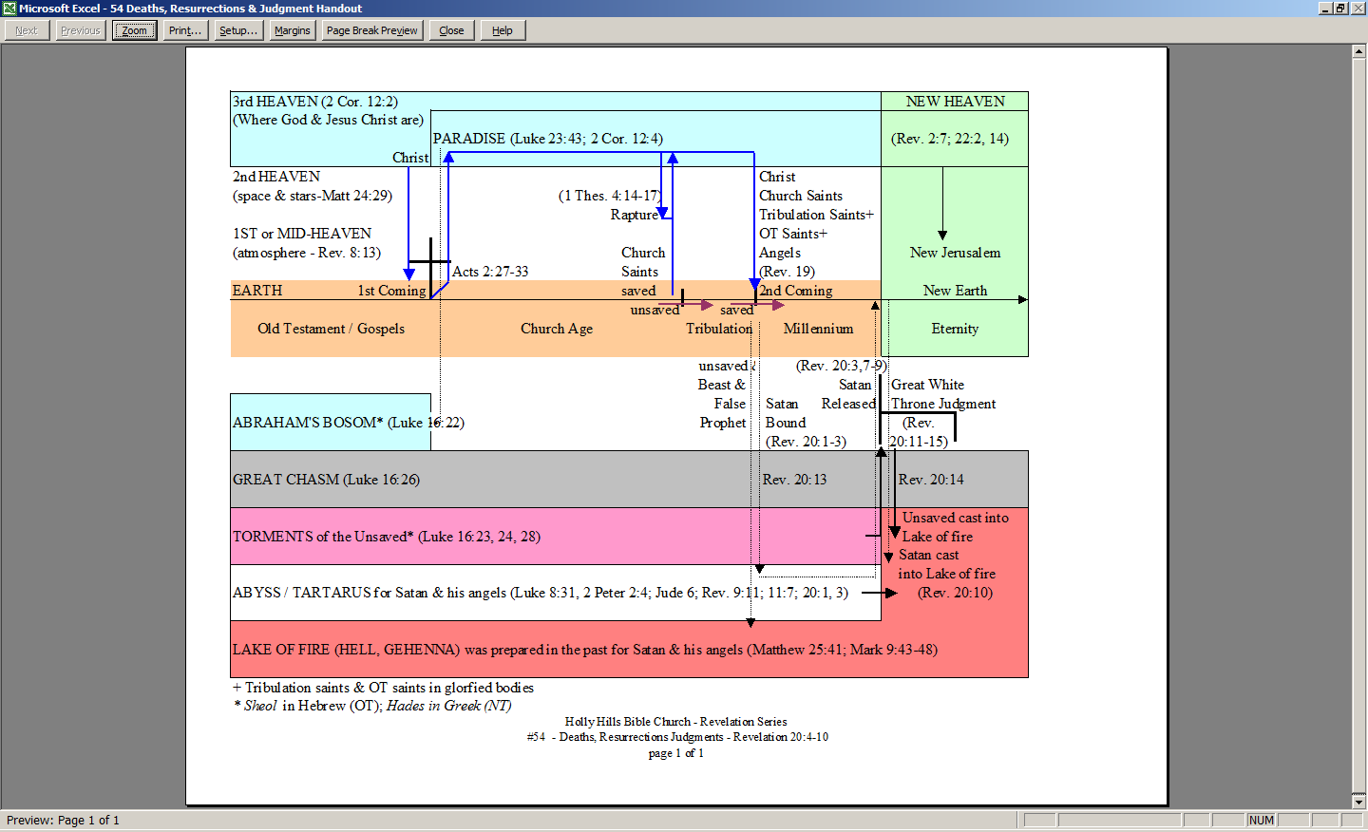
+ Tribulation saints & OT saints in glorfied bodies
* Sheol in Hebrew (OT); Hades in Greek (NT)

