A. Open the program Audio Audition 1.5
- Highlight “Adobe Audition” icon on the desktop and left click on this icon to open this program

- Note: Adobe Audition records in the wav format so it can easily be edited… it is only in memory in this format… when done recording, use the File Save As and select the format wanted, wav, mp3 etc.


1. To record use the red dot option

2. Make sure the New Waveform has these settings and then left click on OK
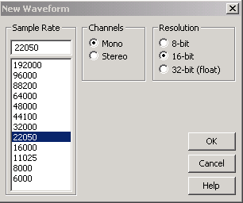

- After a few seconds, stop recording and use Edit->Delete Selection to remove this recording,

- Use File->Save As, and choose the format and name you want to save the file in.. usually wav if you are
going to edit and resave the file, wav files are not compressed, so you can edit and save without loosing any quality, but if mp3 or wma is used, then you loose some quality each time the file is resaved.

- Press F10 to monitor the incoming sound, and when ready to record use the red dot option as above.

- You can use the pause at any time and then resume recording where you left off by pressing red dot.

- Use Stop square to stop recording. Save the file before proceeding., “filename” + “-a” is recommended,

- After the B and C steps resave the file this time with “filename” + “-b” to distinguish this as the edited file.

Note: Earphones are recommended when doing step B.. helps a lot to find where the beginning and end are, and must be used if middle portion is edited, hard limited etc, in any way.

B. Clip begin & end of file, with 1sec “Generate->Silence”
- Note: The sound file is visually shown as a horizontal pattern that represent the sound intensity.. Large vertical green pattern represents loud sounds, a smaller vertical green pattern is for softer sounds, and the left to right display is time related, i.e. the beginning on left to the ending on right. Because the recording includes lots of time before and after the lesson, we need to remove it and add 1 second of silence to the beginning and end.

- Move mouse pointer to about the place you think the lesson begins, i.e. right after teacher’s opening prayer,

- Press and hold down the left mouse button and move the mouse to the left til the beginning of the file is reached .

- Select the Tab at the top “Generate” and left click on “Silence” and make sure Silence Time is set to 1 seconds.. then click the OK button

- In a similar fashion select a portion of the pattern at the end of the message and expand it and find the place by listening when the teacher ends his prayer. Hold down the left mouse button and move the mouse to the right till the position is all the way to the end and release it.

- Now use “Generate” tab and left click on “Silence” and make sure Silence Time is set to 1 seconds.. then click the OK button to replace the selected part of the file with 1 second of silence..

C. Hard Limit to make the average peaks up to within the +/- 0-1db area
  - Make sure none of the wave form is selected.. one left click anywhere on the wave form will do

- Choose the tab at the top “Effects” then “Amplitude” and left click on “Hard Limiting”

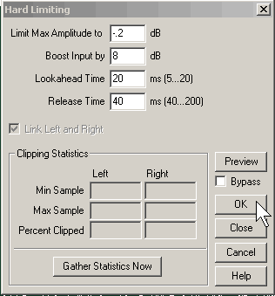
- Keep “Limit Max Amplitude to” field at -0.2db even if the gain amount selected is zero.
- Move cursor to “Boost Input by” field, and change the # to a value to bring the peaks up to that # of db required for making the wave intensity louder but not too loud. This requires a bit of guess work to have the wav file end up with most of its peaks reaching between 0 and 1db, at the top and bottom of pattern.

- Choose “Ok” option to do the limiting, it should automatically select the entire file

Note: If time allows, low volume sections such as questions or scripture reading, etc, could be boosted individually by selecting with the left mouse button held down and moved over the targeted section and released. Then doing another Hard Limit on just that section.

F3 repeats the last thing done.. useful for many same edit tasks, like hard limiting portions in the middle..

File->Save As with the “-b” suffix, and then File->Save As to save the final format.. mp3 usually and upload it.

