Simple Version BENQ recorder file source
1. Copy current days lesson file from BENQ to C:\!Msgs
2. Rename to yyyymmddhhTT#-##SER-##q.mp3 <- added “q” as BENQ source
3. Open the file for Editing in Audio Audition 1.5
4. Clip begin & end of file, with 1sec “Generate->Silence” (Ctrl+F7)
5. Convert to 22Khz sample rate and 16bit Resolution in mono format. (Ctrl+F8)
6. Save this file with “File”+“Save As” make sure “Save as Type” is Windows PCM (wav)
filename should be yyyymmddhhTT#-##SER-##qa.wav <- is clipped as PCM(wav) as version “a”
7. Set ID3 data using 2 hits of Ctrl+F12,
change Song Title <- get info from web preset values or teacher/handouts or previous lessons
If not set make Comments end with “c22” <- indicates clipped and converted to 22khz sample rate wav
8. Resave this file with “File”+“Save” same filename here
filename should be yyyymmddhhTT#-##SER-##qa.wav <- has ID3v1 info added as version “a”

9. Save this file with “File”+“Save As” making new file for final work here
filename should be yyyymmddhhTT#-##SER-##qb.wav <- now saved as version “b” for final work
10. Hard Limit to make the average peaks up to within the +/- 0-1db area (Ctrl+F9)
11a. If Noise Reduction needed, use a captured sample of typical noise to do (Ctrl+F10)
11b. If Graphic Equalization needed, make or use preset(s) to do (Ctrl+F11)
12. If 11a or 11b used, do final Hard Limit to make average peaks to within +/- 1db area (Ctrl+F9)
13. Use 2 hits Ctrl+F12 to add “H#nrehH#” to View->Wave Properties-> Comments, with # = gain(s) used
c=clipped, 22=22khzSampleRate, H=HardLimited, #=db gain used, nr=noise reduced eh=equalized hum
14. Resave with “File”+“Save”, filename should be yyyymmddhhTT#-##SER-##qb.wav

15. Save with “File”+“Save Copy As” into the .mp3 file format, (Type: mp3PRO)
>>!! BE SURE TO CHECK “Options” for preset of “24kbps 22Khz 16bit Mono”
AND remove “qb” add “.mp3” so filename should be yyyymmddhhTT#-##SER-##.mp3
When done, goto: “Last Steps in preparing
Simple Version Tape or hard-drive file source files for uploading”

1. If needed rename master to yyyymmddhhTT#-##SER-##t.wav <-added “t” tape source (no “t” if hard-drive)
2. Open the file for Editing in Audio Audition 1.5
3. Clip begin & end of file, with 1sec “Generate->Silence” (Ctrl+F7)
4. Merge center for best flow of content
5. Save this file with “File”+“Save As” make sure “Save as Type” is Windows PCM (wav)
filename should be yyyymmddhhTT#-##SER-##ta.wav <- is clipped as PCM(wav) as “a” (no “t” if hard-drive)
6. If needed, convert to 22Khz sample rate and 16bit Resolution in mono format. (Ctrl+F8)
7. Set ID3 data using 2 hits of Ctrl+F12,
change Song Title <- get info from web preset values or teacher/handouts or previous lessons
If not set make Comments end with “c22” <- indicates clipped and converted to 22khz sample rate wav
8. Resave this file with “File”+“Save” same filename here
filename should be yyyymmddhhTT#-##SER-##ta.wav <- has ID3v1 info added as “a” (no “t” if hard-drive)

9. Save this file with “File”+“Save As” making new file for final work here
filename should be yyyymmddhhTT#-##SER-##tb.wav <- now saved as “b” for final work (no “t” if hard-drive)
10. Hard Limit to make the average peaks up to within the +/- 0-1db area (Ctrl+F9)
11a. If Noise Reduction needed, use a captured sample of typical noise to do (Ctrl+F10)
11b. If Graphic Equalization needed, make or use preset(s) to do (Ctrl+F11)
12. If 11a or 11b used, do final Hard Limit to make average peaks to within +/- 1db area (Ctrl+F9)
13. Use 2 hits Ctrl+F12 to add “H#nrehH#” to View->Wave Properties-> Comments, with # = gain(s) used
c=clipped, 22=22khzSampleRate, H=HardLimited, #=db gain used, nr=noise reduced eh=equalized hum
14. Resave with “File”+“Save”, filename should be yyyymmddhhTT#-##SER-##tb.wav (no “t” if hard-drive)

15. Save with “File”+“Save Copy As” into the .mp3 file format, (Type: mp3PRO)
>>!! BE SURE TO CHECK “Options” for preset of “24kbps 22Khz 16bit Mono”
AND remove “tb” or “b” and add “.mp3” so filename should be yyyymmddhhTT#-##SER-##.mp3
When done, goto: “Last Steps in preparing files for uploading”

Last Steps in preparing files for uploading
16. Use “File”+“Close All” to close open files
then exit Audio Audition

17. Use “Multi ID3 Tag Editor” program, make sure the “ID3 Tags” tab is selected
- Use “PlayList+Remove+Remove All”, to clear previous selected folder
- Use “PlayList+Add+Add Folder”, to select the folder of the mp3 files for this series
- Select the mp3 file just created from the list of mp3 files
- Use “Copy to ID3v2” option,
- Copy paste or type in copyright: Holly Hills Bible Church Denver, CO USA
- Add to the Title any clipped words not copied from ID2v1 data
- Use “Save” option
- Leave the program open in case needed for after next program used

18. Use “Tag&Rename” program,
- Make sure tabs “Multi File Tag Editor” at top and “ID3v2” in middle are selected
- Make sure the Folder selected is for this series of mp3 files
- Make sure the ID3v2 info has parallel information throughout the series
- Make sure the new lesson information & format matches the previous ones
- For major changes
go back to the filename.wav files, and change,
then save each one, and make new mp3 file
- For minor changes
goto 17 above, make changes, and save the changes
then return to this program & use “View+Refresh File List”(Ctrl+R) to reload list and verify changes
- When satisfied, Close “Tag&Rename” and “Multi ID3 Tag Editor” programs

19. Click on icon for “HHBC dBase” link & upload this mp3 file (see next mini procedure)

The HHBC dBase program.
- Choose the HHBC Msg dBase Icon on the desktop. This will take you to the web site and the Database editing program area.
- From the Summary Window of options, choose Series name
- From the Series Window of options, choose “Jump to Lessons” to see if there is an existing entry for this date. If there is one click the left mouse button on the link for that lesson to open it. If there is no lesson for this date, then Jump to the top and use the “Add a lesson” option.
- If not already checked, check the “Publish this lesson on the website” check box
- Make sure the Title is 1st numbered, then given a scripture and or Title as appropriate for this series. Use the previous lessons as a guide for keeping them consistently Titled.

NOTE: If scripture is in the Title, there must be a comma after the Book, like Ruth, 1:2-5. The comma will keep the auto link generator from thinking you want this linked to a web site for scripture look up.

- Select the Teacher or use the “Set to Primary Teacher” Link
- Set the Date and time with the format
- yyyy-mm-dd hh:mm, year dash month dash day space hour Colon Minute
- Move down in the windows to “Passages” and add in the reference if available, this should not be abbreviated.
- Scroll the inner window to the bottom for the option “Browse” and click on it.
- Find the mp3 file created above, click once on it to select it, and choose the option “Open”
- Choose the option “Save” to upload the changes and the file to the web.
- Takes time for this, typically about 3-4 min minimum with DSL, so be patient

NOTE: When the file correctly uploads, there will be a message on the screen with a link to the file uploaded. If there is an error, just repeat from the “Browse” point in the instructions above.
Expanded Version BENQ recorder file source
(for Tape or HD source, use order & filenames of “Simple Version Tape or HD source”)

1. Copy current days lesson file from BENQ to C:\!Msgs
- BenQ has USB port.. use it to connect to USB port on computer..
- Use Windows Explorer, select “My Computer” to be able to see all drives, C: D: etc
- Highlight the “Removable Disk(E:)” and double click on its icon to open this device
- Highlight the “MICIN” and double click on its icon to open this subdirectory
- Highlight the file name of the lesson auto named M+mmdd##.MP3 and right click once, choose “Copy” with left mouse button to put this file into the memory of the computer
- Highlight “DO#+10GB(C:)” double click its icon to open its contents..
- Highlight “!Msgs” and double click on its icon to open its contents..
- Move mouse pointer to an area in the right window and right click, choose “paste” with left mouse button to paste the file into this subdirectory..

- One Right click on this icon at the bottom right and
then One Left click on “Unplug or Eject Hardware”

- Highlight 2nd line item “USB Mass Storage Device” & Double Left click its icon
- Highlight BenQ Joybee ### USB Device then One Left click on “OK”
- Close “Save to Remove Hardware” and “Unplug or Eject Hardware” Windows
- LEAVE the BenQ recorder attached to the computer so its internal batter can charge up

2. Rename to yyyymmddhhTT#-##SER-##q.mp3 <- added “q” as BENQ source
- Use Windows Explorer to locate the C:\!Msgs folder and the file just copied, usually M+mmdd##.MP3
- One left click on filename, and then one right click on it will give a menu.
- Select the “Rename” option to change the filename by typing in new name using the HHBC naming convention format, with a final small letter “q” just before the .mp3 filename extension. The q tells us this file has a BenQ recorder source.

- NOTE: .mp3 is the file extension used by computer operating systems to know this is a certain kind of formatted file. In this case it is a “filename.mp3” file that will be played by certain programs and not others as a “sound” file. Without this ending, the programs would not know how to handle the file information.. i.e. as sound vs video or pictures, etc.

- Here is a sample of the HHBC filename convention for the sound files..

- yyyymmddhhTT#-##SERIES-##q.mp3
- year month day hour teacher Num dash seriesNum Name dash lessonNum q .mp3
- Examples…
- 2006120309HR1-28ROM-60q.mp3 = Dec 3, 2006 Roger H. Romans class #60q.mp3
- 2006120310PV1- 27ISAIAH-45q.mp3 = 10a.m. lesson 45, source is the BenQ recorder

3. Open the file for Editing in Audio Audition 1.5
- Use Windows Explorer, select “My Computer” to be able to see all drives, C: D: etc
- Highlight “DO#+10GB(C:)” double click its icon to open its contents..
- Highlight “!Msgs” and double click on its icon to open its contents
- Find and highlight the file name you just moved to this directory, named: Mmmdd##.MP3
- Right click on this file name, and Highlight the “Open With” option,
- Highlight “Adobe Audition” and left click on this option to open this sound file for editing

- Note: Adobe Audition loads the mp3 file into a format it can use to allow it to be edited… it is only in memory in this format… but it has come from a mp3 format so DO NOT use the File+Save option at this point or you will force the program to reconvert it to mp3 and save with a lot of loss in the process.

4. Clip begin & end of file, with 1sec “Generate->Silence”
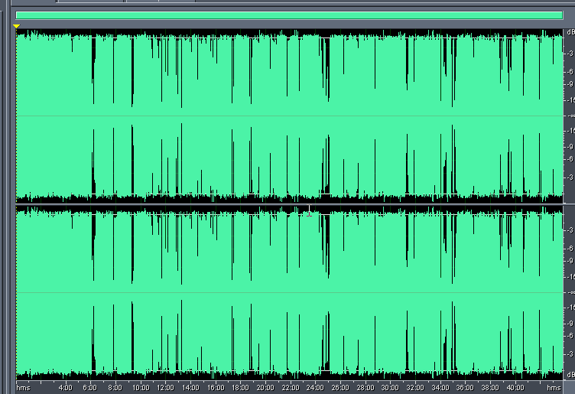
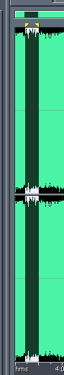

- Note: The sound file is visually shown as 2 (for stereo) horizontal patterns that represent the sound intensity.. Large vertical green pattern represents loud sounds, smaller vertical green pattern is for softer sounds, and the left to right display is time related, i.e. the beginning on left to the ending on right. Because the recording includes lots of time before and after the lesson, we need to remove it so we can easily convert the file to mono sound, and not have to convert all the extra time at the beginning and end.

- Move mouse pointer to about the place you think the lesson begins, i.e. right after teacher’s opening prayer,

- Press and hold down the left mouse button and move the mouse to the left about ½ inch, and release the mouse button to highlight a small time portion of the 2 horizontal patterns.

- Now select the “Zoom to selection” option shown pointed to at the left

- This will expand the pattern so only the selected area is in view..
- Press the space bar to listen to the selection and press the space bar again to stop listening.
- With this listening process locate the ending of the prayer and place the mouse pointer at that point, hold down the left mouse button and move the mouse to the left.. keep holding the left button down, the pattern will move allowing you to select all the way to the beginning of the file, then release the button.
- Select the Tab at the top “Generate” and left click on “Silence” and make sure Silence Time is set to 1 seconds.. then click the OK button

NOTE: to save time, you can choose the “Skip” option now while the program is “saving the undo info”.. you will see a “Undo Saving Cancelled” window, choose “Yes” and that will allow the program to continue replacing the selected part of the file with 1 sec of silence.

- In a similar fashion select a portion of the pattern at the end of the message and expand it and find the place by listening when the teachers ends his prayer. Hold down the left mouse button and move the mouse to the right till the position is all the way to the end and release it.
- Select the Tab at the top “Generate” and left click on “Silence” and make sure Silence Time is set to 1 seconds.. then click the OK button. Again if desired use the Skip option as above..

5. Convert to 22Khz sample rate and 16bit resolution in mono format. (F11)
- NOTE: You must convert to this sample rate in mono because the MP3 recorder samples at 96k and the program receiving that file and converts it to a 44khz wav file in memory. This is too large a file for web and cd distribution of the spoken word. DO NOT save the file here!!

- Press F11, or choose the tab at top “Edit”, then select the “Convert Sample Type” option. This will bring up the “Convert Sample Type” window.
- Click on the Sample Rate Conversion Presets Drill Down arrow, and choose “22khz 16bit Mono” preset option, then choose OK.
- The entire sound file will be converted from Stereo to Mono, then resampled to 22khz, this takes a bit of time so be patient!!
- When done converting, move to next step.

6. Save this file with “File”+“Save As” make sure format is Windows PCM (wav)
- Choose tab “File” then “Save As”, make sure you have the location “Save In” set for “!Msgs”.
- Use the “Save As Type” Drill down arrow to pick the “Windows PCM (*.wav)” option.
- Change the Filename by typing in new and deleting old name to the HHBC naming convention format, with final small letters “qa” just before the .wav file name extension.
- Filename should be yyyymmddhhTT#-##SER-##qa.wav <- is now PCM(wav) as version “a”

7. Set ID3 data using 2 hits of Ctrl+F12
- Press Ctrl+F12 Twice to automatically open the ID3v1 input form window and auto fill in ID3v1 data
- change Song Title <- get info from web preset values or teacher/handouts or previous lessons
- If not set make Comments end with “c22” <- indicates clipped & converted to 22khz sample rate wav
- Choose “OK” when finished adding the Song Title and the suffix to Comments line.

NOTE: Pressing Ctrl+F12 twice uses the AutoHotKey utility (WaveProperties##.exe) to add in ID3v1 information using the “View+Propeties+Text Fields” Tabs window. This information is gathered from the file name you just gave this file… This utility will not add anything to Song Title if it contains a previous entry, and it adds “c22” only if finds no Comments, if there are Comments, it adds “c22H#nrehH#” (for use in Step 13).

NOTE: If there are errors in the data, the file name must contain errors, such as VP instead of PV for Peterman, Vern. Stop and correct the file name and use File+Save to resave this file with the correct name if this has occurred (you need to later delete the wrongly named file. Each Series may have a unique “Song Title” line, like:
Class/Session ## space Series name space scripture space class subject or title if avail.
So, for a session in Romans: 60 Romans 8:9-11, or 45 Isaiah Chapters 49-51
Type in a title line if appropriate for the session you are editing.

8. Resave this file with “File”+“Save” same filename here
- Keep filename the same: yyyymmddhhTT#-##SER-##qa.wav <- has ID3v1 info added still version “a”

9. Save this file with “File”+“Save As” making new file for final work here
- Change “a” to “b” so filename is: yyyymmddhhTT#-##SER-##qb.wav <- now is version “b” for final work

10. Hard Limit to make the average peaks up to within the +/- 0-1db area
  - Use one left click to move to the beginning of the file
- Then use one left click to expand view to the entire file

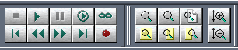

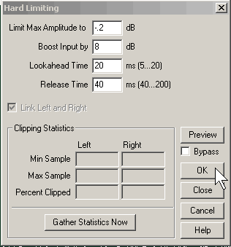
- Choose the tab at the top “Effects” then “Amplitude” and left click on “Hard Limiting”
- Keep “Limit Max Amplitude to” field at -0.2db even if the gain amount selected is zero.
- Move cursor to “Boot Input by” field, and change the # to a value to bring the peaks up to that # of db required for making the wave intensity louder but not too loud. This requires a bit of guess work to have the wav file end up with most of its peaks reaching between 0 and 1db, at the top and bottom of pattern.
- Choose “Ok” option to do the limiting, it should automatically select the entire file

Note: If time allows, low volume sections such as questions or scripture reading, etc, could be boosted individually by selecting with the left mouse button held down and moved over the targeted section and released. Then doing another Hard Limit on just that section.

11a. If Noise Reduction needed, use a captured sample of typical noise to do
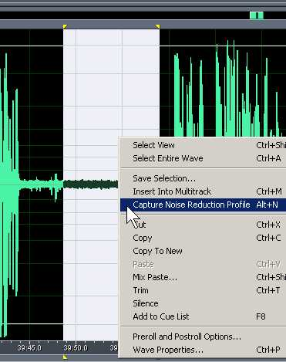
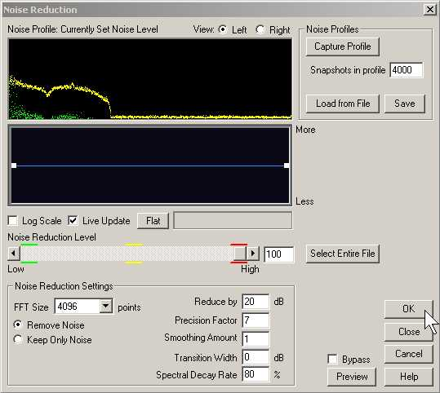
- Select a portion of the wav file pattern showing no +/- audio content
- May need to zoom in to view a smaller portion to select the as in view at left
- With pointer over the selected area in grey, Right click once for the menu and choose the “Capture Noise Reduction Profile”
- If an error message appears it will likely be because too small a time length was selected, need about 1 sec or so to get the noise profile
- After the profile is saved,
Use one left click to move to the beginning of the file
Then use one left click to expand view to the entire file

- Choose the “Effects+Noise Reduction+Noise Reduction” option to get the window seen at left.

- Reduce by 20 db is typical, use max of 40 db for a lot of noise

- Precision of 7 etc should not be adjusted with unless know the effects these cause, values chosen work for almost all circumstances

- Use “Preview” option to hear how it will sound after this setting is done

- Choose “OK” to begin the Noise Reduction, it should automatically have selected the entire file.

As of 3/5/2007
Reduce by 20 typical max of 40 for really bad noise.
Precision Factor 7
Smoothing Amount 0 ⬅ made 0 for echo probs when > 18db HL used
Transition Width 0 dB
Spectral Decay Rate 80%

11b. If Graphic Equalization needed, make or use preset(s) to do
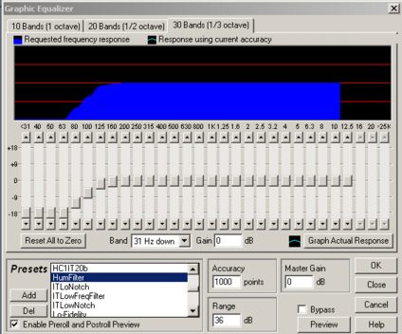
- Use one left click to move to the beginning of the file
- Then use one left click to expand view to the entire file
- Use “Effects+Filters+Graphic Equalizer” options to get window at left
- The Presets selection here is for typical “HumFilter” use
- Lots of amplification or early recordings will have a hum that this filter should remove
- “Preview” to check how it sounds Normal settings and gains are as selected in this example
- Choose “OK” to begin the Equalization, it should automatically have selected the entire file

12. If 11a or 11b used, do final Hard Limit to make average peaks to within +/- 0-1db area

13. Use 2 Hits of Ctrl+F12 to add “H#nrehH#” to View->Wave Properties-> Comments with # = gain(s) used
c=clipped, 22=22khzSampleRate, H=HardLimited, #=db gain used, nr=noise reduced eh=equalized hum

  - Notice the Comment line may only be 1 line long
  - Change the # to the values(s) used during the Hard Limiting
  - Enter only things done
  - Choose “Ok” when done

14. Resave with “File”+“Save”, filename should be yyyymmddhhTT#-##SER-##qb.wav

15. Save with “File”+“Save Copy As” into the .mp3 file format, (Type: mp3PRO)
>>!! BE SURE TO CHECK “Options” for preset of “24kbps 22Khz 16bit Mono”
AND remove “qb” add “.mp3” so filename should be yyyymmddhhTT#-##SER-##.mp3
When done, goto: “Last Steps in preparing files for uploading”

