Introduction to Who we were – Who we are – Who we are becoming

For the next four Sundays – including today – we will be taking a look at what God’s word says about who we were as unbelievers, who we are as believers and who we are becoming, as believers. Our examination of what Scripture says about these things will bring us to some intriguing understandings of the unbeliever’s and the believer’s ‘spiritual anatomy’. Briefly, we will be looking at:

- The unbeliever: The Old Man, the Sin Nature; and the believer: the New Man and the New Nature
- Identification Truths about these Spiritual entities
- Body, soul and spirit of the unbeliever and the believer
- Adam and Eve were originally created in the image of God, but believers are being conformed and transformed into the image of Christ

The unbeliever: The Old Man, the Sin Nature; and the believer: the New Man and the New Nature

When believers hear these terms, there is often at least some uncertainty as to what these terms mean, and perhaps even a lot of uncertainty:

- Old Man
- Sin Nature
- New Man
- New Nature

To gain clarity of these terms, let’s start with:

1 Corinthians 15:20-22
But now Christ has been raised from the dead, the first fruits of those who are asleep. 21 For since by a man came death, by a man also came the resurrection of the dead. 22 For as in Adam all die, so also in Christ all will be made alive.

1 Corinthians chapter 15 is primarily about the resurrection, but verses 21 and 22 provide some important insights for us in our present study. Those insights include:

In Adam: All human beings are conceived and born ‘in Adam’, that is, they are positionally ‘in Adam’ and identified with him, so that all unbelievers have Adam as the spiritual head of the race of fallen mankind. This is the fixed position of each unbeliever. All those ‘in Adam’ share his spiritual history, and the consequences of that history, and are identified with him.

In Christ: All of those who were conceived and born in Adam, once having believed the gospel of salvation, are placed into Christ – they are from that time forward ‘in Christ’, by God’s doing (1 Corinthians 1:30). All those ‘in Christ’ share His spiritual history, and the consequences of that history, and are identified with Him.

To put these ‘in Adam’ and ‘in Christ’ terms in an arrangement that will help us gain clarity on these other terms (Old Man, Sin Nature, New Man New Nature), we’ll present this graphic:
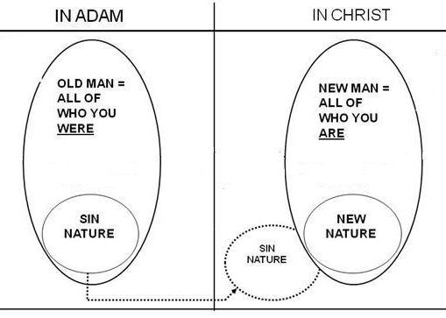
First, let’s talk about what the unbeliever, who is ‘in Adam’, consists of. The unbeliever’s positional person, in Adam, is called the Old Man, in the King James and New King James Versions, and the Old Self in the New American Standard Version (capitalizations added; Romans 6:6, Ephesians 4:22; Colossians 3:9). The Old Man is the positional person of all of who the unbeliever is in Adam. The Sin Nature is referred to as “The Sin” in the Greek text of Romans chapters 6 and 7. The Sin Nature is the collection of attributes and characteristics of how the Old Man is inclined to behave. But there is more to the Old Man than just the Sin Nature, which we will look at next time we meet. So the positional person of the Old Man has a Sin Nature, but is not strictly the same as the Sin Nature. A point which we will undertake in more detail soon is that ‘the Flesh’ is the Sin Nature as it acts through the physical human body.

By itself, the inclination of the Sin Nature would not be to believe in Christ – that Christ the Son of God died, was buried and rose again. But as a work of the Holy Spirit the unbeliever is convicted (John 16:8-11), and because of Christ’s death, burial and resurrection, the continuing person (see next page) comes to believe, which is that person’s last act in association with the Old Man. That person is then taken out of being ‘in Adam’, never again to be ‘in Adam’, and never again having an association with the positional person of the Old Man. That person who was positionally ‘in Adam’ is now, by faith in God’s work through Christ, made to be positionally and irreversibly ‘in Christ’. That positional person of the believer in Christ is called the New Man, who is all of who we are in Christ, and that New Man has a New Nature – but the New Man is more than just the New Nature, as we will soon see.

Now there is one thing about the diagram above that we must yet address: Why is the Sin Nature shown with a dotted line continuing from the category ‘in Adam’ to the category ‘in Christ’? That is because while the believer will never again deal directly with the Old Man, since he was take out of Adam and placed into Christ, the Sin Nature is associated with this fallen human body. The Sin Nature will remain associated with the fallen human body until we have a new body, which will be like Christ’s (1 John 3:2) and will have no Sin Nature. That is why Romans 6 has us, as believers, dealing with the Sin Nature and not the Old Man who was crucified. We are no longer ‘in Adam’ and never will be again. That positional person of the Old Man cannot resurrect and pop back into our lives, but the Sin Nature that pertained to the Old Man is still associated with the physical human body of the believer until the Lord takes the believer home. Until then, we are graciously equipped to deal with the Sin Nature, since we were baptized into Christ when we believed (Romans 6:1-14).

At this point we must add one more feature to the diagram in order to answer a few of the questions we presented last Sunday.

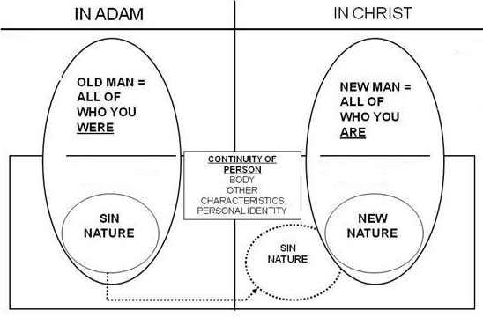

Why is it that Paul could write that we believers are all new in kind creatures – a new in kind creation – (2 Corinthians 5:17; Galatians 6:15), yet refer to himself and to other believers with words like, “I was” (Acts 22:28; 26:12; I Timothy 1:13) and “you were” (Ephesians 2:1-3)? What continues from the person in Adam to the person in Christ that allows such language? If the old things have ‘passed away’ (2 Corinthians 5:17) what about the believer continues from when that believer was an unbeliever?

Here are some of the things that remain the same through that radical spiritual change:

- Human body and all that goes with it and identifies that body
- Personal identity and earthly relationships
- Personal characteristics, including likes and dislikes
- Earthly skills and knowledge

It is the spiritual aspects of this continuing person who is taken out of Adam and placed into Christ, and it is the spiritual aspects of this continuing person that God will change over the course of earthly time:

- Conformed to the image of Christ (Romans 8:28, 29)
- Transformed into the image of Christ (2 Corinthians 3:18)
- Growing and maturing spiritually (Ephesians 4:12-16; 2 Peter 3:18)
- Sanctified – set apart and made Holy (Hebrews 10:14)

These changes are making the continuing person more and more into the positional person of the New Man. The New Man is not changing. The New Nature is not changing. And the Sin Nature is not somehow made any better along the way. But the continuing person that includes our personal identity will be changed. And when we see Christ face to face we will be fully like Him (1 John 3:2), in body, soul and spirit, and the changes will be complete. Yet each will have and maintain his or her own specific identity and individual relationship and fellowship with Christ on into eternity (Revelation 2:17).
_____________________________________________________________________________________________________________________

Clarifying Ephesians 4:22: These understandings are consistent with Ephesians 4:22 expressing an action that has been taken once we believed (position: “having laid aside the Old Man”), rather than an action that must be taken by the believer continuously (condition: “lay aside the Old Man”). Further, the corruption of the Old Man continues only in the unbeliever.

Kenneth Wuest, on Ephesians 4:22 (page 111), “That you have put off once for all with reference to your former manner of life the old man which is being corrupted according to the passionate desires of deceit; moreover, that you are being constantly renewed with reference to the spirit of your mind that you have put on once for all the new man which after God was created in righteousness and holiness of truth.”

Harold Hoehner, on Ephesians 4:22, (pages 603, 605, 606), “….accomplished events rather than a process… they have put off or laid aside that old person at conversion…”… “Paul then is teaching, that having been taught in Him, believers have been taught that the old person, according to the former lifestyle was laid aside at the time of their faith in the one who taught them, namely Christ.”…”The present tense denotes continuing action, which indicates that the corruption continues in the unregenerate person.”

H.A. Ironside, Ephesians commentary (page 124), "Some people confound the old man with the old nature. You see, the old man is more than the old nature. The old man is the man of old, what you once were before you were converted. Now you are through with the old man." H.A. Ironside, Romans commentary (page 77), "My old man is not merely my old nature...". Wm. Newell, Romans commentary (page 147), "Also, we must not confuse the “old man” with “the flesh...”

