Made in the Image and Likeness of God

Genesis 1:26-27 (NASU; all quotes NASU unless noted otherwise)
Then God said, "Let Us make man in Our image, according to Our likeness; and let them rule over the fish of the sea and over the birds of the sky and over the cattle and over all the earth, and over every creeping thing that creeps on the earth." 27 God created man in His own image, in the image of God He created him; male and female He created them.

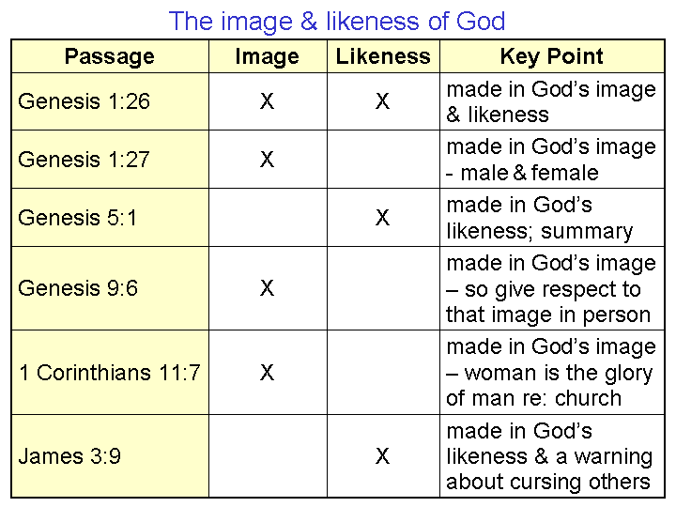
When the earth was not yet a week old, the three persons of the godhead, Father, Son and Holy Spirit, communicated with one another, using the pronouns, “Us” and “Our”. God created mankind male and female, in which both male and female human beings were made in the image of God. As we see from the chart, image and likeness appear to be used as synonyms throughout God’s word, apparently using the words interchangeably. The nuance of difference in the two words would be that image relates to representation and appearance, whereas likeness relates to corresponding to the original pattern. The use of both words together regarding the creation of mankind is only found in Genesis 1:26. But the two words are found together in two other passages, and their use seems also to be intended as synonyms:

Genesis 5:3
When Adam had lived one hundred and thirty years, he became the father of a son in his own likeness, according to his image, and named him Seth.

Deuteronomy 4:16
…so that you do not act corruptly and make a graven image for yourselves in the form of any figure, the likeness of male or female…

So what are we to conclude regarding the creation of mankind in the image and likeness of God, and the impact of the fall of mankind into sin? Here are some starting principles:

- What is similar in character to God in mankind is ‘the image and likeness of God’.
- The image and likeness of God refers to the original state of creation.
- After the fall (Genesis 3), the image and likeness of God remains, but is marred.
- That image and likeness, though marred, remains, so respect the remaining image.
As to the specific aspects of the image of God, Scripture provides for us these insights:

- It is a personal image and likeness (Genesis 2:19-23)
- It is a spiritual image and likeness (1 Corinthians 15:45)
- It is a moral image and likeness (Ephesians 4:22-24; Colossians 3:9-10)
- It is an interpersonal image and likeness (Genesis 1:26; 1 John 1:3)
- It is an authority image and likeness (Genesis 1:26)
- It is a creative image and likeness (Exodus 25:8, 9)

Another point to observe is that while mankind was made in the image of God in these aspects, mankind, even before the fall, could only express these aspects of God in limited degree, whereas God is infinite in His qualities. Though the nature of these aspects of the image of God remained after the fall, each one of them was corrupted or diminished in some way. It is likewise very important that we recognize the ways in which God, as He made mankind in His own image, even at the time when mankind was innocent, was quite different from mankind:

- God is not a physical being (except as Jesus Christ was born later as a human, but remained deity), and when mankind was created, no person of the godhead held any human form. Only with the birth of Christ did a person of the godhead take on a physical human form – adding humanity to His deity without changing His character as deity.
- God is eternally righteous by His very character, but man was initially created innocent, with the capacity to sin.
- Mankind was created in the context of a time based universe, but God is not subject to time, which is basic to this creation. God is unchanging and unchangeable, whereas each person within mankind is changing and changeable.
- God is infinite in His character, but mankind is finite, even in the respect to which he expresses the image of God.

So where do we go from here?

While some have taught that salvation by faith in Christ offers to make us Adam again, taking us back to the garden, a closer examination of Scripture shows that:

- God does not restore things on this earth to the garden of Eden, but to the conditions of the Millennial Kingdom (Isaiah 11:6; 65:25).
- The Millennial Kingdom is the direction toward which God is managing all of this present creation, when all things will be summed up in Christ (Ephesians 1:9, 10).
- This present heaven and earth will be ended, and a new heaven and earth will be created (2 Peter 3:10-13; Revelation 21:1).
- The only thing from the garden of Eden that will specifically show up in the new heaven and new earth will be the tree of life (Revelation 2:7; 22:1-19).

So if God isn’t going to take us back to the garden of Eden, back into being Adam again, then what is God doing with us? What direction is He taking us?
Romans 8:28-29
And we know that God causes all things to work together for good to those who love God, to those who are called according to His purpose. 29 For those whom He foreknew, He also predestined to become conformed to the image of His Son, so that He would be the firstborn among many brethren;

2 Corinthians 3:18 Expanded & Explained (see 2 Corinthians handout)
But all of us who are in Christ, with a face that is not veiled by the Law, having died in relationship to the Law and living by God’s amazing grace, are right now continuing to behold as we read and hear the written word of God, seeing as one who looks into a mirror, the glory – the radiant essence of who Christ is – the glory that comes from Christ Himself, and we are in fact in the very the process of being changed and transformed into the same spiritual character, growing from one level of Christ’s glory to the next, and every part of this beholding and transformation is from the God-given ministries of the Holy Spirit.

We also have this important insight, which also uses the word ‘image’:

1 Corinthians 15:45-49
So also it is written,
"The first man, Adam, became a living soul." The last Adam became a life-giving spirit. 46
However, the spiritual is not first, but the natural; then the spiritual. 47
The first man is from the earth, earthy; the second man is from heaven.
48 As is the earthy, so also are those who are earthy; and
as is the heavenly, so also are those who are heavenly. 49 Just as we have borne the image of the earthy, __. we will also bear the image of the heavenly.

So what is the difference between being made in God’s image, with the possibility of being ‘Adam again’, and being conformed and transformed into Christ’s image? Well, there are several important differences:

- God’s original creation of mankind in His image was when God had no person of the godhead in the form of a human being, but our being conformed and transformed into Christ’s image will ultimately include each one of us having a ‘new creation’ body like Christ’s. Taking on that new body will not be a process, but will be a change that will take place in a moment. That is a future that the first Adam did not have. That will be a body unlike the one the first Adam had.

- Our being made into the image of Christ, as a process, is to make us daily more in accordance with the history we already share with Christ in our eternal position: death, burial, resurrection, ascension, seating. This history could not have taken place without Christ, who was and is and will be full deity, first having taken on the form of a man, and is now a glorified man. That is a past, impacting our eternal future, that the first Adam did not have. Our future is to ‘catch up’ with our history in Christ.
- While we will one day have a body like Christ’s, and are being conformed and transformed into the image of Christ, we will not simply be made perfectly identical with Christ. What will be different? Though we will be like Him as to the kind of being in body and are being made and will be like Him in character, we will not be deity – He will remain deity and uniquely the Son of God. We will also maintain our individual identity on into eternity, and He will maintain an individual relationship and fellowship with each one of us:

Revelation 2:17
He who has an ear, let him hear what the Spirit says to the churches. To him who overcomes, to him I will give some of the hidden manna, and I will give him a white stone, and a new name written on the stone which no one knows but he who receives it.'

Even though it is our Continuing Person who is changed over the course of this life, as a result of what God is doing in the life of the believer, that ongoing process is not intended to erase or eliminate our personal identities. Christ will remain identifiable as to who He is on into eternity (the Lamb: Revelation 22:1-3), as will the apostles (Revelation 21:14), and we ourselves (Revelation 2:17).

- Though Adam was innocent, He was not righteous, as Christ is (1 John 2:1). We are not being made into Adam’s innocence, but rather made into Christ’s righteousness. In Adam’s innocence, he could choose to fall into sin. In Christ’s righteousness, as a part of His image to which we are being conformed and transformed, there is no path to falling again into the first Adam’s sin.

The body Adam was given came to have a sin nature attached to and associated with it at the time that Adam sinned. The body we will have will not only not have a sin nature attached and associated with it, but will not have the capacity for a sin nature to be attached and associated with it. Every increment of conformity to the image of Christ and transformation to the image of Christ will be an increment in preparation for the new body and the alignment of our Continuing Person with the New Man and the New Nature.

- As we looked at the physical / spiritual ‘components’ of man last Sunday (Physical: body / brain; Spiritual: soul / spirit), we would do well to note that all of the lasting changes that are taking place in the life of the believer are on the spiritual side (soul / spirit). The body, on the physical side, will be replaced with a new body, like Christ’s.

- Adam fell into sin, and since then, “…all have sinned and fall short of the glory of God…” (Romans 3:23), but as we are transformed through beholding Christ, we grow from glory to glory, since His glory is made to be in us (Ephesians 3:20, 21). Glory is the radiant essence of who God is – fundamental to His character.

