Being conformed – what is God doing?

Last Sunday we began to explore what it means for the believer to be conformed to the image of Christ. In doing so, we introduced God’s substantial and necessary part in conforming us to the image of Christ. Today we will provide more detail and backing for God’s part in conforming us to the image of Christ.

Physical & spiritual

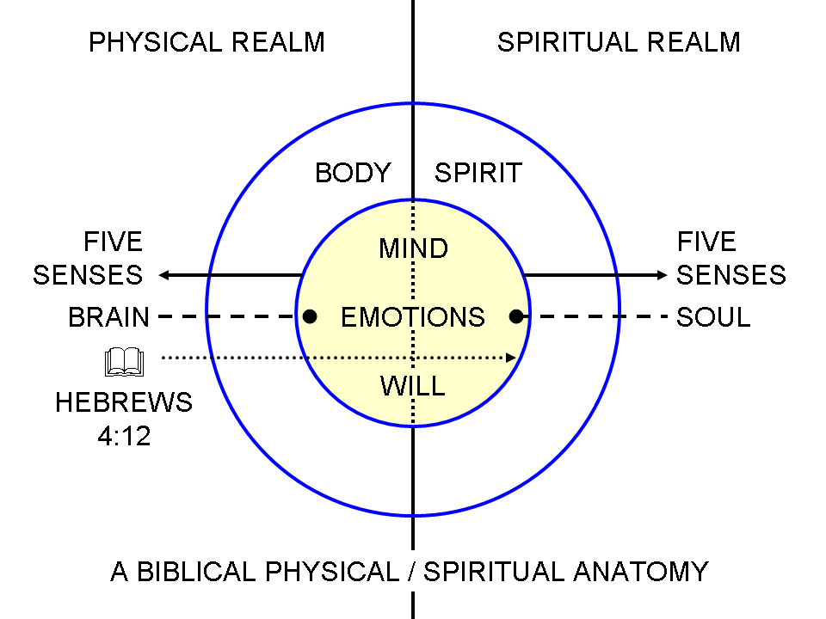
One of the points we have made in previous weeks is that God made human beings to be both physical beings and spiritual beings. God causes all things to work together – or some translations have it that God works all things together for good – to the end that the believer is conformed to the image of Christ. The ‘all things’ includes things that are physical and things that are spiritual to the end that the spiritual aspect of the believer’s Continuing Person is conformed to the image of Christ. We have already discussed the difference between being made in the image of God and being conformed to the image of Christ (5th lesson, January 30).

God is a God of sovereign action, direction & purpose

Romans 8:28-30 (NASU; all Scripture references are NASU unless stated otherwise)
And we know that God causes all things to work together for good to those who love God, to those who are called according to His purpose. 29 For those whom He foreknew, He also predestined to become conformed to the image of His Son, so that He would be the firstborn among many brethren; 30 and these whom He predestined, He also called; and these whom He called, He also justified; and these whom He justified, He also glorified.

God is the one who takes the action, both in once-for-all actions and in ongoing processes. God also works with purpose and specific direction. God is not running an open-ended experiment in our lives, just to see what will happen or how it will turn out. God also does not do things in our lives that have just a purely negative impact. He is not controlling and directing the ‘all things’ only intending or hoping that it generally turns out that these things conform us to the image of Christ – He has predestined the outcome so that it most certainly takes place, and that’s a good thing, even if the event or process can be truthfully called ‘bad’.
In the pages that follow we will look at how God can work through both physical and spiritual influences to conform each one of us to the image of Christ. Note that the examples are of how God can work, but not always how God uses His working to conform us to the image of Christ. In other times and places and among other people groups God had other promises, purposes and determinations regarding the outcome of the events than He has with us in the body of Christ.

God is sovereign over political authority

Daniel 2:37-38
"You, O king, are the king of kings, to whom the God of heaven has given the kingdom, the power, the strength and the glory; 38 and wherever the sons of men dwell, or the beasts of the field, or the birds of the sky, He has given them into your hand and has caused you to rule over them all...

John 19:10-11
So Pilate said to Him, "You do not speak to me? Do You not know that I have authority to release You, and I have authority to crucify You?" 11 Jesus answered, "You would have no authority over Me, unless it had been given you from above; for this reason he who delivered Me to you has the greater sin."

God can work through natural law or miracles & does respond to prayer

Matthew 5:44-46
"But I say to you, love your enemies and pray for those who persecute you, 45 so that you may be sons of your Father who is in heaven; for He causes His sun to rise on the evil and the good, and sends rain on the righteous and the unrighteous."

James 5:17-18
Elijah was a man with a nature like ours, and he prayed earnestly that it would not rain, and it did not rain on the earth for three years and six months. 18 Then he prayed again, and the sky poured rain and the earth produced its fruit.

God can allow problems impacting our human bodies, even using Satan

Job 2:7-8
Then Satan went out from the presence of the LORD and smote Job with sore boils from the sole of his foot to the crown of his head.

2 Corinthians 12:7
Because of the surpassing greatness of the revelations, for this reason, to keep me from exalting myself, there was given me a thorn in the flesh, a messenger of Satan to torment me--to keep me from exalting myself!

There was apparently an apostolic ability to turn someone over to Satan for spiritual discipline (1 Corinthians 5:3-5; 1 Timothy 1:18-20).

God does things in the spiritual realm

We have seen a few examples of how God can even use Satan, but God has fixed in place certain spiritual realities in each believer:

1) We have every aspect of our eternal position in Christ, and He in us, as fixed and untouchable, including our identification with Christ and everything that means in the daily life of the believer. God accomplishes all these things by His grace and those accomplishments are irreversible. Our awareness of our position, our enjoyment of our position, and our walk according to our position may indeed vary over time, and from believer to believer, but our position in Christ and Christ in each of us does not and cannot change or even be threatened. Our eternal position serves as a sound basis – a firm foundation - for our being conformed to the image of Christ. An understanding of our spiritual anatomy, as we explored during the last four Sundays in the month of January, reveals what God has put in place in each believer that does not change, and the part that does change (the spiritual aspect of our Continuing Person).

2) There are ongoing processes in the spiritual realm that result in our being conformed to the image of Christ. Our being transformed through beholding Christ through His written word is a parallel but not identical process to the other processes that God has in place. We will be exploring what that means during the month of March.

But simply stated, our being conformed to the image of Christ is the result of a totally harmonious orchestration of ministries from the Father, the Son and the Holy Spirit. All three persons of the Trinity have a part in that conforming process. The direction of these ministries and even our initial blessing is from the Father. The spiritual accomplishment is by Christ, and the person toward whom we are being conformed is Christ. And the ongoing daily ministration of that accomplishment and process is through the Holy Spirit.

Hal Molloy outlined the ministries of the Holy Spirit for us some years ago, and though some of these are positional, and some involve the transforming process, we have listed them all on the following page together for the sake of consistency and simplicity. See if you can identify which ministries of the Holy Spirit are once and for all events (positional), and which ones are ongoing processes. In addition, see if you can identify which are ongoing processes that are part of conforming us to the image of Christ and which are part of transforming us to the image of Christ.
Some Of The Various Aspects Of The Ministry Of The Holy Spirit In The Believer’s Life

1. The Spirit dwells in believers. John 14:6; Romans 5:5; 8:9: 1 Cor. 3:16

2. The Spirit gives believers access to the Father. Ephesians 2:18

3. The Spirit has fellowship with believers. 2 Cor. 13:14; Phil. 2:1; 1 John 4:13

4. The Spirit teaches believers. 1 John 2:20, 27; 1 Corinthians 2:13

5. The Spirit reveals the glory of Christ to believers. 1 Corinthians 2:9-13; John 16:13-15
6. The Spirit transforms believers. 2 Corinthians 3:18; John 17:24; Eph. 2:6, 7
7. The Spirit manifests his fruit through believers. Galatians 5:22, 23; John 15:5

8. The Spirit gifts every believer for ministry. 1 Cor. 12:7, 11, 27; Ephesians 4:7,8,11,12

9. The Spirit empowers believers. Acts 1:8; Ephesians 3:18

10. The Spirit fills believers. Acts 2:4; Ephesians 5:18

11. The Spirit desires against believers' sin nature. Galatians 5:17; Romans 8:13

12. The Spirit controls the mind of the new man. Romans 8:5, 6; Philippians 2:5

13. The Spirit frees believers. Romans 8:2; 2 Corinthians 3:17

14. The Spirit guides believers. Romans 8:14; Galatians 5:18, 25

15. The Spirit intercedes in prayer for the believer. Romans 8:26, 27; Eph. 6:18; Phil. 3:3

16. The Spirit is God's guarantee of His promises to the believer. 2 Corinthians 5:5; Ephesians 1:13, 14

17. The Spirit is the agent in the believer's sanctification. 2 Thessalonians 2:13, 14; Romans 15:16

18. The Spirit assures believers. Romans 8:16; 1 John 4:13

19. The Spirit glorifies Christ through believers. John 16:13, 14; 1 Corinthians 12:3

20. The Spirit can be grieved & quenched by the believer. Ephesians 4:30; 1 Thessalonians 5:19

21. The Spirit is the means by which a believer walks. Galatians 3:2, 3; 5:16

- The Spirit perfects the believer. Galatians 3:3

